**PooPooPiPe Playtest Report**

**Team:** 99 **Project Name:** PooPooPiPe

**Date:** 7/10/20 **Project Version:** Final (v1.0)

**Playtest Goals**

Determine whether players understand the system.

Determine whether the attacks and the theme matched with concept

Determine whether there are possibility of unfairness in my game

**Playtest Notes**

**Test #1: In-Hwa Jo (inhwa1025@khu.ac.kr) – friend who is not a digipen student**

The playtest took place at 3pm on July 8. She seemed a little surprised at the game made by students, not major games, as she was not a student who learns game development. She said we were amazing because we made a game in 1 year. She watched prologue cut scene and she felt that the cut scenes went well with the sound effects. When the main menu came up, she tested the options, credits, tutorials, and so on. There was no particular response elsewhere, but when she played tutorial without full screen, the mouse input didn’t work well. After finishing the tutorial, she started the game in earnest.

It took her a total of 15 minutes to clear from level 1 to 10. On the game play screen, she tried to tap the UI several times, and said it was fun because of the sound effects which matched the background sound of the game. However, when she entered level select, she found a bug saying that there are 10 levels in total game but only up to Level 8. At first, she looked confident because the game was so easy, but as the level passed and the color pipes appeared, she clearly showed a longer play time. She said that the game was harder than her expect and the traps were fresh. I watched her reaction carefully when the auto rotation puzzle (yellow puzzle) came out in level 5. Because through the last play test, when people failed at level 5, the fail screen immediately covered the entire screen, so they couldn’t notice what was wrong. Therefore, after much consideration, I added a fart sound effect that signals failure for about two seconds when the players fail, then, gave them a chance to recognize that the pipe has turned automatically, and put up the fail screen. Through this, she looked embarrassed at first sight at level 5 because she didn’t know what to do, but, did recognize that she was going through a failure. However, she still seemed to be having a hard time with level 5. It took about 25 minutes to play a total of two round.

After play test, she gave us feedbacks about poopoo pipe. First, the mouse input didn’t work when she turned off the full screen in tutorial. I realized from her feedback that we didn’t apply the newly created input to the tutorial. Thanks for her, as we were able to fix it quickly. Second, there were no last two level in level select. Finally, the fact that our game is a puzzle game is so common, but it is a very attractive game because it has a new story and concept.

**Test #2: Jung Dae-Chur (**[**jungdae.chur@digipen.edu**](mailto:jungdae.chur@digipen.edu)**) - student who is graduated Digipen in Redmond**

The playtest was held at 11 am on July 9th. He seemed to be looking forward to our game as he had already graduated from Digipen. When he saw the prologue cut scenes and the main menu screen, he said that the picture is so high quality. After the cutscenes and the menu, he played tutorial and he stated that he wanted us to add more explanation about how to play the game.

It took him a total of 10 minutes to clear from level 1 to level 10. During game playing, the mouse control was so uncomfortable with moving puzzle in levels. If he dragged the pipes quickly, he missed the pipe and it was uncomfortable. Also, he was very embarrassed about what UI to press after fitting the pipes. Feed back was given that the interface was not intuitive. Regarding the fail screen and fart sound effect that comes up in case of failure, he replied that the fart sound was more fun because it was too realistic. At level 5, he said he knew there was a change in the puzzle when he pressed the play button with an automatic rotation, but he didn’t understand what that meant. In addition, the map with a limited number of rotates said that it was completed when the number reached zero, but the decision of game was marked as failure, so he said that this could be a bug and it should be fixed.

After the play test, we got the feedback. He hoped the tutorial would be little more detailed. He also said that the mouse control was slow. I didn’t think it was uncomfortable before playtesting because I was used to this game for a year. But through this play tests, I absolutely found out this mouse input is really bad. So, after playtest I made the mouse control more comfortable that the puzzle would follow the cursor even if the cursor was quickly manipulated. And he said there is not enough explanation about yellow automatic rotation puzzle in level 5. Therefore, I added some cut scene and warning sound effect before starting level 5 in order to let player understand the role of yellow pipe and increase their concentration.

**Test #3 : Park SeJeong (**[**phw3218@gmail.com**](mailto:phw3218@gmail.com)**) – sophomore student in digipen**

The play test was held at 5pm on July 8. When she saw the cur scene for the first time, and she said that it like a scene from a webtoon and it is high quality. She also liked the sound of UI in the main menu and she pressed all the functions on the main menu screen. when she pressed ‘quit’ UI, there was no question of whether player would really go out or not. She said it is really important part because it was stated in rubric and we should add it.

It took her a total of 10 minutes to play from level1 to level 10. First, she said that drag and drop of the puzzle is so uncomfortable because the mouse manipulation is snapped off. Also, the sound of flushing is too small when the game is cleared. Also, she said that the puzzle difficulty was so easy and similar traps were repeated. She wanted us to pay more attention to map design. At level 5, about the yellow puzzle, her reaction is same with other people above. She wanted us to pay more attention about explanation of yellow puzzle in detailed. Overall, all of the maps were easy for her.

After the playtest, she gave feedback on the discomfort of the mouse input and pointed out that the sound of flushing effect was so small. Through her feedback, the input was improved so that the puzzle would follow the cursor even if the mouse was moved quickly, and so that the drag and drop of the puzzle would not be uncomfortable. And we fix the sound effect of flushing much bigger.

**Syllabus result (above 3 people)**

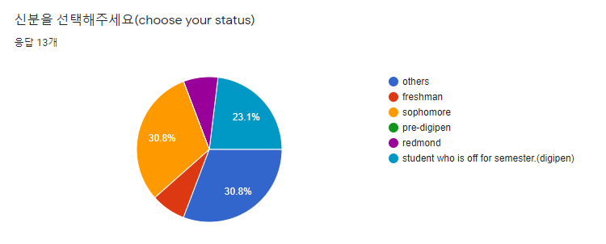

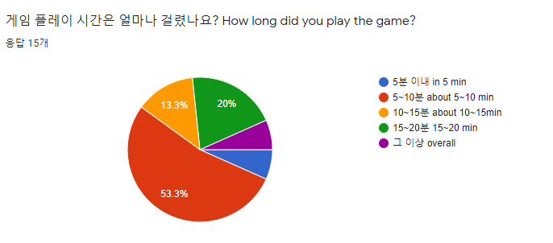

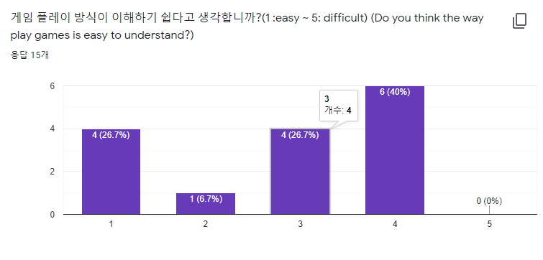

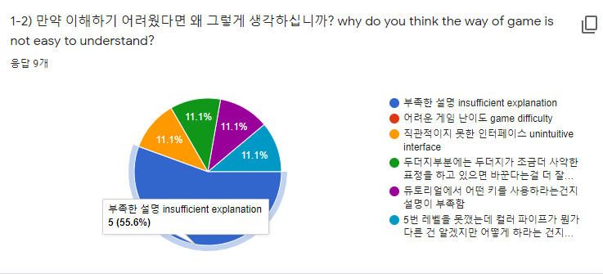

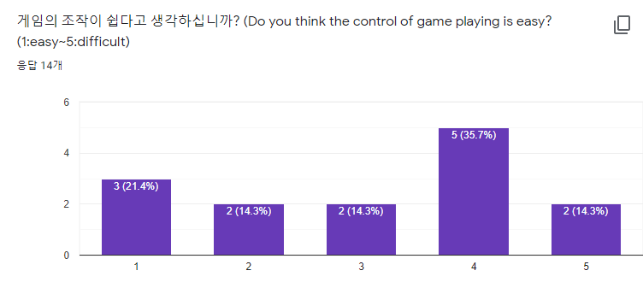

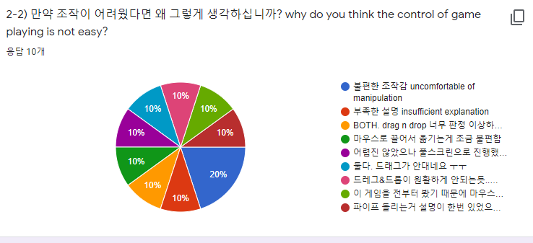

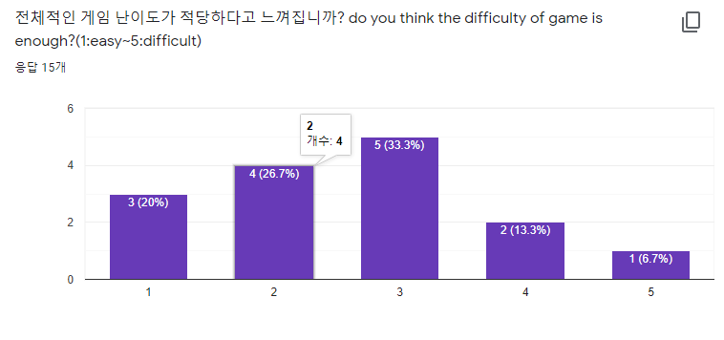

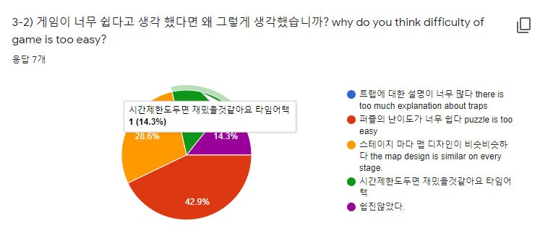

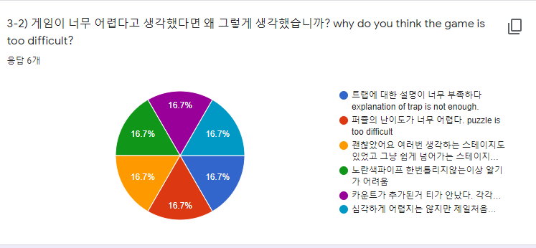

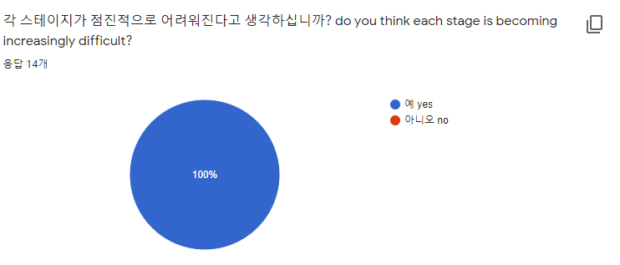

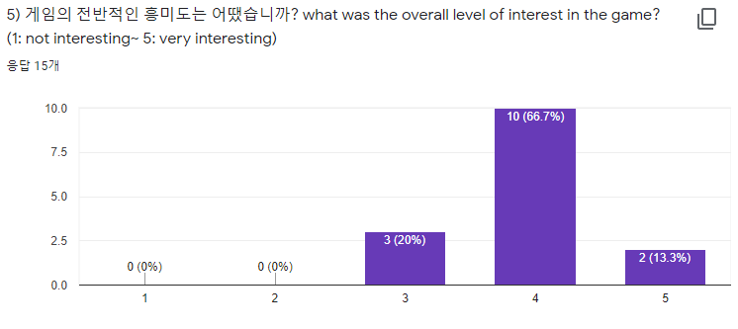

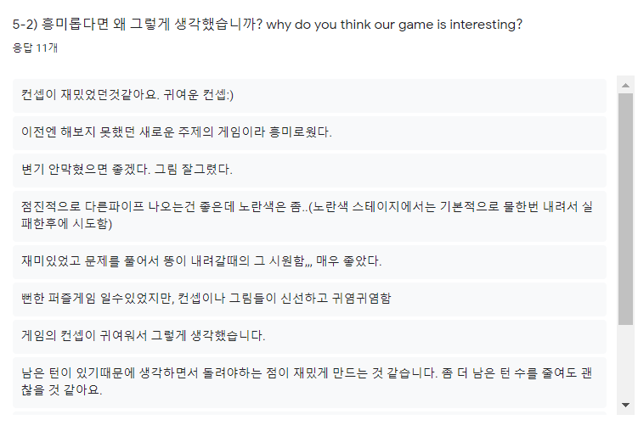

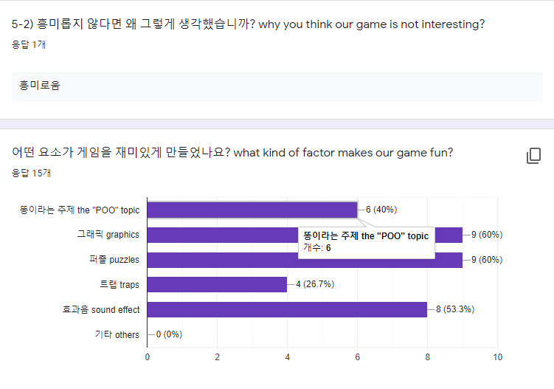

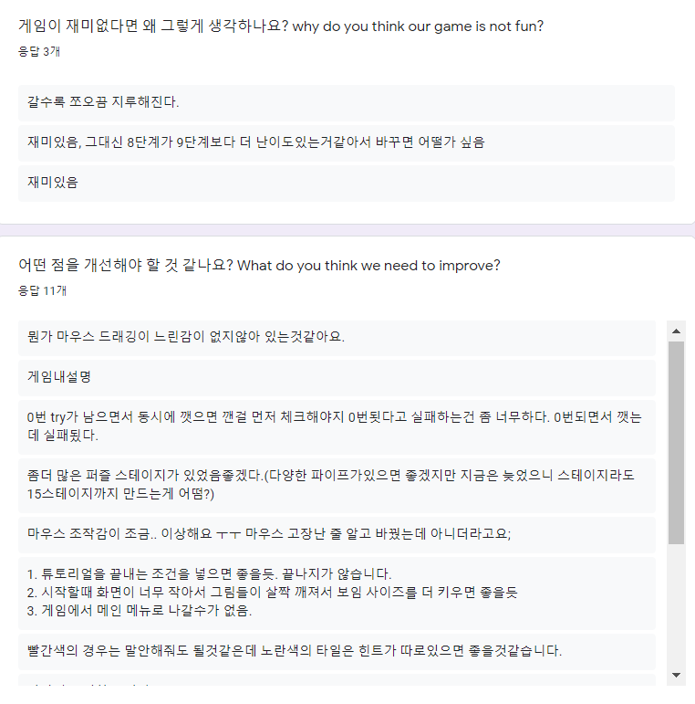

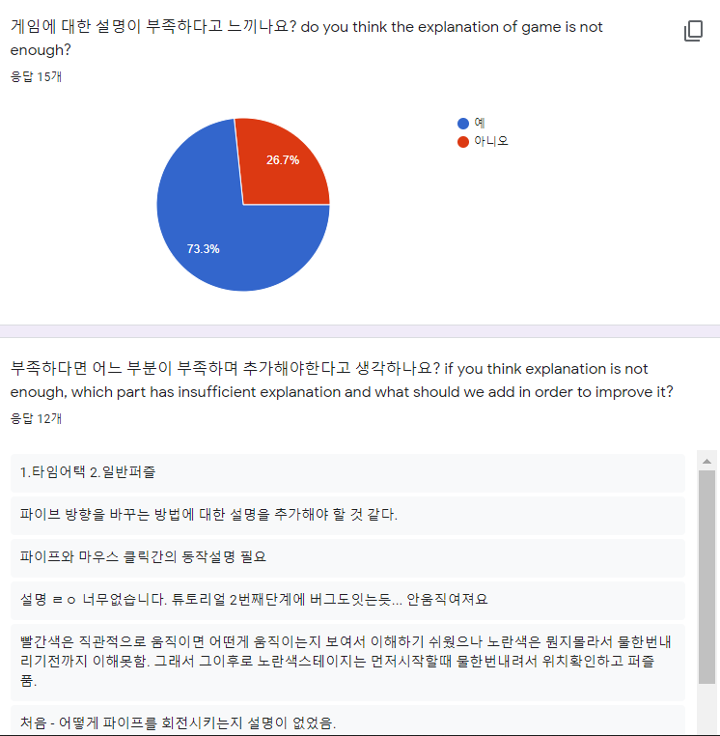

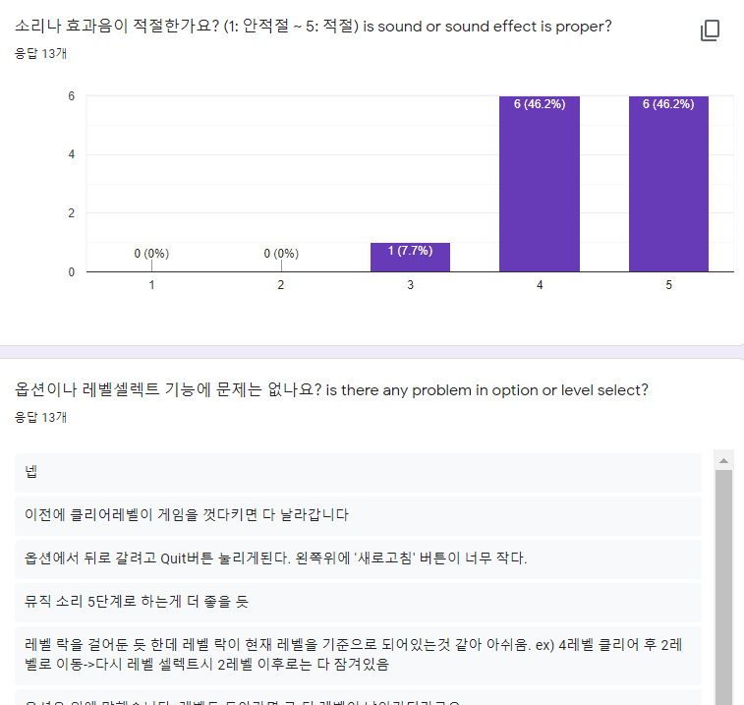

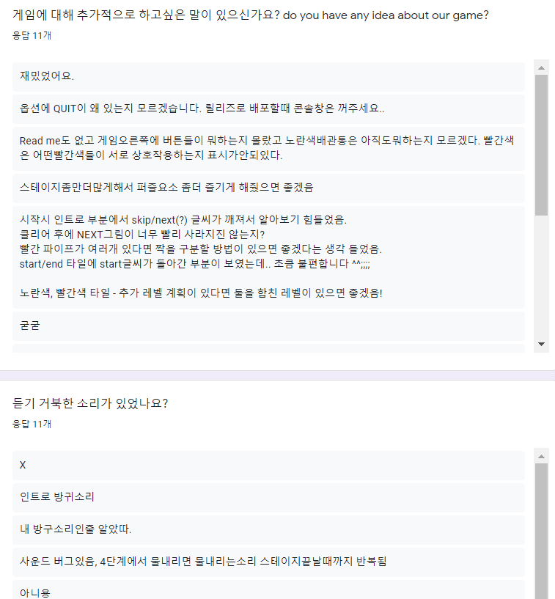

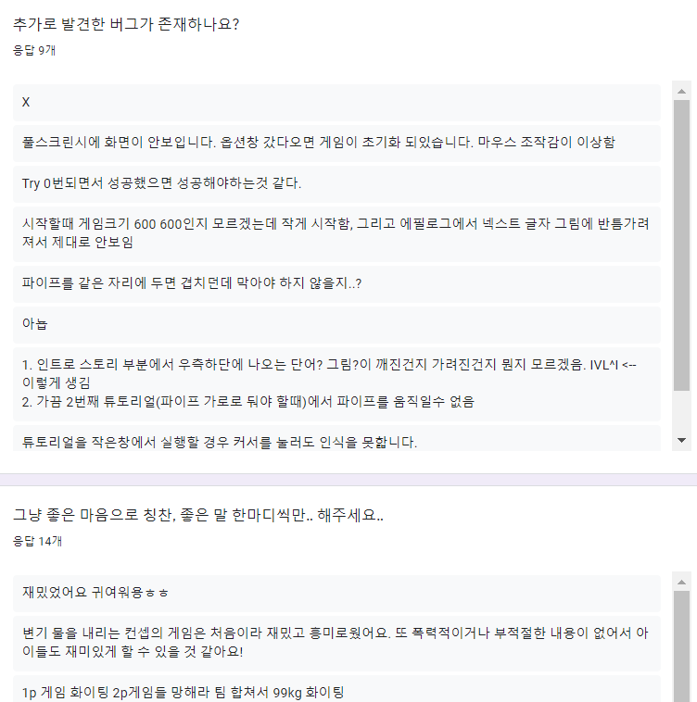

**Playtest analysis**

1. **Uncomfortable of control with mouse**

There were many feedbacks that the control of the drag and drop is uncomfortable. When moving it slowly, the puzzle moved properly, however, when it gets faster, the puzzle didn’t follow the mouse, but drops by itself. It was hard for us to realize because we were used to move them slowly. However, we just realized that the players were different, therefore, this gave us a conclusion that we should fix them. We found the reason that it is because there too many if statements while doing a collision check between the mouse and the puzzle bocks. Therefore, it was hard for the game to follow the mouse speed. We made a bool variable to change it when it does the collision. In addition, we made them just get through single if statement to make the controls more comfortable.

1. **Lack of explanation about yellow puzzle**

Even we added a warning line written, ‘be careful to the pipes with colors’, many people spent hard time to understand the level which uses yellow pipes, and, received lots of feedbacks. Therefore, we came out an idea that if we make a warning and at least give a hint what happens to the yellow pipe. If we gave them an additional warning that they will at least understand what the yellow pipe does. Therefore, we planned to add an additional cutscene before the level, and, adding a siren sound.

1. **Re question about quit**

There were several feedbacks that they got surprised because mistakenly hitting the quit button, the game turn offs instantly. This gave us an idea adding a warning screen asking them if they are sure to quit the game. It is also one of the requirements in the rubric, we planned to add the quitting UI which asks the player.