**GAM250 Playtest Report**

**Team : 99** **Project Name:** PooPooPiPe

**Date:** 7/15/20 **Project Version:** Final(v1.2)

**Playtest Goals**

**Playtest Goals**

Determine whether players understand the system.

Determine whether the attacks and the theme matched with concept

Determine whether there is possibility of unfairness in my game

**Playtest Notes**

**Test#1: Chulseung Lee (fpsemfaos@gmail.com) – sophomore**

Playtest was held at 13th July on Monday, at 3o’clock. First, at the splash screens he said that he wished the Digipen Logo and FMOD logo be much bigger. Moreover, he stated that the sound effects of the cutscenes made the game more interesting. He gave lots of points that we missed, such as uncomfortable controls of the tutorial, and the ‘pause menu’ when hitting the esc button didn’t worked well.

It spent total 7 minutes playing through from level 1 to level 10. He did like the UI sounds however stated his opinion that he wants more. Moreover, when doing the rotation, the coin sounds fitted the game, but expected more realistic sounds which is more metal-y. Moreover, the drag and drop puzzle was too easy to solve, but at the level which was yellow pipe made him very confusing. It looks like it was hard for him to understand just by the cutscenes and the warning sign. However, he did solve the puzzle after 4 tries. The opinion about auto rotation red puzzle was it was creative. The red pipe puzzle felt like it was easy, therefore, he recommended to add a rotation limit too. Moreover, he found that when going to the option, the background music does pause, but wished at least the sound effects work.

After the playtest, he gave feedbacks in conclusion which were pointed during and before the game. By his feedback, we found out the code which was used the ‘esc’ button got mixed each other which cause confusion. By this playtest and discovery, we right away fixed this problem. Moreover, about the sound mute of the option, we plan to fix them to make the only background sounds mute but the sound effects keep playing, therefore the player could realize he is ‘pushing’ the buttons.

**Test#2: Harim Kim**

The playtest was held at 14th of July, PM 7o’clock. We held the playtest face-by-face. She is one of the play testers who already tested our game previously, therefore, she didn’t need additional explanation. She stated that she will give feedbacks comparing with the previous experience she had. She showed satisfaction by the added sound effects and stated that the project does look like a real game.

Starting the game play, she first played the tutorial which she felt that the explanation was less to understand. She assessed that by the addition of the explanation, the game controls got clear. She also surprised that the drag and drop problem we always had from our game is now fixed, so she does not need to move the pipes slowly on purpose. She also complimented the game loading didn’t costs lots of time. Moreover, she praised that the game had big development that it is now able to pause, and adjust the settings, and additional levels which was hard enough, but enjoyable.

Finally, after finishing the play test, we asked her opinion. The most current play test she had, in her memory, was very slow and uncomfortable by lack of functionality. However, she stated that she is surprised that the game had big development in short amount of time. The added sound effects matched with the game, and the ending cutscene gave a feeling that she did finished a game. One thing she pointed that she wanted more levels that uses several traps at the same time as the last level does.

**Test #3: Jeongmin Son**

The play test was held on 14th of July, with face-to-face meeting. He is one of the play testers who already had an experience playing our game. So, he showed interest how our game had changed comparing by before. First, he looked amazed when he saw the loading screen. He asked if the space background is hand drawing. After the loading screen, he first got into the options. He checked the credits through the options, praised that we consider the details for the credits.

He played the whole level of the game, but only spent 5 minutes because he already had an experience of the puzzles of our game, which means he knows how to solve them. During playing the game, he found the error happened to level 5 which the sounds didn’t work. We recorded the video to remember specifically where the problem occurred. At least, there were no other errors which was a big relief.

After the play test, he praised the part of the changes, but also pointed out the problems we still had. First, the part he complimented was that he could see the effort we used to make this game, and detailed parts of polishing which showed we concentrated the functionality of the game. He also stated the artworks were magnificent. However, the problems he pointed out was that the small errors still existed, and if we fix those errors the game will be whole complete.

**Research Playtest**

1. Choose your status

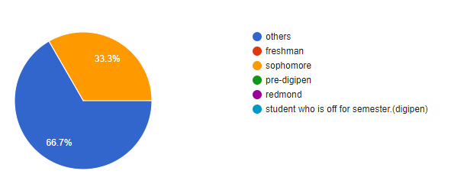

1. How long did you play the game?

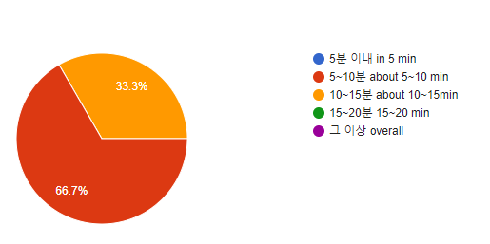

1. Do you have any issue with control?

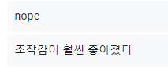

Nope, the feeling of control is much better.

1. Do you think the difficulty of game is enough? (1:easy~5:difficult)

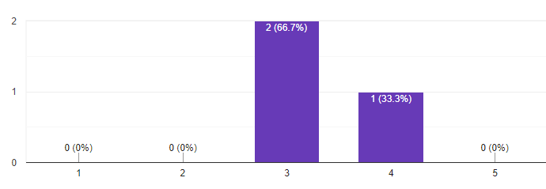

1. Is there any insufficient part of sound effect?

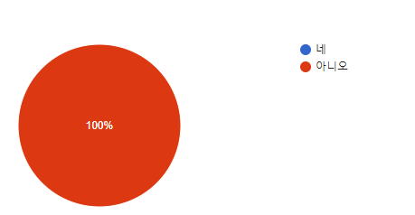

1. Do you think each stage is becoming increasingly difficult?

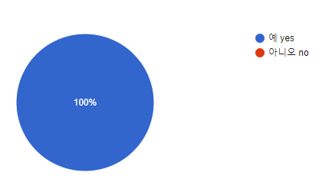

1. what was the overall level of interest in the game? (1: not interesting~ 5: very interesting)

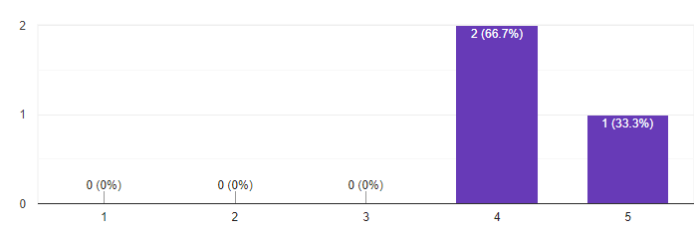

1. do you think the explanation of game is not enough?

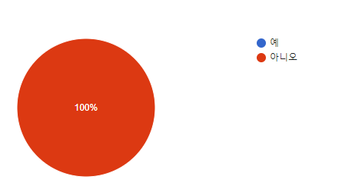

1. if you think explanation is not enough, which part has insufficient explanation and what should we add in order to improve it?

Need more level

1. is there any problem in option or level select?

Nope, work well

1. Is there any bug additionally found?

In Level 3, there was a bug where the poopoo would go down without matching all the puzzles.

**Playtest analysis**

1. **Need more sound effects and background music for depth of the game**

When pre-grading, we got a feedback that the game needs more sound effects. Our game had sound effects when cutscenes appears, warning the player, and when the mouse went to the buttons. However, we also found some parts where the sound effects were missing from the playtests. About this we planned to fix the levels where the sound effects don’t work properly, and, add more sound effects for more various situations (ex. Clicking the pipes). Moreover, the game only uses one single background music. About this, the professor gave a feedback that the music should change if we want the player to realize the game is ended properly. Therefore, as we originally planned, we are going to add different background music for each phase and for cutscenes.

1. **Pause menu**

Our game uses the option screen instead of the pause menu, because there are so many User Interfaces already used in the game itself. Because of this, we planned to add the tutorial, quit, controls button on the option menu, which is still unfinished.