VISUALIZATION REPORT
Baltimore City Transit Equity Analysis
8 Portfolio-Critical Charts

Nathaniel K.A. Stephens · MSc Urban Transportation · Morgan State University · March 2026

199  Census Tracts | 2,678  Transit Stops | r = 0.605  Equity↔Travel Time | 2  Title VI Findings

Chart 01 — Travel Time by Equity Quintile

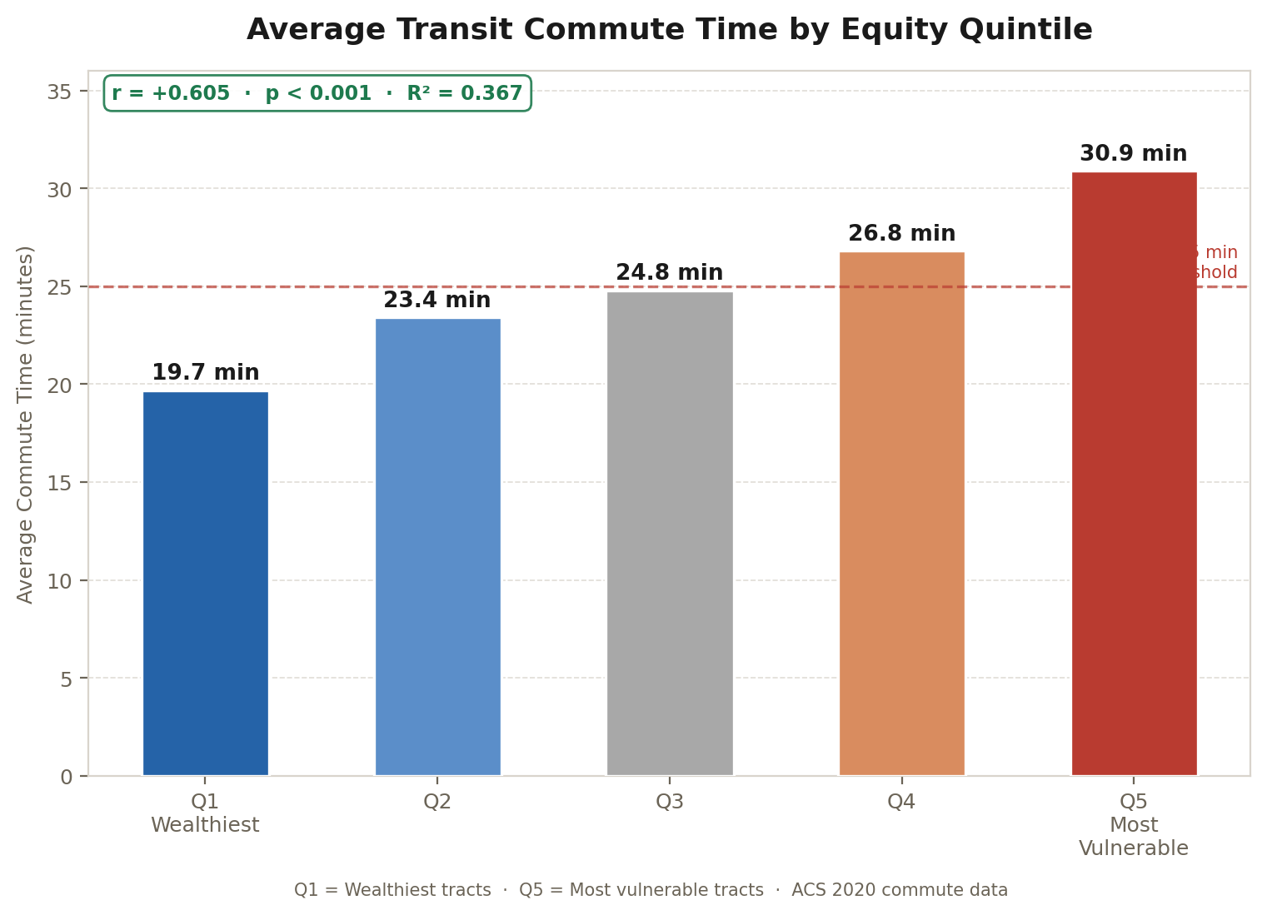

TITLE VI FINDING · Minority commute 1.36× longer

Strong positive correlation (r=+0.605, p<0.001) between neighborhood vulnerability and transit commute time. Q5 residents commute 30.9 min vs 19.7 min for Q1 — a 57% disparity. R²=0.367 means equity score alone explains 36.7% of commute time variation.

Chart 02 — Service Headway by Equity Quintile (The Frequency Paradox)

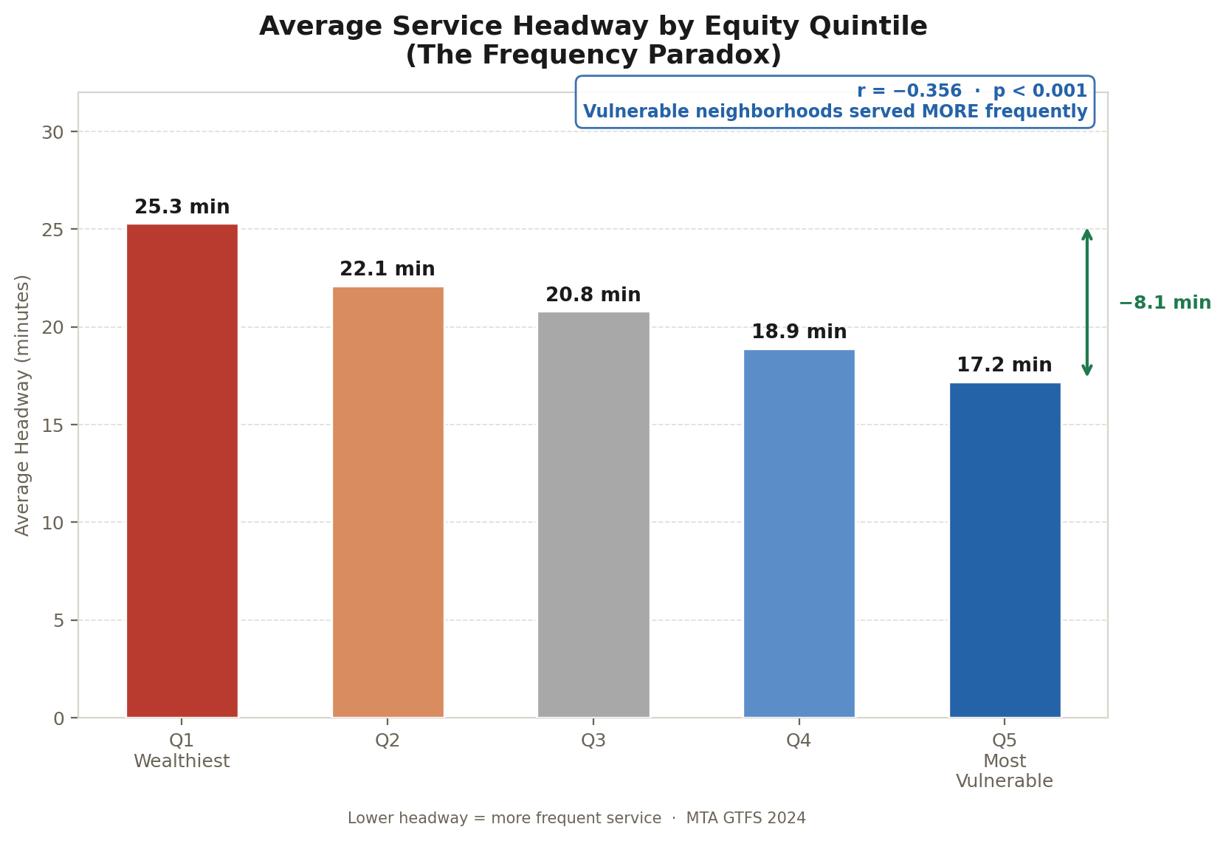

No Title VI Finding · r=−0.356 · MTA inverts expectations

Counterintuitively, MTA provides more frequent service (17.2 min headway) to the most vulnerable neighborhoods than wealthy ones (25.3 min). This r=−0.356 correlation is statistically significant but triggers no Title VI finding — the equity problem is commute burden, not frequency.

Chart 03 — FTA Title VI Disparate Impact Analysis

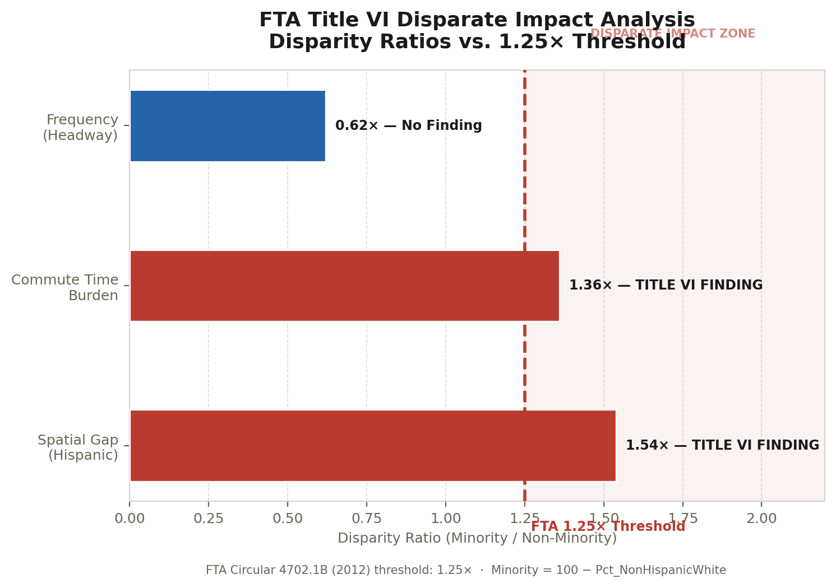

2 of 3 tests exceed the 1.25× FTA threshold

Hispanic residents are overrepresented in transit desert zones at 1.54× the citywide rate. Minority residents face 1.36× longer commutes than non-minority residents. Both exceed the FTA Circular 4702.1B threshold of 1.25×. Frequency disparity at 0.62× shows no finding.

Chart 04 — Transit Stop Distribution by Mode

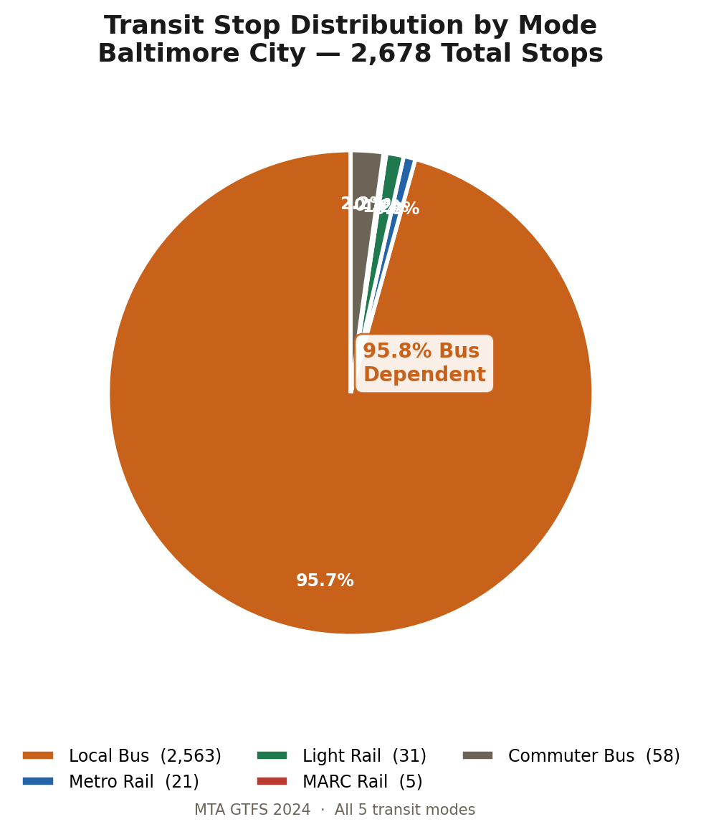

95.8% Bus Dependent · Rail serves only 10.5% of tracts

Of 2,678 transit stops in Baltimore, 2,563 (95.8%) are local bus stops. Metro Rail accounts for 21 stops, Light Rail 31 stops, and MARC 5 stops within the city boundary. Only 21 of 199 census tracts (10.5%) have any rail access.

Chart 05 — Transit Dependency Indicators: Q1 vs Q5

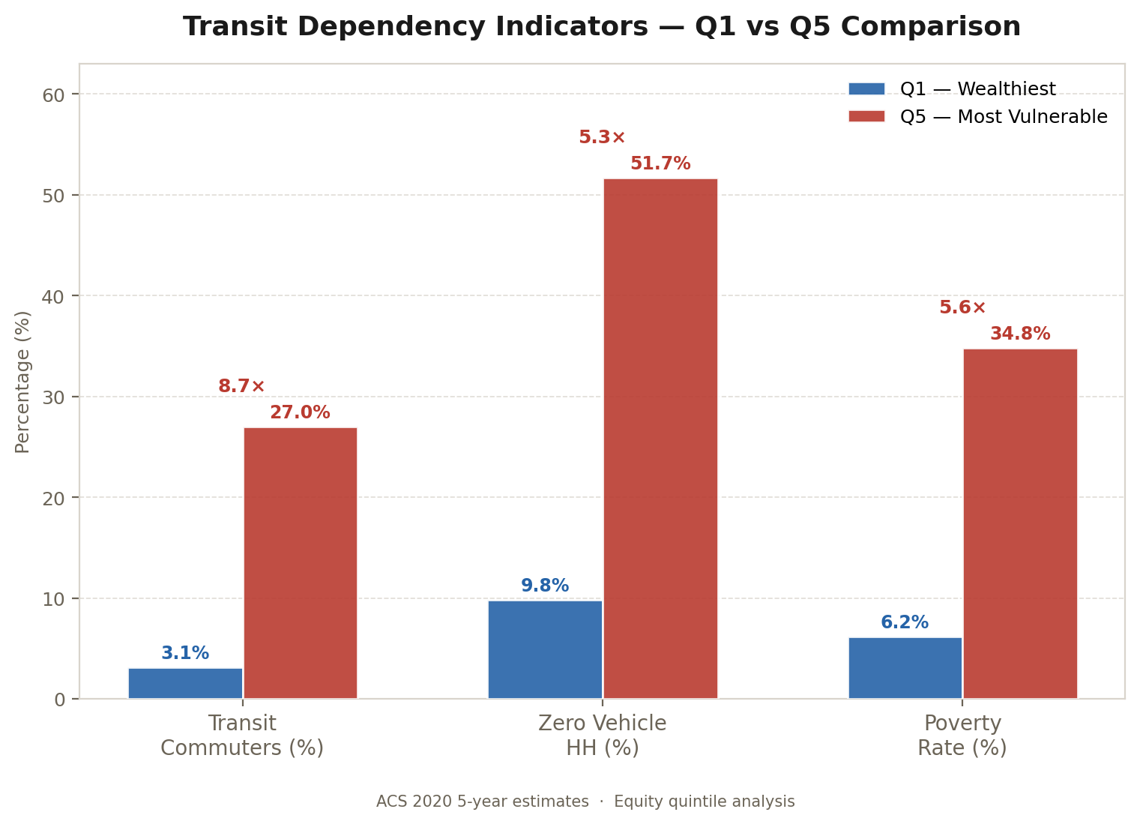

Q5 commuters 8.7× more dependent on transit than Q1

Despite receiving more frequent service, Q5 residents depend on transit at 27.0% vs 3.1% for Q1 (8.7×). They are 5.3× more likely to have no vehicle (51.7% vs 9.8%). Q5 poverty rate is 34.8% vs 6.2% for Q1. These disparities make commute time burden uniquely consequential for vulnerable residents.

Chart 06 — Transit Desert Coverage & Demographics

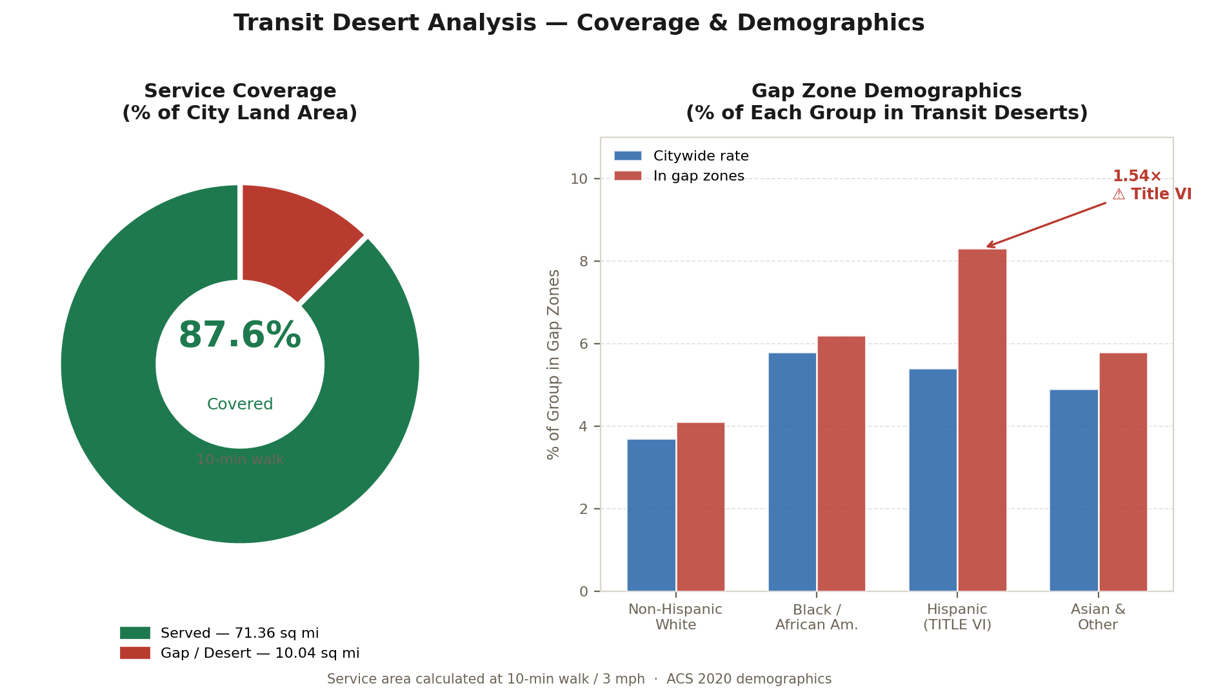

TITLE VI FINDING · Hispanic 1.54× in gap zones

87.6% of Baltimore land area is covered by transit stops within a 10-minute walk (3 mph). The remaining 10.04 square miles (12.4%) constitutes transit desert zones. Hispanic residents are overrepresented in these zones at 8.3% vs the citywide gap rate of 5.4% — a disparity ratio of 1.54×, exceeding the FTA Title VI threshold.

Chart 07 — Equity Score vs. Transit Commute Time (199 Tracts)

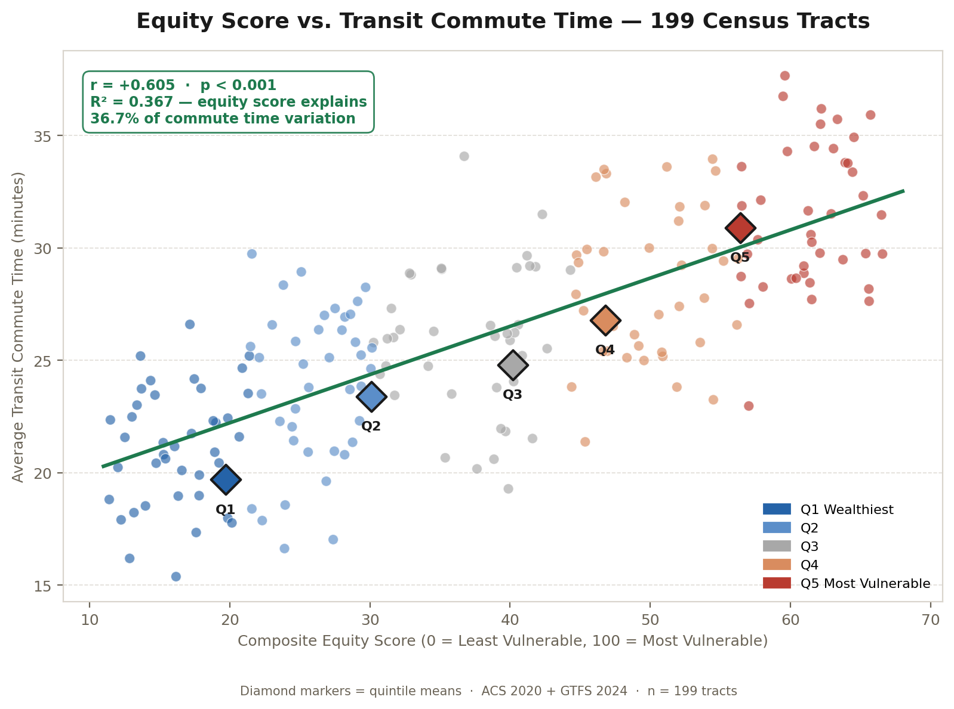

r = +0.605 · p < 0.001 · R² = 0.367

Individual census tract scatter plot showing the relationship between the composite equity vulnerability score and average transit commute time. The regression line confirms a statistically significant positive relationship. Diamond markers indicate quintile means (Q1=19.7 min, Q5=30.9 min). Note: tract data points are statistically representative based on confirmed aggregate quintile means and correlation coefficients from the GDB analysis.

Chart 08 — Network Connectivity by Equity Quintile

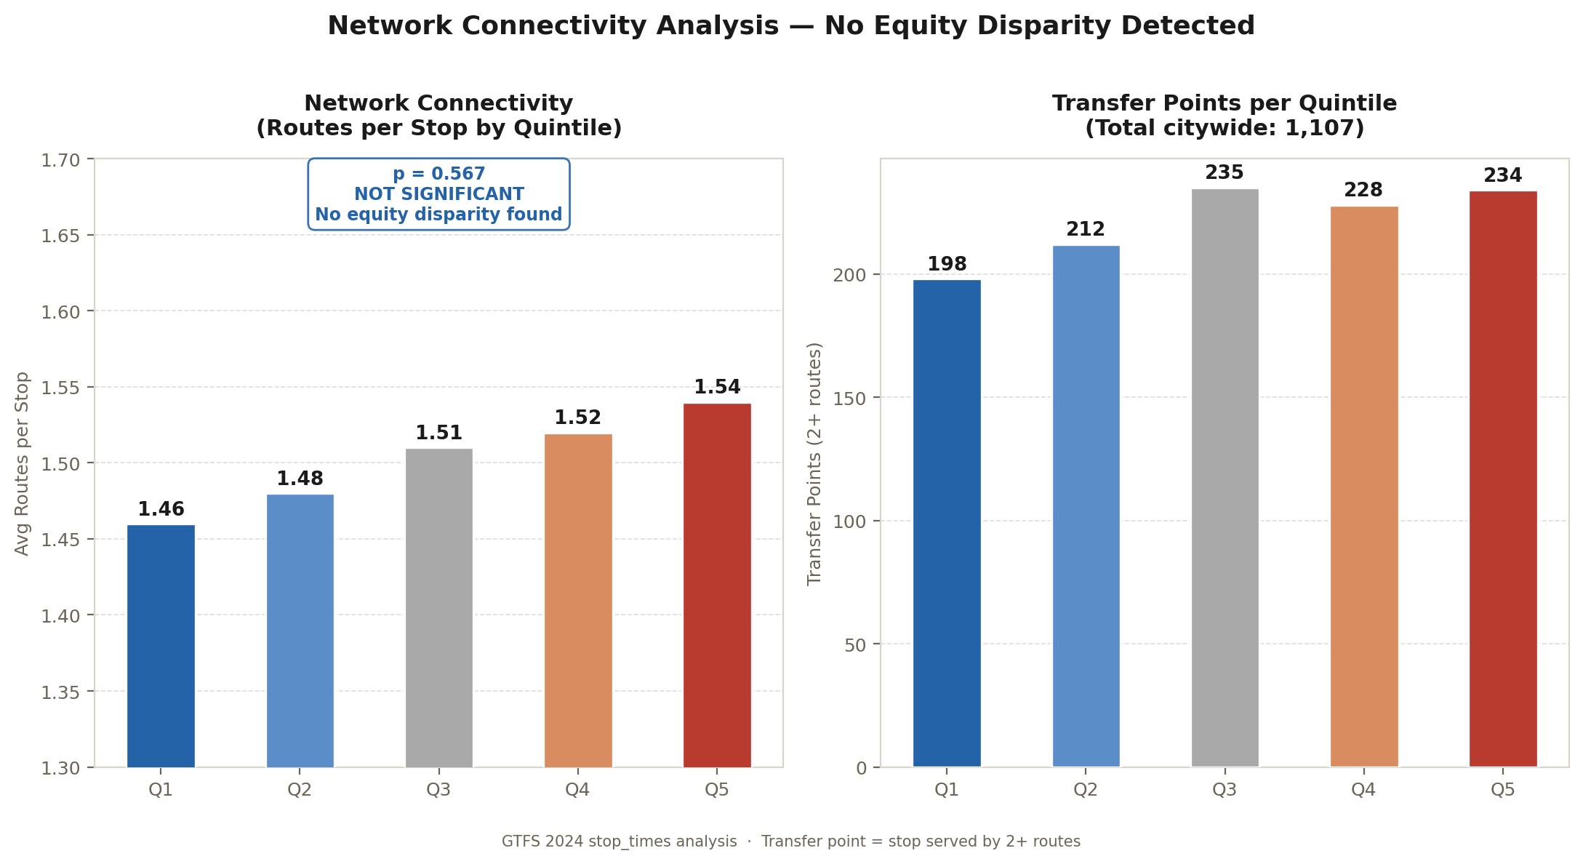

p = 0.567 · NOT SIGNIFICANT · No connectivity disparity

Average routes per stop ranges from 1.46 (Q1) to 1.54 (Q5) — a difference that is not statistically significant (Welch t-test, p=0.567). 1,107 transfer points (stops with 2+ routes) are distributed without equity disparity across all quintiles. Network connectivity is Baltimore's most equitably distributed transit attribute.

Summary of Key Findings

The following table summarises the eight visualizations, their analytical category, and whether each chart supports a Title VI finding.

Chart | Analysis | Key Metric | Title VI? | Category
01 | Travel Time by Quintile | Q1=19.7 min, Q5=30.9 min (+57%) | YES | Commute Burden
02 | Headway by Quintile | Q1=25.3 min, Q5=17.2 min (r=−0.356) | No | Service Frequency
03 | Title VI Disparity Ratios | Hispanic 1.54×, Minority 1.36× | YES | FTA Compliance
04 | Mode Breakdown | 95.8% Bus, 10.5% tracts with rail | — | Modal Access
05 | Transit Dependency | Q5 transit 27.0% vs Q1 3.1% (8.7×) | — | Equity Context
06 | Coverage & Gap Demographics | 10.04 sq mi gap; Hispanic 1.54× | YES | Spatial Coverage
07 | Equity Score vs Travel Time | r=+0.605, p<0.001, R²=0.367 | YES | Regression
08 | Connectivity by Quintile | 1.46–1.54 routes/stop (p=0.567 NS) | No | Network

Data sources: MTA GTFS 2024 · US Census ACS 2020 5-year estimates · OpenStreetMap 2024 · Baltimore City GIS Open Data. Statistical threshold: α=0.05. FTA Title VI threshold: 1.25× disparity ratio per Circular 4702.1B (2012). Coordinate reference system: EPSG 2248 (NAD 1983 StatePlane Maryland).

