How to make auto type program with python! (extremely simple)

1. download and install python at

<https://www.python.org/downloads/>

1. download and install VS code.
2. Open VS code and go to extension tab, download Python extension.

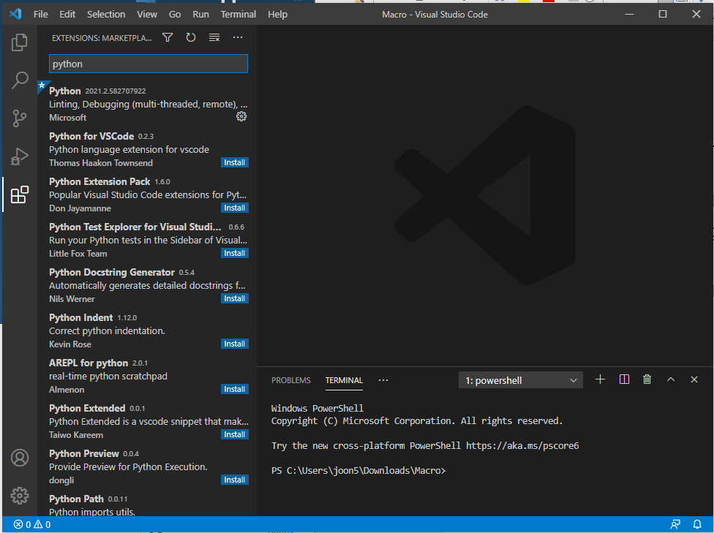

1. Go to File tab, and Open any empty Folder
2. In TERMINAL window, type “pip install pyautogui” and press enter.

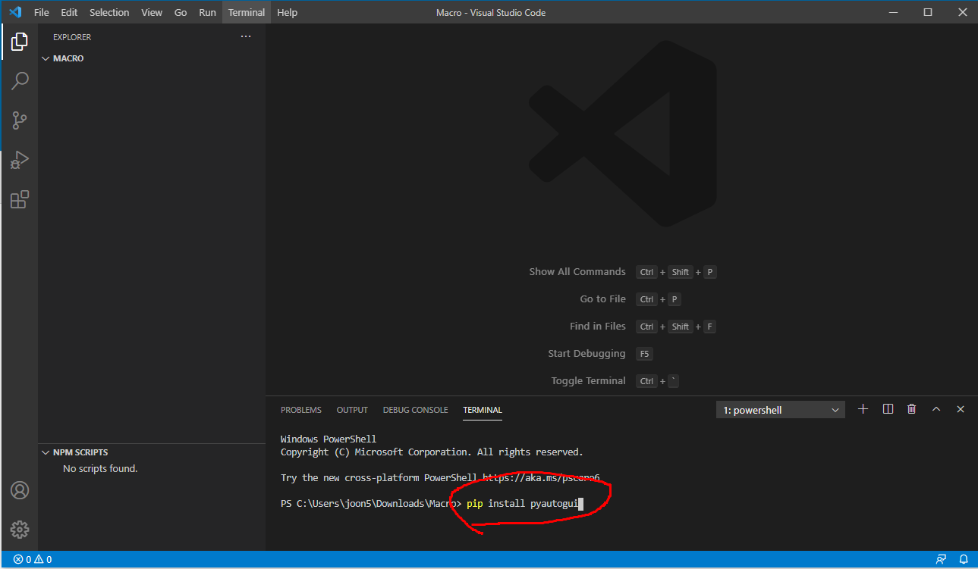

1. create .py source file in your folder (it’s similar to .c file)

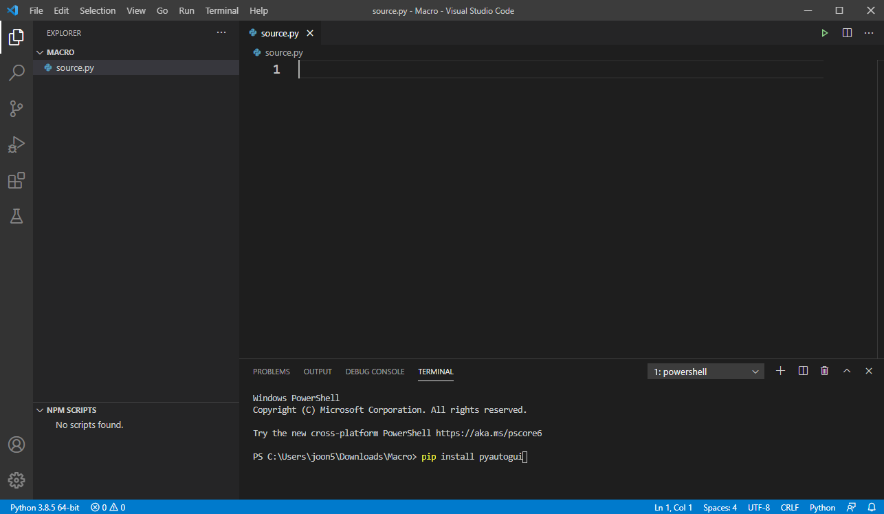

1. Import two modules

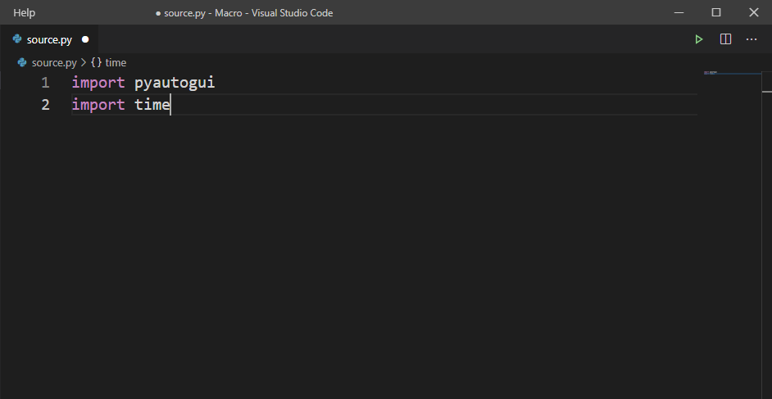

1. pyautogui.typewrite is a function which write strings

between “ ”(double quotes). And pyautogui.press is a

function which press the key in ‘ ’.

(each key has unique string like Enter key : ‘enter’)

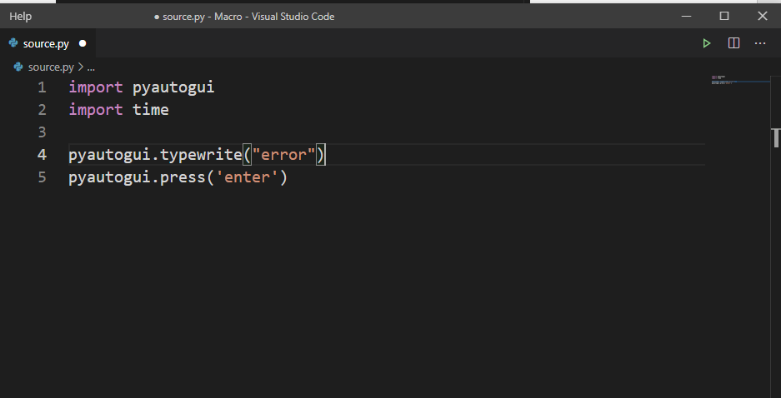

1. a function time.sleep(secs) is used for just waiting.

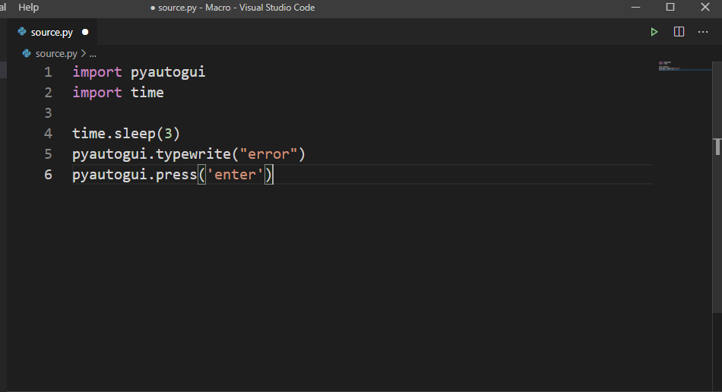

1. It’s done! If you are ready to run, run the program with press Ctrl+F5 in VS code and move to target cursor within given secs(now you know why I used time.sleep function)

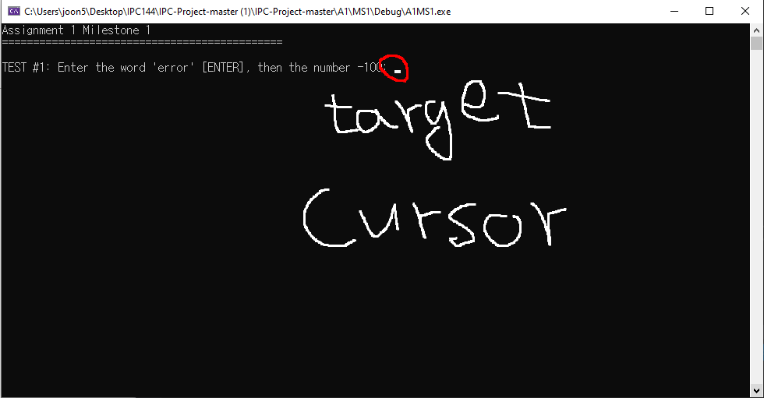

1. So good!

