Navigation 메뉴 (페이스북 메뉴 같은 것)

* <http://stackoverflow.com/questions/8453320/android-sidebar-like-facebook-or-firefox>

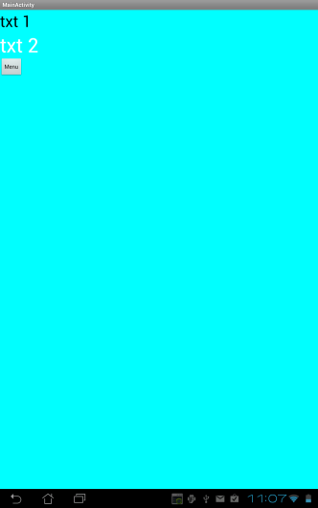

* <https://github.com/dezinezync/TiWinSlider>
* <https://github.com/gitgrimbo/android-sliding-menu-demo>
* <https://github.com/jfeinstein10/SlidingMenu>
* <http://www.youtube.com/watch?v=XwGHJJYBs0Q>
* <https://github.com/korovyansk/android-fb-like-slideout-navigation>
* <https://github.com/darvds/RibbonMenu>
* <https://github.com/Gregadeaux/android-fly-in-app-navigation>
* <http://android.cyrilmottier.com/?p=658>

뷰 메인 컴포넌트 (View Pager 비슷한 부분)

* <http://stackoverflow.com/questions/12020619/navigation-bar-at-the-top-of-each-activity>
* <http://developer.android.com/design/patterns/swipe-views.html>

그리드 뷰 (메인 아이템)

* 커스텀 <http://android-er.blogspot.kr/2011/03/custom-gridview.html>
* Add item
  + adapter.notifyDataChanged();
  + grid.invalidateViews();