**[CS 171] HW1**

***Harvard GSD - Joonhaeng Lee***

1. **Good & Bad Visualizations**

* Seoul Digital Plaza’s façade panel categorized by curvature of panels (Good / Left / 4.5) (<https://www.inexhibit.com/wp-content/uploads/2015/12/Seoul-Design-Plaza-Zaha-Hadid-CURVES-CLADDING.jpg>)

It is a good visualization showing types of building panels categories by curvature types and visualized in three different colors. This visualization is very effective for building professionals providing how building façade fabrication will cost. However, it is not sufficient to give general people information without explanation of the façade, panels, and curvature. The author showed the distribution of panels by types. The visualization is important since this information is related to the fabrication and construction sequence of the building. It might be better if the visualization overlays a transparent image of the site and adjacent buildings to find out the building layout easily.

* Key words related to BIG Data ( Bad/ Right / 1) ( <https://hackernoon.com/using-machine-learning-to-visualize-customer-preferences-6a007cfb9b97> )

It is not a good visualization. The author wants to show frequently presented keywords related to Big data. He made the different sizes of each word addressing the frequency of words presented in the data set. However, it is hard to read. Color and both horizontal and vertical layout exist of the words make the user difficult to read the visualization. Moreover, it is hard to recognize some phrases in the outer boundary of visualization since the font size is so small. One attempt we can do is make all letters horizontal and make an identical color. And use font size as an indicator to show frequency.

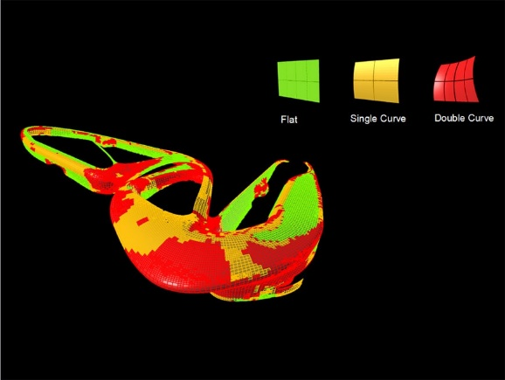 

1. **Exploratory vs. Explanatory Visualization**

* You draw it: How family Income Predicts Children’s College Changes

Autor tried to answer the relationship between family's income level and children's chance to go to college. Interactive visualization catalysis users to think about the relationship between those by themselves before reading the article. This visualization was interesting since it tries to evaluate my answer using drawn graphs. By overlapping my guess and actual data, it intrigues the user's curiosity to move on to read articles more carefully. The audience can be anyone. The author's objective of using this visualization was to make readers participate and think deeply about the contents, and it worked well.

* An interactive visualization of Every line in Hamilton:

It is an exploratory visualization of every line in Hamilton. The visualization makes users hover on data and read through them rather than show an overall relationship of characters in one chart. As a not big fan of Hamilton, I just scrolled over my mouse on dots, play buttons to read data inside. Instead of showing the relationship of data in the bigger picture. Author answer relationships between characters and storyline by showing relationships of words in lines. If the user is interested in Hamilton, it might be easier or more fun to play with this visualization. However, as a person who does not know Hamilton, nor likes musical or rap, this visualization was not effective in addressing visualization's objective.

* Bussed out-How America move its homeless:

The visualizations in the article are explanatory. The author might answer questions such that; where are the homeless's final destination, are they move to a place where people have higher income, what makes them move to another location? Visualizations in this article focus on showing one phenomenon in one visualization. So, it is much easier to understand the contents that the author found during the research. It is for general readers. It tries to criticize the government's funding on the transportation fee of homeless' relocation.

1. **Effective Visualizations**

He shows one plot of 1962 data and explains what is happening in the chart. After that, he shows a series of plots to address changes that happened in 30 years. In 1962’s plot, we can understand that industrialized countries have a higher life expectancy and smaller family size(fertility rate) while developing countries are opposite. In the animation of plots from 1962 to 2003, we saw that developing countries have a similar tendency to have a small family size and have a long life expectancy as industrialized countries did in 1962.

It strikes me that visualization can easily convey complex contents by introducing a complex data set in a sequence. In the last part of the video, the chart includes so much data. However, the audience were followed gradually changing the chart diagram from the beginning. Because of that reason, listeners did not have big trouble understanding the point of the speaker. The design of the axis was impressive too. He tries to pull the third axis after explaining the relationship between the two axes, life expectancy, and fertility rate. It has a great impact on my understanding of visualization.