**ENED 1091 HW#6**

**Due Week of March 14th**

**Problem 1:**  The figure below shows measurements of the flow rate of fluid into a tank taken every 30 seconds.



The volume of fluid in the tank is simply the initial volume plus the integral of the flow rate (assuming no outflow from the tank):

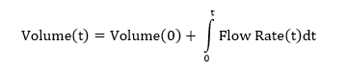

1. Assume the initial volume is 0 gallons. Using the data points given in the graph, estimate the volume at 120 seconds using the trapezoidal rule.

**Work:** 15(3*.5 + 2*.7 + 2*.3)

**Answer:** 52.5 gal

1. Repeat part (a) using Simpson’s Rule.

**Work:** 10(4*.5 + .7 + .7 + 4*.3 + .5)

**Answer:** 51 gal

1. Assume the initial volume is 400 gallons. Using the given data points, estimate the volume at 180 seconds using the trapezoidal rule.

**Work:** 400 + 15(6*.5 + 2*.7 + 3*.3)

**Answer:** 479.5 gal

1. Repeat part (c), again assuming an initial volume of 400 gallons, using Simpson’s Rule.

**Work:** 400 + 10(4*.5 + .7 + .7 + 4*.3 + .5 + .5 + 4*.5 + .3)

**Answer:** 479 gal

**Problem 2:** Consider liquid flowing into a cylindrical tank as shown in the diagram below.

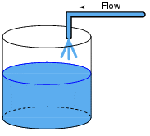

Liquid Level

Height of Tank: 10 ft.

Radius of Tank: 2 ft.

1. Calculate the volume of the tank in cubic ft.

**Work:** V = πr2h

**Answer:** 125.66 ft3

1. Calculate the capacity (or volume) in gallons

**Work:** 1 ft3 = 7.48052 gal

**Answer:** 125.66 ft3 = 940 gal

1. Assuming 400 gallons of liquid in the tank, calculate the liquid level in ft.

**Work:** 1 ft3 = 7.48052 gal 🡪 h = V/πr2

**Answer:** 4.25 ft

1. The volume of liquid in a tank can be calculated by integrating the flow rate:

Assume we have a sensor that measures flow rate into the tank.

Download HW6.mat from the metasite on Blackboard. At the command prompt, type load

HW6. You should see the following in your workspace:

* A vector called t that starts at 0, increments by 30, and ends at 900 seconds
* A vector called Flow_Rate that measures the flow rate into the tank in units of gallons/second corresponding to the times in vector t.
* A vector called yalarm which is a 1000 Hz square wave.

Write a script file that does the following:

1. Loads HW6.mat
2. Sets the initial volume to 400 gallons
3. Calculates the initial liquid level (in feet) and saves this value as the first entry in an vector for liquid level (Level(1))
4. Plots this first data point for liquid level and holds the figure on for future values:

plot(t(1),Level(1),'k*');

xlabel('time (s)');

ylabel('Liquid Level in Tank (ft)');

title('Estimated Liquid Level');

axis([0 900 0 12]); grid;

hold on;

1. Uses a for loop to do the following:

* Estimate the next volume using the Flow_Rate measurements and the trapezoid rule for the integral:



* Use this new value for volume (in gallons) to calculate liquid level (in ft) and save it in your vector for liquid level.
* Add the new value for liquid level to your plot at the corresponding time, t.
* If this liquid level exceeds 9 ft (90% of the tank height), then sound the alarm for a half second (sound(yalarm,44100);pause(0.5);)otherwise just pause for a half second.

***Note: the measurements are really spaced apart by 30 seconds but we are speeding things up a bit for the animation. You should still use 30 seconds for your DeltaT value.***

1. After the for loop, add an fprintf statement to show the final liquid level with one place behind the decimal point.

**Final Plot:**

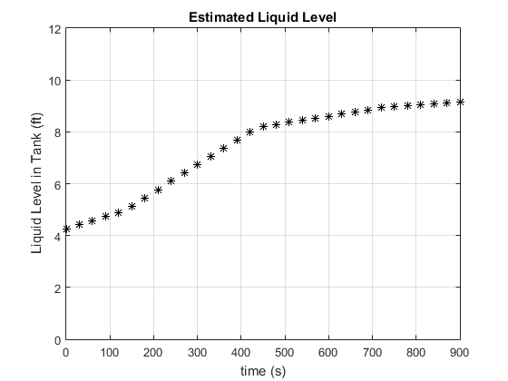

**Final liquid level:**

Final level: 9.1 ft

**MATLAB CODE:**

%Problem 2

load HW6.mat;

cubft_gal = 7.48052; %convert cubft <-> gal

r = 2; %ft

Level = zeros(1,length(t));

V = zeros(1,length(t));

dt = t(2)-t(1);

V(1) = 400; %gallons

Level(1) = (V(1)/cubft_gal)/(pi*r^2);

plot(t(1),Level(1),'k*');

xlabel('time (s)');

ylabel('Liquid Level in Tank (ft)');

title('Estimated Liquid Level');

axis([0 900 0 12]); grid;

hold on;

for k = 1:length(t)-1

V(k+1) = V(k) + dt*(Flow_Rate(k+1) +...

Flow_Rate(k))/2;

end

Level = (V/cubft_gal)/(pi*r^2);

for k = 2:length(t)

plot(t(k),Level(k),'k*');

xlabel('time (s)');

ylabel('Liquid Level in Tank (ft)');

title('Estimated Liquid Level');

axis([0 900 0 12]); grid;

hold on;

if Level(k) > 9

sound(yalarm,44100);pause(0.5);

else

pause(0.5);

end

end

fprintf('Final level: %0.1f ft\n',Level(length(Level)));

**Problem 3:** The diagram below shows a cylindrical tank with liquid flowing in and out.

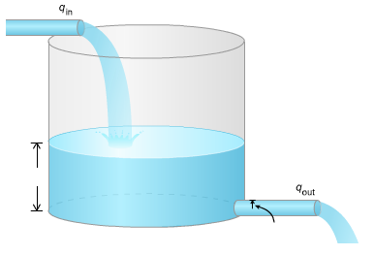

Liquid Level

D = 0.1 ft.

Diameter of outlet

Tank Height: 10 ft.

Tank Radius: 2 ft.

The flow rate out depends on the level of liquid in the tank. **The flow rate out is higher when the liquid level is higher.** The flow rate out can be calculated as follows:



D is the diameter of the outlet pipe (D = 0.1 ft.)

Δz is the height of liquid above the center of the outlet pipe.

g = 32.2 ft/s2

L is the liquid level in the tank (ft)

Assuming the flow rate in is zero and the initial liquid level is 9 ft., we want to calculate how long it takes for the liquid level to drop to 0.1 ft. (top of the outlet pipe). We do not have a sensor to measure flow rate out.

1. Calculate the initial flow rate out. Calculate the time it would take for liquid level to drop to 0.1 ft. (top of the outlet pipe) assuming (incorrectly) that the flow rate out remains at this initial value.
2. There is no closed form expression (equation) to calculate the actual amount of time required to empty the tank. It requires an iterative solution. Create a script file that will do the following:
3. Set Level(1) = 9 (ft.), the initial liquid level in the tank
4. Calculate the initial volume of liquid in the tank (in ft3 not gallons)
5. Calculate the initial flow rate out (ft3/s) using equation above
6. Use an input statement to prompt the user for a DeltaT value (in seconds)
7. Add a while loop that will continue as long as the last calculated value for liquid level exceeds 0.1 (top of the outlet pipe). Your while loop should do the following:

* Estimate the next volume using numerical integration:

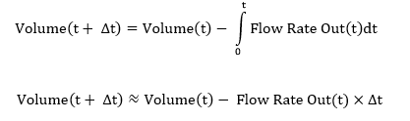

* Calculate the next liquid level from volume (remember volume is in ft^3 not gallons) and save it in the vector, Level.
* Calculate the new flow rate out based on the new liquid level.

1. After the while loop, plot the liquid level (y-axis) vs. time (x-axis).
2. Add fprintf statements to display the final liquid level and the elapsed time.

Run your script for the DeltaT values shown in the table and complete the table using the output from your script.

|  |  |  |
| --- | --- | --- |
| **DeltaT (seconds)** | **Final Liquid Level (ft.)** | **Time Elapsed (seconds)** |
| **30** | 0.081 | 1080 |
| **10** | 0.090 | 1100 |
| **1** | 0.099 | 1103 |
| **0.1** | 0.100 | 1103.7 |
| **0.01** | 0.100 | 1103.77 |

**PLOT OF LIQUID LEVEL (DeltaT = 0.1 seconds only):**

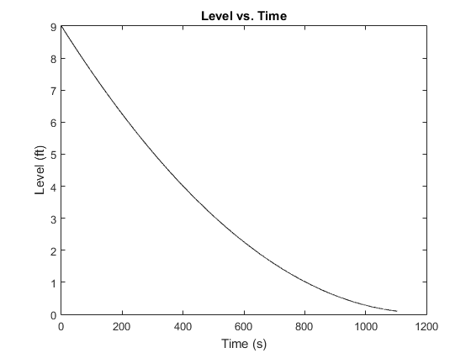

**MATLAB CODE:**

%Problem 3

g = 32.2; %ft/s^2

D = .1; %ft

r = 2; %ft

Level(1) = 9;

V(1) = pi*r^2*Level(1);

Flow_Rate(1) = pi*(D/2)^2*sqrt(2*g*(Level(1)-D/2));

DeltaT = input('DeltaT (s): ');

k = 1;

while Level(k) > .1

k = k + 1;

V(k) = V(k-1) - Flow_Rate(k-1)*DeltaT;

Level(k) = V(k)/(pi*r^2);

Flow_Rate(k) = pi*(D/2)^2*sqrt(...

2*g*(Level(k)-D/2));

end

t = 0:DeltaT:(length(Level)-1)*DeltaT;

plot(t,Level,'k-');

xlabel('Time (s)');

ylabel('Level (ft)');

title('Level vs. Time');

fprintf('Final Liquid Level (ft): %0.3f\n',Level(length(Level)));

fprintf('Time Elapsed (s): %0.3f\n',(length(Level)-1)*DeltaT);

**Question:** From the results in the table, we can see that a DeltaT = 1 second provides an accurate calculation for the time required for the liquid level to drop to the top of the outlet pipe. If the diameter of the outlet pipe increased, how would this affect the DeltaT value required to provide an accurate estimate for required time? Why?

|  |
| --- |
| This would require a smaller DeltaT. This is because with a larger diameter, the rate that Flow Rate is changing would greater. For instance if the diameter was to be increased such that the container was emptied in under a second, then it is clear that a DeltaT of 1 would not be accurate at all. In this case, a much smaller DeltaT would be required. |