**ENED 1091: Homework #7**

**Due Week of April 4th at beginning of Recitation Session**

**Be sure to include units in your answers if units are provided in the problem!**

**Problem 1:** Find the area enclosed by the two curves shown below. The top curve is a portion of an ellipse and the bottom curve is a portion of a circle. The equations for each curve are:

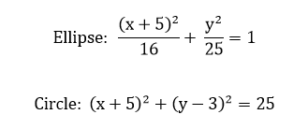

(-5, 5)

(-9, 0)

(1, 0)

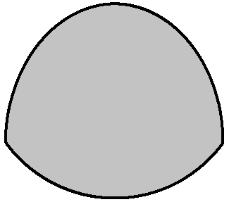

(a) Write an equation for the top curve in terms of y (remember when solving for y, it makes a difference whether your curve is part of the top half of the circle or the bottom half).

**Equation for top curve: yt =**  (-x)^(1/2)*(x + 10)^(1/2) + 3

(b) Write an equation for the bottom curve in terms of y (remember when solving for y, it makes a difference whether your curve is part of the top half of the circle or the bottom half).

**Equation for bottom curve: yb =** -(5*(x + 1)^(1/2)*(- x - 9)^(1/2))/4

(c) Use MATLAB to determine the area between the two curves

**Area:** 27.7665 un2

**Work/MATLAB Commands to derive Area:**

%Problem 1

f1 = sym('(x+5)^2+(y-3)^2=25');

yt = solve(f1,'y');

f2 = sym('(x+5)^2/16+y^2/25=1');

yb = solve(f2,'y');

A = double(int(yt(1)-yb(1),'x',-9,-1));

**Problem 2:** The figure below is a sketch of a deck of a ship which has the shape of two intersecting ***parabolic*** curves. ***Use the location indicated in the figure as the origin!***

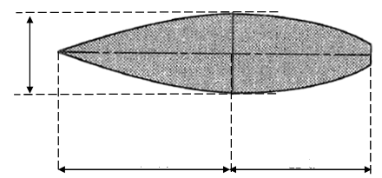

**Origin**

**(0, 0)**

15 ft.

32 ft.

24 ft.

(a) Find the equation for the top parabola

**Equation of Top Parabola:** y = (15/2048)x2

**Work to derive equation:**

15/2 = a*(-32)2 a = 15/2048

(b) Find the equation for the bottom parabola

**Equation of Bottom Parabola:** y = -(15/2048)x2 + 15

**Work to derive equation:**

Same a as above, shifted up fifteen and facing down.

(c) Find the area of the deck

**Area of Deck:** 1225/2

**Work/MATLAB Commands to derive Area:**

%Problem 2

yt = sym('x^2*-15/2048 + 15');

yb = sym('x^2*15/2048');

A = int(yt-yb,'x',-32,24);

**Problem 3:** The figure below represents a concrete roof beam for an auditorium. It has a straight top edge and a ***parabolic*** lower edge. ***Use the location indicated in the figure as the origin!***

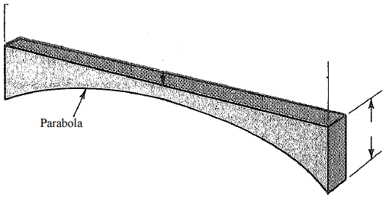

10 m

0.6 m

2.4 m

**Origin**

**(0, 0)**

0.8 m

(a) Find the equation of the parabola

**Equation of Parabola:** y = -.072x2

**Work to derive equation:**

**-**1.8 = a*(5)2 a = -.072

(b) Find the ***volume*** of the beam

**Volume of Beam:** 8.64 m3

**Work/MATLAB Commands to derive Volume:**

%Problem 3

y = sym('x^2*-.072');

A = .8*(10*.6*.8-int(y,'x',-5,5));