**ENED 1091: Homework #8**

**Due Week of April 11th on Recitation Day**

You will definitely want to use the MATLAB symbolic toolbox to evaluate the definite integrals. Show all your work and include all of your MATLAB commands. Include units in your answer!

**Problem 1:** The diagram below is of an odd-shaped window. The top of the window is a ***parabola*** and the bottom of the window is a portion of a ***circle*** with a radius of 4 ft.

***Note: use the origin indicated in the diagram.***

2 ft.

2 ft.

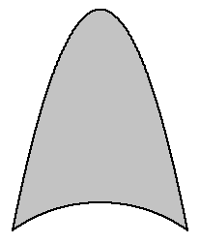

6 ft.

(0, 0) Center of circular arc

4 ft.

Look carefully at the figure.

The y-coordinate of the vertex is NOT 10.

(a) Find the equation of the circle

y2 + x2 = 16

(b) Find the equation of the parabola (Show Work)

Height = 6 + sqrt(16 – 4) = 6 + sqrt(12)

y = (-sqrt(12)/4)*x2 + 6 + sqrt(12)

(c) Find the area (Show Work and/or MATLAB Commands)

Area = 17.9318

%% Problem 1

clear; clc; close all;

y1 = sym('sqrt(16-x^2)');

y2 = sym('(-sqrt(12)/4)*x^2+6+sqrt(12)');

area = double(int(y2-y1,'x',-2,2));

**Problem 2:** The cable ***running*** ***from point A to point B*** for the suspension bridge shown below forms parabolic curves.

1. Find an equation for the parabolic curve from point A to the tower on the left. Point A is the vertex of this curve. **Show Work!** *Use the origin indicated in the diagram.*

600 = a(6002) a = 1/600

y = x2/600

1. Find an equation for the parabolic curve between the two towers. **Show Work!** *Use the origin indicated in the diagram.*

600 = a(10002) a = 600/1000000

y = 600x2/1000000

600 ft.

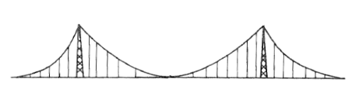

A

B

2000 ft.

600 ft.

600 ft.

**(0, 0)**

1. Find the length (arc length) of the cable from Point A to Point B. *Note: the cable length from Point A to the left tower is exactly the same as the cable length from the right tower to Point B.*  Show all work, calculations and MATLAB commands.

Arclength = 4183.4 ft

%% Problem 2

clear; clc; close all;

y1 = sym('x^2/600');

y2 = sym('600*x^2/1000000');

AL1 = int(sqrt(1+diff(y1,'x')^2),'x',0,600);

AL2 = int(sqrt(1+diff(y2,'x')^2),'x',-1000,1000);

AL = double(2*AL1 + AL2);

**Problem 3:** If you take a flexible chain or wire, support it on both ends, then let it hang in the middle, you end up with a curve called a catenary curve. Catenary curves are used a lot in architecture. One famous example would be the St. Louis Arch. Find the arc length of the catenary curve shown below. Assuming an origin at the center of the base, the equation for the curve is provided. In MATLAB, the hyperbolic cosine function is: ***cosh***. When you integrate, you may get a warning that an explict integral couldn’t be found. Use the ***double*** command and that will result in a numerical value for arc length.

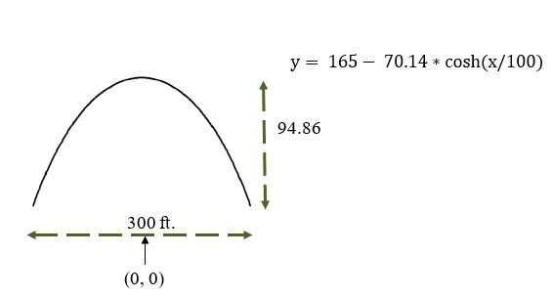

Show all work and MATLAB commands for computing the arc length of the catenary curve.

Arclength = 370.2456 ft

%% Problem 3

clear; clc; close all;

y = sym('165-70.14*cosh(x/100)');

AL = double(int(sqrt(1+diff(y,'x')^2),-150,150));