**ENED 1091: Homework #9**

**Due Week of April 18th**

You will definitely want to use the MATLAB symbolic toolbox to evaluate the definite integrals. Show all your work and include all of your MATLAB commands. Include units in your answer!

**Problem 1:** The diagram below is of an odd-shaped window. The top of the window is a ***parabola*** and the bottom of the window is a portion of a ***circle*** with a radius of 4 ft.

***Note: use the origin indicated in the diagram.***

2 ft.

2 ft.

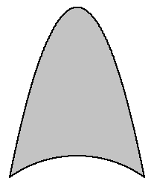

6 ft.

(0, 0) Center of circular arc

4 ft.

Find the centroid of the window. (Show all work and MATLAB commands).

Centroid: (0 ft , 6.18 ft)

%% Problem 1

clear; clc; close all;

y1 = sym('sqrt(16-x^2)');

y2 = sym('(-sqrt(12)/4)*x^2+6+sqrt(12)');

area = double(int(y2-y1,'x',-2,2));

syms x;

x_c = 1/area*int(x*(y2-y1),'x',-2,2);

y_c = double(1/(2*area)*int(y2^2-y1^2,'x',-2,2));

**Problem 2:** Consider the object shown below. The bottom curve is a line and the top curve is a parabola with a vertex of (2, 12) as indicated in the diagram. **Units are in cm.**

1. Find the equation for the parabola (SHOW WORK)

14 = a(10 – 2)2 + 12 a = 1/32

y = 1/32(x – 2)2 + 12

1. Find the equation of the line (SHOW WORK)

Slope = 14/10 = 7/5

y = 7/5x

(c) Find the coordinates of the centroid (SHOW WORK AND MATLAB COMMANDS)

(0, 0)

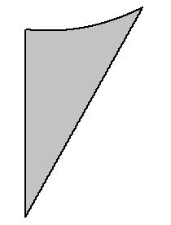

(10, 14)

Vertex

(2, 12)

**Units : cm**

Centroid: (3.18 cm , 8.33 cm)

%% Problem 2

clear; clc; close all;

y1 = sym('7/5*x');

y2 = sym('1/32*(x-2)^2+12');

area = double(int(y2-y1,'x',0,10));

syms x;

x_c = double(1/area*int(x*(y2-y1),'x',0,10));

y_c = double(1/(2*area)*int(y2^2-y1^2,'x',0,10));