How various predictors (age, gender, bmi..etc) effect claim amounts
Appendix
1. Initial data exploration
1.1
Check for rows with empty variable numbers.
Since out of 1340 rows, only 8 rows have missing numbers, it was decided that those rows with missing values to be dropped.
1.2
We have both numeric and categorical predictors.
First we visualise the distribution of the numerical variables (using histograms):
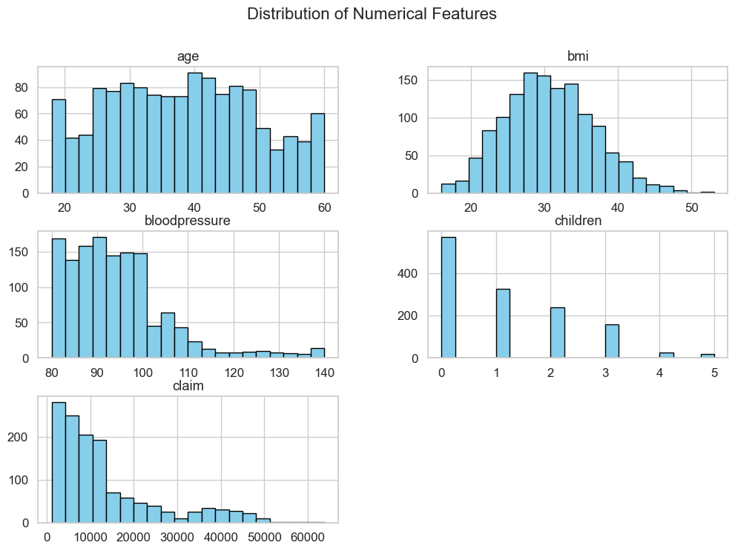
Then we visualise the distribution of categorical variables (using bar plots):
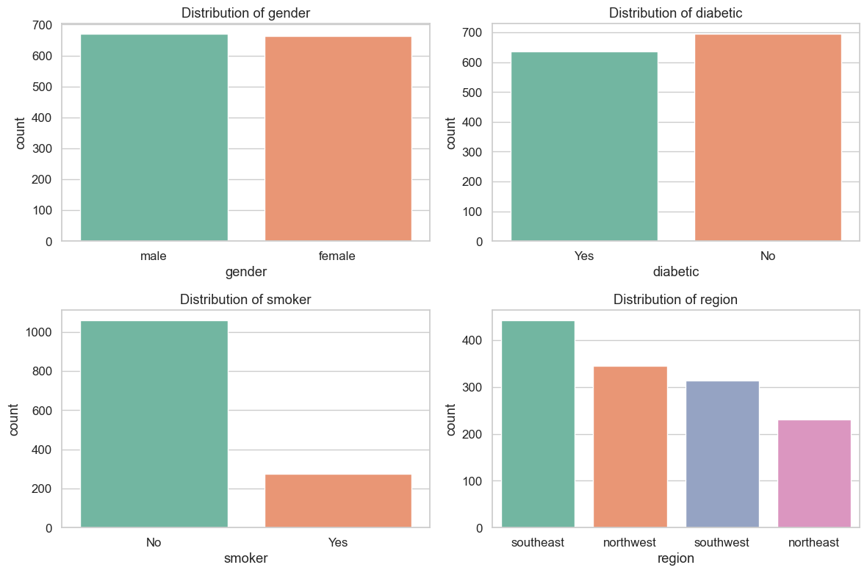

1.3 (Two way summaries of the relationship between potential predictors and target variables – for categorical variables as can’t find correlations for them)
Relations between gender & smoking status AND “average” insurance claims
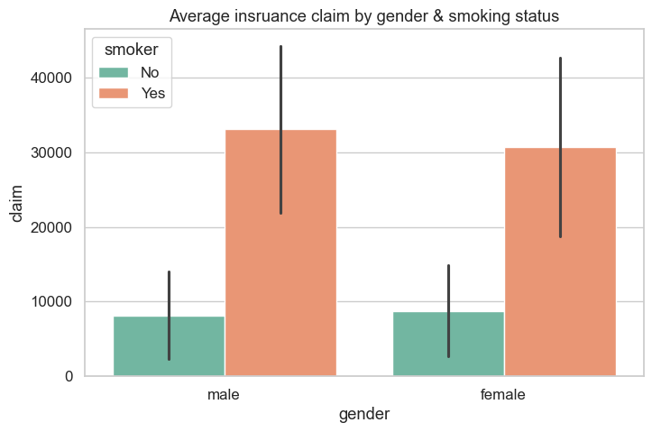
- From this, whether a person is male or female does not affect the claim amount
- However, being a smoker does increase the average claim amount

Relations between region & diabetic status AND average insurance claims
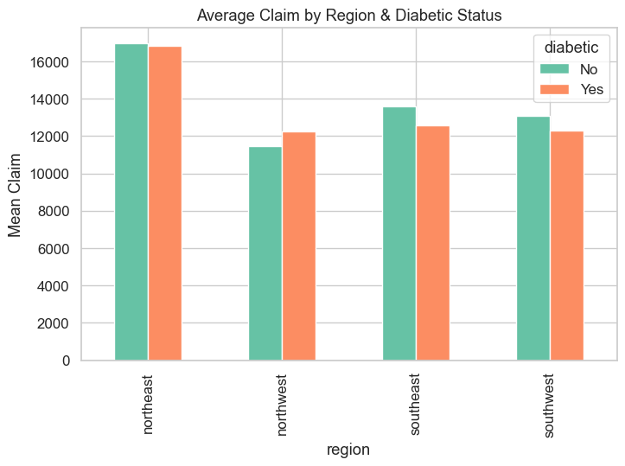
- Generally northeast has higher claims
- Whether diabetic or not doesn’t really lead to higher mean claims

Relations between region & smoker AND average insurance claims
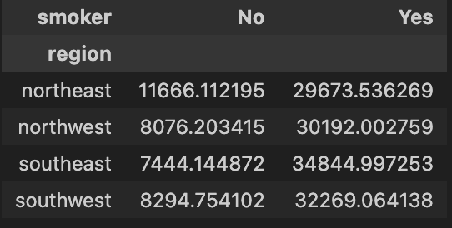
- Smokers have higher mean claims (the regions doesn’t matter)
- For non-smoking individuals, northeast has noticeable higher mean claims

Relations between diabetic & children AND mean insurance claims
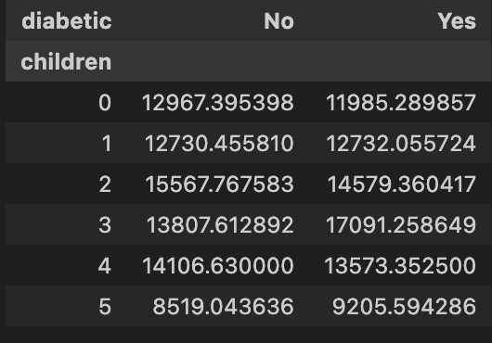
- No noticeable trends based in diabetic & children
1.4 correlation between predictors (ofc numerical variables only)
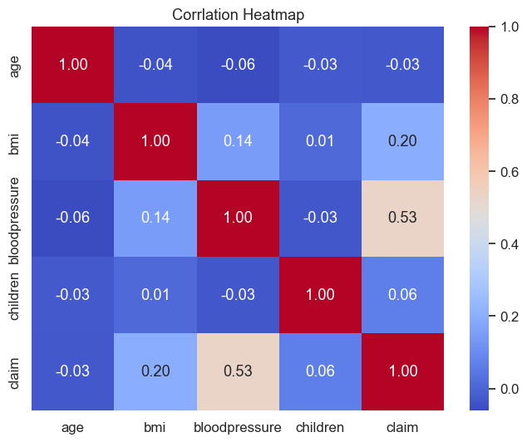
- No noticeable correlation besides blood pressure and claim

1.5 relationship analysis (1/2/3-way summaries)
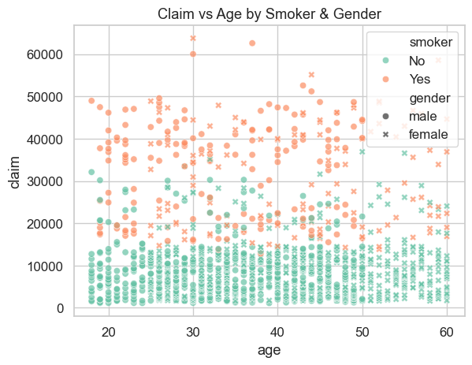
- Clearly smokers have higher claims
- gender and age seem to have no effect

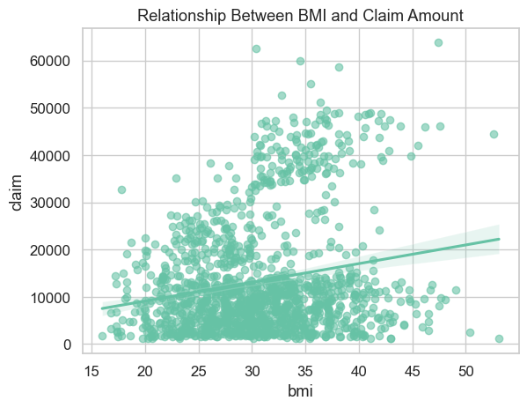
- bmi: 30~45 seems to show more frequent higher claim amounts
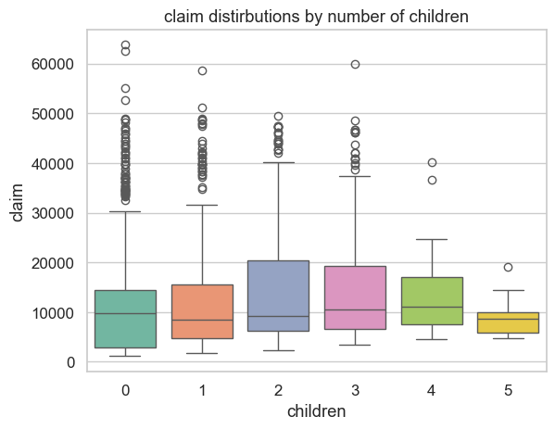
- individuals with 2 and 3 number of children tend to have Higher claims
1.6 creating new variables (going from continuous to band to see group effects)
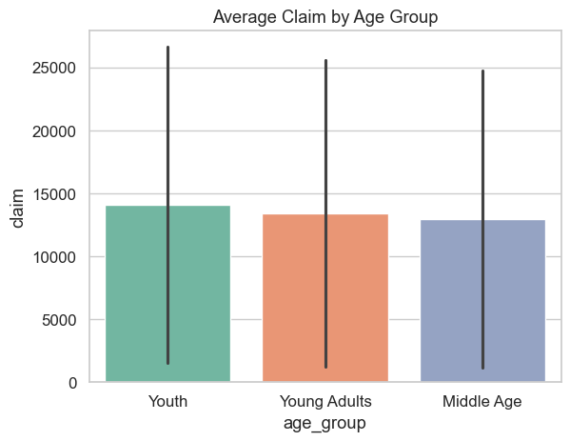
- for age, group them into diff categories
- based on age group, no significant differences (just a slight decrease in claims on older group)
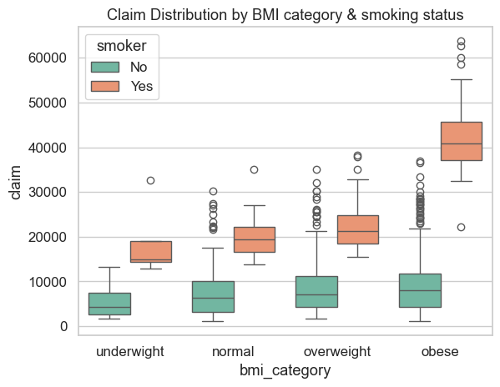
- for bmi, grouped them into diff categories
- also hue the smoker
- clearly, smokers have higher claims
- also, the higher bmi groups tend to have higher claims (especially for smoking and obese)
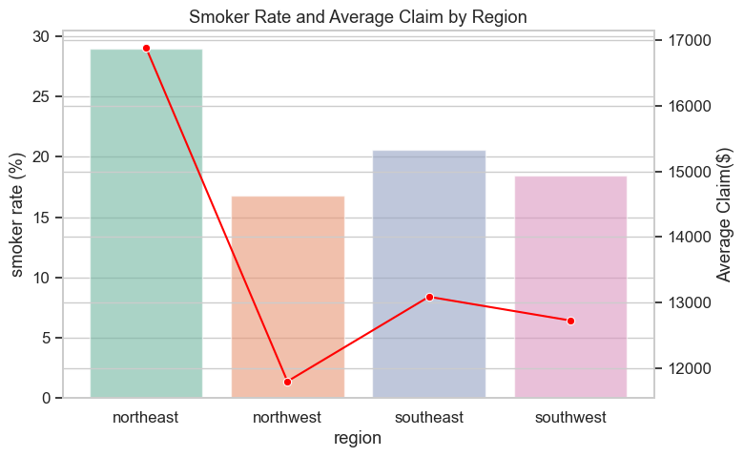
- for each region, calculated two variables: smoker rate (barplot) and average claim (line)
- from this can see that the region with higher smoking rates had higher claims

