JOBSHEET 1
KONSEP DASAR PEMROGRAMAN

Nama : Jonathan Abdiel Haryono
Absen : 16
Kelas : TI 1G

- Pemilihan
package Jobsheet1;
import java.util.Scanner;

public class Pemilihan16 {
public static void main(String[] args) {
Scanner sc = new Scanner(System.in);

int nilaiTugas, nilaiKuis, nilaiUTS, nilaiUAS;
float nilaiAkhir;
boolean isLulus = true;
String nilaiHuruf = "";

System.out.println("Program Menghitung Nilai Akhir");
System.out.println("==============================\n");

System.out.print("Masukkan Nilai Tugas : ");
nilaiTugas = sc.nextInt();

System.out.print("Masukkan Nilai Kuis : ");
nilaiKuis = sc.nextInt();

System.out.print("Masukkan Nilai UTS : ");
nilaiUTS = sc.nextInt();

System.out.print("Masukkan Nilai UAS : ");
nilaiUAS = sc.nextInt();

System.out.println("==============================");

if ((nilaiTugas > 100) || (nilaiTugas < 0) || (nilaiKuis > 100) || (nilaiKuis < 0) || (nilaiUTS > 100) || (nilaiUTS < 0) || (nilaiUAS > 100) || (nilaiUAS < 0)) {
System.out.print("Nilai Tidak Valid");
}
else {
nilaiAkhir = (float) ((nilaiTugas * 0.2) + (nilaiKuis * 0.2) + (nilaiUTS * 0.3) + (nilaiUAS * 0.3));

if (nilaiAkhir > 80 && nilaiAkhir <= 100) {
nilaiHuruf = "A";
}
else if (nilaiAkhir > 73 && nilaiAkhir <= 80) {
nilaiHuruf = "B+";
}
else if (nilaiAkhir > 65 && nilaiAkhir <= 73) {
nilaiHuruf = "B";
}
else if (nilaiAkhir > 60 && nilaiAkhir <= 65) {
nilaiHuruf = "C+";
}
else if (nilaiAkhir > 50 && nilaiAkhir <= 60) {
nilaiHuruf = "C";
}
else if (nilaiAkhir > 39 && nilaiAkhir <= 50) {
nilaiHuruf = "D";
}
else if (nilaiAkhir <= 39 && nilaiAkhir >= 0) {
nilaiHuruf = "E";
}

if (nilaiHuruf == "D" || nilaiHuruf == "E") {
isLulus = false;
}

System.out.printf("Nilai Akhir : %.2f\n", nilaiAkhir);
System.out.println("Nilai Huruf : " + nilaiHuruf);

System.out.println("==============================\n");

if (isLulus) {
System.out.println("SELAMAT! ANDA LULUS!");
}
else {
System.out.println("MAAF, ANDA TIDAK LULUS.");
}
}
System.out.println("\n==============================\n");
}
}
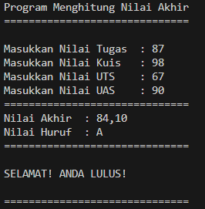

- Perulangan
package Jobsheet1;

import java.util.Scanner;

public class Perulangan16 {
public static void main(String[] args) {
Scanner sc = new Scanner(System.in);

// int n = 36; // NIM : 254107020036
long nim = 0;

System.out.print("Masukkan NIM anda : ");
nim = sc.nextLong();

long n = nim % 100;

if (n < 10) {
n += 10;
}

System.out.println();
for (int i = 1; i <= n; i++) {
if (i == 10 || i == 15) {
continue;
} else if (i % 3 == 0) {
System.out.print("# ");
} else if (i % 2 == 0) {
System.out.print(i + " ");
}
else {
System.out.print("* ");
}
}
System.out.println();
}

}

- Array
package Jobsheet1;

import java.util.Scanner;

public class Array16 {
public static void main(String[] args) {
Scanner sc = new Scanner(System.in);
int totalNilai = 0, totalSKS = 0;

System.out.println("==============================");
System.out.println("Program Menghitung IP Semester");
System.out.println("==============================\n");

System.out.print("Masukkan jumlah mata kuliah : ");
int jumlahMK = sc.nextInt();
sc.nextLine();

String namaMatkul[] = new String[jumlahMK];
int SKS[] = new int[jumlahMK];
int nilai[] = new int[jumlahMK];
String nilaiHuruf[] = new String[jumlahMK];
float nilaiSetara[] = new float[jumlahMK];

for (int i = 0; i < jumlahMK; i++) {
System.out.print("\nMasukkan nama mata kuliah ke-" + (i+1) + " : ");
namaMatkul[i] = sc.nextLine();
System.out.print("Masukkan SKS-nya : ");
SKS[i] = sc.nextInt();
System.out.print("Masukkan nilai angka untuk mata kuliah ini : ");
nilai[i] = sc.nextInt();
sc.nextLine();

if (nilai[i] > 80) {
nilaiHuruf[i] = "A";
nilaiSetara[i] = 4;
}
else if (nilai[i] > 73) {
nilaiHuruf[i] = "B+";
nilaiSetara[i] = (float) 3.5;
}
else if (nilai[i] > 65) {
nilaiHuruf[i] = "B";
nilaiSetara[i] = 3;
}
else if (nilai[i] > 60) {
nilaiHuruf[i] = "C+";
nilaiSetara[i] = (float) 2.5;
}
else if (nilai[i] > 50) {
nilaiHuruf[i] = "C";
nilaiSetara[i] = 2;
}
else if (nilai[i] > 39) {
nilaiHuruf[i] = "D";
nilaiSetara[i] = 1;
}
else {
nilaiHuruf[i] = "E";
nilaiSetara[i] = 0;
}

totalNilai += (nilaiSetara[i] * SKS[i]);
totalSKS += SKS[i];

}

System.out.println("\n====================");
System.out.println("Hasil Konversi Nilai");
System.out.println("====================\n");

System.out.println("====================================================================================");

System.out.printf("%-30s %-20s %-20s %-20s%n", "Mata Kuliah", "Nilai Angka", "Nilai Huruf", "Bobot Nilai");

for (int i = 0; i < jumlahMK; i++) {
System.out.printf("%-33s %-20d %-20s %-20.2f%n", namaMatkul[i], nilai[i], nilaiHuruf[i], nilaiSetara[i]);
}

System.out.println("====================================================================================\n");

float IP = (totalNilai/totalSKS) ;

System.out.println("\n==========");
System.out.println("IP : " + IP);
System.out.println("==========\n");
}
}

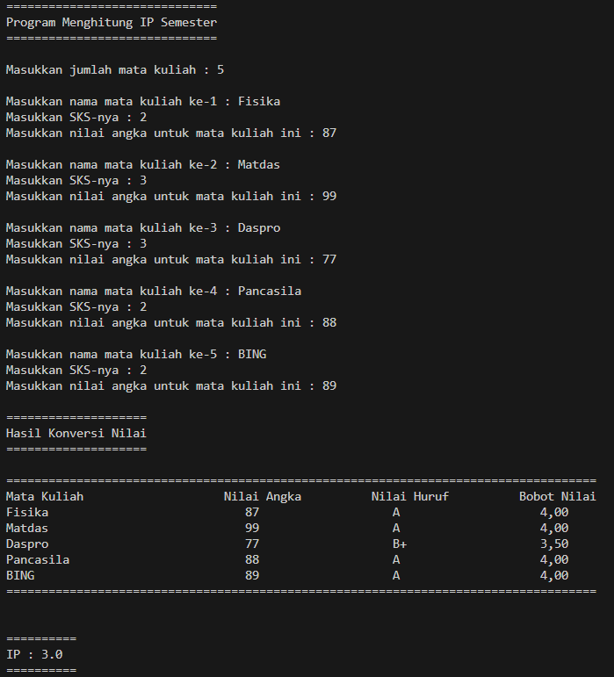

- Fungsi

package Jobsheet1;
import java.util.Scanner;

public class Fungsi16 {
public static void showData(int stok[][], int harga[]) {
int cabang[] = new int[4];
int jenisBunga[] = new int[4];
int totalPendapatan;

for (int i = 0; i < cabang.length; i++) {
totalPendapatan = 0;
System.out.print("RoyalGarden " + (i+1) + " : ");

for (int j = 0; j < jenisBunga.length; j++) {
totalPendapatan += (stok[i][j] * harga[j]);
}
System.out.println(totalPendapatan);

if (totalPendapatan > 1500000) {
System.out.println("Sangat Baik\n");
}
else {
System.out.println("Perlu Evaluasi\n");
}
}
}

public static void main(String[] args) {
Scanner sc = new Scanner(System.in);

int[][] stok = {
{10, 5, 15, 7},
{6, 11, 9, 12},
{2, 10, 10, 5},
{5, 7, 12, 9}
};

int harga[] = {75000, 50000, 60000, 10000};

showData(stok, harga);
}
}
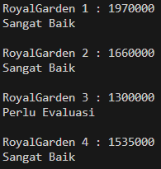
- Tugas 1

package Jobsheet1;

import java.util.Scanner;

public class Tugas1_16 {
public static void main(String[] args) {
Scanner sc = new Scanner(System.in);

char[] kode = { 'A', 'B', 'D', 'E', 'F', 'G', 'H', 'L', 'N', 'T' };
char[][] kota = {
{ 'A', 'B', 'A', 'N', 'T', 'E', 'N' },
{ 'B', 'J', 'A', 'K', 'A', 'R', 'T', 'A' },
{ 'D', 'B', 'A', 'N', 'D', 'U', 'N', 'G' },
{ 'E', 'C', 'I', 'R', 'E', 'B', 'O', 'N' },
{ 'F', 'C', 'I', 'R', 'E', 'B', 'O', 'N' },
{ 'G', 'P', 'E', 'K', 'A', 'L', 'O', 'N', 'G', 'A', 'N' },
{ 'H', 'S', 'E', 'M', 'A', 'R', 'A', 'N', 'G' },
{ 'L', 'S', 'U', 'R', 'A', 'B', 'A', 'Y', 'A' },
{ 'N', 'M', 'A', 'L', 'A', 'N', 'G' },
{ 'T', 'T', 'E', 'G', 'A', 'L' }
};

System.out.print("Masukkan kode plat nomor : ");
String input = sc.nextLine();
Boolean isFound = true;

for (int i = 0; i < kode.length; i++) {
if (input.equalsIgnoreCase(String.valueOf(kode[i]))) {
for (int j = 1; j < kota[i].length; j++) {
System.out.print(kota[i][j]);
}
break;
}
}

System.out.println();
}
}
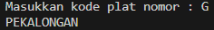

- Tugas 2
package Jobsheet1;
import java.util.Scanner;

public class Tugas2_16 {

static Scanner sc = new Scanner(System.in);

public static String[][] inputSchedule(int jumlah, String komponen[]) {
String jadwal[][] = new String[jumlah][komponen.length];

for (int i = 0; i < jumlah; i++) {
System.out.println("\nJadwal ke-" + (i+1));
for (int j = 0; j < komponen.length; j++) {
System.out.print("Masukkan " + komponen[j] + " : ");
jadwal[i][j] = sc.nextLine();
}
}

return jadwal;
}

public static void showSchedule(int jumlah, String komponen[], String jadwal[][]) {

System.out.printf("%-30s %-20s %-20s %-20s%n", komponen[0], komponen[1], komponen[2], komponen[3]);

for (int i = 0; i < jumlah; i++) {
System.out.printf("%-30s %-20s %-20s %-20s%n", jadwal[i][0], jadwal[i][1], jadwal[i][2], jadwal[i][3]);
}
}

public static void byDay(int jumlah, String komponen[], String jadwal[][]) {

sc.nextLine();
System.out.print("Berdasarkan hari apa anda ingin mencari jadwal : ");
String day = sc.nextLine();

System.out.println();
System.out.printf("%-30s %-20s %-20s %-20s%n", komponen[0], komponen[1], komponen[2], komponen[3]);

for (int i = 0; i < jumlah; i++) {
if (jadwal[i][2].equalsIgnoreCase(day)) {
System.out.printf("%-30s %-20s %-20s %-20s%n", jadwal[i][0], jadwal[i][1], jadwal[i][2], jadwal[i][3]);
}
else {
continue;
}
}
}

public static void byMatkul(int jumlah, String komponen[], String jadwal[][]) {

sc.nextLine();
System.out.print("Berdasarkan mata kuliah apa anda ingin mencari jadwal : ");
String matkul = sc.nextLine();

System.out.println();
System.out.printf("%-30s %-20s %-20s %-20s%n", komponen[0], komponen[1], komponen[2], komponen[3]);

for (int i = 0; i < jumlah; i++) {
if (jadwal[i][0].equalsIgnoreCase(matkul)) {
System.out.printf("%-30s %-20s %-20s %-20s%n", jadwal[i][0], jadwal[i][1], jadwal[i][2], jadwal[i][3]);
}
else {
continue;
}
}
}

public static void main(String[] args) {
String komponen[] = {"Nama Mata Kuliah", "Ruang", "Hari Kuliah", "Jam Kuliah"};
System.out.println("=======================================================");
System.out.println("PROGRAM PENYIMPAN DAN PENGELOLA JADWAL KULIAH MAHASISWA");
System.out.println("=======================================================\n");

System.out.print("Masukkan jumlah jadwal kuliah : ");
int jumlahJadwal = sc.nextInt();
sc.nextLine();

String[][] jadwal = inputSchedule(jumlahJadwal, komponen);

boolean rep = true;
do {
System.out.println("\nPilihan Menu : ");
System.out.println("1. Tampilkan seluruh jadwal");
System.out.println("2. Tampilkan jadwal berdasarkan hari tertentu");
System.out.println("3. Tampilkan jadwal berdasarkan nama mata kuliah tertentu");
System.out.println("4. Exit");

System.out.print("\nMasukkan pilihan anda : ");
int pilihan = sc.nextInt();

if (pilihan == 1) {
showSchedule(jumlahJadwal, komponen, jadwal);
}
else if (pilihan == 2) {
byDay(jumlahJadwal, komponen, jadwal);
}
else if (pilihan == 3) {
byMatkul(jumlahJadwal, komponen, jadwal);
}
else if (pilihan == 4) {
System.out.println("\nTerima kasih sudah menggunakan layanan kami\n");
break;
}
else {
System.out.println("Pilihan tidak valid! Masukkan ulang!");
}
} while (rep);

}
}

