**Task1**

1. **Parse, Clean and Data Transformation:**

Both files was handled uniform format for date.

* Converting JSON file to CSV file and handling uniform format.

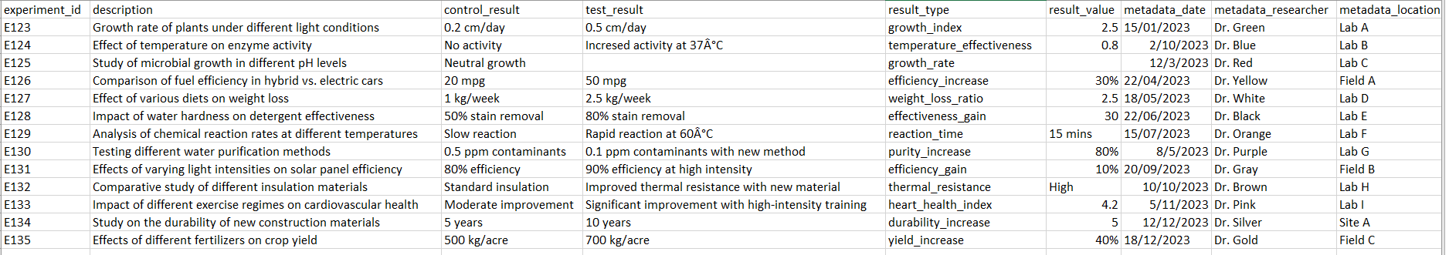

* Converting XML file to CSV file and handling uniform format.

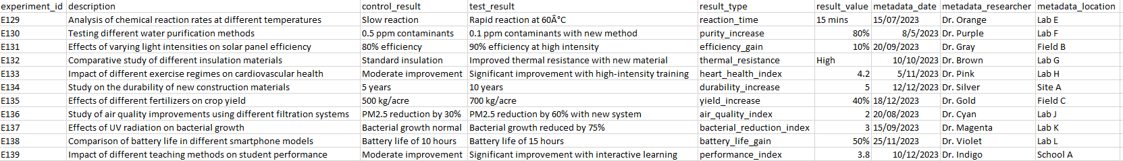

* Final CSV file after merging two files.

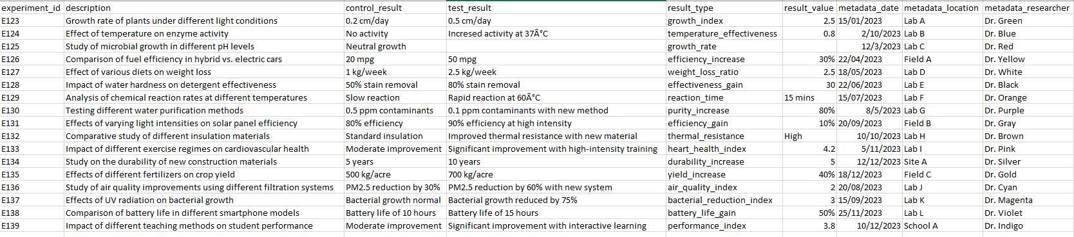

**2. Reporting:**

After reading and understanding data we have littles option to act with missing data:

First: we can put in missing data average value in missing part but we can’t do this because no relation between rows.

Second: we can delete row from our data but we can’t do that if data is so small.

Third: we can put zeros in missing parts.