Visualización de datos

# A9: Creación de la visualización y entrega del proyecto.

Alumno: Jordi Sanchez Ferrer

Antes de empezar con la PRAC, a la hora de subir la visualización a Tableau Public me da un error cuando intento visualizarla en la parte de los mapas. Primero pensaba que debería ser por el tamaño de la visualización, pero he probado lo mismo con una versión low de la misma visualización y tampoco. Por lo tanto, he decidido subir las dos visualizaciones y, como mínimo, podemos ver online la parte del detalle.

Además de tener las dos visualizaciones publicadas, todos los ficheros están colgados en el siguiente repositorio de github:

[*https://github.com/joorrddii4/VisualizacionA9*](https://github.com/joorrddii4/VisualizacionA9)

Contenido

A9: Creación de la visualización y entrega del proyecto. 1

Selección de datasets 3

Implementación de la solución interactiva 10

Funcionalidades de la visualización 10

## Selección de datasets

El dataset escogido se llama **The Our World in Data COVID vaccination data**. Dada la situación que vivimos, creo que es un conjunto de datos interesante para realizar una visualización que ayude a ver la evolución de la pandemia.

Adjunto en esta entrega encontraremos el dataset mencionado.

#### Descripción

Estos datos muestran, para cada día y país, los datos nuevos y acumulados recogidos en relación al SARS-CoV-2.

Autor: Our World in Data

Fuente: <https://ourworldindata.org/coronavirus-source-data>

Fecha de creación: 1 de enero de 2020

Fecha de la última actualización: 23 de Abril de 2021

Dimensiones: 83657x59 registros

Ámbito geográfico: Mundial

Idioma: Inglés

Categoría: Salud

Etiquetas: [covid](https://analisi.transparenciacatalunya.cat/browse?tags=covid), [covid19](https://analisi.transparenciacatalunya.cat/browse?tags=covid19), [covid-19](https://analisi.transparenciacatalunya.cat/browse?tags=covid-19), [coronavirus](https://analisi.transparenciacatalunya.cat/browse?tags=coronavirus), [epidemiologia](https://analisi.transparenciacatalunya.cat/browse?tags=epidemiologia), [vacuna](https://analisi.transparenciacatalunya.cat/browse?tags=vacuna), [salut](https://analisi.transparenciacatalunya.cat/browse?tags=salut)

Licencia: [Creative Commons BY license](https://creativecommons.org/licenses/by/4.0/)

#### Columnas del conjunto de datos

|  |  |  |
| --- | --- | --- |
| **Nombre de la columna** | **Fuente** | **Descripción** |
| iso_code | International Organization for Standardization | ISO 3166-1 alpha-3 – three-letter country codes |
| continent | Our World in Data | Continent of the geographical location |
| location | Our World in Data | Geographical location |
| date | Our World in Data | Date of observation |
| total_cases | COVID-19 Data Repository by the Center for Systems Science and Engineering (CSSE) at Johns Hopkins University | Total confirmed cases of COVID-19 |
| new_cases | COVID-19 Data Repository by the Center for Systems Science and Engineering (CSSE) at Johns Hopkins University | New confirmed cases of COVID-19 |
| new_cases_smoothed | COVID-19 Data Repository by the Center for Systems Science and Engineering (CSSE) at Johns Hopkins University | New confirmed cases of COVID-19 (7-day smoothed) |
| total_deaths | COVID-19 Data Repository by the Center for Systems Science and Engineering (CSSE) at Johns Hopkins University | Total deaths attributed to COVID-19 |
| new_deaths | COVID-19 Data Repository by the Center for Systems Science and Engineering (CSSE) at Johns Hopkins University | New deaths attributed to COVID-19 |
| new_deaths_smoothed | COVID-19 Data Repository by the Center for Systems Science and Engineering (CSSE) at Johns Hopkins University | New deaths attributed to COVID-19 (7-day smoothed) |
| total_cases_per_million | COVID-19 Data Repository by the Center for Systems Science and Engineering (CSSE) at Johns Hopkins University | Total confirmed cases of COVID-19 per 1,000,000 people |
| new_cases_per_million | COVID-19 Data Repository by the Center for Systems Science and Engineering (CSSE) at Johns Hopkins University | New confirmed cases of COVID-19 per 1,000,000 people |
| new_cases_smoothed_per_million | COVID-19 Data Repository by the Center for Systems Science and Engineering (CSSE) at Johns Hopkins University | New confirmed cases of COVID-19 (7-day smoothed) per 1,000,000 people |
| total_deaths_per_million | COVID-19 Data Repository by the Center for Systems Science and Engineering (CSSE) at Johns Hopkins University | Total deaths attributed to COVID-19 per 1,000,000 people |
| new_deaths_per_million | COVID-19 Data Repository by the Center for Systems Science and Engineering (CSSE) at Johns Hopkins University | New deaths attributed to COVID-19 per 1,000,000 people |
| new_deaths_smoothed_per_million | COVID-19 Data Repository by the Center for Systems Science and Engineering (CSSE) at Johns Hopkins University | New deaths attributed to COVID-19 (7-day smoothed) per 1,000,000 people |
| reproduction_rate | Arroyo Marioli et al. (2020). https://doi.org/10.2139/ssrn.3581633 | Real-time estimate of the effective reproduction rate (R) of COVID-19. See https://github.com/crondonm/TrackingR/tree/main/Estimates-Database |
| icu_patients | European CDC for European countries / UK Government / HHS for the United States / COVID-19 Tracker for Canada | Number of COVID-19 patients in intensive care units (ICUs) on a given day |
| icu_patients_per_million | European CDC for European countries / UK Government / HHS for the United States / COVID-19 Tracker for Canada | Number of COVID-19 patients in intensive care units (ICUs) on a given day per 1,000,000 people |
| hosp_patients | European CDC for European countries / UK Government / HHS for the United States / COVID-19 Tracker for Canada | Number of COVID-19 patients in hospital on a given day |
| hosp_patients_per_million | European CDC for European countries / UK Government / HHS for the United States / COVID-19 Tracker for Canada | Number of COVID-19 patients in hospital on a given day per 1,000,000 people |
| weekly_icu_admissions | European CDC for European countries / UK Government | Number of COVID-19 patients newly admitted to intensive care units (ICUs) in a given week |
| weekly_icu_admissions_per_million | European CDC for European countries / UK Government | Number of COVID-19 patients newly admitted to intensive care units (ICUs) in a given week per 1,000,000 people |
| weekly_hosp_admissions | European CDC for European countries / UK Government / HHS for the United States | Number of COVID-19 patients newly admitted to hospitals in a given week |
| weekly_hosp_admissions_per_million | European CDC for European countries / UK Government / HHS for the United States | Number of COVID-19 patients newly admitted to hospitals in a given week per 1,000,000 people |
| total_tests | National government reports | Total tests for COVID-19 |
| new_tests | National government reports | New tests for COVID-19 (only calculated for consecutive days) |
| total_tests_per_thousand | National government reports | Total tests for COVID-19 per 1,000 people |
| new_tests_per_thousand | National government reports | New tests for COVID-19 per 1,000 people |
| new_tests_smoothed | National government reports | New tests for COVID-19 (7-day smoothed). For countries that don't report testing data on a daily basis, we assume that testing changed equally on a daily basis over any periods in which no data was reported. This produces a complete series of daily figures, which is then averaged over a rolling 7-day window |
| new_tests_smoothed_per_thousand | National government reports | New tests for COVID-19 (7-day smoothed) per 1,000 people |
| positive_rate | National government reports | The share of COVID-19 tests that are positive, given as a rolling 7-day average (this is the inverse of tests_per_case) |
| tests_per_case | National government reports | Tests conducted per new confirmed case of COVID-19, given as a rolling 7-day average (this is the inverse of positive_rate) |
| tests_units | National government reports | Units used by the location to report its testing data |
| total_vaccinations | National government reports | Total number of COVID-19 vaccination doses administered |
| people_vaccinated | National government reports | Total number of people who received at least one vaccine dose |
| people_fully_vaccinated | National government reports | Total number of people who received all doses prescribed by the vaccination protocol |
| new_vaccinations | National government reports | New COVID-19 vaccination doses administered (only calculated for consecutive days) |
| new_vaccinations_smoothed | National government reports | New COVID-19 vaccination doses administered (7-day smoothed). For countries that don't report vaccination data on a daily basis, we assume that vaccination changed equally on a daily basis over any periods in which no data was reported. This produces a complete series of daily figures, which is then averaged over a rolling 7-day window |
| total_vaccinations_per_hundred | National government reports | Total number of COVID-19 vaccination doses administered per 100 people in the total population |
| people_vaccinated_per_hundred | National government reports | Total number of people who received at least one vaccine dose per 100 people in the total population |
| people_fully_vaccinated_per_hundred | National government reports | Total number of people who received all doses prescribed by the vaccination protocol per 100 people in the total population |
| new_vaccinations_smoothed_per_million | National government reports | New COVID-19 vaccination doses administered (7-day smoothed) per 1,000,000 people in the total population |
| stringency_index | Oxford COVID-19 Government Response Tracker, Blavatnik School of Government | Government Response Stringency Index: composite measure based on 9 response indicators including school closures, workplace closures, and travel bans, rescaled to a value from 0 to 100 (100 = strictest response) |
| population | United Nations, Department of Economic and Social Affairs, Population Division, World Population Prospects 2019 Revision | Population in 2020 |
| population_density | World Bank World Development Indicators, sourced from Food and Agriculture Organization and World Bank estimates | Number of people divided by land area, measured in square kilometers, most recent year available |
| median_age | UN Population Division, World Population Prospects, 2017 Revision | Median age of the population, UN projection for 2020 |
| aged_65_older | World Bank World Development Indicators based on age/sex distributions of United Nations World Population Prospects 2017 Revision | Share of the population that is 65 years and older, most recent year available |
| aged_70_older | United Nations, Department of Economic and Social Affairs, Population Division (2017), World Population Prospects 2017 Revision | Share of the population that is 70 years and older in 2015 |
| gdp_per_capita | World Bank World Development Indicators, source from World Bank, International Comparison Program database | Gross domestic product at purchasing power parity (constant 2011 international dollars), most recent year available |
| extreme_poverty | World Bank World Development Indicators, sourced from World Bank Development Research Group | Share of the population living in extreme poverty, most recent year available since 2010 |
| cardiovasc_death_rate | Global Burden of Disease Collaborative Network, Global Burden of Disease Study 2017 Results | Death rate from cardiovascular disease in 2017 (annual number of deaths per 100,000 people) |
| diabetes_prevalence | World Bank World Development Indicators, sourced from International Diabetes Federation, Diabetes Atlas | Diabetes prevalence (% of population aged 20 to 79) in 2017 |
| female_smokers | World Bank World Development Indicators, sourced from World Health Organization, Global Health Observatory Data Repository | Share of women who smoke, most recent year available |
| male_smokers | World Bank World Development Indicators, sourced from World Health Organization, Global Health Observatory Data Repository | Share of men who smoke, most recent year available |
| handwashing_facilities | United Nations Statistics Division | Share of the population with basic handwashing facilities on premises, most recent year available |
| hospital_beds_per_thousand | OECD, Eurostat, World Bank, national government records and other sources | Hospital beds per 1,000 people, most recent year available since 2010 |
| life_expectancy | James C. Riley, Clio Infra, United Nations Population Division | Life expectancy at birth in 2019 |
| human_development_index | United Nations Development Programme (UNDP) | A composite index measuring average achievement in three basic dimensions of human development—a long and healthy life, knowledge and a decent standard of living. Values for 2019, imported from http://hdr.undp.org/en/indicators/137506 |

#### Transformaciones realizadas

Al cargar el dataset, todos los campos numéricos se identificaban como string y eso influía en los recuentos realizados en la visualización, por lo que se crearon campos calculados para todos ellos en los que se hace una transformación a entero/decimal.

## Implementación de la solución interactiva

Para la visualización he optado por trabajar con **Tableau**, ya que es una herramienta muy completa que quiero aprender a dominar y llegar a explotar su potencial. Tengo experiencia en otras herramientas similares como PowerBI y Qlikview/Sense, pero Tableau ha sido un nuevo descubrimiento para mí.

#### Vistas

**Vista de mapas:**

En esta visualización es en la que me da problemas al subirlo a public.tableau. Está subida, pero no carga los datos correctamente o me da un error como el que adjunto al final de este informe.

<https://public.tableau.com/app/profile/jordi.s.nchez.ferrer/viz/EvolucincasosCovidmundiales-Mapas/Dashboard1>

**Vista de detalle:**

<https://public.tableau.com/app/profile/jordi.s.nchez.ferrer/viz/EvolucincasosCovidmundiales/Dashboard2>

## Funcionalidades de la visualización

En la vista de mapa encontramos 4 mapas que hacen referencia a la evolución de casos positivos por covid, muertes por Covid, tests realizados y vacunaciones.

En la parte superior tenemos un filtro por días que está preparado para ir avanzando automáticamente y mostrando la evolución dia a dia en los mapas. También encontramos un botón vinculado a la segunda visualización que nos ayudará a navegar entre ellas.

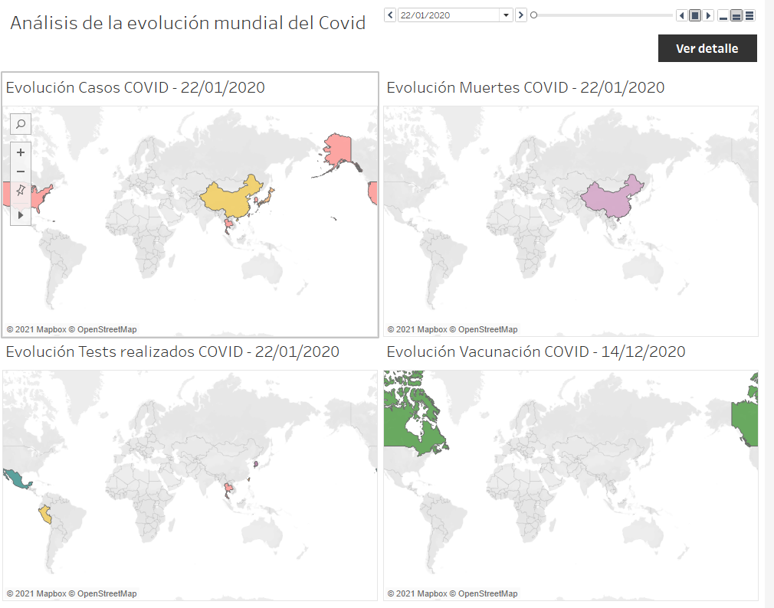

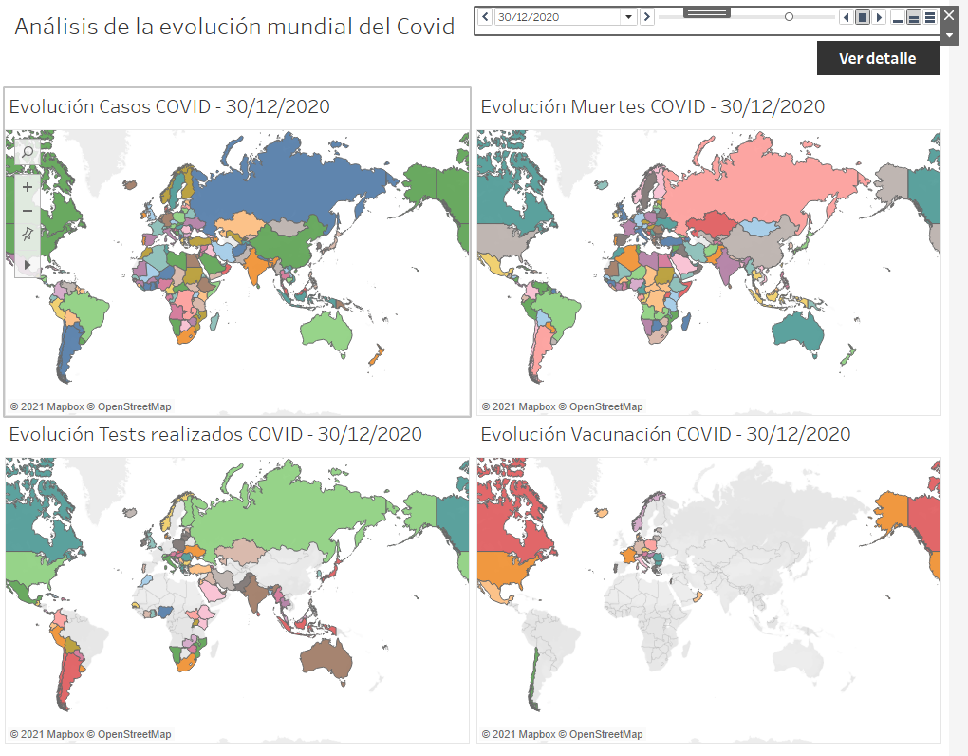

En la vista de detalle encontramos un resumen de casos positivos, muertes por Covid, tests realizados y vacunaciones. Vemos también un gráfico por cada una de estas variables en los que podemos observar el top 10 paises en cada variable. Finalmente vemos unos gráficos con la evolución de nuevos casos, muertes, tests y vacunaciones diarias.

En la parte superior encontramos un filtro por país, para poder adaptar los detalles al país que nos interese y un botón vinculado a la primera visualización que nos ayudará a navegar entre ellas.

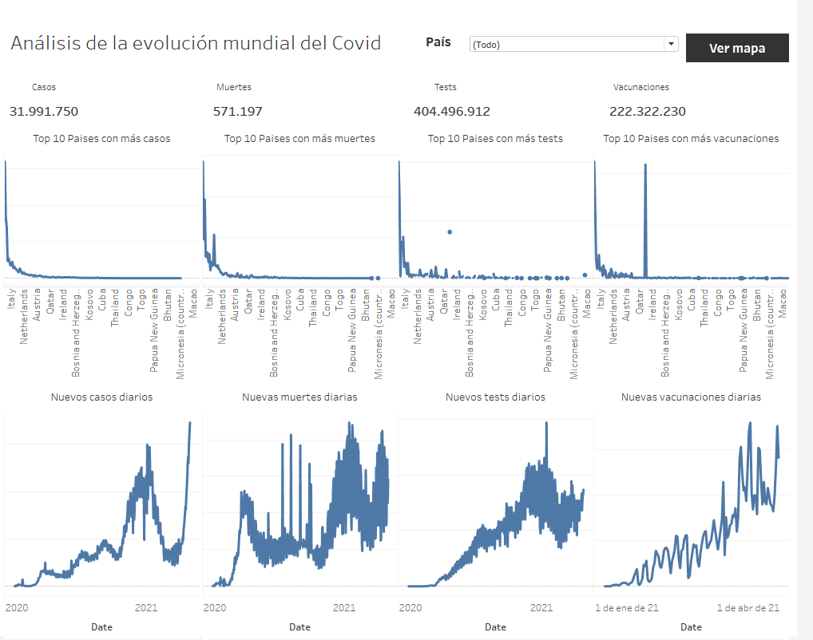

## Anexo

El error siguiente es el que me devuelve public.tableau al intentar visualizar los mapas.

