# 2IMP10 Program Verification Techniques: Assignment 1

Lois Nijland (0860184), Joost Pieterse (0848231)

*1. Show (provide a table) the check as performed by the PCTL labelling algorithm for t1* ⇒ *AFc1.*

First we rewrite t1 ⇒ AFc1 to ¬t1 v AFc1

Now we construct the table and insert V in the table if the formula on the left holds in the corresponding state w.

|  |  |  |  |  |  |  |  |  |
| --- | --- | --- | --- | --- | --- | --- | --- | --- |
|  | w0 | w1 | w2 | w3 | w4 | w5 | w6 | w7 |
| t1 |  | V |  |  | V |  |  | V |
| ¬t1 | V |  | V | V |  | V | V |  |
| c1 |  |  |  | V |  |  | V |  |
| AFc1 – S |  |  |  | V |  |  | V |  |
| AFc1 – R |  |  |  | V |  |  | V |  |
| AFc1 – T |  |  |  | V |  |  | V |  |
| ¬t1 v AFc1 | V |  | V | V |  | V | V |  |

*2. Show (provide a table) the check as performed by the PCTL labelling algorithm for t1* ⇒ *AF(c1 v c2).*

First we rewrite t1 ⇒ AF(c1 v c2) to ¬t1 v AF(c1 v c2)

Now we construct the table and insert V in the table if the formula on the left holds in the corresponding state w.

|  |  |  |  |  |  |  |  |  |
| --- | --- | --- | --- | --- | --- | --- | --- | --- |
|  | w0 | w1 | w2 | w3 | w4 | w5 | w6 | w7 |
| t1 |  | V |  |  | V |  |  | V |
| ¬t1 | V |  | V | V |  | V | V |  |
| c1 |  |  |  | V |  |  | V |  |
| c2 |  |  |  |  |  | V |  | V |
| c1 v c2 |  |  |  | V |  | V | V | V |
| AF(c1 v c2) – S |  |  |  | V |  | V | V | V |
| AF(c1 v c2) – R |  |  |  | V | V | V | V | V |
| AF(c1 v c2) – R |  | V | V | V | V | V | V | V |
| AF(c1 v c2) – R | V | V | V | V | V | V | V | V |
| AF(c1 v c2) – T | V | V | V | V | V | V | V | V |
| ¬t1 v AF(c1 v c2) | V | V | V | V | V | V | V | V |

*3. Show (provide the construction of the automata) the check as performed by the PLTL algorithm for* ⬜*(n1 v t1).*

ϕ = ⬜(n1 v t1)

¬ϕ = ¬⬜(n1 v t1)

= ¬¬**◇**¬(n1 v t1)

= **◇**¬(n1 v t1)

= **◇**(¬n1 ∧ ¬t1)

= true U (¬n1 ∧ ¬t1)

Build pre-atoms for ϕ, giving nodes for A¬ϕ.

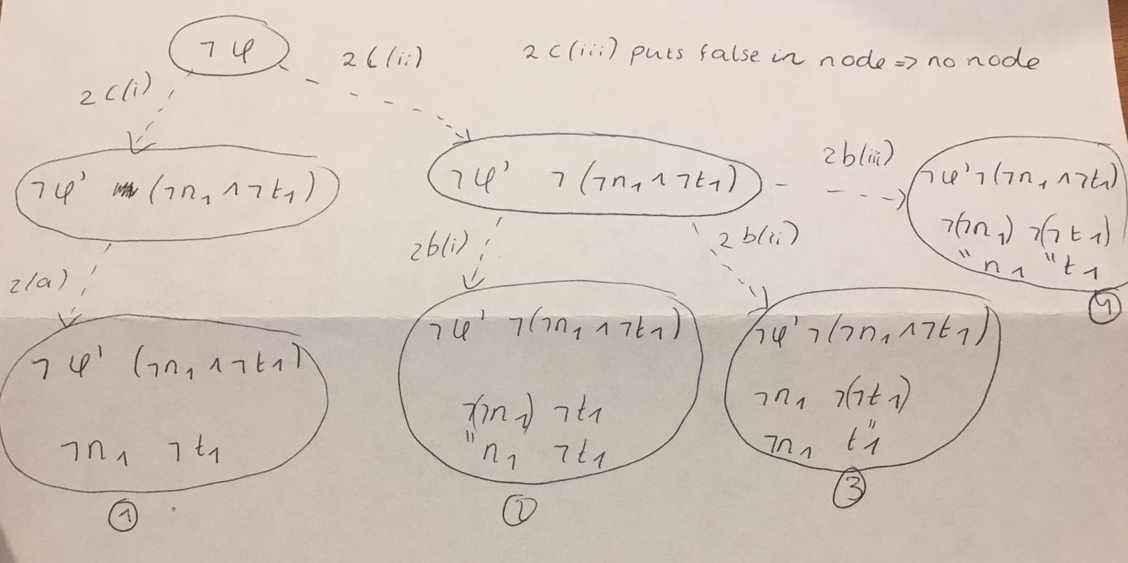

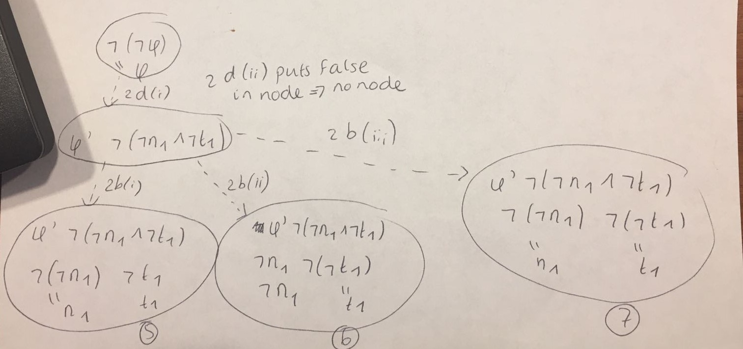

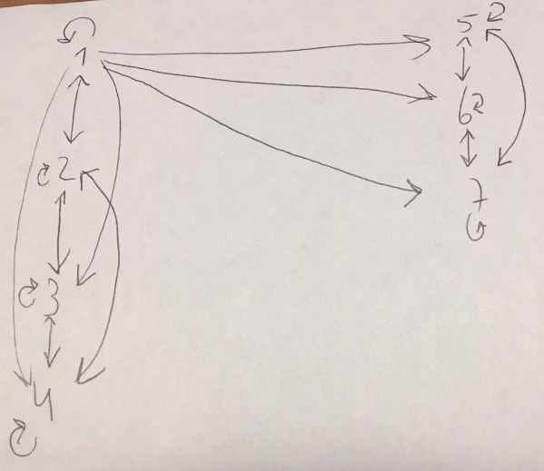

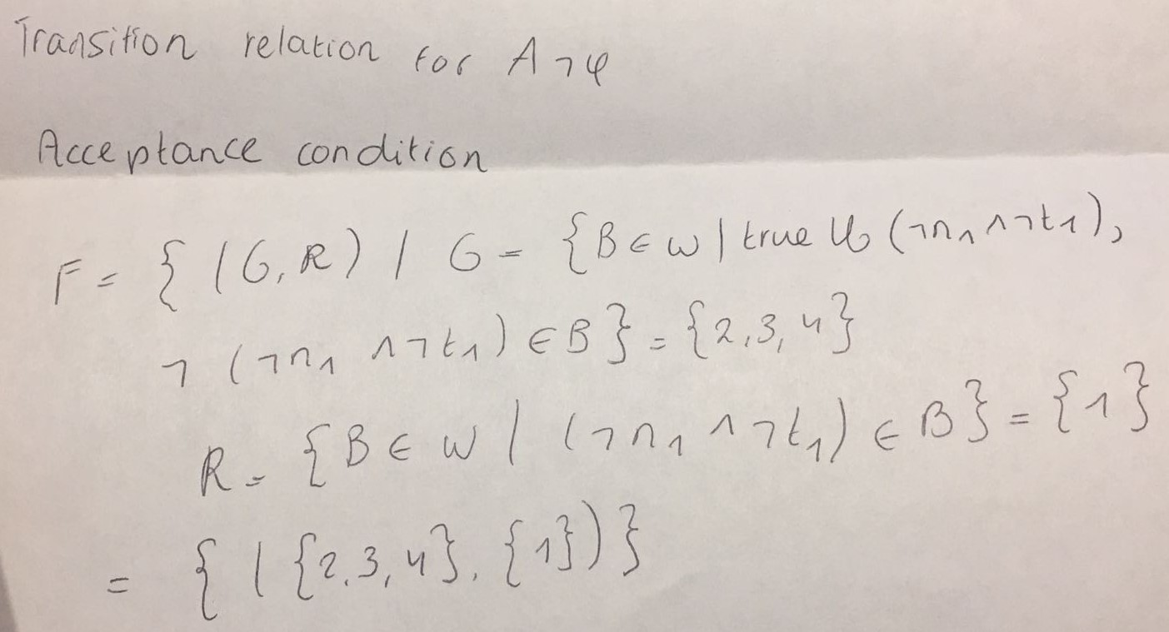

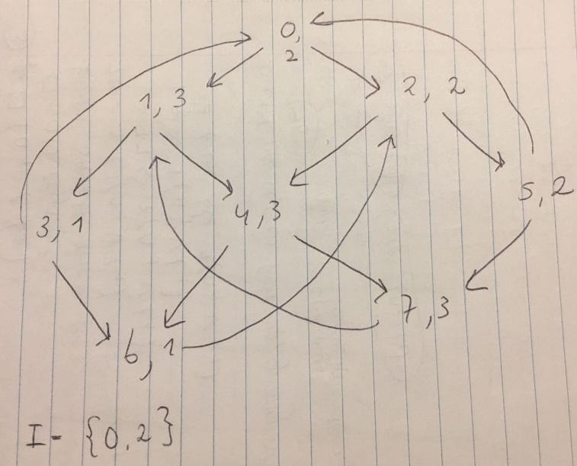

*4. Write the SMV code for MUXTEXLessNaive from the Lecture Notes, WITH SELF-LOOPS ADDED AROUND n1 AND n2. Run the checker on the three formulas above; compare with your answers-by-hand. (Write the PLTL formula with the G for* ⬜ *etc.) If there are differences in the results, explain them.*