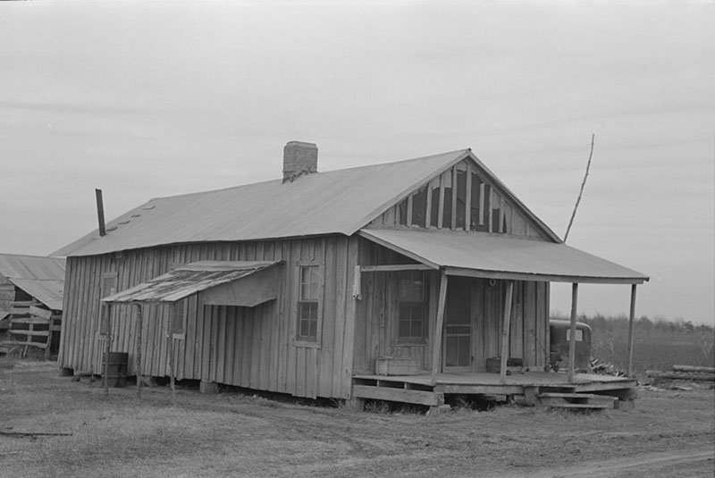

Faulkner Fan Fic: Practicing Character Development

and Scene Building in Faulkner’s Universe

**Preface:** This creative writing project appeals to students who are familiar with writing fan fiction in established universes such as *Harry Potter* or *Star Wars* but is designed for any novice creative writing student. The project empowers students to control the narrative by enhancing and changing a problematic story’s perspective.

The project teaches writing students how to develop characters, write dialogue, play with both perspective and point of view, work within an already established universe for setting, and write scenes. Students will give voice to minor characters in William Faulkner’s universe using Digital Yoknapatwpha tools to flesh out characters and rewrite scenes in Faulkner’s fiction.

**Activities:**

**Activity #1: Analysis of Elements of Fiction in “Barn Burning” and Alice Walker’s “Everyday Use”**

**Study: Read William Faulkner’s “Barn Burning” and Alice Walker’s “Everyday Use”**

**Explore: Visit Alice Walker’s official web page and the Digital Yoknpatwpha’s “Barn Burning” pages to understand more about each of the stories.**

Digital Yoknapatawpha  [https://faulkner.iath.virginia.edu/Links to an external site.](https://nam04.safelinks.protection.outlook.com/?url=https%3A%2F%2Ffaulkner.iath.virginia.edu%2F&data=05%7C01%7Cmbeach7%40stlcc.edu%7C660e44d64efe42b1330908db66e32f97%7C4cd64bfea7a14304947b1393797262a2%7C0%7C0%7C638216899380721336%7CUnknown%7CTWFpbGZsb3d8eyJWIjoiMC4wLjAwMDAiLCJQIjoiV2luMzIiLCJBTiI6Ik1haWwiLCJXVCI6Mn0%3D%7C3000%7C%7C%7C&sdata=L99Cp4S%2BxHPuLvN9NphrrxJO%2BkNg4N7252tuqSEFFVY%3D&reserved=0)

Alice Walker’s official website <https://alicewalkersgarden.com/about/>

**Respond: In small groups, compare and contrast the main character, the setting, the point of view, the conflict, and the climax of each story. Also discuss the following questions:**

**What information from DY or Walker’s webpage helped you understand the story?**

**How does the author’s choice of central character and point of view inform the story?**

**Whose voices are silenced in each story?**

**How many scenes are in each story?**

**How do the settings add to the conflict in the stories?**

**How does each story use fire both literally and symbolically?**

**Groups will report their answers to the entire class.**

**Activity #2: Creating a Character Chart using DY**

**Explore: Visit Digital Yoknapatwpha at** <https://faulkner.iath.virginia.edu/>

**Walkthrough**

**a)** Select “Barn Burning” from the list of Faulkner’s body of work (see book icons on home page).

**b)** Once you’ve selected “Barn Burning,” you will be on a page with a map of the story you selected (in this case “Barn Burning”).

**c)** On the left-hand side of the page is a box labeled “Display Controls.”  Select “All” or “Major and Secondary” under “Show Characters.”

**d)** Slide your cursor over the characters on the map until you chose a character to use for the fan fic. You may also click the “Alphabetic List” box under “Show Characters.” A new box with an alphabetical list of characters from the story appears.  Find your chosen character and check their name and click “Show” at the bottom of the box.  The character will appear on the map.

**e)** Click on your chosen character.  An informational box will open with the following tabs: Biography, Information, Events, Location.  Use the information from this box to complete the questions on the attached character chart.

**Create: Complete a character chart for one of the minor characters in “Barn Burning.” You should select a minor character you are interested in writing for a revision of a scene in “Barn Burning.” You should use as much information as you from the Digital Yoknapatwpha’s character listing for the character chart. On the character chart, designate what information you gleaned from DY and the story and what information you are inventing.**

**CHARACTER CHART LINK**

**Activity #3: Researching Setting using DY and other sites to set the scene.**

**Study:** Select one event/scene from “Barn Burning” in which your character appears.  This will be the scene you will later re-vision when you write from your chosen character’s point of view.  Research the scene by visiting Southern Tenant Farmers Museum [https://stfm.astate.edu/Links to an external site](https://nam04.safelinks.protection.outlook.com/?url=https%3A%2F%2Fstfm.astate.edu%2F&data=05%7C01%7Cmbeach7%40stlcc.edu%7C660e44d64efe42b1330908db66e32f97%7C4cd64bfea7a14304947b1393797262a2%7C0%7C0%7C638216899380721336%7CUnknown%7CTWFpbGZsb3d8eyJWIjoiMC4wLjAwMDAiLCJQIjoiV2luMzIiLCJBTiI6Ik1haWwiLCJXVCI6Mn0%3D%7C3000%7C%7C%7C&sdata=xkvHv8HCE7cdxfWyX5uKlgClDLFl14JFOyQyBvD5VMo%3D&reserved=0) and the Oklahoma Historical Society <https://www.okhistory.org/publications/enc/entry.php?entry=TE009>

Next, return to Digital Yoknapatwpha.

**Walkthrough**

1. Return to the “Barn Burning” map inDigital Yoknapatawpha  [https://faulkner.iath.virginia.edu/](https://nam04.safelinks.protection.outlook.com/?url=https%3A%2F%2Ffaulkner.iath.virginia.edu%2F&data=05%7C01%7Cmbeach7%40stlcc.edu%7C424136e7a7654cf441a108db66e2c820%7C4cd64bfea7a14304947b1393797262a2%7C0%7C0%7C638216896440765450%7CUnknown%7CTWFpbGZsb3d8eyJWIjoiMC4wLjAwMDAiLCJQIjoiV2luMzIiLCJBTiI6Ik1haWwiLCJXVCI6Mn0%3D%7C3000%7C%7C%7C&sdata=%2ByIJM4JJpwJmuGHmkmPynQlDHTuWM5iLwxE5gOjAX38%3D&reserved=0)
2. Look at the timeline at the bottom of the “Barn Burning” map page to establish the setting’s time period.

**c)** On the left-hand side of the page is a box labeled “Display Controls.”  Select “Event Locations”

**d)** Click on the locations on the map until you find an event your character is in.

**e)** An informational box will open with the following tabs: Biography, Information, Events, Location.  Use the information from this box to **write a description of the event/scene.**

**Respond:** Answer the following questions.

What information did you glean from the three sites that will help you re-create the Faulkner scene?

Where does the scene take place?

Describe the scene through the viewpoint of your chosen character:

**Activity #4: Writing the Scene**

**Create: Now that you have selected and thoroughly developed a character and researched tenant farming and the time period the story takes place, you should re-vision a scene from “Barn Burning” from the point of view of your selected character. For instance, if you select the Black servant at the deSpain mansion, you may re-envision the scene when Abner sullies the entrance rug. You will write the scene from the servant’s point of view.**

**Each scene should include action, description, narration, dialogue, and interiority and should give the chosen scene dimension based their alternative perspective.**

**Activity #5: Workshopping Scenes**

**Study: Read each classmate’s scene and make notes about what works and doesn’t work.**

**Respond: The class will work together to help one another improve their scenes. If two students chose the same character and scene, they should work together to align the scenes so they “match.” For instance, if two students chose to write from the same judge’s perspective, they should decide which of their names to use. Names from the overall Faulkner universe are preferred.**

**Activity #6: Putting it all together**

**Revise: Revise, edit, improve your scene based on the feedback from workshop.**

**Collaborate: The class will rewrite/revision various scenes from the viewpoint of minor characters in Faulkner’s short story, workshop and align those scenes, and then collaboratively decide on an order of the scenes for their final longer Fan Fic.**

**Final Product: Class Faulkner Fan Fic**

**Teachers and students may use a free education website creator, Wakelet, or any online platform to display their final work.**

**Digital Tools and Resources:**

Digital Yoknapatawpha  [https://faulkner.iath.virginia.edu/Links to an external site.](https://nam04.safelinks.protection.outlook.com/?url=https%3A%2F%2Ffaulkner.iath.virginia.edu%2F&data=05%7C01%7Cmbeach7%40stlcc.edu%7C660e44d64efe42b1330908db66e32f97%7C4cd64bfea7a14304947b1393797262a2%7C0%7C0%7C638216899380721336%7CUnknown%7CTWFpbGZsb3d8eyJWIjoiMC4wLjAwMDAiLCJQIjoiV2luMzIiLCJBTiI6Ik1haWwiLCJXVCI6Mn0%3D%7C3000%7C%7C%7C&sdata=L99Cp4S%2BxHPuLvN9NphrrxJO%2BkNg4N7252tuqSEFFVY%3D&reserved=0)

Alice Walker’s official website <https://alicewalkersgarden.com/about/>

Southern Tenant Farmers Museum [https://stfm.astate.edu/Links to an external site.](https://nam04.safelinks.protection.outlook.com/?url=https%3A%2F%2Fstfm.astate.edu%2F&data=05%7C01%7Cmbeach7%40stlcc.edu%7C660e44d64efe42b1330908db66e32f97%7C4cd64bfea7a14304947b1393797262a2%7C0%7C0%7C638216899380721336%7CUnknown%7CTWFpbGZsb3d8eyJWIjoiMC4wLjAwMDAiLCJQIjoiV2luMzIiLCJBTiI6Ik1haWwiLCJXVCI6Mn0%3D%7C3000%7C%7C%7C&sdata=xkvHv8HCE7cdxfWyX5uKlgClDLFl14JFOyQyBvD5VMo%3D&reserved=0)

Oklahoma Historical Society <https://www.okhistory.org/publications/enc/entry.php?entry=TE009>

Digital Portfolio -- <https://wakelet.com/>

**Paired Author:** Alice Walker

**Alternative Pairing**: The short novel *Tobacco Road* by Erskine Caldwell

**Modality: In-person or Online Synchronous**

**For Teachers**

Each activity can be used as scaffolded for the final product or can be used separately depending on the instructor’s desired outcomes.

You will need to allot some time to in-class instruction on Digital Yoknapatawpha. The DY tools and pages for this assignment are fairly simple to use.

**Pilot Classroom:** This project was piloted in a synchronous online creative writing class for college freshmen and sophomores at St. Louis Community College.

**Learning Goals**

**Learning Goal #1:** To identify major and minor characters, point of view, setting, scene building, and plot.

Learning Goal #2: To research social/historical context in imaginative writing through the use of digital resources.

Learning Goal #3: To practice stepping outside of self to write/invent characters and scenes from different perspectives in different time periods.

**Student Samples:** <https://wakelet.com/wake/bSRYNx4QX5ycwrAFeHpzD>

**PDF LESSON PLAN**