**Why Cold-Pressed Juice?**

Consuming juice is a great way to source your daily nutrients. When you consider that approximately five cups of vegetables or fruits go into one cup of juice, it’s no wonder people are turning to it for convenience. But not all juices are of the same quality… many studies are confirming that cold-pressed juices are superior to their centrifugal counterpart.

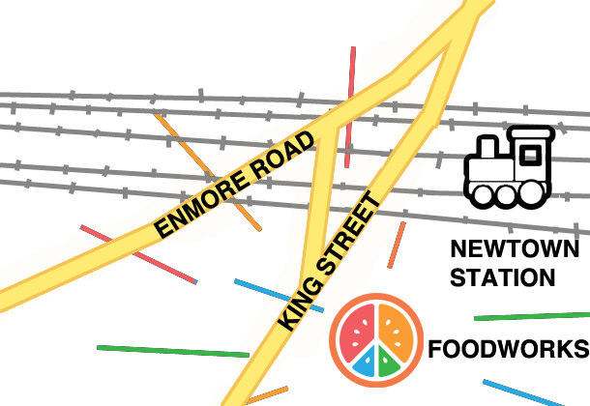Centrifugal juicers employ fast-spinning and chopping devices that create heat through friction. Combined with static electricity and air, this heat rapidly increases the oxidisation process, killing off many of the nutrients found in fresh vegetables and fruits. The enzymes that help us to absorb and assimilate nutrients are also destroyed in this process. Without these enzymes the body has to use its own stores, drawing energy unnecessarily.

Cold-pressed juicers on the other hand use a slow-speed masticating process to extract the juice (much in the same way as teeth!) This way all of the essential vitamins, minerals, phytonutrients and enzymes remain in tact. Cold-pressed juice gets the most out of fruits and veggies and tastes amazing. **We make our juices fresh to order.** The slow nature of the juicer means our juices take a little longer to make, so you can SMS your order ahead of time to 0411 268 848.

We hope you love our juices as much as we do!

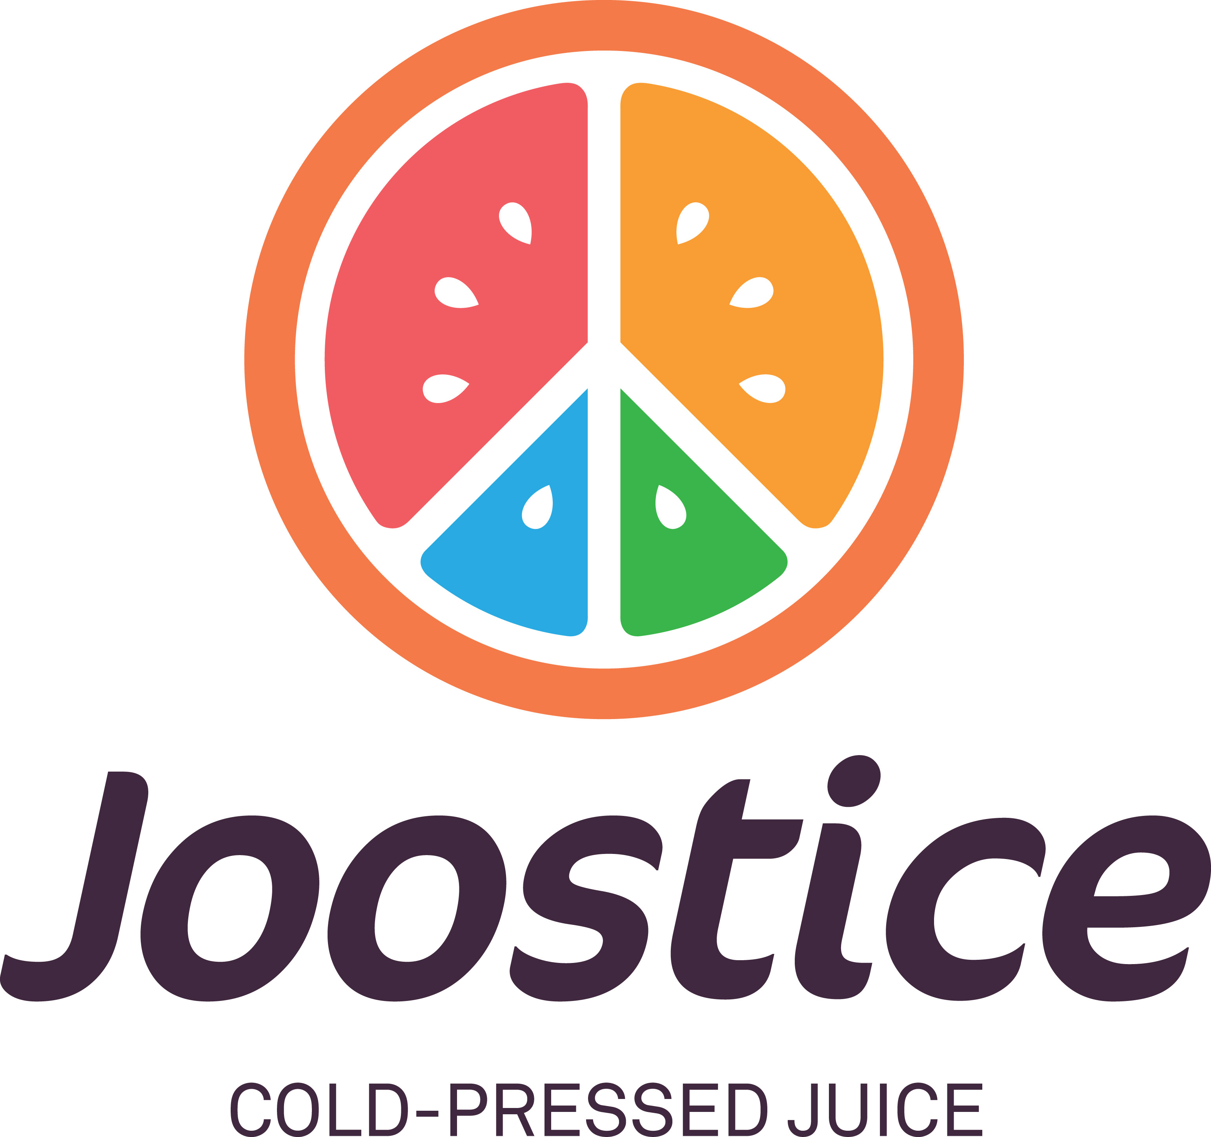**About Us**

Joostice is a social business. We are a not-for-profit company limited by guarantee with, as our objective, a mission to support public interest journalism.

Public interest journalism is increasingly falling beyond the capacity of traditional media organisations. Individuals and civil society groups are stepping up to the task in the tradition of Edmund Morel.

Our idea: Juice for justice. We want to create a sustainable revenue stream to support critical investigations that shed light on injustice, so that these acts of truth telling may be the catalyst for fairer and freer societies.

**Location**

Shop 17/ 330 King St Newtown 2042. We are in Newtown Central, above Foodworks just next to Newtown Station

**Opening Hours**

**Mon-Fri:** 7am-5pm **| Sat:** 8am-4pm

**Sun/Public Holidays:** 9am-3pm

*\*\*\* JUICE FOR JUSTICE \*\*\**

**www.joostice.com**

**github.com/joostice/**

**facebook.com/joostice/**

**twitter: @joostice_**

**SMS-to-Order: 0411 268 848**

**PAY WITH BITCOIN:**



**Ingredients**

We endeavour to source the freshest, best quality, local, fair-trade produce;

**Acai**- High in antioxidants, rich in B vitamins, supports brain & immune function.

**Almonds**- Excellent source of vitamin E, folate, manganese, protein & energy.

**Apple**- Dietary fibre, high in vitamin C, calcium and potassium.

**Avocado**- Healthy fats, anti-inflammatory, high in vitamin C, E and folate.

**Banana**- Rich in potassium, fibre, vitamin B6 and has prebiotic properties.

**Barleygrass**- Alkalising, plant source of vitamin B12, rich in chlorophyll, folic acid.

**Beetroot**- Supports cardiovascular system and detoxification, high in folate & fibre.

**Blueberry**- Rich in Antioxidants and vitamin K, low GI, supports memory function.

**Cacao**- Great source of magnesium, phosphorus, iron and copper.

**Camu Camu**- Extremely high in vitamin C (thirty times more than oranges).

**Carrot**- Rich in antioxidants, excellent source of vitamin A, K and C.

**Cayenne Pepper**- High in vitamins A, E, C, B6, K and manganese, immune support.

**Celery**- Anti-inflammatory properties, good source of Vitamin K, A and tryptophan.

**Chia**- Contains all essential amino acids and is the highest plant source of omega 3s.

**Chlorella**- Highest source of chlorophyll, alkalising, detoxifies body of heavy metals.

**Cinnamon**- Anti-microbial, anti-inflammatory, aids blood sugar control.

**Coconut**- Rich in electrolytes, anti-microbial, healthy fats, good source of calcium.

**Coriander**- Anti-bacterial, rich in flavonoids, vitamins A, K, C, calcium and iron.

**Cucumber**- Cooling effects, anti-inflammatory properties, good source of vitamin K.

**Fennel**- Antioxidant-rich, supports immune function, high in fibre.

**Ginger-** Anti-inflammatory, carminative, relieves motion sickness and nausea.

**Kale**- Supports detoxification, lowers cholesterol, exceptionally high in vitamin K.

**Lemon**- Alkalising, high in vitamin C, anti-bacterial, strong antioxidants.

**Maca**- Supports the endocrine system, high in iron, vitamin C, potassium and copper.

**Mint**- Cooling action, good source of vitamin A, iron, zinc, phosphorous and niacin.

**Orange**- Immune support, high in vitamin C, B1, fibre, folate, and calcium.

**Parsley**- High in iron, rich in vitamin K, C, A and folic acid.

**Pineapple**- Excellent source of vitamin C, B6 and manganese.

**Pre-Probiotics**- Supports digestive health by providing and feeding healthy bacteria.

**Protein powder**- Bio-available form of amino acids for tissue rebuilding and repair.

**Raw honey**- Anti-bacterial, anti-viral, anti-fungal.

**Silverbeet**- Good source of iron, magnesium, calcium, potassium, vitamins K & A.

**Spirulina**- Complete protein (up to 71% protein), chlorophyll, rich in minerals.

**Stevia**- Alkalising, low in calories, contains antioxidants.

**Strawberry**- High in vitamin C, manganese, anti-inflammatory properties.

**Walnuts**- High levels of vitamin E, Omega 3s, manganese and copper.

**Watermelon**- Contains vitamin C, A and anti-inflammatory phytonutrients.

**Wheatgrass**- Alkalising, blood builder, source of chlorophyll, vitamin C and iron.

===========================================

**Additions (1.5)**

Powerup your juice or smoothie with;

Wheatgrass, Barleygrass, Spirulina, Chlorella, Maca, Camu Camu, Cacao, Pre-Probiotics and/or Raw Protein powder.

===========================================

**Home Delivery & Juice Packages**

Coming soon! Register your interest by emailing info@joostice.com

**Cold-Pressed Juices**

Reg. (395ml) – add $1 to go Large (500ml)

**Orange Juice – (4)**

**Carrot Head – (5)**

Orange, Carrot, Celery

**A2Beet – (5)**

Apple, Beetroot, Carrot, Lemon

**Kalebration – (5)**

Apple, Fennel, Kale

**Green Machine – (6)**

Cucumber, Celery, Silverbeet, Coriander, Kale, Apple, Lemon

**DESIGN Your Own == choose one of 238-1 (6)**

++ add ginger to any juice

**Smoothies**

**AvoCacaoNani – (6)**

Avocado, Cacao, Banana, Raw Honey, Almond Milk

**Sunlover – (7)**

Acai Berry, Blueberry, Apple Juice and Banana

**Double Plus Green – (7)**

Kale, Spinach, Parsley, Mint, Apple, Young Coconut, Stevia, Cinnamon

**Protein Power – (8)**

Almond Milk, Raw Protein Powder (bio-fermented Brown Rice and Pea Protein), Chia, Raw Honey and Cinnamon

**Island Times – (7)**

Pineapple, Young Coconut, Mint, Stevia.

**Miscellaneous**

**Cold-Press Coffee - (5)**

organic coffee, agave, vanilla, water

**Acai Bowl** **– (10)**

Acai, granola, strawberry, banana, raw honey