**BM41050: Applied Experimental Methods**

**The effect of bevel angle and tissue stiffness on needle deflection**

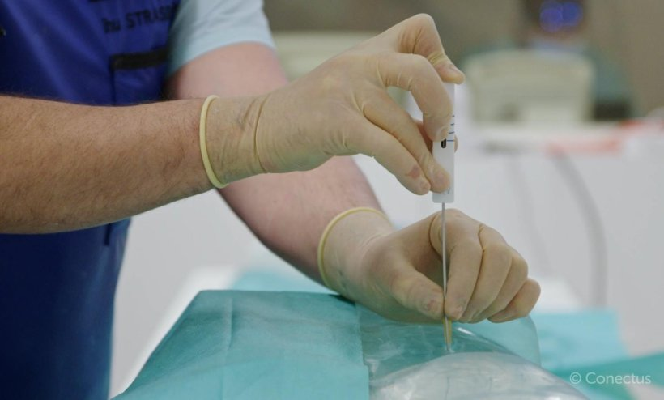

**Author: Joost Wijnmaalen(4715861) & Djoeke Pelsma(), Biomedical Engineering, 2023**

**Abstract:**

Contents

I. Introduction 3

II. Materials and Methods 3

A. Materials 3

B. Protocol 4

Appendix 1 7

7

1. Introduction

Many clinical procedures such as wound draining, IV administration, and cancer biopsy make use of needles. The success of these procedures can be influenced by the ability of the needle to precisely target the area of interest and avoid damaging the surrounding tissue (de Jong, 2015).

Many parameters can influence this deflection like insertions speed (Roesthuis et al., 2011), material properties (de Jong, 2015), and geometry (Li et al., 2020). This paper aims to find the answer to the following research question: “What is the relationship between needle deflection, tip geometry, and tissue stiffness?”

This information is relevant as understanding the influence of tip geometry and tissue stiffness can give clinicians insight into needle administration. This can be especially useful for precise cancerous tissue biopsy because cancerous tissue has vastly different mechanical properties than healthy tissue(Katira et al. 2013).

ZY

Y

The relationship between needle deflection, tip geometry, and tissue stiffness has been extensively studied by van Veen et al. (2012), and this paper is meant to validate the conclusion from that study. The conclusion from van Veen et al. (2012) is as follows: “Increasing the gel elasticity results in larger insertion forces and needle deflections. Varying the tip shapes demonstrates that bevel-tipped needles produce the largest deflection”(p.1). Gel elasticity represents tissue stiffness in the experiment from van Veen et al. (2012).

This paper begins by introducing the methods used for this experiment. This section is followed by the presentation of the results. These results will be explained in the discussion, and finally, a short conclusion will be presented.

Ultimately, this paper argues that a better understanding of needle deflection can reduce the damage to surrounding tissue and improve the outcomes of certain procedures.

# Materials and Methods

This section will discuss the methods used for conducting the experiment. This includes the materials, protocol, and analysis.

## Materials

The materials that were used in this study will be described in this section. The materials and the resulting setup are chosen in such a way that the results are as reliable and consistent as possible.

Two different needles were used for this experiment. One 200 mm blunt needle, and one 200 mm beveled needle.

To insert the needle in a consistent and controlled manner, a guiding system was devised. This consisted of two wooden rods the needles were inserted into, PVC tubing to guide this rod, and a wooden needle guide to avoid deflection upon insertion (Figure 1). A picture containing mirror, sketch, art, design

Figure : Needle guiding system. I: Guiding support, II: PVC guiding tube, III: nail and slot, IV: wooden rod, V: needle, VI: needle guide

The wooden rods had a diameter of 12 mm and a height of 300 mm(Figure 1B). These rods had a 20 mm long, 1 mm diameter hole drilled into the center. In this hole, a needle was inserted and attached with hot glue. The wooden rods had a nail inserted at a height of 150 mm. This nail was placed in a random orientation for the rod with the blunt needle, and was placed parallel to the bevel slope in the rod with the beveled needle. PVC tubing having a length of 250 mm and a diameter of 13 mm was used to guide the wooden rods. The PVC tubing had slots parallel to the x-direction, for the needle of the wooden rods to fall into (Figure 1A). This was to assure the needle faced the same direction for every pass. The needle guide at the end of the PVC tubing had the same diameter as the wooden rod, a height of 20mm, and a hole diameter of 1mm (Figure 1C). The guiding system was held up by two 150 mm wooden beams which were joined by a stainless steel corner joint. This construction tried to mimic the construction used by van Veen et al. (2012) in a low-cost manner. Although this setup does not use a motor-guided needle, the handle due to the use of the wooden rod gives a better feel about the insertion speed and force than simply handling the needle with one's hands.

The guiding system was mounted onto an MDF plate being 600x600x600 mm (LxWxH). On this building plate, two phone stands were mounted at a distance of 300 mm from the gelatine container(Figure 2A). The distance was chosen as far away as possible to avoid the influence of parallax from the needle on the measuring paper. 300mm was about the maximum distance before the lines of the measuring paper were indistinguishable. The mounting system was attached in such a way that it does not interfere with the camera and that the container of gelatine can be moved throughout every measurement. This is important as preliminary testing showed the needle following exactly the same pathway when the insertion hole was the same. A picture containing rectangle, wall, indoor, design

Y

X

Figure : Test set-up. I: Camera stand y-direction, II: camera stand x-direction, III: gelatin, IV: needle guiding system, V: needle, VI: measuring paper

For the recording of the needle deflection, two iPhone 14s were used. The default camera app on the iPhone was used, as well as the standard picture type. No zoom was used.

For replicating the tissue gelatin was used, similar to van Veen et al. (2012). The gelatin consisted of Dr. Oetker's gelatin powder and 2100 ml tap water. Two batches with respectively 105 and 210 grams of gelatin were created. The mixtures were inserted into separated stainless steel stockpots and put over low fire, without reaching a boil, until the powder was completely dissolved.

These mixtures were then poured into two separate transparent storage containers with dimensions of 20x10x14,2 mm (LxWxH), from the brand Rotho. Two containers were used to easily switch between stiffness. These containers were put into the fridge for 24 hours at 5 °C, to develop the gelatine. On the container, measuring paper was applied with duct tape. The measuring paper indicated millimeters (Figure 2B).

## Protocol

The test protocol was set up in such a way as to maximize the chance of finding an effect. The study focuses on manipulating independent variables, observing dependent variables, and minimizing the effect of nuisance variables.

The dependent variable was in this case deflection, which was measured in millimeters with the measuring paper and the camera. The independent variables were needle geometry and tissue stiffness (mass-percentage gelatin). The nuisance variables, in this case, were plentiful. The relevant nuisance variables are temperature, humidity, insertion speed, sensor accuracy, needle wear, and gelatin wear.

The gelatin was thawed outside the fridge for 10 hours to get the temperature of the gelatin back to room temperature. This was done to mitigate the effects of differences in temperature throughout the tests. Keeping the camera in the same position relative to the needle was also important, to avoid changes in measurements due to the parallax between the camera needle and measuring paper. This was done by not moving the camera throughout the experiment, and keeping the needle at the same place by using the mounted needle guide. To mitigate the influence of needle and gelatin wear as well as to account for time-dependent variables such as temperature and humidity which can vary throughout the day. Four ECs were considered (Figure 3). It is important that ECs are randomly assigned to the EUs. This was done by using the randomize function(“=RAND”) in Microsoft Excel. Every EC was repeated 35 times to enable sufficient estimation of the experimental error.

Figure : Condition matrix with respective ECs and replications

When performing the experiment the needle was moved to its most downward position in exactly three seconds for every pass, to get a consistent insertion speed. The gelatin was shifted along the x-axis at every EU so as not to use the exact same entry hole. Data sampling was done by retrieving the video and filling in the runtable(Appendix 1).

## Analysis

Resampling, filtering (when applicable), and  
analysis methods used to study effects in the  
collected data are introduced. Ways in which  
data is presented or visualized are denoted.

Resampling, filtering (when applicable), and  
analysis methods used to study effects in the  
collected data are introduced. Ways in which  
data is presented or visualized are denoted.

# Results

Clear presentation of outcomes (according to  
the provided data summary and analysis  
methods). The main effects visible in the  
data are described. A raw data plot is also  
provided.

It is clear that the authors carefully looked at  
the raw and/or summarized data.  
Secondary/unanticipated effects are  
visualized and described, but not interpreted

# Discussion

Results are discussed in the context of the  
introduced the research question. (Sub)optimal  
or (un)expected effects are related to the  
experimental methods, design, or material  
choices.

The strong and weak points of the study are  
described objectively. Results are interpreted  
concerning other work (other  
groups/literature). The discussion ends with a  
clear take-home message

This study had several strong and weak points. The strong points of this study were that it mimicked the study by van Veen et al. (2012) in several ways. This study also uses a needle guide and includes a way to get consistent insertion speeds. Another strong point is that in this study the gelatin was shifted between every EU to mitigate the effects of gelatin wear. Finally, this study randomizes the ECs to deal with certain nuisance variables like temperature, humidity, and wear. A weak point of this study is that the created needle guide does not allow for a controlled rotational speed. Van Veen et al. (2012) show that rotation speed influences the needle deflection.

# A picture containing text, screenshot Description automatically generatedAppendix 1

# 

