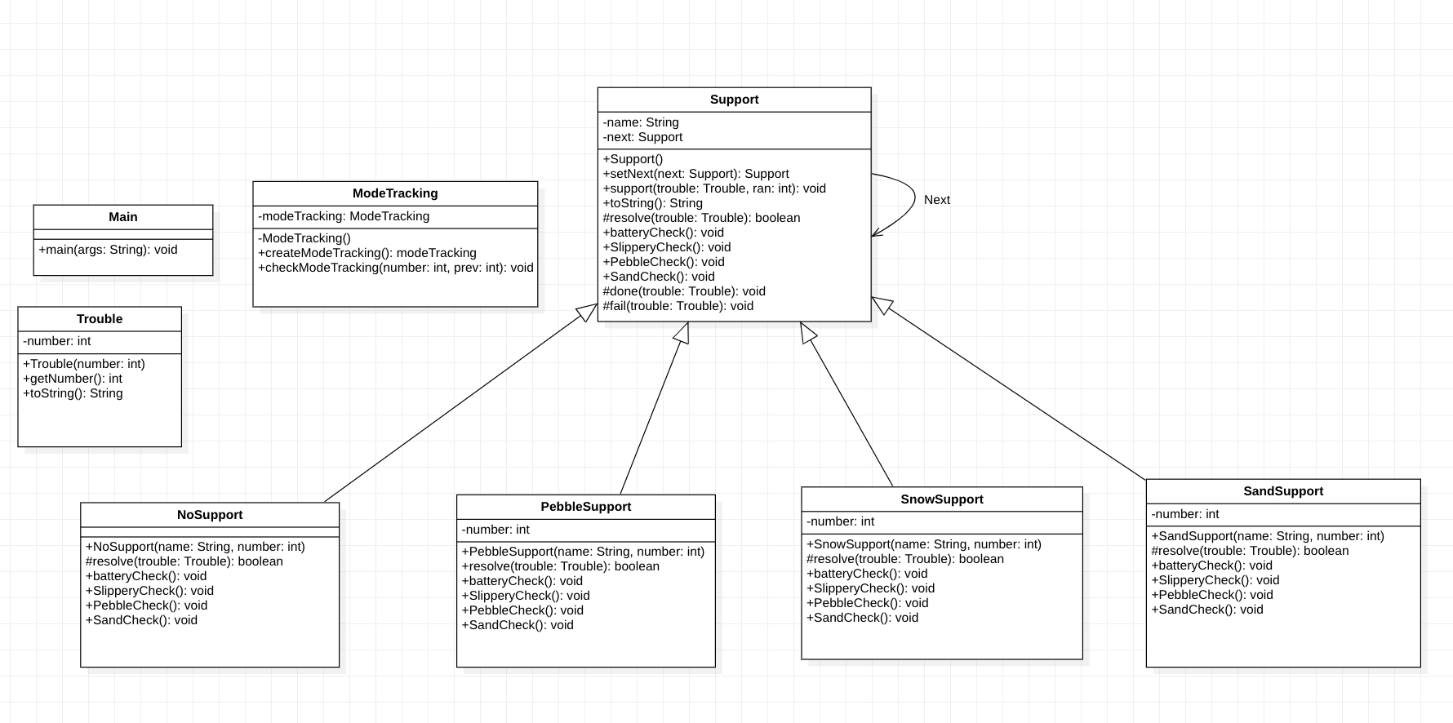

* UML diagram

The program determines the mode of the vehicle with random numbers. It was implemented as a chain of responses.  
The main function calls the modeTracking object implemented in Singleton pattern. You know what the current state is, and you output an appropriate message accordingly.  
The order of objects implemented by each Chain of Responsibility is NoSupport, SnowSupport, sandSupport, and pebbleSupport. These objects are a subclass of Support. Support was implemented as a template method, and the batteryCheck was executed in common, and the rest was implemented according to the running mode object. In the Support class, methods are defined as abstract, and in each mode class, methods have been redefined to suit their needs. For example, in the PebbleSupport function, only the commonly used batteryCheck function and the PebbleCheck() function are activated and used.

