Discovering Informal Learning Cultures of Blind Individuals Pursuing STEM Disciplines

A Quantitative Ethnography Using Public Listserv Archives

JooYoung Seo

2020-03-23

# Abstract

Over the past decade, the importance of Science, Technology, Engineering, and Mathematics (STEM) subjects has received a lot of research attention in formal and informal learning settings. Despite the comprehensive need for STEM literacy and positive effect on learning, students with disabilities who are increasingly participating in regular classrooms experience significant difficulties in STEM; blind students, in particular, have become even more disenfranchised with the visually-oriented STEM practices. While several attempts have been made to address STEM accessibility issues for the blind, existing studies have been primarily limited to either usability field test or special curriculum design from a top-down approach taken by researchers with little attention devoted to bottom-up research where the lived experiences of blind STEM learners, as central storytellers, are naturally portrayed to yield their own challenges and shared cultures. This study is proposed to discover collective knowledge sharing patterns and informal learning cultures of blind individuals pursuing STEM disciplines as captured through computer-mediated mailing listservs. Using the National Federation of the Blind Mailing List, which is one of the world largest online mailing communities for the blind, this research will conduct longitudinal quantitative ethnography for the four STEM-oriented listserv archives in the public domain (i.e., NFB-Science and Engineering; Computer Science; Artists-Making-Art; BlindMath) between December 2008 and December 2018 to develop a comprehensive understanding of learning experiences voiced by blind individuals. More specifically, the following three research questions will be investigated through this study across a total of 23,540 messages: (1) What are the common STEM issues of blind learners that provoke discussion? (2) What are the patterns of interaction between blind mentors and mentees in the STEM-related mailing lists? And (3) What strategies are proposed or utilized by blind individuals pursuing STEM disciplines in the mailing lists? The findings of this dissertation study should make an important contribution to the field of Learning Sciences by discussing “How Blind People Learn STEM” and “How a Blind Learning Scientist Research” through rigorous, reliable, and reproducible methods offered by computer-assisted text analysis, called Structural Topic Modelling.

# Introduction

## Background and Importance of the Topic

Over the past decade, the importance of Science, Technology, Engineering, and Mathematics (STEM) education has received considerable research attention in formal and informal learning settings. Although the actual definition of STEM education and the consensus of the extent of their interconnectedness still remain unclear parameters (Bell, 2016; Brown, 2012; Capraro, Capraro, & Morgan, 2013; Hwang & Taylor, 2016; A. Roberts, 2013), it is now generally accepted that recent STEM education, as a dynamic process that changes over time, represents the purposeful integration either between the four subjects or with various other disciplines (e.g., languages; designs; the arts) whereby learners are engaged into solving real-world problem practices (Breiner, Harkness, Johnson, & Koehler, 2012; Labov, Reid, & Yamamoto, 2010; Sanders, 2009).

STEM has many implications for current learning systems. From a broader global view, for example, traditional manufacturing jobs HAVE quickly been replaced with careers demanding an applied STEM knowledge in many countries to secure economic prosperity (Basham & Marino, 2013; Bell, 2016; Kaku, 2012). Hwang & Taylor (2016), on the other hand, argue, “knowledge in STEM helps students to live a better quality of life because STEM is fully embedded in daily life situations” (p. 40). In fact, recent years have witnessed traditional lecture-based teaching strategies has been increasingly replaced with more project-based learning design (Breiner et al., 2012) to foster inquiry-driven nature, which in turn enhances high-order thinking, such as fundamental scientific, quantitative, and critical thinking skills, moving beyond low-level cognitive tasks (e.g., recalling facts in isolation) (Basham & Marino, 2013; Beck-Winchatz & Riccobono, 2008).

Taken all together, as Zollman (2012) claims, being STEM proficient can address not only societal, but also personal needs to be a fulfilled citizenry in an increasingly global economy (Hughes, 2010; Hwang & Taylor, 2016).

## Research Problem: A Knowledge Gap

Despite this comprehensive need for STEM literacy, students with disabilities, who have been increasingly participating in regular classrooms with the legislative support for equal access to general education (Rao, Ok, & Bryant, 2014; Roberts, Park, Brown, & Cook, 2011), experience significant difficulties in STEM (Israel, Maynard, & Williamson, 2013). Students with disabilities continuously perform below their peers without disabilities on standardized measures in STEM subjects (Basham & Marino, 2013; Hwang & Taylor, 2016; Israel et al., 2013), and often fall behind in STEM content since middle school (Israel et al., 2013; Marino, 2010). This disengagement has led to rare presence of those with disabilities in STEM workforce as only about 5 percent of students with disabilities enter the STEM careers (Leddy, 2010). However, a few studies have pointed out the struggles come primarily from the dearth of accessible teaching materials, inclusive curricula, and experiences of instructors teaching student with disabilities; rather than students’ disabilities themselves (Basham & Marino, 2013; Martin et al., 2011; Thurston, Shuman, Middendorf, & Johnson, 2017). Martin et al. (2011) argue, “In order to be afforded equal opportunity, especially in STEM fields, people with disabilities must be able to work their way through multiple barriers” (p. 295). This implies that more inclusive STEM materials and scaffolding learning designs are imperative for students with disabilities to fully engage with STEM content before leaving them taking all responsibilities for the STEM frustration (Basham & Marino, 2013; Samsonov, Pedersen, & Hill, 2006; Thurston et al., 2017).

While each individual with disabilities still lacks accessible STEM curricula, blind students, in particular, experience extra challenges and have become even more disenfranchised with STEM subjects (Beck-Winchatz & Riccobono, 2008; Cryer, 2013; Edwards, McCartney, & Fogarolo, 2006; Gardner, 2002; Jones, Minogue, Oppewal, Cook, & Broadwell, 2006; Supalo et al., 2006). According to American Printing House for the Blind (2017), there are approximately 63,657 U.S. children, youth, and adult students in educational settings (between the age of 0 and 21) who are legally blind (i.e., those with central visual acuity of 20/200 or less in the better eye with the best possible correction, or visual field of 20 degrees or less). Globally, there are approximately 1.3 billion people with some varying degree of visual impairments, and 36 million of whom are blind (i.e., visual acuity worse than 3/60, World Health Organization, 2018). These people have faced consistantly the following issues when engaged with STEM content. First, material accessibility issue. As STEM materials and curricula are designed in the ways of heavily relying on visual model, those who cannot employ visual sense for their learning encounter rudimentary barriers in accessing such information unlike sighted counterparts (Beck-Winchatz & Riccobono, 2008; Cryer, 2013). Second, instructional inclusivity issue. Teachers and instructors in general education system are often unfamiliar with non-visual teaching methods for STEM content, which keeps unintentionally marginalizing their blind students in classes (Beck-Winchatz & Riccobono, 2008; Fraser & Maguvhe, 2008; Gardner, 2002). Third, networking issue. As blind students have increasingly become integrated into regular classrooms with the support of legislation advocating for equal access for all (e.g., Individuals with Disabilities Educational Act, 1997, 2004; Americans with Disabilities Act, 1990; Sections 504 (1973) and 508 (1998) of the Rehabilitation Act), they are frequently the only non-visual learner in classes. In other words, they lack natural opportunities to meet blind peers or adults who can possibly serve as role models to inspire them to develop confidence in STEM subjects (Beck-Winchatz & Riccobono, 2008). Finally, low social and self- expectation issue. Teachers, parents, and blind students themselves do not hold high expectation towards success in STEM areas as being blind (Beck-Winchatz & Riccobono, 2008; Martin et al., 2011).

In spite of these critical lags behind their sighted counterparts, scant research has been devoted to investigating “How Blind People Learn STEM” in scientific ways with a hasty conclusion that a costly retrofitted change must be required for their special needs (Beck-Winchatz & Riccobono, 2008). Although several valuable attempts have been made to address these issues by initiating organizations (AccessSTEM, n.d.; The National Center for Blind Youth in Science, 2004), offering STEM workshops and programs (Fraser & Maguvhe, 2008; Supalo et al., 2006, 2009), and designing accessible STEM materials (Ferreira & Freitas, 2004; Jones et al., 2006; Karshmer & Bledsoe, 2002; Levy & Lahav, 2012; Singh, 2008) tailored for blind students; yet, these existing studies have primarily relied upon either usability field test (Edwards et al., 2006; Gardner, 2002) or special curriculum design (Supalo et al., 2009) from a top-down approach taken by researchers where blind individuals are regarded as ultimate subjects for evaluating the usefulness of their proposed products and/or instructions. To put it another way, there still remains a paucity of bottom-up research in which the lived experiences of blind STEM learners, as central storytellers, are naturally portrayed to yield their own challenges and shared cultures in greater detail that can deepen our understanding of their learning patterns. Moreover, currently, neither systematically quantitative nor in-depth qualitative data exists that examines what specifically prevents blind individuals from learning STEM disciplines and, how they attempt to address these barriers by themselves as blind STEM learners beyond simply being either passive or dependent of others’ help. With the support of the Internet and assistive technology (e.g., screen reading software and refreshable braille display hardware), in the meantime, blind individuals all over the world have increasingly become connected to each other, and the mailing list is one of the widely used accessible bridging media between them. In other words, recently much of informal learning and knowledge sharing communications among blind people has been accumulated through computer-mediated mailing list archives, which could provide us with great investigative value.

## Purpose of the Study

This study is proposed to discover such collective knowledge sharing patterns and informal learning cultures of blind individuals pursuing Science, Technology, Engineering, and Mathematics (STEM) disciplines as captured through computer-mediated mailing listservs. Using the world largest online mailing lists for the blind (National Federation of the Blind Mailing Lists, n.d.), this research will conduct longitudinal quantitative ethnography (Shaffer, 2017) for the four STEM-oriented listserv archives in the public domain (i.e., NFB-Science and Engineering; Computer Science; Artists-Making-Art; BlindMath) between December 2008 and December 2018 to develop a comprehensive understanding of learning experiences voiced by blind individuals.

More specifically, a total of 23,540 messages (1,920 messages from Science & Engineering; 12,428 NFB in Computer Science; 378 Artists-Making-Art; 8,814 BlindMath respectively) will be collected and anallyzed throughout this study. This is, to my knowledge, one of the largest corpora of texts where blind individuals describe their stories, challenges, and solutions for STEM learning experiences in their own words at a community level (National Federation of the Blind, n.d.) that has not been fabricated by any third-party researcher(s). However, this text-as-data research requires its unique analytical procedures that may differ from other traditional quantitative or qualitative alone approaches. For example, conventional quantitative methods, which take either numerical or predefined-categorical variable(s) for its analyses, cannot be readily applied to this unstructured text data. On the other hand, it is logistically infeasible for either a single or even multiple researcher(s) to qualitatively read and code all of the 10-year text communications in a reasonable timeframe with a reliable consistency (Nelson, Burk, Knudsen, & McCall, 2018; M. E. Roberts et al., 2013).

This study, thus, will employ the concept of quantitative ethnography defined as using both computer-assisted algorithms and humanistic deep interpretation to explore a meaningful discovery out of a large amount of textual data (Shaffer, 2017). Quantitative ethnography is one of the recently developed mixed methods in which exploratory data science techniques (e.g., descriptive analysis; clustering analysis; social network analysis; relational analysis) to a large-scale (or more, big data sized) corpora of texts are employed to help researchers uncover meaningful patterns of the target data in the least intrusive fashion which would otherwise be infeasible to analyze with conventional qualitative approaches (Shaffer, 2017). In other words, typical quantitative ethnography study involves descriptive and syntactical pattern discovery assisted by computer algorithms first, then followed by researcher’s deep interpretation of the detected patterns to relate it to semantical explanation, and this mixed-method interaction between data-driven computation and context-driven interpretation iteratively contributes to one another until a comprehensive understanding of the data is saturated (Nelson, 2017; Shaffer, 2017). This novel methodology, therefore, requires both computer skills to control algorithms in a technological manner and deep understanding of the target subjects to situate the quantified results within a contextual fashion. As a more than 10-year programmer, I have some proven expertise in software engineering and package development in the open-source statistical computing R community (R Core Team, 2019; Seo & Choi, 2019), and at the same time, I, as a blind researcher, have investigated accessibility issues and STEM-related topics for blind learners for several years (Seo, 2018, 2019; Seo & Richard, 2018). Hence, I believe that my background can meet the readiness of this method in some ways.

## Research Questions

Throughout this quantitative ethnography, the following three overarching research questions will be investigated.

### Overarching Qualitative Research Questions

* RQ1: What are the common STEM issues of blind learners that provoke discussion?
* RQ2: What are the patterns of interaction between blind mentors and mentees in the STEM-related mailing lists?
* RQ3: What strategies are proposed or utilized by blind individuals pursuing STEM disciplines in the mailing lists?

However, as explained above, reading through a total of 23,540 messages to find the answers from a conventional qualitative approach is logistically infeasible. Thus, the following data-driven research questions will be explored first in order to guide the overall questions systematically.

### Quantitative Research Questions

#### RQ1: Descriptive Questions

* RQ1.1: What is the frequency and variation patterns of collective knowledge participations of members in the target mailing listservs between December 2008 and December 2018?
* RQ1.2: What are the top-10 most participated topics among members found in the target online listservs per year?
* RQ1.3: What are the characteristics of the most represented population of the mailing listserv?
* RQ1.4: What are the characteristics of the least represented population of the mailing listserv?

#### RQ2 Exploratory Network Question

* RQ2.1: What does the directionality of the relationship between discussion starters and participants among the mailing lists members look like?

#### RQ3: Data Clustering Questions

* RQ3.1: What are estimated latent topics across all of the four target mailing lists calculated by Structural Topic Models? (simply stated, What kinds of conversations are provoked across all of the four NFB mailing lists?)
* RQ3.2: In what ways are the estimated structural topics correlated with each other?
* RQ3.3: How does the rate of topics (i.e., topical prevalence) change over time?
* RQ3.4: How do these topical distributions (detected from RQ3.1) vary by the four types of the NFB mailing lists?
* RQ3.5: How do these topical distributions (detected from RQ3.1) vary by the number of discussants (i.e., the number of conversation participants)?
* RQ3.6: How do the detected topical distributions vary by the number of discussants and the type of mailing lists over time?

While these data-driven questions are quantitatively explored, the overall three qualitative research questions will be pursued on top of the computational results. This way will allow the researcher [me] to analyze and interpret the entire corpus of the target texts in a rigorous, reliable, and reproducible fashion. That is, the virtue of the concept of Quantitative Ethnography (Shaffer, 2017).

## Significance and Value of the Study

The findings of this dissertation study should make an important contribution to the field of the Learning Sciences in the following ways. Firstly, this scientific investigation of “How blind people learn for STEM” in the field of the Learning Sciences can bring meaningful discussion points. Although “How *People* [emphasis added] Learn” should be applied to any inquiries of the Learning Sciences, current scholarly efforts in the field have been largely devoted to learning improvements from and for so-called able-bodied viewpoints. In other words, the field has yet neglected to extend the scope of learners across dis/abilities while leaving the topic for special education. This dissertation will serve not only to shed light on a blind spot of the separation between general VS. special education paradigm, but also to draw holistic attention of researchers, practitioners, policy makers, curriculum developers, and others towards the need for inclusive STEM learning ecology where sighted and blind learners are all taken into account under the fundamental question of “How People Learn.” Secondly, the research can suggest a novel methodology to investigate large corpora of texts in rigorous, reliable, and reproducible ways. Drawing upon analytical procedure of the five phases of “Knowledge Discovery in Textual Databases” (KDT; Feldman & Dagan, 1995) combined with the three-step “Computational Grounded Theory” (Nelson, 2017), this study will detail each phase of the proposed investigative phenomenon to offer the readers reproducible trustworthiness across the study holistically, which often remains a vague room in traditional qualitative research. Last but not least, this dissertation can describe how a blind learning scientist researches. Unlike either special education or social welfare fields, finding a researcher who is blind is quite rare. Moreover, little is known about the challenges and solutions of a blind person from a researcher’s perspective going beyond study subjects. I, as a lifelong blind person myself, will self-report on how I research from data collection to analysis throughout this research to inspire other sighted and blind learning scientists to look into non-visual techniques in the field where video-based interaction analysis is dominant.

## Possible Study Limitations

It should be advised, however, the data that this research deals with cannot represent all blind individuals in the world despite its popularity since (1) the target listservs only allow English-speaking membership communications which cannot reflect any voices of blind learners who use different languages; (2) some technologies discussed among the members are not available in all countries; and (3) it is hard to retrieve the members’ demographic information, which might have effects on their STEM learning phenomenon due to the annonymous identity of public email data. Therefore, a full discussion of the study generalizability lies beyond the scope of this study.

# Literature Review

This chapter is devoted to outlining some definitions and related literature underpinning this study. There are two lines of literature that this study will rest upon. First concerns STEM education; second involves computer-assisted text analysis.

The former, as a content-oriented review, will cover the definition, pedagogical backgrounds, and existing issues of STEM education in general (see Chapter 2.1 through 2.4). The latter, on the other hand, is method-oriented. This will walk through some methodological background that this research will employ (see Chapter 2.5).

## What is STEM?

At the outset, what we mean by “STEM” should be defined. A search of over the past 10-year literature yields that the term “STEM” was first used as a government arrangement, particularly from inside the National Science Foundation (NSF) (Breiner et al., 2012). In the early 1990s, NSF originally utilized the acronym SMET (Science, Mathematics, Engineering, and Technology) to refer to the career areas in those disciplines or a educational modules that coordinates information and abilities from those areas. In 2001, however, the term was rearranged to “STEM” (i.e., Science, Technology, Engineering, and Mathematics curriculum) by Judith Ramaley, a former director of education and human resources at NSF to avoid “issues of vulgarity” (Breiner et al., 2012; Christenson, 2011; Sanders, 2009). While Ramely (2011) originally employed the term to develop a coherent, not necessarily integrated, curriculum where “science and mathematics served as *bookends* for technology and engineering” (as cited in Christenson, 2011, emphasis added)—and some still follow this initial stance by defining “STEM” as separate knowledge bases (Bell & Lederman, 2003; Clough, 2000); others perceive the concept as “the generic label of a higher category spanning four areas” (Hwang & Taylor, 2016, p. 39) across various disciplines (Kaufman, Moss, & Osborn, 2003; Morrison, 2006).

Although the actual definition of STEM education and the consensus of the extent of their interconnectedness still remain unclear parameters (Bell, 2016; Brown, 2012; Capraro et al., 2013; Hwang & Taylor, 2016; A. Roberts, 2013), it is now generally accepted that recent STEM education, as a dynamic process that changes over time, represents the purposeful integration either between the four subjects or with various other disciplines (e.g., languages; designs; the arts) whereby learners are engaged into solving real-world problem practices (Breiner et al., 2012; Labov et al., 2010; Sanders, 2009). For example, NSF characterizes STEM areas broadly, “including not only the common categories of mathematics, natural sciences, engineering, and computer and information sciences, but also such social/behavioral sciences as psychology, economics, sociology, and political science” (as cited in Breiner et al., 2012, p. 4). In a similar vein, Sanders (2009), one of the leading scholars in STEM education, defines the scope of STEM as follows: “STEM education includes approaches that explore teaching and learning *among any two or more* of the STEM subject areas, and/or *between* a STEM subject and *one or more* other school subjects” (p. 21, emphasis added). Likewise, recently many scholars posit that the STEM does not have to be bounded by the four subjects; rather, other disciplines such as the Arts, linguistics, and designs can be integrated with them to better cultivate our problem-solving skills (Christenson, 2011; Heil, Pearson, & Burger, 2013; Hwang & Taylor, 2016; Kaufman et al., 2003; Zollman, 2012). In sum, as Breiner et al. (2012) stated, “the notion of integration” might be “the most important modern conception of STEM education” (p. 5). Taking this broader viewpoint, in what follows, I will mean by the term STEM not only as “symbiotic relationship among the four interwoven fields” (Basham & Marino, 2013, p. 9), but also for “the purposeful integration” with various other disciplines such as languages; designs; and the arts whereby learners are engaged into solving real-world problem practices (Breiner et al., 2012; Labov et al., 2010; Sanders, 2009).

STEM has many implications for current learning systems. From a broader global view, for example, STEM literacy has been increasingly recognized as being critical for current and future workforce ecologies. Traditional manufacturing jobs HAVE quickly been replaced with careers demanding an applied STEM knowledge in many countries to secure economic prosperity (Basham & Marino, 2013; Bell, 2016; Kaku, 2012). According to the U.S. Department of Education (2015), nearly 62 percent of the fastest growing jobs require proficient STEM-related knowledge or skills (Basham & Marino, 2013; Hwang & Taylor, 2016; Kaku, 2012). Breiner et al. (2012) describes as to how this global trend can lead to education reshape, as follows:

As the federal government has made STEM a top priority in funding, multiple agencies have been vying for these dollars. Programs have been established as joint ventures between various agencies within government, business, institutions of higher education (IHE), parents, and existing K-12 school systems. (p. 3)

Besides the importance of STEM from a global perspective, on the other hand, STEM education possesses valuable impacts on teaching and learning per se (Hwang & Taylor, 2016). Zollman (2012) highlights we should “move from *learning for STEM literacy* to *the ability to use STEM literacy* for continued learning” beyond defining STEM education (p. 18, emphasis added). Following his emphasis on the need for “STEM literacy,” Hwang & Taylor (2016) argue, “knowledge in STEM helps students to live a better quality of life because STEM is fully embedded in daily life situations” (p. 40). In fact, recent years have witnessed traditional lecture-based teaching strategies has been increasingly replaced with more project-based learning design (Breiner et al., 2012) to foster inquiry-driven nature, which in turn enhances high-order thinking, such as fundamental scientific, quantitative, and critical thinking skills, moving beyond low-level cognitive tasks (e.g., recalling facts in isolation) (Basham & Marino, 2013; Beck-Winchatz & Riccobono, 2008). Taken all together, as Zollman (2012) claims, being STEM proficient can address not only societal, but also personal needs to be a fulfilled citizenry in an increasingly global economy (Hughes, 2010; Hwang & Taylor, 2016).

Among various perception of STEM education, this dissertation will, in particular, follow the “Ecological Model of STEM Education” proposed by Basham, Israel, & Maynard (2010). Resting upon the four nested ecological model systems (Bronfenbrenner, 1977, 1994), Basham et al. (2010) have proposed a framework that offers “more accessible, relevant, and effective instruction in science, technology, engineering, and mathematics (STEM) education to all students” (p. 9) as follows. First, macro-system that speaks to the social and political goals that drive the instructive needs related to STEM. At the foremost worldwide level, STEM instruction activities reflect the interaction of cultural, financial, and social beliefs, and the political objectives that develop from those convictions. Second, exosystem that represents the interconnected systems influencing student; however, any of these systems does not directly interact with the learner yet (Bronfenbrenner, 1977). Basham et al. (2010) explain, “this is where the state, regional, and community impact on STEM is important” (p. 13). Third, mesosystem which refers to connections between the systems that impact the student (e.g., the association between the individual’s domestic environment, the school, and the exosystem). All of the systems, at this level, directly impact the learner and linked with one another. Bronfenbrenner (1994) describes the mesosystem as the complex interaction of different micro-systems. This crossing point incorporates components for integrating STEM instruction into different situations such as home, school, and work (Basham et al., 2010). And finally, microsystem that is “characterized by a focus on the student and the interactions the student has with the environment, peers, teachers, and family” (Basham et al., 2010, p. 15). This includes all the connections that associated specifically with the student as they relate to STEM (Basham et al., 2010). Taken all together, it is not unreasonable to contend that the current STEM education, which is somewhat blurry, should possess complex and nested systemss that call for multi-dimentional approaches.

## Taking a Big Picture: Growing Trends of STEM Learning Captured through Bibliometrics

Since the early 2000s when Judith Ramaley coined the term “STEM” (Christenson, 2011), there has been burgeoning research on how to foster such connected learning across STEM content more effectively through innovative tools, curriculum and instructional designs (Bell, 2016; Bell & Lederman, 2003; Breiner et al., 2012; Brown, 2012; Capraro et al., 2013; Heil et al., 2013). In order to identify this emerging trend in a holistic and scientific manner, I have conducted a bibliometric analysis (i.e., bibliometrics).

Bibliometrics is a method to summarize scientific publications by measuring certain metadata variables with quantitative statistics (Aria & Cuccurullo, 2017; Thelwall, 2008). Some typical results that bibliometrics can reveal include: growth of papers by year and citations, rankings of most prolific contributors, authorship patterns, rankings of geographical distribution of authors, rankings of most productive institutions, collaboration among institutions, range and percentage of references per paper, and frequency distribution of subject descriptors (Gireesh, Gowda, & others, 2008; Hung, 2012). As its capability of quantifying a large collection of articles can depict research performance evaluation (e.g., growth; maturity; leading authors; conceptual and intellectual maps; and trends of a scientific community), it has been increasingly employed by policymakers, university and government labs, research directors and administrators, information specialists and librarians, and scholars (Aria & Cuccurullo, 2017).

As of 10:37 AM 7/28/2019, a total of 604 articles were retrieved from the Clarivate Analytics Web of Science database (<http://www.webofknowledge.com>) using the following search query conditions:

* Search Query: AB=("stem education" OR "stem learning") AND LA="english" AND DT="article"
* Language: English
* Document Type: Article
* Timespan: All years
* Indexes: SCI-EXPANDED, SSCI, A&HCI, CPCI-S, CPCI-SSH, BKCI-S, BKCI-SSH, ESCI, CCR-EXPANDED, IC

Using an open-source Statistical language environment R (Version 3.6.2; R Core Team, 2019) and “bibliometrix” package (Aria & Cuccurullo, 2017), I have conducted the following three analyses with the collected metadata: (1) Annual scientific growth by year; (2) Country scientific production by authors’ affiliation; and (3) Conceptual structure with wordcloud and multiple correspondence analysis.

As illustrated in Figure 1, there have been rising publications in regards to STEM within learning discourse, and this trend, although western countries are dominant, can be also seen globally (Figure 2).

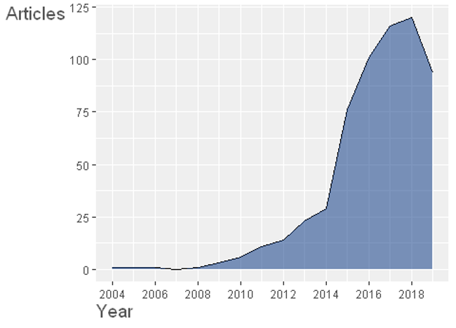

Figure 1: Annual scientific production chart of 604 articles on STEM learning and STEM education.

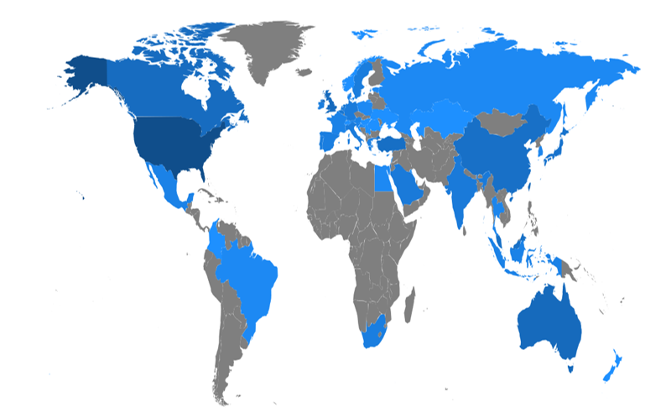

Figure 2: Country scientific production chart drawn from authors’ affiliation information.

Figure 3, a wordcloud based on Keywords-Plus of each article, illuminates Science and Math education, in particular, play a central role in STEM education to engage students with high performance in inquiry-based instructions using technology-enhanced design. A conceptual structure map made by multiple correspondence analysis of the most top-20 cited articles with five clusters further depicts this paradigm in detail (see Figure 4). While the cluster results are subject to researcher’s interpretation, I would label them respectively as follows: (1) Inquiry-based learning in higher education; (2) STEM-oriented content components; (3) Curriculum for professional development; (4) Pedagogical relationship between STEM and making (while highlighting equity issues across gender and ethnicity); and (5) Integrated instructional design focusing on collaborative project-based learning experience. Among these five topics emerged, in the following section, I will unpack the fourth and fifth clusters, the pedagogical frameworks for STEM learning, in the line of learning sciences literature.

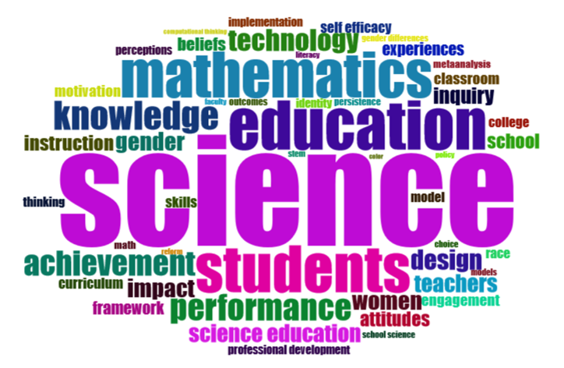

Figure 3: A wordcloud made by term frequency of the Keywords-Plus (ID) field of each article.

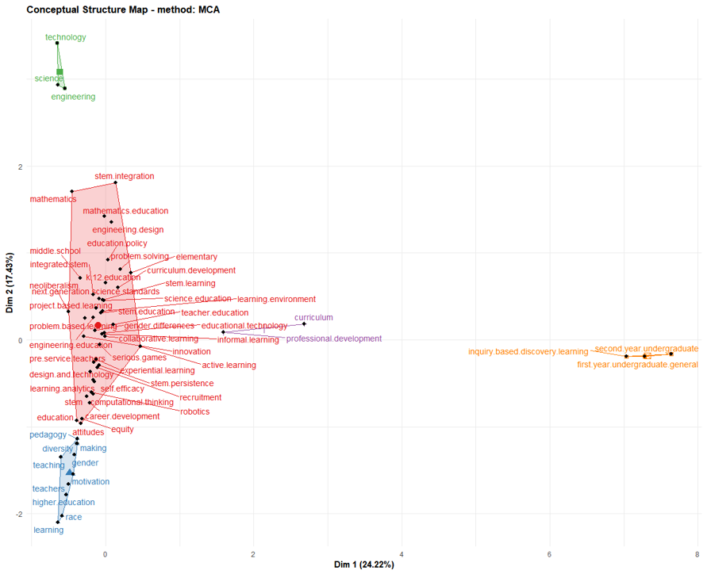

Figure 4: A conceptual structure map made by multiple correspondence analysis of the most top-20 cited articles with 5 clusters.

## Pedagogical Frameworks for STEM Education: Making and Socially Shared Cognition

A systematic review of related literature, as also illustrated through the bibliometrics results above, has yielded that there have been two strands of the pedagogical theories that framework current STEM education. The first concerns how “making” has been placed as a critical construct in STEM learning; second explains how socially “shared cognition” has been developed as an important virtue in the line of learning STEM history. I have outlined this section based on these two key concepts: Making and shared cognition.

### From experience to Critical, and to Making

Blikstein (2013) describes there have been three theoretical and pedagogical pillars for making, which in turn resonates with STEM education: (1) experiential education; (2) critical pedagogy; and (3) constructionism.

Experiential education can be traced back to Dewey (2013) that places emphasis on the power of authentic experience as a means of connecting students to what is being learned. As real-world experiences play an imperative role in meaningfully engaging individuals in learning context, facilitating vivid personal interactions with contents, objects, environments, and contexts is considered valuable assets for better learning (Dewey, 2013). Many scholars (e.g., Freudenthal, 1973; Froebel, 1885; Montessori, 1917; Von Glasersfeld, 1984) have established their following work drawing upon his pedagogy to enunciate the relationship between experience and learning (Blikstein, 2013).

While experiential education highlights the importance of individual experience as an authentic context in learning, Freire (2000) casts a critical question as to whether current (traditional) school system fosters such experiential learning or simply manufactures learners with diverse possibilities by following decontextualized “banking education.” Behind his criticism of school as an oppressing system lies his claim that learning should be saturated with culturally meaningful curriculum construction and empowered in a way that opens possibilities for students (Blikstein, 2013; Freire, 2000). This idea has an imperative influence on much of contemporary theories and frameworks including but not limited to community of practice (Wenger, 1998), growth mindset (Dweck, 2000), and culturally responsive theory (Paris, 2012; Scott, Sheridan, & Clark, 2015).

Building upon Piaget’s Constructivism (Piaget & Cook, 1952), while sharing the undergirding philosophy with the theories mentioned above, Seymour Papert, the father of making, coined the term Constructionism (Martinez & Stager, 2013; Papert & Harel, 1991). He posits that human learning, the construction of knowledge more specifically, can remarkably happen when we externalize our ideas by building and making, and when interacting with tangible objects (Kafai & Resnick, 1996; Martinez & Stager, 2013; Papert, 1993). He and his colleagues have devoted to applying this concept to learning practices such as Logo programming and Lego mindstorms, which are an externalized robotic object that students can directly test, experiment and play around their coding with (Papert, 1980; Resnick, Ocko, & others, 1990). Noticeable success of this pedagogy in terms of motivating and engaging learners into learning by making has inspired following digital fabrication tools we currently witness, such as Scratch, Raspberry Pi, Arduino, LittleBits, and so much (Bdeir, 2009; Resnick et al., 2009; Sobota, PiŜl, Balda, & Schlegel, 2013). Such Constructionism, as a core pillar of Learning by Making, has been massively employed in the STEAM (Science, Technology, Engineering, Arts, and Mathematics) (see Fortus, Krajcik, Dershimer, Marx, & Mamlok-Naaman, 2005; Halverson, 2013; Kolodner et al., 2003; Peppler, 2010; Peppler & Kafai, 2007).

### Sociocultural Perspective towards Collaborative Shared Cognition

While the three pedagogical pillars discussed above concern how we now get to understand the value of making in STEM learning context, sociocultural perspective is also recognized as its fundamental contribution to shared cognition in STEM education where collaboration plays a central role.

Sociocultural perspective, although it takes a wide range of forms of variations, is originally based on Vygotsky’s social constructivism (Vygotsky, 1980). He differentiated his theories from Piaget’s cognitive constructivism by highlighting social and cultural impact on human learning going beyond biological, physiological, and cognitive development within individual level (see Piaget & Cook, 1952; Vygotsky, 1980). In other words, Vygotsky claims how a person is situated within a society and culture inevitably leads to his/her learning including knowledge and experience as we cannot bracket the individual out of sociocultural value he/she is standing. The Zone of Proximal Development (ZPD) illustrates well such idea about how imperative social interaction with other peers and experts would be in broadening a learning scope of individuals (Chaiklin, 2003). This social interaction is important in most STEM disciplines in which students develop their working knowledge by directly and indirectly engaging with their peers and experts through collaborative problem-solving practices (Bell & Lederman, 2003; Capraro et al., 2013; Kaufman et al., 2003; Labov et al., 2010; Tsui, 2007; Zollman, 2012).

Subscribing to his emphasis on sociocultural facet of learning, much of learning science research has evolved towards shared learning by meaningfully connecting individuals and deeply considering the impact of social and cultural factors in learning. The most well-known early scholarly work was done by Brown, Collins, & Duguid (1989). Brown and colleagues, in their article, introduced the term “Situated Learning” that mirrors Vygotsky’s sociocultural perspective in learning context. They claim traditional didactic education separates between “knowing” and “doing” ignoring integral learning cognition of activity and situation. As solutions, knowledge through activity, learning through cognitive apprenticeship, and cognitive apprenticeship and collaborative learning are suggested throughout the piece to situate authentic cognition between “know what” and “know how” (Brown et al., 1989). The apprenticeship-based learning is congruent with the experiential learning and constructionism in the sense that they all support learning by doing which is the undergirding principle of Learning by Making; that is, the crux of STEM education.

In 1991, Lave and Wenger published historical paper concerning participation in learning that offered the early model of communities of practice (see Lave & Wenger, 1991). In the paper, “Legitimate Peripheral Participation” (LPP) is discussed that can be best described from the following lines:

A person’s intentions to learn are engaged and the meaning of learning is configured through the process of becoming a full participant in a sociocultural practice. (Lave & Wenger, 1991, p. 29)

Seven years later, Wenger brought scholarly attention again into the confluence of communities and participation in learning through his another influential study (see Wenger, 1998). The term “Communities of Practice” (CoP) has been widely popularized and recognized in both formal and informal learning settings since this publication. Extending the early work discussed in the LPP article (Lave & Wenger, 1991), he discussed how a community, as a collaborative learning environment around a shared domain of interest, fosters an identity of a learner as a member of the community (Wenger, 1998).

Their work has an important meaning in STEM-oriented learning environments in which a community (e.g., labs, classes, and teams) continuously witnesses the occurrence of learning when legitimate peripheral participants (newcomers) move towards becoming full participants with a shared identity of the community to which he/she belongs (Halverson & Sheridan, 2014; Lave & Wenger, 1991). Furthermore, this resonates with the current STEM education which by nature seeks “knowledge building community” (Scardamalia & Bereiter, 2006) where “transforming school classes to inquiry communities” is focused (Hakkarainen, Paavola, Kangas, & Seitamaa-Hakkarainen, 2013, p. 59). In a knowledge building community, shared ideas (i.e., conceptual artifacts) as well as physical objects actively emerge (Hakkarainen et al., 2013). When it comes to meaning negotiation within a community, the “Activity Theory” (Cole, 1998; Engeström, Miettinen, & Punamäki, 1999) should also offer us a great insight in the sense that our learning itself can be seen as mediated activities by artifacts, which turns back to the idea that learning is “object-oriented” within “knowledge creation activities” where collaboration takes place around them (Hakkarainen et al., 2013, p. 59).

All things considered, behind the learning by doing (and making) STEM paradigm within a collaborative inquiry-based instructions lie the two historical strands of pedagogical discourses: (1) theories as to Learning by Making from the Dewey’s experiential education to Freire’s critical pedagogy, and to Papert’s Constructionism. (2) Sociocultural perspective towards shared cognition beyond an individual from Vygotsky’s social constructivism to Brown and colleagues’ situated learning, to Lave and Wenger’s situated cognition (i.e., Legitimate Peripheral Participation), and to Wenger’s Communities of Practice.

## Three Issues in Current STEM Education: Equity; Inclusivity; and Accessibility

Despite the growing importance of “STEM literacy” (Zollman, 2012) and its promising values for learning (Hwang & Taylor, 2016), occupational (Breiner et al., 2012), and economic (Basham & Marino, 2013; Bell, 2016; Kaku, 2012) benefits, there have been three primary critiques that call for scholarly and practical attention: (1) Equity issue of gendered disparity; (2) Inclusivity issue of ethnic/racial diversity; and (3) Accessibility issue of discriminating dis/abilities. In the following sections, each of these three issues will be covered briefly.

### Equity Issue of Gendered Disparity

Several scholars have investigated the relationship between STEM disciplines and gender as a predicting factor to see how much gendered equity issue exists in our learning systems. A recent study conducted by Ganley, George, Cimpian, & Makowski (2018), for example, highlights underrepresented women population in postsecondary STEM majors. Based upon both the Education Longitudinal Study of 2002 and newly gathered data on students’ perceptions of college major traits, they reported “perceived gender bias against women” plays a critical role in predicting the gender balance in college majors with “the perception of the major” (e.g., math- or science-oriented) being less important (Ganley et al., 2018). This suggests that the society, at macro-system level (Basham et al., 2010; Bronfenbrenner, 1977, 1994), should recognize the tacit perceptions of gender discrimination against college major choices.

Simlar findings were discovered in STEM faculty ecology. Xu (2008) pointed out that women had a significantly higher likelihood to change positions within academic careers in STEM although the two genders seemed to be equally devoted to their jobs. An academic culture such as research support, advancement opportunities, and free expression of ideas had put barriers providing women fewer opportunities, which in turn led to dissatisfaction with their work (Xu, 2008). Furthermore, as cited in Torres (2012), 16 percent of women were reported to had resigned after three years, which was 4 percent for men.

There are a few studies, however, which have explored the interplay between maker toolkits used in STEM-oriented classes and gender participation. According to Buechley, Eisenberg, Catchen, & Crockett (2008), e-textiles, such as the Lilypad Arduino, could engage girls with hands-on coding and engineering activities that typically had held them back from central participation due to male-friendly designs. In a similar vein, but from deeper historical and cultural perspectives, Buchholz, Shively, Peppler, & Wohlwend (2014) also found that such e-textiles improved girls’ empowered access to maker learning by overcoming pre-assumptions separating gendered interests and skills. Together, current STEM environments, ranging from curricula, to career paths, and to electronic toolkits, have been primarily designed with males in mind while a small step towards equitable gendered access could make a big difference.

### Inclusivity Issue of Ethnic/Racial Diversity

On the other hand, many learning scientists have also underscored the importance of cultural aspects and its educational impact on students’ identity behind instructions, tools, and designs. For instance, Nasir, Rosebery, Warren, & Lee (2014) have posited our learning involves cultural assumptions; thus, using cultural diversity as an educational and research design asset is imperative to foster more inclusive learning environments for all backgrounds. Following this stance, some have attempted to bring culturally-responsive approaches into teaching computing and making settings (Scott et al., 2015); others have further centered on the cultural facets nested within our content creation tools used in STEM classes (Lachney, Babbitt, & Eglash, 2016; Richard & Kafai, 2016).

Similarly, researchers have found that e-textiles, as mentioned above, can be also utilized to interweave cultural practices with computational skills (Kafai, Searle, Martinez, & Brayboy, 2014), and this has led to the recently advancing studies such as the bidirectional media design activities tailored for culturally and ethnically diverse youth using seamless integration between a plug-and-play physical electronics (e.g., Lilypad; the MaKeyMaKey( and digital block-based coding environments (e.g., Scratch) (Richard & Giri, 2017; Richard & Kafai, 2015a, 2015b). Richard and colleagues, through their research, have highlighted that using multiple combination of various toolkits with different material affordances fostered for more inclusive collaboration across not only genders, but also diverse cultural background, which was also found effective for a collegiate hardware and software hackathon (Richard et al., 2015).

Overall, we can understand that current lerning design as well as content creation tools in STEM education are not value-free in terms of cultural pre-assumption; thus, multi-dimentional approaches, while not prefixing in favor of a certain dominant group, would serve to create new STEM culture welcoming diversity.

### Accessibility Issue of Discriminating Dis/Abilities

Despite this comprehensive need for STEM literacy, students with disabilities, who have been increasingly participating in regular classrooms with the legislative support for equal access to general education (Rao et al., 2014; Roberts et al., 2011), experience significant difficulties in STEM (Israel et al., 2013). Students with disabilities continuously perform below their peers without disabilities on standardized measures in STEM subjects (Basham & Marino, 2013; Hwang & Taylor, 2016; Israel et al., 2013), and often fall behind in STEM content since middle school (Israel et al., 2013; Marino, 2010). This disengagement has led to rare presence of those with disabilities in STEM workforce as only about 5 percent of students with disabilities enter the STEM careers (Leddy, 2010). However, a few studies have pointed out the struggles come primarily from the dearth of accessible teaching materials, inclusive curricula, and experiences of instructors teaching student with disabilities; rather than students’ disabilities themselves (Basham & Marino, 2013; Martin et al., 2011; Thurston et al., 2017). Martin et al. (2011) argue, “In order to be afforded equal opportunity, especially in STEM fields, people with disabilities must be able to work their way through multiple barriers” (p. 295). This implies that more inclusive STEM materials and scaffolding learning designs are imperative for students with disabilities to fully engage with STEM content before leaving them taking all responsibilities for the STEM frustration (Basham & Marino, 2013; Samsonov et al., 2006; Thurston et al., 2017).

#### Challenges of Blind Learners in STEM Education

While each individual with disabilities still lacks accessible STEM curricula, blind students, in particular, experience extra challenges and have become even more disenfranchised with STEM subjects (Beck-Winchatz & Riccobono, 2008; Cryer, 2013; Edwards et al., 2006; Gardner, 2002; Jones et al., 2006; Supalo et al., 2006). According to American Printing House for the Blind (2017), there are approximately 63,657 U.S. children, youth, and adult students in educational settings (between the age of 0 and 21) who are legally blind (i.e., those with central visual acuity of 20/200 or less in the better eye with the best possible correction, or visual field of 20 degrees or less). Globally, there are approximately 1.3 billion people with some varying degree of visual impairments, and 36 million of whom are blind (i.e., visual acuity worse than 3/60, World Health Organization, 2018). These people have faced consistantly the following issues when engaged with STEM content. First, material accessibility issue. As STEM materials and curricula are designed in the ways of heavily relying on visual model, those who cannot employ visual sense for their learning encounter rudimentary barriers in accessing such information unlike sighted counterparts (Beck-Winchatz & Riccobono, 2008; Cryer, 2013). Second, instructional inclusivity issue. Teachers and instructors in general education system are often unfamiliar with non-visual teaching methods for STEM content, which keeps unintentionally marginalizing their blind students in classes (Beck-Winchatz & Riccobono, 2008; Fraser & Maguvhe, 2008; Gardner, 2002). Third, networking issue. As blind students have increasingly become integrated into regular classrooms with the support of legislation advocating for equal access for all (e.g., Individuals with Disabilities Educational Act, 1997, 2004; Americans with Disabilities Act, 1990; Sections 504 (1973) and 508 (1998) of the Rehabilitation Act), they are frequently the only non-visual learner in classes. In other words, they lack natural opportunities to meet blind peers or adults who can possibly serve as role models to inspire them to develop confidence in STEM subjects (Beck-Winchatz & Riccobono, 2008). Finally, low social and self- expectation issue. Teachers, parents, and blind students themselves do not hold high expectation towards success in STEM areas as being blind (Beck-Winchatz & Riccobono, 2008; Martin et al., 2011).

Some scholars also have highlighted the current accessibility of maker toolkits which have been widely popularized for entry electronic and coding concepts. For example, Seo & Richard (2018) have conducted an exploratory study tailored for high school students with visual impairments and young adult (aged between 14 through 20) utilizing a wooden block-based physical robot platform called Kibo. They found, while a small modification (e.g., attaching Braille labels; using audible output modules) could improve not only blind individuals’ interest in computer programming, but also group cognition and their computational thinking, current maker toolkits are designed wihtout accessibility in mind (Seo & Richard, 2018).

Similarly, less tangible bread board design in electronic kits (e.g., Arduino; Raspberry PI), inaccessible maker toolkits instruction documents for assistive technology, and a lack of multi-sensory modules have been pointed out as three critical challenges of engaging blind individuals into a tinkering culture which is the virtue of STEM-focused disciplines (Seo, 2018, 2019). Taken together, it can be assumed that blind people have especially been excluded in STEM learning cultures which inevitably require visual sense.

## Overview of Computer-Assisted Text Analysis

This section will explain about some methodological backgrounds that this study will rest upon by focusing on computer-assisted text analysis.

Over the years, content analysis has been widely used in various social science disciplines to examine patterns within communication artifacts in a systematic and replicable fashion. As opposed to traditional methods of qualitative research, which have been often criticized by postpositivists for its vague reliability and validity, content analysts have attempted to actively address such issues using the following techniques (Nelson, 2017): (1) Developing a coding scheme (i.e., codebook) based upon researchers’ expertise and established theories through iterative phases that can be used as a reasonable basis to categorize given data for internal validity. (2) Coding consistently according to the developed code reference throughout each of researchers’ analytical processes for within-researcher reliability. (3) Testing inter-rater reliability coefficients (e.g., Cohen’s ; Krippendorff’s ) to ensure statistically valid agreements between different coders on assigned labels (i.e., codes) across each segmented unit of analysis for between-researcher reliability (Cohen, 1960, 1968; Conger, 1980; Fleiss, 1971; Fleiss, Cohen, & Everitt, 1969; Krippendorff, 2018; Light, 1971). (4) Detailing each step of data processing and analytical strategies transparently to make sure other researchers can reproduce the full analysis for external validity.

Despite its ideal methodological rigor, on the other hand, there exist certain problems with the use of conventional hand-coding content analysis (Nelson, 2017). First, generating coding categories is limited to researchers’ pre-assumed knowledge, which may or may not capture hidden patterns out of target complex communication texts. Thus, to what extent a subjectively-developed coding scheme can explain underlying patterns within data (internal validity) can remain in the researchers’ black box. Second, either within- or between-researcher reliability, or both can be unstable. For a human rater, Consistently coding the same text in the same way several times is very difficult due to fatigue, emotion, and other environmental factors. Furthermore, it is even more challenging for different individuals to steadily agree on coding processes over a long transcript. Third, study replicability (i.e., external validity) is not realistically secured. Repeatedly-trained coding results, in favor of a person holding more powerful authority, until team members reach a certain level of reliability coenfficient make it often difficult for other researchers to reproduce the same analysis. Finally, due to the time-consuming nature of hand-coding procedures, the traditional content analysis cannot deal with large corpora of texts exceeding human-manageable amount, which unintentionally leaves out other available data holding value of discovery.

Computer-assisted text analysis has emerged to address these issues with the growing advances in computing power and natural language processing (NLP) algorithms. While there have been some scholarly debates revolving around what specific combination of methods and algorithms can offer social scientists the best meaningful patterns from text data (Bail, 2014; Biernacki, 2012, 2015; DiMaggio, Nag, & Blei, 2013; Lee & Martin, 2015; Nelson, 2017; Reed, 2015), it is commonly agreed that using computer-assisted content analysis can be more efficient than hand-coding analysis alone in terms of the capability to process any size of data in more consistent, scalable, and less timelier ways (Grimmer & King, 2011; Hillard, Purpura, & Wilkerson, 2008; Lowe & Benoit, 2013; Reich, Tingley, Leder-Luis, Roberts, & Stewart, 2015). Moreover, as cited in Reich et al. (2015), some experimental studies have provided scientific evidence to computer-automated text clusters can be “more semantically coherent than even a taxonomy created by the documents’ authors” (p. 158) (Grimmer & King, 2011; Grimmer & Stewart, 2013), which has increasingly attracted many social scientists’ interests in applying computational text analysis to their disciplines including political science (Grimmer, 2010; King, Pan, & Roberts, 2013; Schwartz & Ungar, 2015), sociology (Bohr & Dunlap, 2018; Chakrabarti & Frye, 2017; Nelson, 2017; Nelson et al., 2018), psychology (Tausczik & Pennebaker, 2010; Yu & Ho, 2014), and education (Anaya & Boticario, 2011; Reich et al., 2015).

Computer-assisted text analysis is typically carried out using machine learning, which is defined as “a general field in computer science that seeks to develop ways for computers to learn without being explicitly programmed” (Nelson, 2017, p. 8), and it can take either of two forms: supervised text classification or unsupervised text clustering. In what follows, I will briefly introduce the two different types of computer-assisted text analysis.

### Deductive Text Classification Using Supervised Machine Learning

The first flavor of computer-assisted text analysis is using supervised machine learning algorithms to classify text into predefined categories. Just as in conventional content analysis of text done by hand, researchers need to manually prepare for some complete dataset (i.e., training data) that contains pairs of text as inputs and their each corresponding codes (i.e., labels) as outputs. Based on the training data created by humans as a supervisor, computational analysis is carried out to elicit parameters for classifying the rest of the data to predict how humans would have labelled them (Reich et al., 2015). In summary, supervised machine learning is utilized when categorizing texts into existing coding schemes deductively to overcome some limitations of hand-coding conventions as pointed out above.

However, supervised machine learning comes at cost of a non-trivial number of efforts including manually-coded train, validation, and test datasets, which encourages researchers to look into more automated methods (Nelson et al., 2018).

### Inductive Text Clustering Using Unsupervised Machine Learning

The second form of computer-assisted text analysis is using unsupervised machine learning algorithms to automatically and inductively cluster text into computationally-derived themes without any predetermined labels (Nelson, 2017; Reich et al., 2015). Unlike either hand-coding or supervised content analysis, this type of methods does not require user input besides raw data along with the number of desired output clusters (denoted with K), “from which parameters of interest are derived” (Reich et al., 2015, p. 159). Drawing upon syntactic features in a corpus (e.g., word co-occurrence), computers first identify patterns within and across texts, which are then further examined by humans for its substantial meaning in the line of text content and structure (Reich et al., 2015), and it often proves “to have semantically meaningful correlates” (Reich et al., 2015, p. 159).

One of the well-established unsupervised methods is probabilistic topic modelling (Blei, 2012). Based on the co-occurrence of words in the document corpus and repeated sampling methods, probabilistic topic models “simultaneously estimate topics and assign topic weights to each document” (Nelson et al., 2018, p. 21). To put it another way, probabilistic topic models treats each document as a mixture of topics (denoted with either or probability), and each topic as a mixture of words (denoted with probability) (see Blei, 2012; Grimmer, 2010; Grimmer & King, 2011; Roberts et al., 2013). Using these calculated and featured topical proportion, therefore, researchers can estimate general semantic themes within a corpus of documents (Blei, 2012; Reich et al., 2015). The following description by Reich et al. (2015) further explains how topic modelling can support human reading of large corpora of texts:

Topic models use the patterns of word co-occurrences to infer semantic relationships. Loosely speaking, if two words frequently co-occur across many of the documents, we infer that they reference a similar concept or theme. The topics themselves are distributions over words. For example, consider an assignment where students write a paragraph about what they do in a typical day. One topic might be about learning, and give high probability to words such as “learning,” “homework,” “class,” but low probability to words such as “cooking” or “eating.” Each document exhibits a mixture over the topics, which encode the proportion of words within the document that the software estimates to have come from each topic. The semantic themes uncovered by the model provide a useful structure for summarizing large sets of documents. These methods complement human reading by organizing the unstructured corpus. Topic models have been widely applied throughout the social sciences and digital humanities (see Blei, 2012, and references therein). (p. 159)

The following description is also instrumental for those who new to topic modelling:

Briefly, the intuition behind topic modeling is that each document in a corpus is produced or “structured” from a set number of topics. Topic modeling algorithms analyze the co-occurrence of words within a document over a large number of documents to, in effect, reverse engineer these topics from the larger corpus. More practically, topic modeling algorithms . . . . serve to reduce a complicated corpus to simpler, interpretable, groups of words. The output of a topic modeling algorithm is lists of weighted words, where each list is a topic and where higher weighted words in a list are more indicative of that topic, and it represents each document as a distribution over topics, which can be used to detect thematic patterns across documents. (Nelson, 2017, pp. 14–15)

There exist many algorithms available for topic modelling including, but not limited to, the Latent Dirichlet Allocation (LDA; Blei, Ng, & Jordan, 2003), the most basic topic model method; the Correlated Topic Model (CTM; Blei & Lafferty, 2007), the hierarchical model of document collections based on LDA; and the Structural Topic Model (STM; Roberts et al., 2013), the similar algorithm to CTM but having an added capability to estimate a topic model with document-level metadata as covariates. For this dissertation, I will employ the STM algorithm, in particular, which will be described in the following section for its benefits.

### Abductive Text Interpretation Using Structural Topic Modelling

Although unsupervised topic modelling can alleviate laborious work of either hand-coding or supervised machine learning content analysis, it cannot be perfect alone without humans’ explicit and iterative interpretation (Nelson, 2017; Nelson et al., 2018; Roberts et al., 2013). In other words, automated results calculated by any computer algorithms is subject to a human’s critical scrutiny, and the abductive interaction between computer algorithms and human interpretation is required for meaningful discovery out of a large corpus of texts.

Unlike other topic models, the STM algorithm provides social scientists, who deal with complex sociocultural phenomena, with some advanced features supporting for human-centered meaning discovery going beyond being passive to automated results. One of the distinctive capabilities is that researchers can consider the effects of covariates (e.g., information about the author or document; year; gender) on their estimated topic models (i.e., themes) by incorporating document-level metadata into their model just as in formulating a linear regression model (Reich et al., 2015). Hence, researchers can “leverage this existing information [the covariates] and facilitate accurate inferences for how the observed variables relate to the latent topics” (Reich et al., 2015, p. 161).

The STM algorithm has been developed in and for open-source statistical R language (R Core Team, 2019; Roberts, Stewart, & Tingley, 2019), and the package developers describe its four key affordances as follows (Reich et al., 2015, p. 161):

1. Estimated topics, including a small set of label words most indicative of that topic and archetypal documents from each topic.
2. Relationships between covariates and topics.
3. The prevalence of each topic throughout the corpus along with documents most heavily focused on each topic.
4. Correlation patterns between topics (i.e., which topics are most likely to occur together within a document).

Since the package provides users with a wide range of features such as text pre-processor, data transformation, estimation for the likelihood of a held-out test, visualization and evaluation of each exploratory procedure fitting topic models (see Figure 5 for its detailed workflow; Roberts et al., 2019), researchers can preserve “the superior abilities [of humanistic insights] to interpret text holistically” while benefitting from “the formal rigor, reliability, and reproducibility of computer-assisted methods” (Nelson, 2017, p. 6). With its versatile applicability for large unstructured textual data, in fact, recently there have been a growing body of research in social science disciplines using the STM algorithm (see Tvinnereim, Fløttum, Gjerstad, Johannesson, & Nordø, 2017; Bohr & Dunlap, 2018; Chakrabarti & Frye, 2017; Grajzl, 2019; Mishler, 2015; Nelson et al., 2018; Reich et al., 2015; Roberts et al., 2013). Given the study purpose that aims at uncovering informal STEM learning cultures of blind people and its data involving large corpora of texts which cannot be read by humans in a reasonable timeframe (see Chapter 1.3), I will employ the STM package (Roberts et al., 2019) throughout this dissertation study to abductively explore both “topical prevalence” (how often a topic is discussed) and “topical content” (the words used in discussing a topic) (Reich et al., 2015; Roberts et al., 2013).

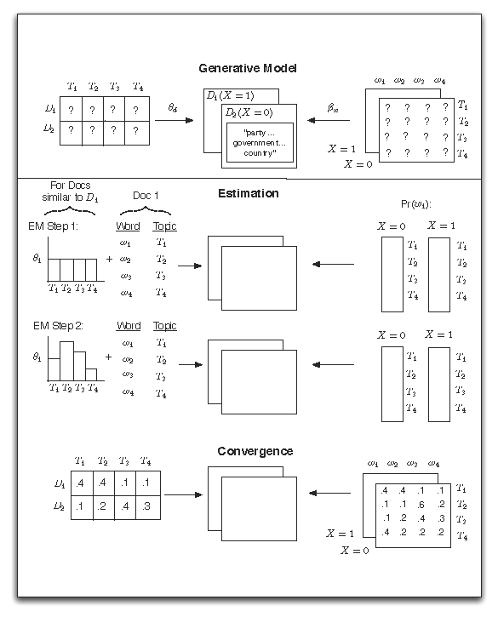

Figure 5: Heuristic description of generative process and estimation of the STM (adapted from Roberts, Stewart, Tingley, & others, 2014, p. 4).

# Methods

## Research Design

The overall design of this mixed methods research will subscribe to the concept of “quantitative ethnography” defined as using both computer-assisted algorithms and human insights to explore a meaningful discovery out of a large amount of data (Shaffer, 2017). Quantitative ethnography is one of the recently developed mixed methods in which exploratory data science techniques (e.g., descriptive analysis; clustering analysis; social network analysis; relational analysis) to a large-scale (or more, big data sized) corpora of texts are employed to help researchers uncover meaningful patterns of the target data in the least intrusive fashion which would otherwise be infeasible to analyze with conventional qualitative approaches (Shaffer, 2017). In other words, typical quantitative ethnography study involves descriptive and syntactical pattern discovery assisted by computer algorithms first, then followed by researcher’s deep interpretation of the detected patterns to relate it to semantical explanation, and this mixed-method interaction between data-driven computation and context-driven interpretation iteratively contributes to one another until a comprehensive understanding of the data is saturated (Nelson, 2017; Shaffer, 2017).

From a more analytical viewpoint, this methodology also aligns with what Feldman & Dagan (1995) refer to as “Knowledge Discovery in Textual Databases” (hereafter, KDT) which involves “the process of extracting meaningful, non-trivial patterns or knowledge from a set of unstructured texts” (Hung, 2012, p. 4).

As an extension of “Knowledge Discovery in Databases” (KDD; also known as Data Mining, U. M. Fayyad et al., 1996), text data mining (i.e., KDT; Feldman & Dagan, 1995) is typically conducted in the following five procedures: (1) data extraction; (2) data cleaning; (3) data transformation; (4) text mining; and (5) results evaluation and interpretation. The first three phases involve data preprocessing; the latter (4 and 5) requires human-centered analysis and evaluation of text mining algorithms, which leads to an iterative cycle until a meaningful discovery is sufficiently saturated (U. Fayyad et al., 1996; Feldman & Dagan, 1995; Hung, 2012). The subsequent sections will delineate the prospective data analysis by following the five-step KDT model, combined with the three-step “Computational Grounded Theory” (Nelson, 2017) in particular for the text mining phase that will be detailed later in Chapter 3.3.3 (see Figure 6).

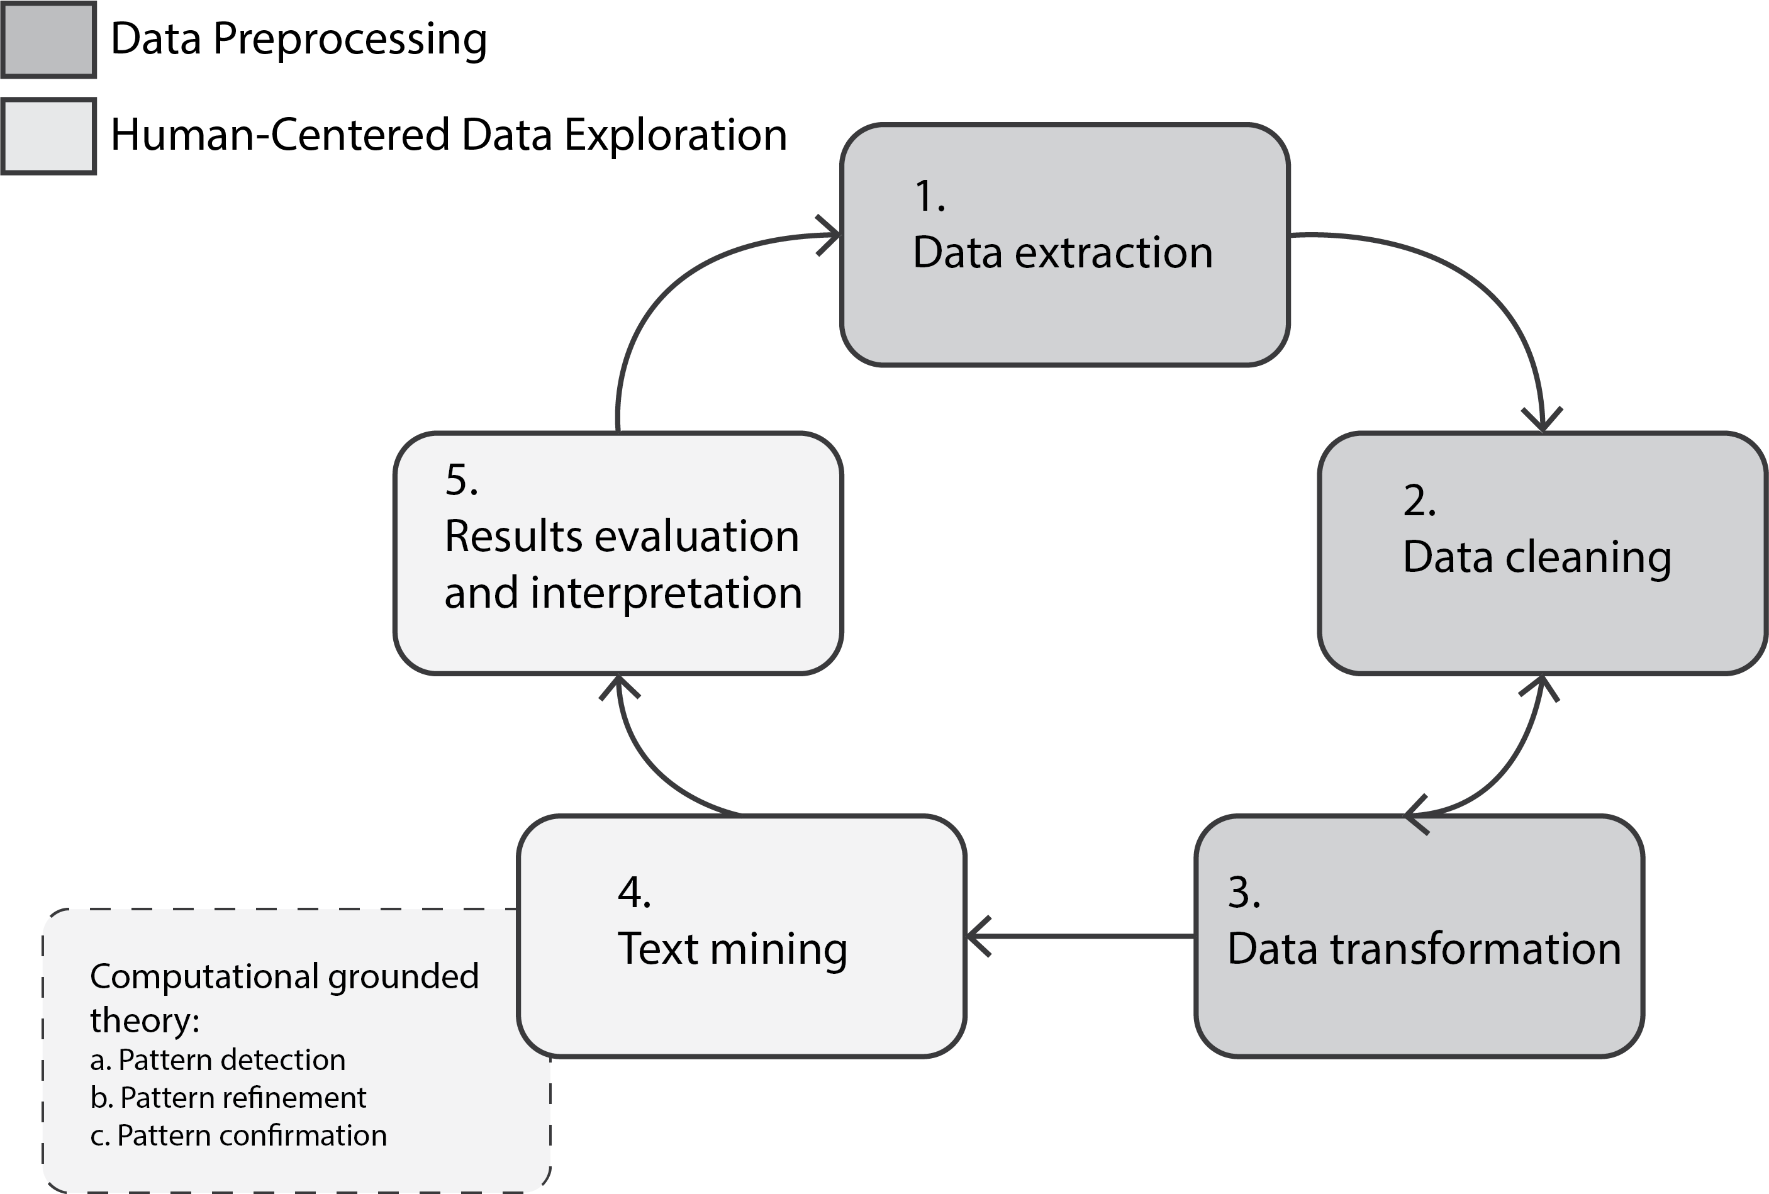

Figure 6: An analytical procedure chart following the five phases of Knowledge Discovery in Textual Databases (Feldman & Dagan, 1995) combined with Computational Grounded Theory (Nelson, 2017).

## Data Collection

The complete (i.e., ideal) population pool of this research will be blind people who cannot (either completely or partially) employ their functional visions for learning STEM content. While There is no internationally agreed definition on blindness, this study will use The statutory definition of legally blind, “those who have a central visual acuity of 20/200 or less in the better eye with the best possible correction, or a visual field of 20 degrees or less” (as cited in American Printing House for the Blind, 2017). In order to access this population more realistically, a purposeful convenient sampling strategy will be used.

The target community of this quantitative ethnography is the National Federation of the Blind (n.d.), which is one of the world largest blind communities. Longitudinal text data that contains members’ textual communication between December 2008 and December 2018 will be obtained by the publicly downloadable mailing list archives on their website [National Federation of the Blind Mailing Lists (n.d.); <https://www.nfbnet.org/mailman/listinfo>]. Among 257 active mailing lists, the following four STEM-oriented archives will be included for this research (see Table 1 for further descriptions): (1) Science and Engineering; (2) Computer Science; (3) Artists-Making-Art; and (4) BlindMath .

All personally identifiable information (e.g., names; email addresses; email signature lines; and other sensitive or private portions) will be systematically either removed or replaced with pseudonyms for the data analyses and report procedures. No direct human interaction with the list members will be made since the aim of this research is to observe natural phenomenon of blind people pursuing STEM in the least intrusive manner to reflect their voices using the recently past archives.

As of May 21, 2019, the Office for the Research Protections of the university determined the proposed study, entitled “Exploring Knowledge Sharing and Online Interactions in the Public Mailing Lists for Blind People,” as “Not Human Research” category (see Appendix 4). This means the Institutional Review Board (IRB) review and approval are not required for data collection and analysis for this study. As a double-checking process to address any unexpected ethical issues in advance, on the other hand, I have also contacted a gatekeeper (the lawyer) of the NFB organization to inquire about the permission of conducting this study, and have been confirmed that this proposed research does not need any official document process (see Appendix 5). However, in any event where I feel the need to include a specific case of certain individuals’ characteristics or their words at any stage of this research, I will ask permissions of each individual beforehand, following the Penn State IRB informed consent process. Regardless of the openness of the mailing archives, the overall data collection and analysis will be carried out with appropriate procedures from the ethical code of research suggested by the Penn State IRB office.

Table 1:

*A summary of the target NFB mailing lists.*

|  |  |  |  |  |  |
| --- | --- | --- | --- | --- | --- |
| Categories | Mailing Lists | Topics | Number of Subscribers | Number of Messages (Dec 2008-Dec 2018) | URL |
| Science & Engineering | NFB Science and Engineering Division | To promote education solutions for the blind, share professional successes, and encourage new solutions and techniques to succeed in science and engineering as a blind person. | 259 | 1,920 | http://nfbnet.org/mailman/listinfo/nfb-science_nfbnet.org |
| Technology | NFB in Computer Science | The Discussion of the business and operation of the NFB in Computer Science. To share information about the worlds of computer science and technology. | 302 | 12,428 | http://nfbnet.org/mailman/listinfo/nfbcs_nfbnet.org |
| Arts | Artists-Making-Art | explore art with all senses. | 83 | 378 | http://nfbnet.org/mailman/listinfo/artists-making-art_nfbnet.org |
| Math | BlindMath | Sources for accessible texts, information about tactile and auditory graphing programs, suggestions for insuring that math lectures are accessible to blind students, and strategies used by blind math instructors. | 655 | 8,814 | http://nfbnet.org/mailman/listinfo/blindmath_nfbnet.org |

*Note.* *Topics* column information has been retrieved from each corresponding list URL respectively.

## Data Analysis Procedures

As explained in Chapter 3.1, the analytical procedure of this study will be based upon the five-phase “Knowledge Discovery in Textual Databases” (KDT) model [Feldman & Dagan (1995); Figure 6]. Data management and analysis will be performed using statistical computing language R (Version 3.6.2; R Core Team, 2019) environment and required packages. All coding process employed for this research will be provided as supplemental material (see Appendix 6; Appendix 7) subscribing to the recent trend of reproducible research to demystify computer-assisted text analysis and enhance its reliability (Brown, 2013; Nelson, 2017; Nelson et al., 2018). The subsections below will outline each step of the data analysis following the KDT procedure.

### Phase I: Data Extraction

The first phase of the KDT model is preparing for data to analyze. As described in Chapter 3.2, this research will focus on the four STEM-oriented mailing list archives between December 2008 and December 2018 (see Table 1). The following criteria has been implemented for choosing these four mailing lists:

1. The list topic must be closely related to STEM (Science, Technology, Engineering, and Mathematics) subjects.
2. The list must have a sufficient history (at least 8 to 10 years) to play a role in capturing longitudinal STEM activities of blind people including their challenges and solutions.
3. The list must have sufficient number of memberships (at least more than 50).
4. The list communication must be done in English.

Although the National Federation of the Blind Mailing Lists (n.d.) allows anyone with a modern Internet browser to manually download their public mailing archives in a zipped (i.e., gzip) format, I will use Unix shell commands instead to extract the target archive files in a systematic and replicable fashion (see Appendix 6). No “robots exclusion protocol” (i.e., robots.txt) that defines the allowing level of web crawling has been found in the site root. This implies any search engine can parse each content tree available of this site (Drott, 2002), which in turn justifies using shell commands to crawl these public archives.

At the end of this initial stage, I will be able to retrieve all required target archives from the National Federation of the Blind Mailing Lists (n.d.) website and extract them as an mbox format. Mbox is a plain-text file type that holds concatenated email messages.

### Phase II and III: Data Cleaning and Transformation

The second (Data Cleaning) and third (Data Transformation) steps are carried out simultaneously until a researcher finds the transformed data good to proceed towards actual analysis. Ideal data shape through these steps would take “tidy data” structure (Wickham & others, 2014) in which rows correspond to individual obsevations (i.e., samples); columns to variables (also known as either features or attributes).

To complete this goal, I have developed an R package, called “mboxr” (Seo & Choi, 2019), which takes mbox-formatted file(s) as an input and converts it into a structured data as its output in a tidy form (also called “tibble” in R environment, Müller & Wickham, 2019). Since “mboxr” package (Seo & Choi, 2019) has been published in the peer-reviewed “Comprehensive R Archive Network” (CRAN; <https://cran.r-project.org/>), its stability has been validated by other computational Statisticians to some reliable degree. Furthermore, the package has been under active development at GitHub repository (<https://github.com/jooyoungseo/mboxr>); thus, the source code of this package is transparently available to analyze.

In light of the seamless nature between data cleaning and transformation, the following will be undertaken together at this stage:

1. Cleaning the mbox files extracted through the previous stage (Chapter 3.3.1). As some mbox files retrieved will have to be fixed for non-escaped issues for a new line starting with “From” in message body, I will address this problem by replacing “From” with “>From” following the standard email message protocols (see Appendix 7).
2. Transforming mbox files into a tibble format (the tidy data structure used in R; Wickham & others, 2014) using “mboxr” package (Seo & Choi, 2019).
3. Removing unnecessary prefix from subject fields of each archives. Since each mailing archive has unique prefix within their subject lines (e.g., NFB-CS; NFB-Science; Arts-Making; BlindMath respectively), it must be taken out to help the next text mining phase to uncover more pronounced results.

At the end of this process, the mbox files obtained in the previous section will be transformed into a large data frame with one-message-per-row structure along with 11 variables (see Table 2 for the sample dataset), and a total of 23,540 messages (1920 messages from Science & Engineering; 12428 NFB in Computer Science; 378 Artists-Making-Art; 8814 BlindMath) will be ready for analysis. Please consult with Appendix 7 to learn about how to reproduce this stage in detail.

Table 2:

*A Structured Sample of Email Texts.*

|  |  |  |  |  |  |  |  |  |  |  |  |
| --- | --- | --- | --- | --- | --- | --- | --- | --- | --- | --- | --- |
| Variable | date | weekday | message_ID | in_reply_to | references | num_discussants | from | to | cc | subject | content |
| Description | Date and time of message sent (UTC/GMT). | Day of the week for current message sent as an abbreviated three-character string. | A globally unique message identifier containing url-encoded characters. | Message-ID to which current message is replying, if any. | All appended Message-ID(s) involved in current message thread, if any. | The number of discussants for current message thread calculated by using references field. | Sender’s Name along with email address. | Recipient’s name along with email address. | Copied member(s) along with their email address(es). | Message subject. | Message content. |
| Example | 2018-02-23 12:12:47 UTC | Fri | <002501d3ac3b$095e76b0$1c1b6410$@gmail.com> | <007802c3bz3b$095e76b0$1c1b6410$@pseudo.pseu> | <007802c3bz3b$095e76b0$1c1b6410$@pseudo.pseu> <008901z4dq3p$095e76b0$1c1b6410$@pseudo.pseu> | 3 | sjysky at gmail.com (JooYoung Seo) | NA | NA | [nfbcs] Pseudo Subject | This is message. Sincerely, JooYoung |

*Note.* This demonstrates one sample message instance (i.e., the unit of analysis for this study) along with each description and example. *to* and *cc* are not retrievable from NFB mailing list archives; instead, in_reply_to and references provide alternative information respectively. from field will be systematically replaced with pseudonyms for this study to protect personal information.

### Phase IV: Text Mining

This phase is the crux of this research in which computational algorithms will be utilized to help humanistic deep reading of the structured textual data. At this stage, I will perform the following three analyses that respond to the RQ1 through 3 of the quantitative research questions (Chapter 1.4.2): First, descriptive statistics (i.e., counting and central tendency analysis) will be performed to systematically capture the frequency and variation of message exchange patterns within each listserv over time. Through this initial analysis, the research questions from 1.1 through 1.4 under descriptive question will be answered by counting the frequency of each categorical variables (i.e., message_ID; from; subject; num_discussants [as a covariate] columns) out of the 11 available features. Second, directional network analysis will be carried out to elicit the communication patterns among subscribers within each listserv. Through this analysis, the exploratory network question, RQ2.1, will be examined with message_ID variable being the from-node; in_reply_to being the to-node; and the frequency of the message exchange between the nodes being the edge weight. Last but not least, structural topic modelling (Roberts et al., 2013) – one of the natural language processing algorithms that probabilistically discovers latent structural topics within a large corpus of documents – will be employed to identify common themes within the four mailing list archives. Through this analysis, the data clustering questions, RQ3.1 through 3.6, will be addressed using content variable as a text input coupled with some document-level metadata as covariates (i.e., mailing_list_type; date; num_discussants).

While the first two analyses can be performed without researcher’s special control except for each required variable; the last one, topic modelling, needs iterative humanistic intervention (i.e., continuous interpretation). In order to systematically perform human-centered topic modelling analysis, thus, this phase, in particular, will follow the three-step methodological framework called “computational grounded theory” proposed by Nelson (2017) that by definition “combines expert human knowledge and hermeneutic skills with the processing power and pattern recognition of computers, producing a more methodologically rigorous but interpretive approach to content analysis” (p. 1). A standard workflow for the framework proceeds as follows: (1) pattern detection; (2) pattern refinement; and (3) pattern confirmation. The following details each step tailored for this study (see Appendix 8 for reproducible scripts for this text mining section).

*Note*: Any figures illustrated below are made from “Gadarian data,” one of the demo datasets (Roberts et al., 2019), for demonstration purpose.

#### Step 1: Pattern Detection

The first step involves using unsupervised machine learning techniques to inductively explore novel patterns in a large collection of texts (Nelson, 2017). To reduce complicated corpus to interpretable groups of words, probabilistic topic modelling algorithms (Chapter 2.5.2) will be utilized to cluster documents to syntactically correlated topics of words. Among various unsupervised topic modelling algorithms, the Structural Topic Model (STM; Roberts et al., 2019) will be employed for this study as detailed in Chapter 2.5.3 for its investigative benefits including the estimation capability of topic models with document-level metadata as covariates (see Figure 5; Roberts et al., 2014). Fitting a basic Structural Topic Model requires the following components from researchers:

1. Structured data frame containing both document texts and each corresponding meta data.

These can be prepared from the phase II (Data Cleaning and Transformation; Chapter 3.3.2) as a tidy data form called “tibble” just like Table 2. In the table with 11 variables, either subject or content field will be employed for document text input; the remaining attributes for metadata. While all document-level metadata should be used for covariates to probabilistically predict estimate latent topics within the corpus, I assume either date or num_discussants field would suffice. Another covariate that I would be able to explore is mailing_list_type that defines what category of STEM a document belongs to. For example, the new categorical variable, mailing_list_type, would have four levels (Science_Eng for NFB-Science; Technology for NFB-CS; Arts for Arts-Making; and Math for BlindMath respectively). More detailed examples on how to formulate hypotheses using document-level metadata will be described in the next section 3.3.3.2.

1. The number of desired topics (denoted with K) to cluster documents within a corpus.

As mentioned in Chapter 2.5.2, this parameter is used to control “the granularity of the requested summary” (Reich et al., 2015). Although the K value, in the computer science field, is commonly set “by maximizing the predictive power of the model on a heldout sample” (Mimno, Wallach, Talley, Leenders, & McCallum, 2011; Reich et al., 2015, p. 164), some research highlight such methodology may not always lead to the most useful and interpretable model (Chang, Boyd-Graber, Gerrish, Wang, & Blei, 2009). Hence, the choice of K, on substantive grounds, should be made by comparing several values to reflect the best granularity of the corpus summary (Reich et al., 2015). The STM package (Roberts et al., 2019) has a function to help researchers search the most pronounced K value by estimating and visualizing topics for different user-specified topic numbers (see Figure 7).

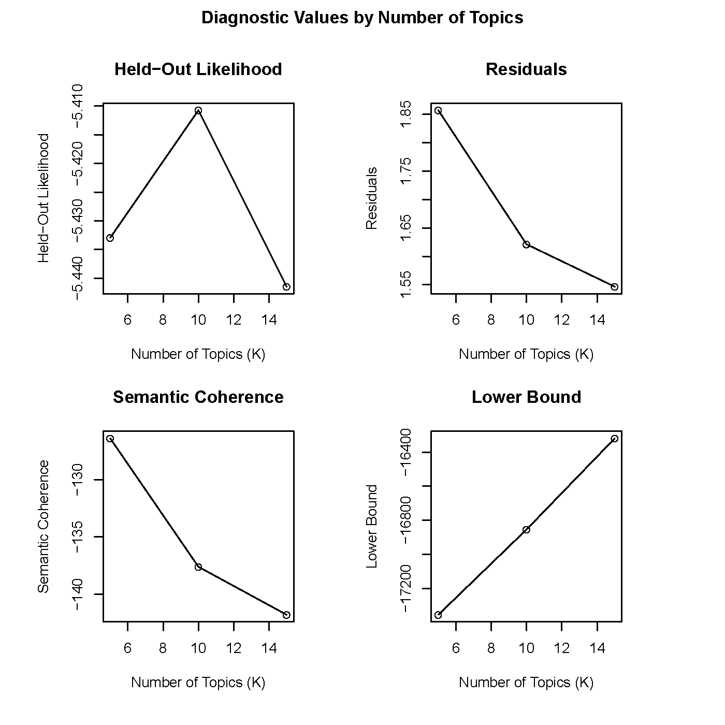

Figure 7: An example set of plots for evaluating optimal topic numbers via visual representation of stm::plot.searchK() diagnostic functions.

Taken both structured text input and the number of topics all together, a parametric (i.e., probabilistic) topic model will be defined by the STM algorithm based upon Bayesian inference and the posterior distribution (Reich et al., 2015; Roberts et al., 2019). Once a topic model is estimated, it can then be visually represented to give researchers a better sense of both topical prevalence, “the proportion of document devoted to a given topic,” and topical content, “the rate of word use within a given topic” (Roberts et al., 2013, p. 1).

Figure 8; 9; 10; and 11 illustrate an estimated topic model using the example data in four different plots respectively.

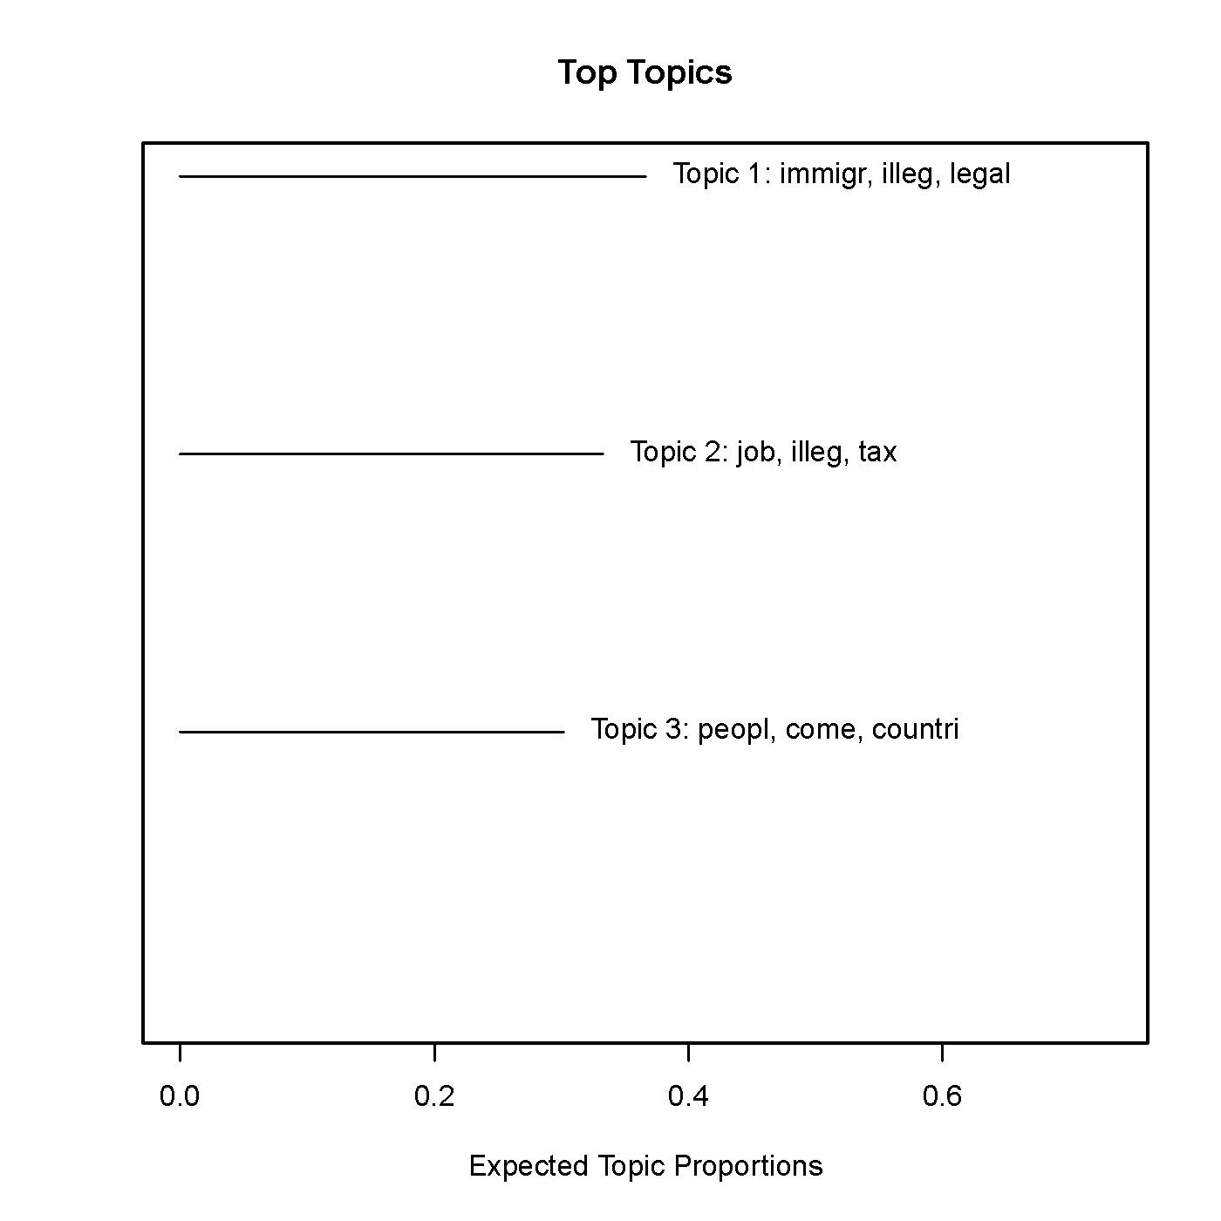

Figure 8: The first type visualization of an estimated structural Topic Model with topic words with their corpus frequency.

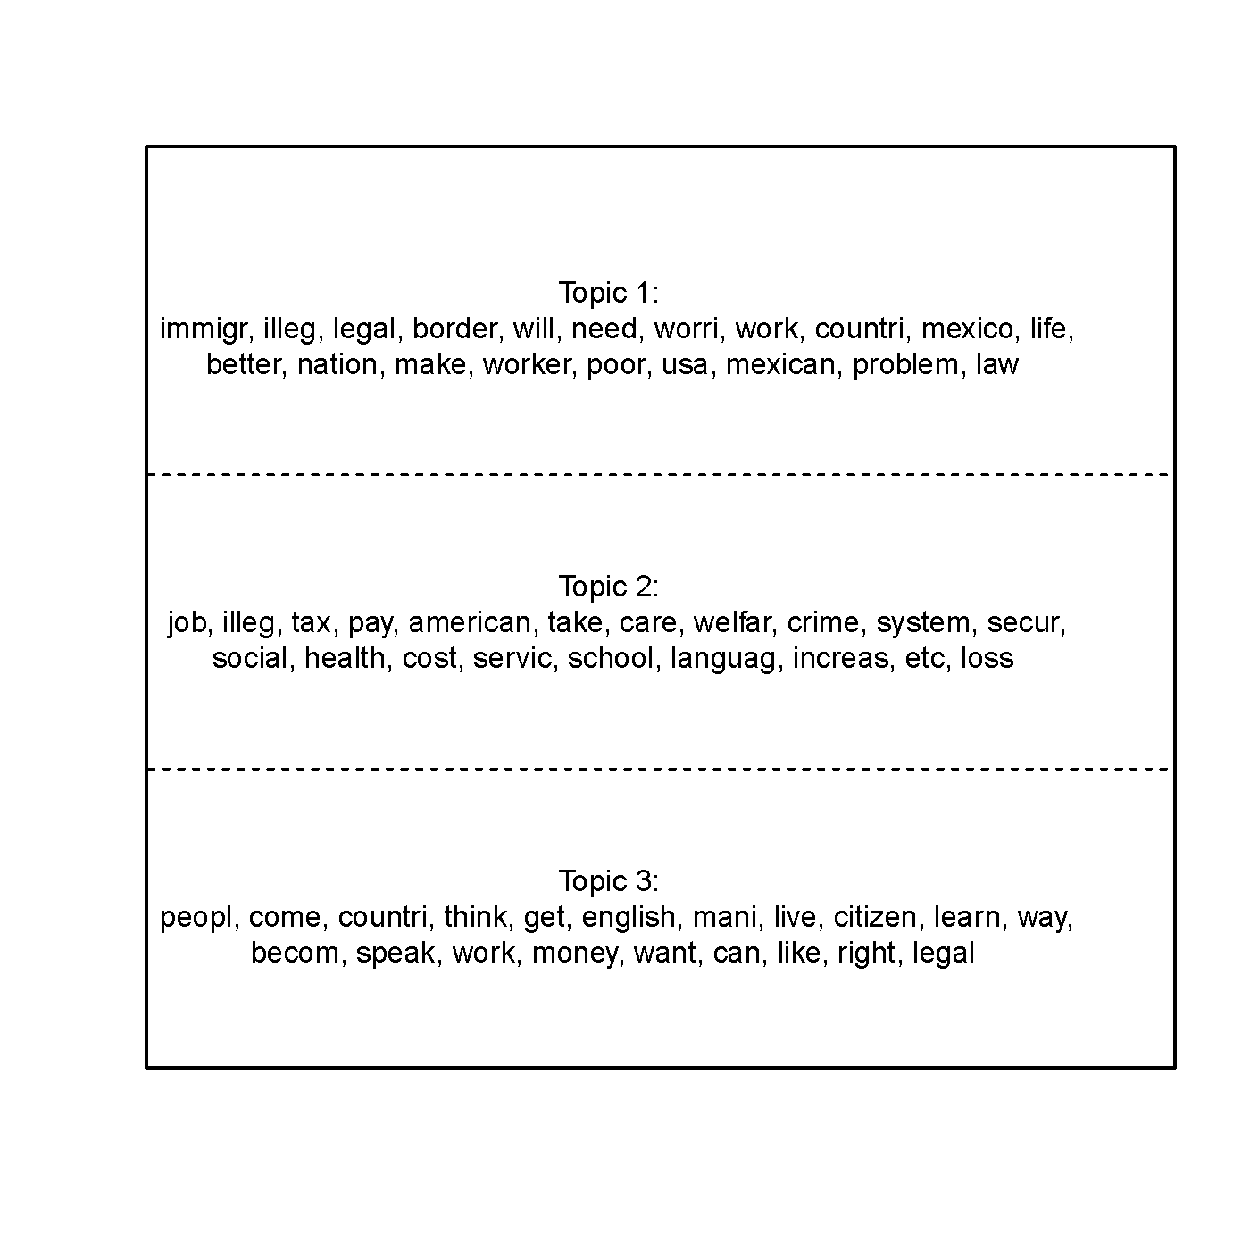

Figure 9: The second type visualization of an estimated structural Topic Model with easy printing of tables of indicative words for each topic.

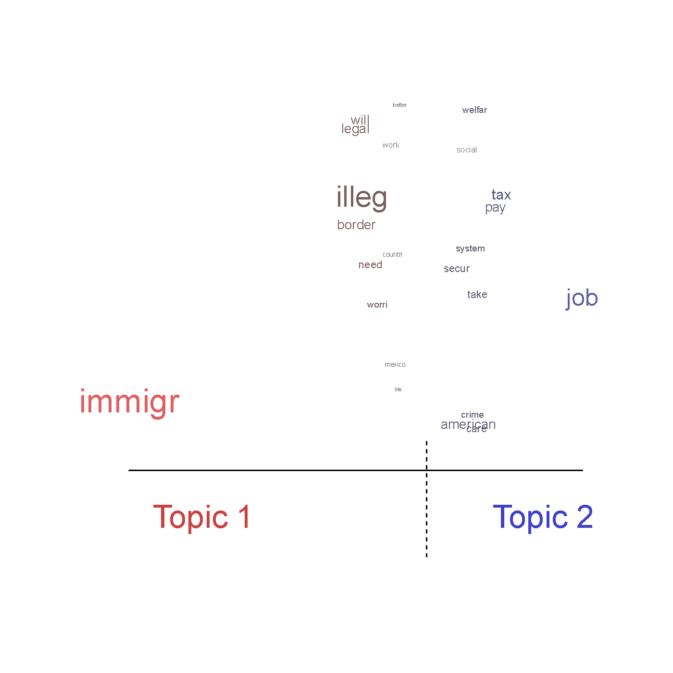

Figure 10: The third type visualization of an estimated structural Topic Model depicting differences between two topics, content covariates or combinations.

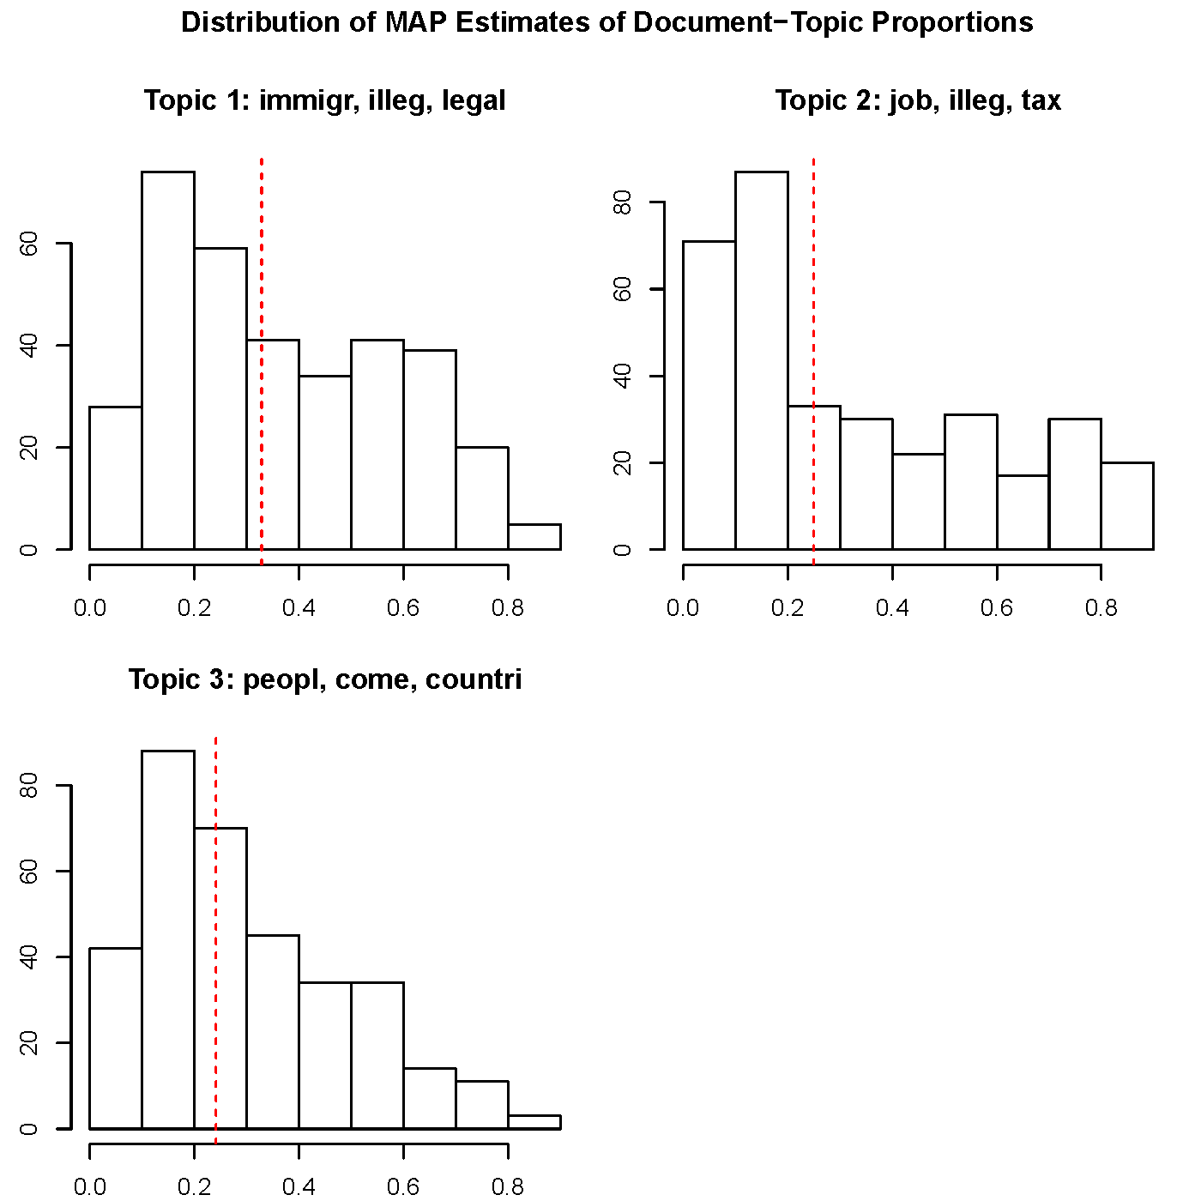

Figure 11: The fourth type visualization of an estimated structural Topic Model using a histogram of the expected distribution of topic proportions across the documents.

#### Step 2: Pattern Refinement

The second step involves “an interpretive engagement with the data through qualitative deep reading or further exploration of the data” (Nelson, 2017, p. 1). Whereas the prior step remains in syntactic pattern recognition calculated by computer algorithms; this stage more concerns semantic pattern interpretation from humanistic deep reading of the texts. However, there is continuity between the step 1 and 2.

To result in coherent relationship between such syntactic and semantic patterns, the STM package functions (e.g., stm::cloud() and stm::plot.findThoughts()), which plot most representative documents for a particular topic, will be employed to get a better sense of the content of actual documents with a high topical content (Roberts et al., 2019). Figure 12 and 13 depict how a deep exploration of a specific topic can be performed visually.

Another refinement that can be carried out at this stage is formulating some possible hypotheses. As noted in Chapter 3.3.3.1, there are some document-level metadata (e.g., date; num_discussants; and mailing_list_type field) that can be used as covariates to estimate a topic model. Once a topic model has been established to a satisfactory level with either subject or content field being text input, such metadata covariates will then “be used in the estimation of topic prevalence (how often a topic is discussed), topical content (the words used in discussing a topic), or both” (Reich et al., 2015, p. 161). Some possible hypotheses for this study would include:

* The topical distributions (detected from step 1) vary by the type of mailing lists and the number of discussants over time.
* Kinds of conversations are provoked differently by the type of mailing lists.

With such metadata covariates added, the topic model can be re-estimated to offer richer contextual information. Consequently, at the end of this step 2, a more holistic interpretation of the data will be made by incorporating both syntactical and semantical patterns and returning to a human-centered hypotheses refinement (Nelson, 2017; Reich et al., 2015).

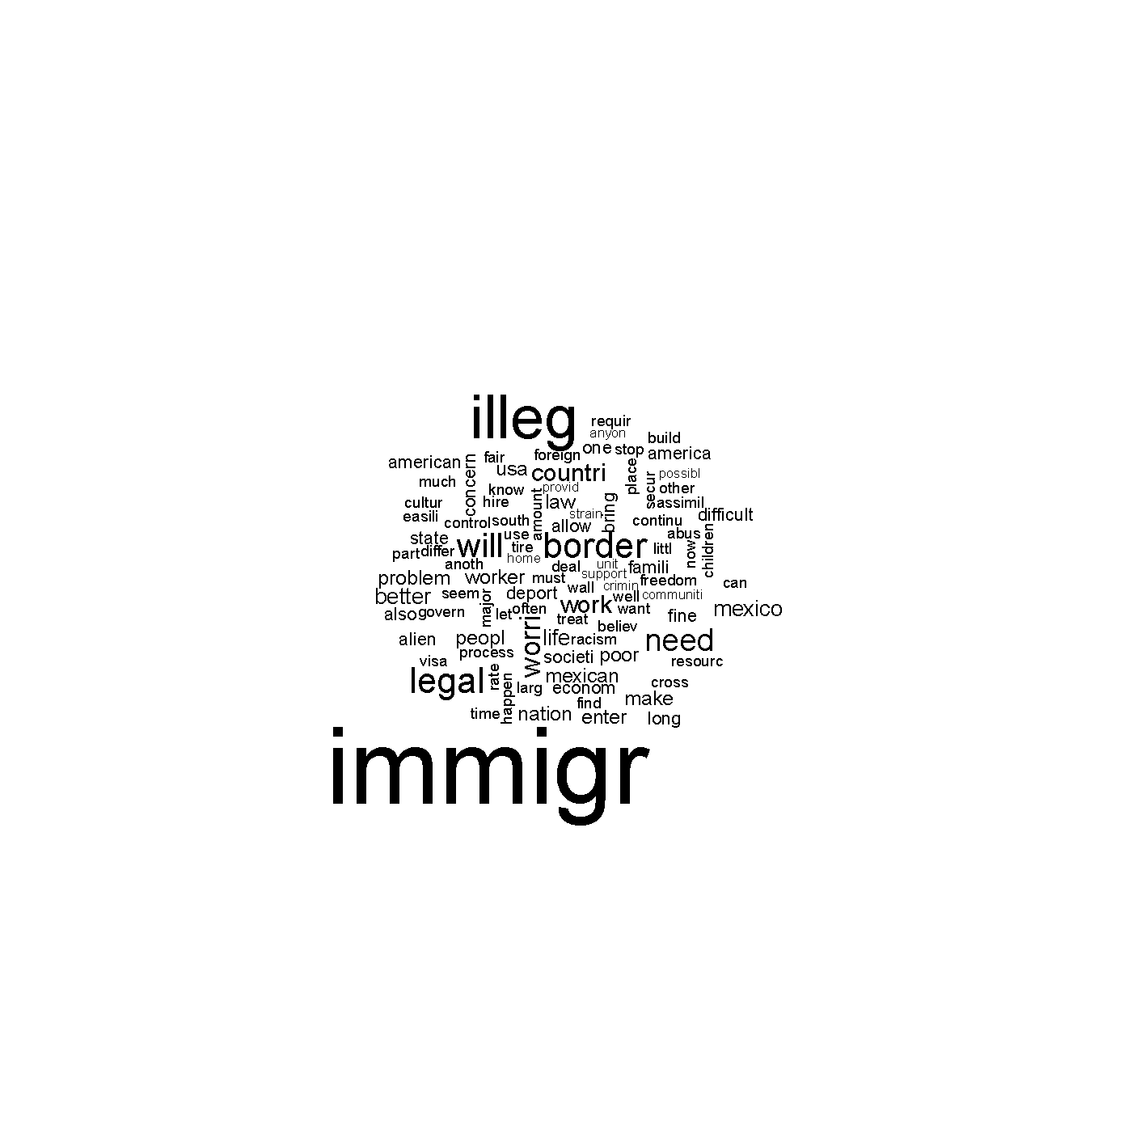

Figure 12: A wordcloud representation to plot a particular topic content.

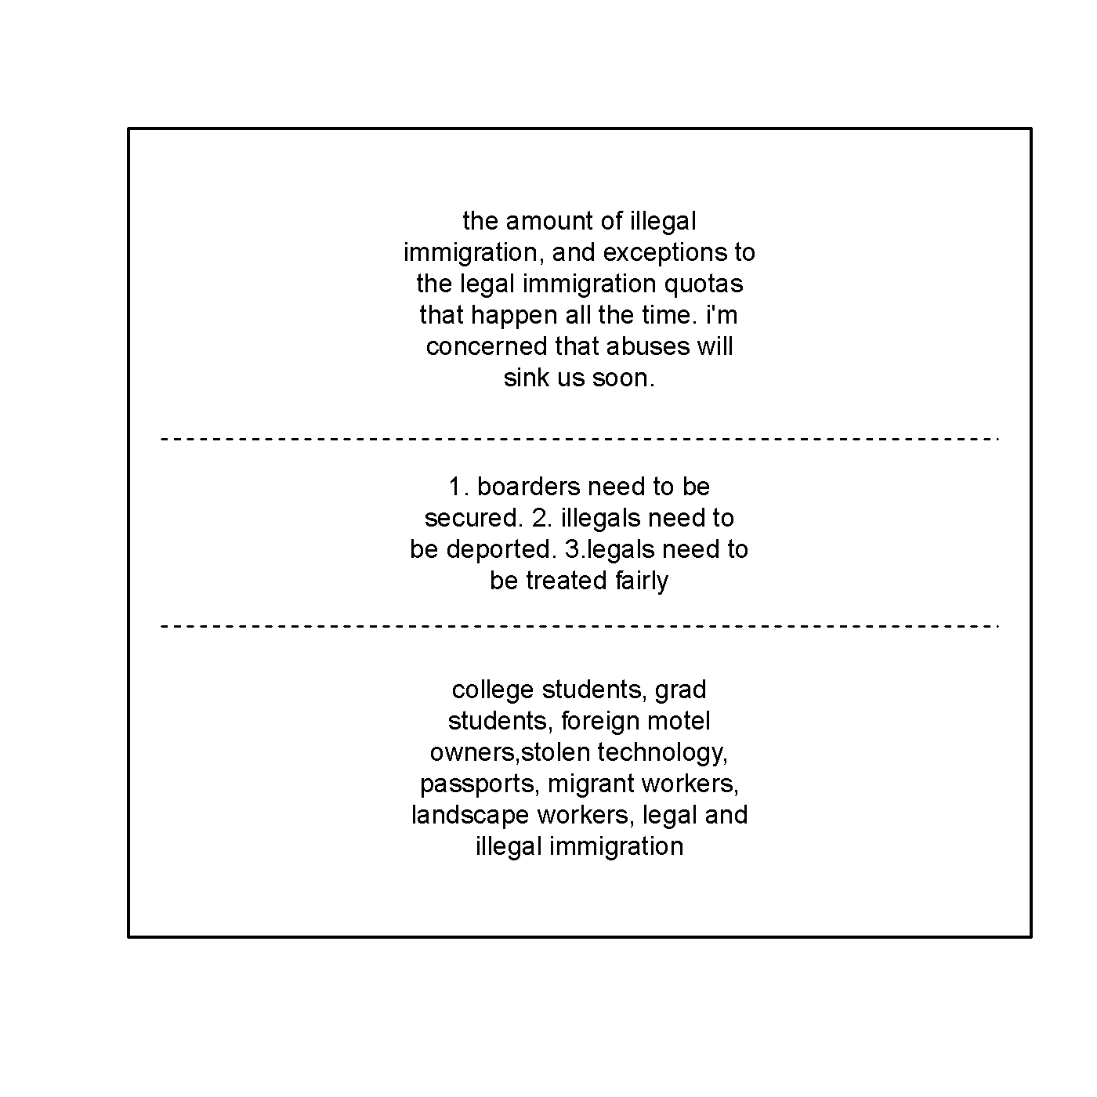

Figure 13: A visualization of most representative documents for a particular topic.

#### Step 3: Pattern Confirmation

The last step of the Phase III involves “using computational methods to more reliably test the validity of the inductively identified patterns in the text” (Nelson, 2017, p. 7). To put it another way, this will concern assessment of the detected and refined patterns through the prior steps by utilizing further computational and statistical techniques.

For instance, the semantic coherence and exclusivity for high likelihood models (Figure 14); LOESS (Locally Weighted Scatterplot Smoothing) line of the topic proportions on a covariate (Figure 15); and topic correlations (Figure 16) will be tested for the model validity in a rigorous manner.

Going through this Pattern Confirmation step, I will be able to uncover the most salient patterns within and across the four NFB mailing lists over the past ten years.

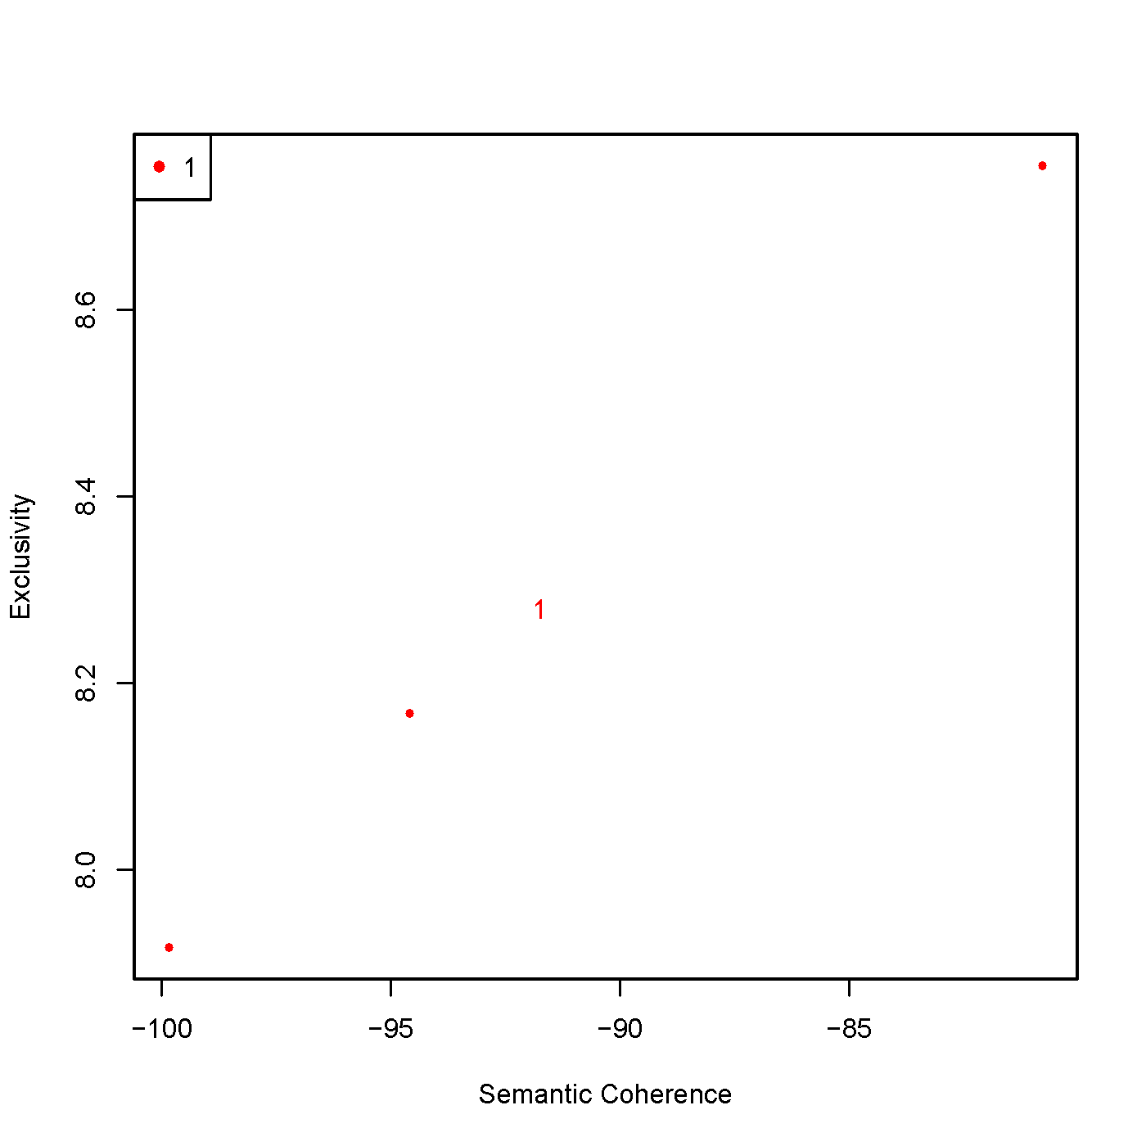

Figure 14: A visual representation plotting semantic coherence and exclusivity for high likelihood models.

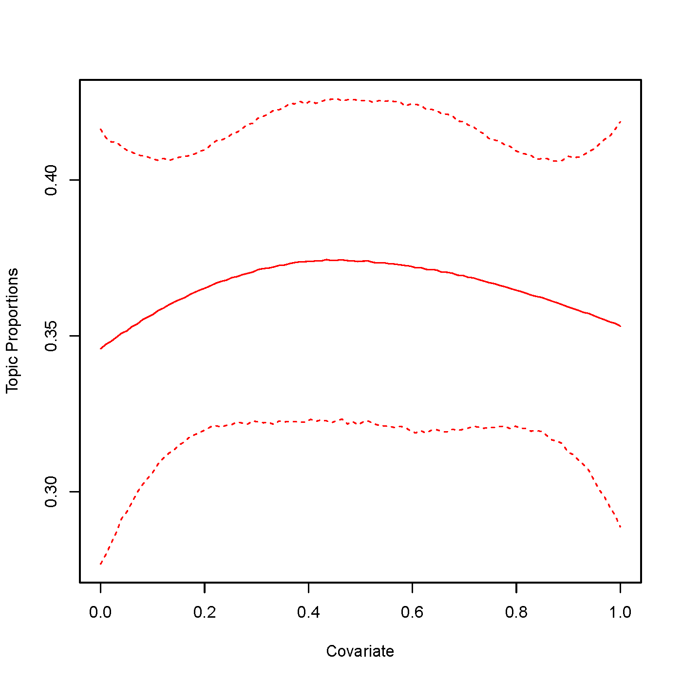

Figure 15: A visualization plotting a LOESS line of the topic proportions on a covariate inputted by the researcher.

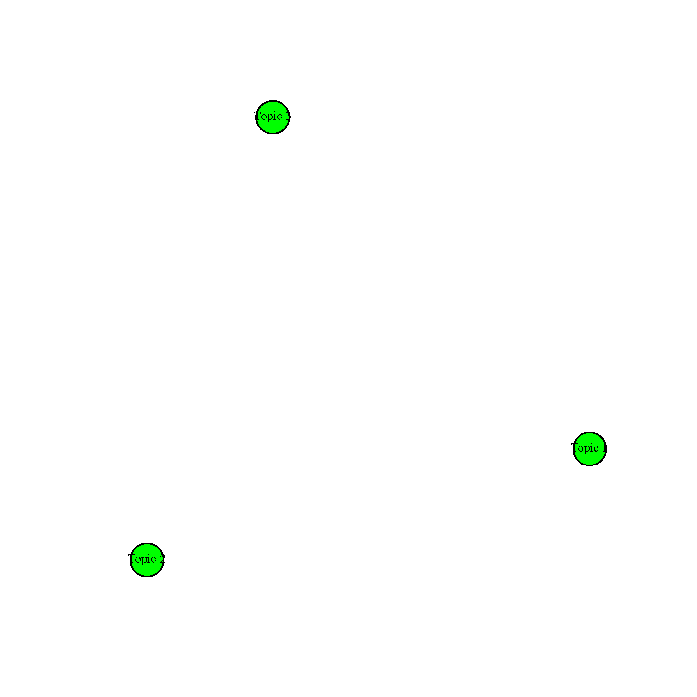

Figure 16: A topic correlation graph estimated where nodes are topics and edges indicate a positive correlation.

### Phase V: Results Evaluation and Interpretation

This last phase of the KDT model plays a conclusive role in integrating all prior analytical points into the study results through the researcher’s subjective and qualitative interpretation (Fayyad et al., 1996; Feldman & Dagan, 1995). All of the computational results will be repeatedly triangulated with my own interpretive reflexivity as one of the lifelong blind individuals pursuing STEM disciplines.

Since the study has not yet been conducted, the actual scope of discussion cannot be addressed now; however, the expected findings would include all answers to the set of proposed research questions (Chapter 1.3) concerning the informal learning experiences of blind individuals pursuing STEM subjects. Combining computational results quantified by structural topic modelling, descriptive statistics, and network analysis with qualitative observation driven by my insights as a lifelong blind learner, this research will contribute to a comprehensive understanding of how blind people learn STEM in general; and what challenges and solutions have been discussed among blind people to engage them in STEM education specifically. The findings of this study will help learning scientists, STEM educators, product/instructional designers better understand what is being discussed as challenging issues in learning STEM directly voiced by a large number of blind individuals to develop a future program, curriculum, and tools that can embrace blind learners’ needs.

Further details on the study implications have been already mentioned in Chapter 1.5.

## Timeline of the Study

Given that this quantitative ethnographic study will employ public data that will avoid any direct human-subject interaction while protecting personal information, it is resonably estimated that the time spent on data collection will be expedited (see Appendix 4 and Appendix 5). Furthermore, the Researcher’s resources and skills to conduct the quantitative ethnography have been confirmed by the committee members of the International Conference for Quantitative Ethnography to participate in their 2019 Doctoral Consortium held in October with fully sponsored (see Appendix 9).

All things considered, I suggest the following timelines for this dissertation study:

* September, 2019: completing phase I (Data Extraction; Chapter 3.3.1); II and III (Data Cleaning and Transformation; Chapter 3.3.2).
* October - December, 2019: Completing Phase IV (Text Mining; Chapter 3.3.3).
* January - February, 2020: Iteratively evaluating and unpacking the results through my reflexivity (Phase V Results Evaluation and Interpretation Chapter 3.3.4).
* March - April, 2020: Compiling all procedures and results up to dissertation format.
* May - June, 2020: Having a final defense for the dissertation work.
* August, 2020: Accomplishing the Ph.D. commencement.

# Appendix

# Determination Letter from the Office for Research Protections

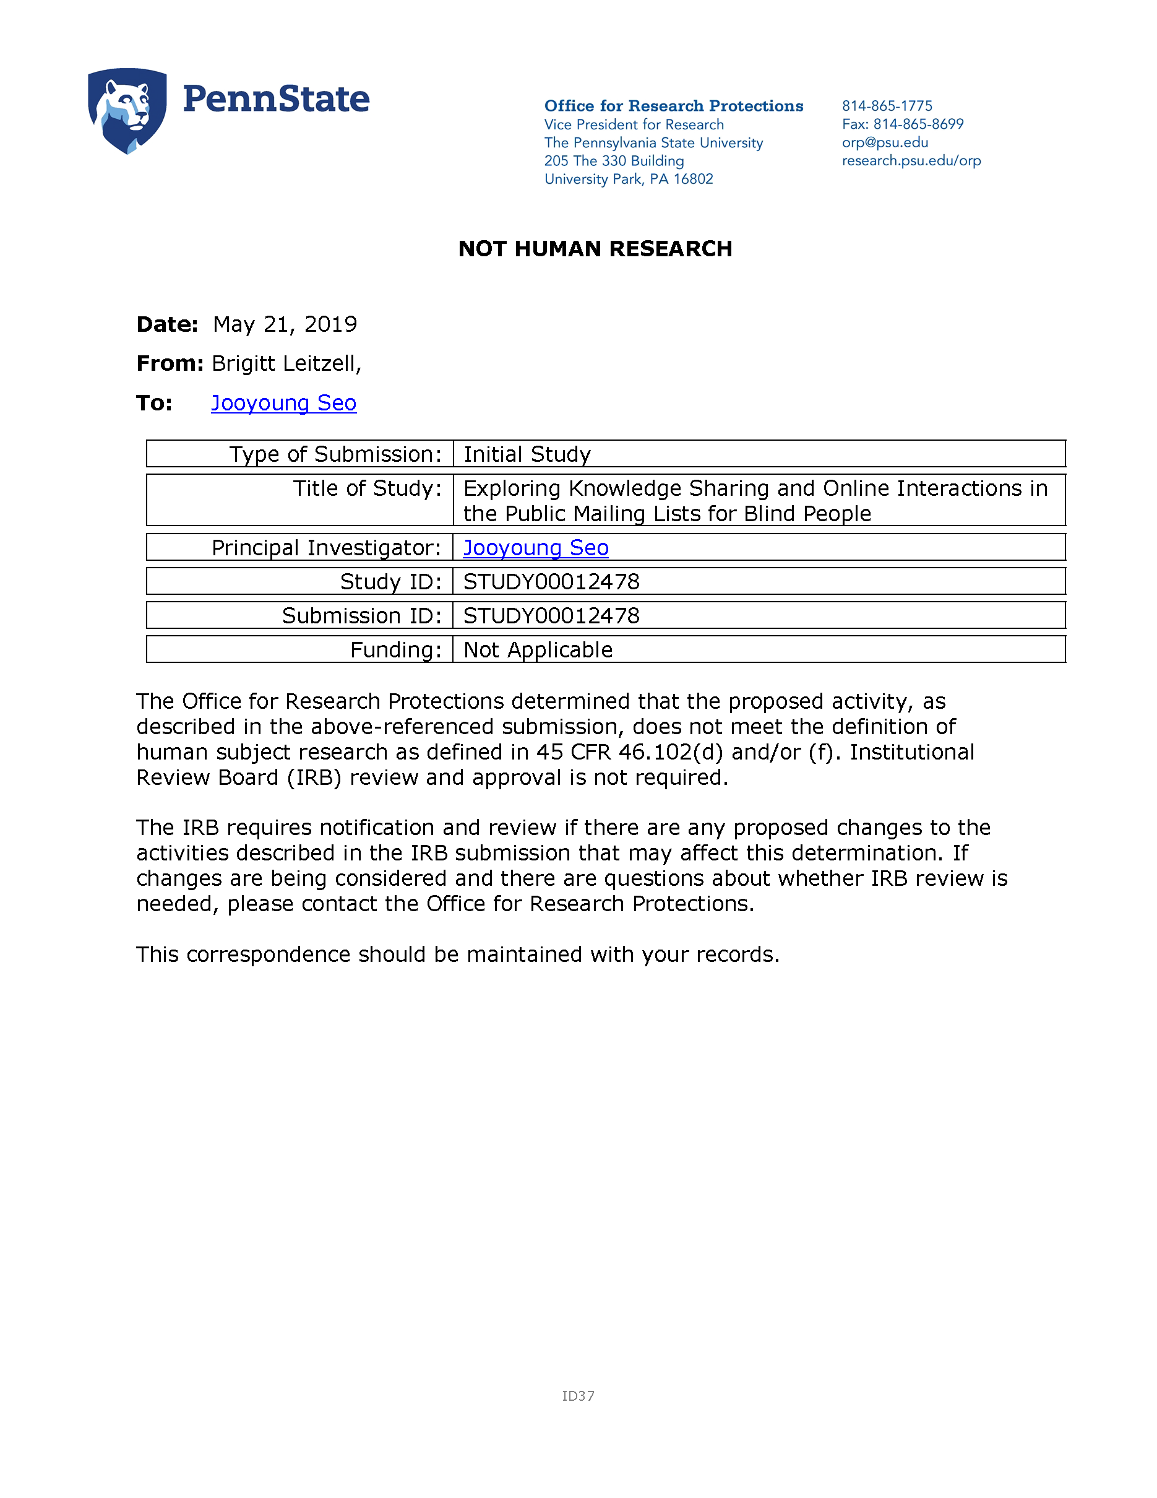

Figure 17: Determination letter from the Office for Research Protections.

# Contact with a Gatekeeper of the Study Target Community

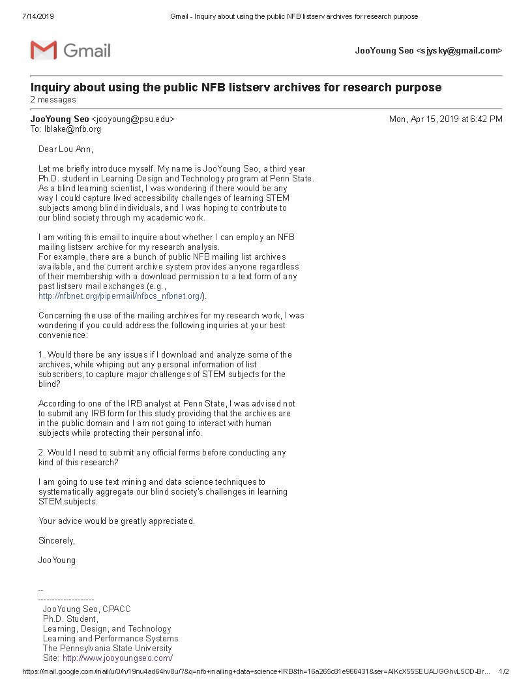

Figure 18: Email exchange with the community gatekeeper (page 1).

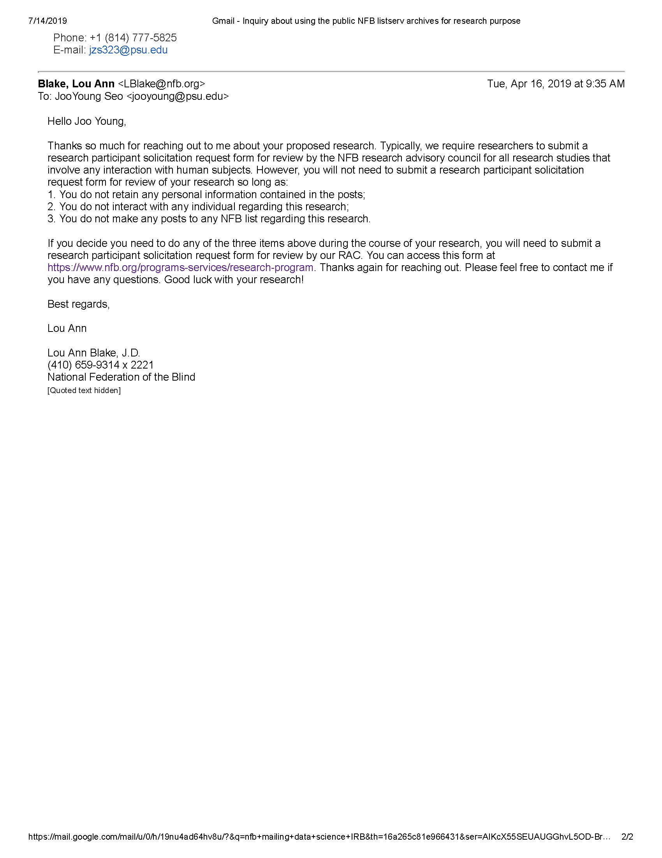

Figure 19: Email exchange with the community gatekeeper (page 2).

# Unix Shell Commands for Data Extraction

The following commands will be used for data extraction step of this study (Chapter 3.3.1). Any Unix-like operating systems can be used as long as wget and gzip commands are installed. In Windows OS, [*Cygwin*](https://www.cygwin.com/) can emulate the Unix Bash shell.

# Step 1: Downloading Each of the Four Public Mailing Archives  
## 1. Nfb-science:  
wget -r --no-parent -w 1 -l 1 --restrict-file-names=nocontrol http://nfbnet.org/pipermail/nfb-science_nfbnet.org/  
  
## 2. The nfbcs Archives:  
wget -r --no-parent -w 1 -l 1 --restrict-file-names=nocontrol http://nfbnet.org/pipermail/nfbcs_nfbnet.org/  
  
## 3. Artists-Making-Art Archives:  
wget -r --no-parent -w 1 -l 1 --restrict-file-names=nocontrol http://nfbnet.org/pipermail/artists-making-art_nfbnet.org/  
  
## 4. BlindMath:  
wget -r --no-parent -w 1 -l 1 --restrict-file-names=nocontrol http://nfbnet.org/pipermail/blindmath_nfbnet.org/  
  
# Step 2: Unzipping Each Downloaded Archive as an Mbox Format  
## Issue the following commands in each of the downloaded archive root directories:  
gzip -d *.gz # Unzipping *.gz files into *.txt.  
mv *.txt *.mbox # Changing file extension from *.txt to *.mbox for mail data manipulation later.  
mkdir mbox # Creating a new directory, called "mbox."  
mv *.mbox mbox/ # Moving all *.mbox files inside the newly created "mbox" directory.

# R Script Used for Data Cleaning and Transformation

For the data cleaning and transformation, two open-source languages, R and Python, are required on your system. Download and install R from [The R-project for statistical computing](https://cran.r-project.org/bin/windows/base/); Python from [Anaconda Distribution](https://www.anaconda.com/distribution/).

# Selecting a CRAN Mirror:  
chooseCRANmirror(ind = 1)  
  
# Installing Required Packages:  
install.packages(c("mboxr", "tidyverse"))  
  
# Loading the Installed Packages within current R session:  
library(mboxr)  
library(tidyverse)  
  
# Resaving Plain-Text Mbox Files into One Structured R Data:  
data <- merge_mbox_all(path = "[path/to/mbox_directory]", file = "[output_file_name.rds]") # Do this command for each of the four mailing archives.  
  
# Making Sure Whether the Data Has Benn Structured:  
glimpse(data)  
  
# 'From' Escaping Issue in Target Archives The following mbox files have  
# non-escaped 'From ' issue that means a new line starting with the word 'From '  
# in the mail body is mistakenly treated by a Python mbox parser as a breaking  
# point between each message 'From' line. To resolve this issue, I have to  
# replace 'From ' with '>From ' for every occurrence found in mail body to  
# escape.  
  
### Five files have this issue in NFB-CS archive: * 2013-April.mbox *  
### 2013-November.mbox * 2016-July.mbox * 2017-February.mbox * 2017-May.mbox  
  
### No file has escaping issue in both Science and Arts archives.  
  
### Eight files have the escaping issue in BlindMath archive: * 2012-May.mbox *  
### 2013-November.mbox * 2014-August.mbox * 2015-January.mbox * 2016-March.mbox *  
### 2017-February.mbox * 2018-May.mbox * 2019-March.mbox

# R Script Used for Text Mining

The following R scripts are transparently provided for study reproducibility performed in Chapter 3.3.3.

# Selecting a CRAN Mirror:  
chooseCRANmirror(ind = 1)  
  
# Installing Required Package:  
install.packages("stm")  
  
# Loading the Installed Packages within current R session:  
library(stm)  
  
# The following scripts are employed in Step 1 (Pattern Detection) 1.1: Searching  
# the number of desired topics:  
K <- c(5, 10, 15)  
temp <- textProcessor(documents = gadarian$open.ended.response, metadata = gadarian)  
out <- prepDocuments(temp$documents, temp$vocab, temp$meta)  
documents <- out$documents  
vocab <- out$vocab  
meta <- out$meta  
set.seed(2138)  
K <- c(5, 10, 15)  
kresult <- searchK(documents, vocab, K, prevalence = ~treatment + s(pid_rep), data = meta)  
  
plot(kresult)  
  
## 1.2: Visualizing estimated Structural Topic Models in four ways: Examples with  
## the Gadarian Data  
plot(gadarianFit)  
plot(gadarianFit, type = "labels")  
plot(gadarianFit, type = "perspectives", topics = c(1, 2))  
plot(gadarianFit, type = "hist")  
  
# The following scripts are employed in Step 2 (Pattern Refinement) Use the  
# wordcloud package to plot a wordcloud for a particular topic  
cloud(gadarianFit, 1)  
  
## Outputs most representative documents for a particular topic. Use this in order  
## to get a better sense of the content of actual documents with a high topical  
## content. We can plot findThoughts objects using plot() or plotQuote  
thought <- findThoughts(gadarianFit, texts = gadarian$open.ended.response, topics = 1,   
 n = 3)  
  
# plotQuote takes a set of sentences plotQuote(thought$docs[[1]])  
  
# we can use the generic plot as a shorthand which will make one plot per topic  
plot(thought)  
  
# The following scripts are employed in Step 3 (Pattern Confirmation) Plots  
# semantic coherence and exclusivity for high likelihood models.  
temp <- textProcessor(documents = gadarian$open.ended.response, metadata = gadarian)  
meta <- temp$meta  
vocab <- temp$vocab  
docs <- temp$documents  
out <- prepDocuments(docs, vocab, meta)  
docs <- out$documents  
vocab <- out$vocab  
meta <- out$meta  
set.seed(2138)  
mod.out <- selectModel(docs, vocab, K = 3, prevalence = ~treatment + s(pid_rep),   
 data = meta, runs = 5)  
plotModels(mod.out)  
  
## Plots a loess line of the topic proportions on a covariate inputted by the  
## user.  
plotTopicLoess(gadarianFit, topics = 1, covariate = gadarian$pid_rep)  
  
## Uses a topic correlation graph estimated by topicCorr and the igraph package to  
## plot a network where nodes are topics and edges indicate a positive  
## correlation. This function becomes more useful with larger numbers of topics.  
## it is demonstrated here with a small model simply to show how the syntax works.  
cormat <- topicCorr(gadarianFit)  
plot(cormat)

# Accepted Letter for the 2019 ICQE Doctoral Consortium



Figure 20: An official accepted letter from the committee of the International Conference for Quantitative Ethnography for its 2019 Doctoral Consortium.

# References

AccessSTEM. (n.d.). *About the accessstem project*. DO-IT Center, University of Washington. Retrieved June 12, 2019, from <https://www.washington.edu/doit/programs/accessstem/overview/about-accessstem-project>

American Printing House for the Blind. (2017, September 30). *Annual report: Financial year 2017*. Retrieved June 10, 2019, from <https://www.aph.org/files/annual-reports/APH-Audit-Report-FY17.pdf>

Anaya, A. R., & Boticario, J. G. (2011). Application of machine learning techniques to analyse student interactions and improve the collaboration process. *Expert Systems with Applications*, *38*(2), 1171–1181.

Aria, M., & Cuccurullo, C. (2017). Bibliometrix: An r-tool for comprehensive science mapping analysis. *Journal of Informetrics*, *11*(4), 959–975.

Bail, C. A. (2014). The cultural environment: Measuring culture with big data. *Theory and Society*, *43*(3-4), 465–482.

Basham, J. D., Israel, M., & Maynard, K. (2010). An ecological model of stem education: Operationalizing stem for all. *Journal of Special Education Technology*, *25*(3), 9–19.

Basham, J. D., & Marino, M. T. (2013). Understanding stem education and supporting students through universal design for learning. *Teaching Exceptional Children*, *45*(4), 8–15.

Bdeir, A. (2009). Electronics as material: LittleBits. In *Proceedings of the 3rd international conference on tangible and embedded interaction* (pp. 397–400). ACM.

Beck-Winchatz, B., & Riccobono, M. A. (2008). Advancing participation of blind students in science, technology, engineering, and math. *Advances in Space Research*, *42*(11), 1855–1858.

Bell, D. (2016). The reality of stem education, design and technology teachers’ perceptions: A phenomenographic study. *International Journal of Technology and Design Education*, *26*(1), 61–79.

Bell, R. L., & Lederman, N. G. (2003). Understandings of the nature of science and decision making on science and technology based issues. *Science Education*, *87*(3), 352–377.

Biernacki, R. (2012). *Reinventing evidence in social inquiry: Decoding facts and variables*. Springer.

Biernacki, R. (2015). Erratum: How to do things with historical texts. *American Journal of Cultural Sociology*, *3*(3), 311–352.

Blei, D. M. (2012). Probabilistic topic models. *Commun. ACM*, *55*(4), 77–84. doi:[10.1145/2133806.2133826](https://doi.org/10.1145/2133806.2133826)

Blei, D. M., & Lafferty, J. D. (2007). A correlated topic model of science. *The Annals of Applied Statistics*, *1*(1), 17–35. doi:[10.1214/07-AOAS114](https://doi.org/10.1214/07-AOAS114)

Blei, D. M., Ng, A., & Jordan, M. (2003). Latent dirichlet allocation. *Journal of Machine Learning Research*, *3*, 993–1022.

Blikstein, P. (2013). Digital fabrication and" making. *Education: The Democratization of Invention, in Walter-Herrmann, J. & Büching, C.,(eds.), FabLabs: Of Machines, Makers and Inventors,Bielefeld: Transcript Publishers*.

Bohr, J., & Dunlap, R. E. (2018). Key topics in environmental sociology, 1990?2014: Results from a computational text analysis. *Environmental Sociology*, *4*(2), 181–195. doi:[10.1080/23251042.2017.1393863](https://doi.org/10.1080/23251042.2017.1393863)

Breiner, J. M., Harkness, S. S., Johnson, C. C., & Koehler, C. M. (2012). What is stem? A discussion about conceptions of stem in education and partnerships. *School Science and Mathematics*, *112*(1), 3–11.

Bronfenbrenner, U. (1977). Toward an experimental ecology of human development. *American Psychologist*, *32*(7), 513.

Bronfenbrenner, U. (1994). Ecological models of human development. *Readings on the Development of Children*, *2*(1), 37–43.

Brown, H. E. (2013). Race, legality, and the social policy consequences of anti-immigration mobilization. *American Sociological Review*, *78*(2), 290–314.

Brown, J. (2012). The current status of stem education research. *Journal of STEM Education: Innovations and Research*, *13*(5), 7.

Brown, J. S., Collins, A., & Duguid, P. (1989). Situated cognition and the culture of learning. *Educational Researcher*, *18*(1), 32–42.

Buchholz, B., Shively, K., Peppler, K., & Wohlwend, K. (2014). Hands on, hands off: Gendered access in crafting and electronics practices. *Mind, Culture, and Activity*, *21*(4), 278–297.

Buechley, L., Eisenberg, M., Catchen, J., & Crockett, A. (2008). The lilypad arduino: Using computational textiles to investigate engagement, aesthetics, and diversity in computer science education. In *Proceedings of the sigchi conference on human factors in computing systems* (pp. 423–432). ACM.

Capraro, R. M., Capraro, M. M., & Morgan, J. R. (2013). *STEM project-based learning: An integrated science, technology, engineering, and mathematics (stem) approach*. Springer Science & Business Media.

Chaiklin, S. (2003). The zone of proximal development in vygotskys analysis of learning and instruction. *Vygotskys Educational Theory in Cultural Context*, *1*, 39–64.

Chakrabarti, P., & Frye, M. (2017). A mixed-methods framework for analyzing text data: Integrating computational techniques with qualitative methods in demography. *Demographic Research*, *37*, 1351–1382.

Chang, J., Boyd-Graber, J. L., Gerrish, S., Wang, C., & Blei, D. M. (2009). Reading tea leaves: How humans interpret topic models. In *Neural information processing systems* (Vol. 22, pp. 288–296).

Christenson, J. (2011, November 13). *Ramaley coined stem term now used nationwide*. Winona Daily News. Retrieved May 29, 2019, from <https://www.winonadailynews.com/news/local/article_457afe3e-0db3-11e1-abe0-001cc4c03286.html>

Clough, M. P. (2000). The nature of science: Understanding how the game of science is played. *The Clearing House: A Journal of Educational Strategies, Issues and Ideas*, *74*(1), 13–17.

Cohen, J. (1960). A coefficient of agreement for nominal scales. *Educational and Psychological Measurement*, *20*(1), 37–46.

Cohen, J. (1968). Weighted kappa: Nominal scale agreement provision for scaled disagreement or partial credit. *Psychological Bulletin*, *70*(4), 213–220.

Cole, M. (1998). *Cultural psychology: A once and future discipline*. Harvard University Press.

Conger, A. J. (1980). Integration and generalization of kappas for multiple raters. *Psychological Bulletin*, *88*(2), 322.

Cryer, H. (2013). Teaching stem subjects to blind and partially sighted students: Literature review and resources (literature review# 6). Birmingham, uk: RNIBCentre for accessible information.

Dewey, J. (2013). *The school and society and the child and the curriculum*. University of Chicago Press.

DiMaggio, P., Nag, M., & Blei, D. (2013). Exploiting affinities between topic modeling and the sociological perspective on culture: Application to newspaper coverage of us government arts funding. *Poetics*, *41*(6), 570–606.

Drott, M. C. (2002). Indexing aids at corporate websites: The use of robots. Txt and meta tags. *Information Processing & Management*, *38*(2), 209–219.

Dweck, C. S. (2000). *Self-theories: Their role in motivation, personality, and development*. Psychology Press.

Edwards, A. D., McCartney, H., & Fogarolo, F. (2006). Lambda:: A multimodal approach to making mathematics accessible to blind students. In *Proceedings of the 8th international acm sigaccess conference on computers and accessibility* (pp. 48–54). ACM.

Engeström, Y., Miettinen, R., & Punamäki, R.-L. (1999). *Perspectives on activity theory*. Cambridge University Press.

Fayyad, U. M., Piatetsky-Shapiro, G., Smyth, P., & Uthurusamy, R. (Eds.). (1996). *Advances in knowledge discovery and data mining*. Menlo Park, CA, USA: American Association for Artificial Intelligence.

Fayyad, U., Piatetsky-Shapiro, G., & Smyth, P. (1996). From data mining to knowledge discovery in databases. *AI Magazine*, *17*(3), 37.

Feldman, R., & Dagan, I. (1995). Knowledge discovery in textual databases (kdt). In *KDD* (Vol. 95, pp. 112–117).

Ferreira, H., & Freitas, D. (2004). Enhancing the accessibility of mathematics for blind people: The audiomath project. In *International conference on computers for handicapped persons* (pp. 678–685). Springer.

Fleiss, J. L. (1971). Measuring nominal scale agreement among many raters. *Psychological Bulletin*, *76*(5), 378.

Fleiss, J. L., Cohen, J., & Everitt, B. (1969). Large sample standard errors of kappa and weighted kappa. *Psychological Bulletin*, *72*(5), 323.

Fortus, D., Krajcik, J., Dershimer, R. C., Marx, R. W., & Mamlok-Naaman, R. (2005). Design-based science and real-world problem-solving. *International Journal of Science Education*, *27*(7), 855–879.

Fraser, W. J., & Maguvhe, M. O. (2008). Teaching life sciences to blind and visually impaired learners. *Journal of Biological Education*, *42*(2), 84–89.

Freire, P. (2000). *Pedagogy of the oppressed*. Bloomsbury Publishing.

Freudenthal, H. (1973). Mathematics as an educational task (dordrecht, the netherlands: Reidel).

Froebel, F. (1885). *The education of man*. A. Lovell & Company.

Ganley, C. M., George, C. E., Cimpian, J. R., & Makowski, M. B. (2018). Gender equity in college majors: Looking beyond the stem/non-stem dichotomy for answers regarding female participation. *American Educational Research Journal*, *55*(3), 453–487.

Gardner, J. A. (2002). Access by blind students and professionals to mainstream math and science. In *International conference on computers for handicapped persons* (pp. 502–507). Springer.

Gireesh, A. G., Gowda, M., & others. (2008). Acm transactions on information systems (1989–2006): A bibliometric study. *Information Studies*, *14*(4), 223–234.

Grajzl, C., Peterand Irby. (2019). Reflections on study abroad: A computational linguistics approach. *Journal of Computational Social Science*. doi:[10.1007/s42001-019-00038-8](https://doi.org/10.1007/s42001-019-00038-8)

Grimmer, J. (2010). A bayesian hierarchical topic model for political texts: Measuring expressed agendas in senate press releases. *Political Analysis*, *18*(1), 1–35.

Grimmer, J., & King, G. (2011). General purpose computer-assisted clustering and conceptualization. *Proceedings of the National Academy of Sciences*, *108*(7), 2643–2650.

Grimmer, J., & Stewart, B. M. (2013). Text as data: The promise and pitfalls of automatic content analysis methods for political texts. *Political Analysis*, *21*(3), 267–297.

Hakkarainen, K., Paavola, S., Kangas, K., & Seitamaa-Hakkarainen, P. (2013). Socio-cultural perspectives on collaborative learning: Towards collaborative knowledge creation. In C. E. Hmelo-Silver, C. A. Chinn, C. K. K. Chan, & A. M. O’Donnell (Eds.), *International handbook of collaborative learning* (pp. 57–73). New York: Routledge.

Halverson, E. R. (2013). Digital art making as a representational process. *Journal of the Learning Sciences*, *22*(1), 121–162.

Halverson, E. R., & Sheridan, K. (2014). The maker movement in education. *Harvard Educational Review*, *84*(4), 495–504.

Heil, D., Pearson, G., & Burger, S. (2013). Understanding integrated stem education: Report on a national study. In *ASEE annual conference & exposition, atlanta, georgia*.

Hillard, D., Purpura, S., & Wilkerson, J. (2008). Computer-assisted topic classification for mixed-methods social science research. *Journal of Information Technology & Politics*, *4*(4), 31–46.

Hughes, B. (2010). Park forest middle school stem education fair 2010. *Technology and Engineering Teacher*, *70*(2), 32.

Hung, K., Jui-Longand Zhang. (2012). Examining mobile learning trends 2003–2008: A categorical meta-trend analysis using text mining techniques. *Journal of Computing in Higher Education*, *24*(1), 1–17. doi:[10.1007/s12528-011-9044-9](https://doi.org/10.1007/s12528-011-9044-9)

Hwang, J., & Taylor, J. C. (2016). Stemming on stem: A stem education framework for students with disabilities. *Journal of Science Education for Students with Disabilities*, *19*(1), 39–49.

Israel, M., Maynard, K., & Williamson, P. (2013). Promoting literacy-embedded, authentic stem instruction for students with disabilities and other struggling learners. *Teaching Exceptional Children*, *45*(4), 18–25.

Jones, M. G., Minogue, J., Oppewal, T., Cook, M. P., & Broadwell, B. (2006). Visualizing without vision at the microscale: Students with visual impairments explore cells with touch. *Journal of Science Education and Technology*, *15*(5-6), 345–351.

Kafai, Y. B., & Resnick, M. (1996). *Constructionism in practice: Designing, thinking, and learning in a digital world*. Routledge.

Kafai, Y., Searle, K., Martinez, C., & Brayboy, B. (2014). Ethnocomputing with electronic textiles: Culturally responsive open design to broaden participation in computing in american indian youth and communities. In *Proceedings of the 45th acm technical symposium on computer science education* (pp. 241–246). ACM.

Kaku, M. (2012). *Physics of the future: How science will shape human destiny and our daily lives by the year 2100*. Anchor.

Karshmer, A. I., & Bledsoe, C. (2002). Access to mathematics by blind students. In *International conference on computers for handicapped persons* (pp. 471–476). Springer.

Kaufman, D., Moss, D. M., & Osborn, T. A. (2003). *Beyond the boundaries: A transdisciplinary approach to learning and teaching*. Greenwood Publishing Group.

King, G., Pan, J., & Roberts, M. E. (2013). How censorship in china allows government criticism but silences collective expression. *American Political Science Review*, *107*(2), 326–343.

Kolodner, J. L., Camp, P. J., Crismond, D., Fasse, B., Gray, J., Holbrook, J., & Puntambekar, M., Sadhana andRyan. (2003). Problem-based learning meets case-based reasoning in the middle-school science classroom: Putting learning by design (tm) into practice. *The Journal of the Learning Sciences*, *12*(4), 495–547.

Krippendorff, K. (2018). *Content analysis: An introduction to its methodology*. Sage publications.

Labov, J. B., Reid, A. H., & Yamamoto, K. R. (2010). Integrated biology and undergraduate science education: A new biology education for the twenty-first century? *CBE?Life Sciences Education*, *9*(1), 10–16.

Lachney, M., Babbitt, W., & Eglash, R. (2016). Software design in the ‘construction genre’of learning technology: Content aware versus content agonistic. *Computational Culture: A Journal of Software Studies*, *5*, 1–15.

Lave, J., & Wenger, E. (1991). *Situated learning: Legitimate peripheral participation*. Cambridge university press.

Leddy, M. H. (2010). Technology to advance high school and undergraduate students with disabilities in science, technology, engineering, and mathematics. *Journal of Special Education Technology*, *25*(3), 3–8.

Lee, M., & Martin, J. L. (2015). Coding, counting and cultural cartography. *American Journal of Cultural Sociology*, *3*(1), 1–33.

Levy, S. T., & Lahav, O. (2012). Enabling people who are blind to experience science inquiry learning through sound-based mediation. *Journal of Computer Assisted Learning*, *28*(6), 499–513.

Light, R. J. (1971). Measures of response agreement for qualitative data: Some generalizations and alternatives. *Psychological Bulletin*, *76*(5), 365.

Lowe, W., & Benoit, K. (2013). Validating estimates of latent traits from textual data using human judgment as a benchmark. *Political Analysis*, *21*(3), 298–313.

Marino, M. T. (2010). Defining a technology research agenda for elementary and secondary students with learning and other high-incidence disabilities in inclusive science classrooms. *Journal of Special Education Technology*, *25*(1), 1–27.

Martin, J. K., Stumbo, N. J., Martin, L. G., Collins, K. D., Hedrick, B. N., Nordstrom, D., & Peterson, M. (2011). Recruitment of students with disabilities: Exploration of science, technology, engineering, and mathematics. *Journal of Postsecondary Education and Disability*, *24*(4), 285–299.

Martinez, S. L., & Stager, G. (2013). *Invent to learn: Making, tinkering, and engineering in the classroom*. Constructing modern knowledge press.

Mimno, D., Wallach, H. M., Talley, E., Leenders, M., & McCallum, A. (2011). Optimizing semantic coherence in topic models. In *Proceedings of the conference on empirical methods in natural language processing* (pp. 262–272). Stroudsburg, PA, USA: Association for Computational Linguistics. Retrieved from <http://dl.acm.org/citation.cfm?id=2145432.2145462>

Mishler, E. S. P., Alanand Crabb. (2015). Using structural topic modeling to detect events and cluster twitter users in the ukrainian crisis. In C. Stephanidis (Ed.), *HCI international 2015 - posters’ extended abstracts* (pp. 639–644). Cham: Springer International Publishing.

Montessori, M. (1917). *The advanced montessori method...* (Vol. 1). Frederick A. Stokes Company.

Morrison, J. S. (2006). Attributes of stem education: The students, the academy, the classroom. *TIES STEM Education Monograph Series. Baltimore: Teaching Institute for Excellence in STEM*.

Müller, K., & Wickham, H. (2019). *Tibble: Simple data frames*. Retrieved from <https://CRAN.R-project.org/package=tibble>

Nasir, N., Rosebery, A., Warren, B., & Lee, C. (2014). Learning as a cultural process: Achieving equity through diversity. In R. K. Sawyer (Ed.), *The cambridge handbook of the learning sciences* (2nd ed., pp. 686–706). Cambridge, United Kingdom: Cambridge University Press. doi:[10.1017/CBO9781139519526](https://doi.org/10.1017/CBO9781139519526)

National Federation of the Blind. (n.d.). *About us*. Retrieved July 21, 2019, from <https://nfb.org/about-us>

National Federation of the Blind Mailing Lists. (n.d.). *Nfbnet.org mailing lists*. National Federation of the Blind. Retrieved June 15, 2019, from <https://www.nfbnet.org/mailman/listinfo>

Nelson, L. K. (2017). Computational grounded theory: A methodological framework. *Sociological Methods & Research*, 0049124117729703. doi:[10.1177/0049124117729703](https://doi.org/10.1177/0049124117729703)

Nelson, L. K., Burk, D., Knudsen, M., & McCall, L. (2018). The future of coding: A comparison of hand-coding and three types of computer-assisted text analysis methods. *Sociological Methods & Research*, 0049124118769114. doi:[10.1177/0049124118769114](https://doi.org/10.1177/0049124118769114)

Papert, S. (1980). *Mindstorms: Children, computers, and powerful ideas*. Basic Books, Inc.

Papert, S. (1993). *The children’s machine: Rethinking school in the age of the computer.* ERIC.

Papert, S., & Harel, I. (1991). Situating constructionism. *Constructionism*, *36*(2), 1–11.

Paris, D. (2012). Culturally sustaining pedagogy: A needed change in stance, terminology, and practice. *Educational Researcher*, *41*(3), 93–97.

Peppler, K. (2010). Media arts: Arts education for a digital age. *Teachers College Record*, *112*(8), 2118–2153.

Peppler, K. A., & Kafai, Y. B. (2007). From supergoo to scratch: Exploring creative digital media production in informal learning. *Learning, Media and Technology*, *32*(2), 149–166.

Piaget, J., & Cook, M. (1952). *The origins of intelligence in children* (Vol. 8). International Universities Press New York.

Rao, K., Ok, M. W., & Bryant, B. R. (2014). A review of research on universal design educational models. *Remedial and Special Education*, *35*(3), 153–166.

R Core Team. (2019). *R: A language and environment for statistical computing*. Vienna, Austria: R Foundation for Statistical Computing. Retrieved from <https://www.R-project.org/>

Reed, I. A. (2015). Counting, interpreting and their potential interrelation in the human sciences. *American Journal of Cultural Sociology*, *3*(3), 353–364.

Reich, J., Tingley, D., Leder-Luis, J., Roberts, M. E., & Stewart, B. M. (2015). Computer assisted reading and discovery for student generated text in massive open online courses. *Journal of Learning Analytics*, *2*(1), 156–184.

Resnick, M., Maloney, J., Monroy-Hernández, A., Rusk, N., Eastmond, E., Brennan, K., … others. (2009). Scratch: Programming for all. *Communications of the ACM*, *52*(11), 60–67.

Resnick, M., Ocko, S., & others. (1990). *LEGO/logo–learning through and about design*. Epistemology; Learning Group, MIT Media Laboratory Cambridge, MA.

Richard, G. T., & Giri, S. (2017). Inclusive collaborative learning with multi-interface design: Implications for diverse and equitable makerspace education. In. Philadelphia, PA: International Society of the Learning Sciences.

Richard, G. T., & Kafai, Y. B. (2015a). Making physical and digital games with e-textiles: A workshop for youth making responsive wearable games and controllers. In *Proceedings of the 14th international conference on interaction design and children* (pp. 399–402). ACM.

Richard, G. T., & Kafai, Y. B. (2015b). Responsive make and play: Youth making physically and digitally interactive and wearable game controllers. In *More playful user interfaces* (pp. 71–93). Springer.

Richard, G. T., & Kafai, Y. B. (2016). Blind spots in youth diy programming: Examining diversity in creators, content, and comments within the scratch online community. In *Proceedings of the 2016 chi conference on human factors in computing systems* (pp. 1473–1485). ACM.

Richard, G. T., Kafai, Y. B., Adleberg, B., & Telhan, O. (2015). StitchFest: Diversifying a college hackathon to broaden participation and perceptions in computing. In *Proceedings of the 46th acm technical symposium on computer science education* (pp. 114–119). ACM.

Roberts, A. (2013). STEM is here. Now what? *Technology and Engineering Teacher*, *73*(1), 22.

Roberts, K. D., Park, H. J., Brown, S., & Cook, B. (2011). Universal design for instruction in postsecondary education: A systematic review of empirically based articles. *Journal of Postsecondary Education and Disability*, *24*(1), 5–15.

Roberts, M. E., Stewart, B. M., Tingley, D., Airoldi, E. M., & others. (2013). The structural topic model and applied social science. In *Advances in neural information processing systems workshop on topic models: Computation, application, and evaluation* (pp. 1–20).

Roberts, M. E., Stewart, B. M., Tingley, D., & others. (2014). Stm: R package for structural topic models. *Journal of Statistical Software*, *10*(2), 1–40.

Roberts, M., Stewart, B., & Tingley, D. (2019). *Stm: Estimation of the structural topic model*. Retrieved from <http://structuraltopicmodel.com>

Samsonov, P., Pedersen, S., & Hill, C. L. (2006). Using problem-based learning software with at-risk students: A case study. *Computers in the Schools*, *23*(1-2), 111–124.

Sanders, M. E. (2009). Stem, stem education, stemmania. *Technology Teacher*, *68*(4), 20–26.

Scardamalia, M., & Bereiter, C. (2006). Knowledge building: Theory, pedagogy, and technology. In R. K. Sawyer (Ed.), *The cambridge handbook of the learning sciences* (pp. 97–115). New York, NY: Cambridge University Press.

Schwartz, H. A., & Ungar, L. H. (2015). Data-driven content analysis of social media: A systematic overview of automated methods. *The ANNALS of the American Academy of Political and Social Science*, *659*(1), 78–94.

Scott, K. A., Sheridan, K. M., & Clark, K. (2015). Culturally responsive computing: A theory revisited. *Learning, Media and Technology*, *40*(4), 412–436.

Seo, J. (2018). Accessibility and inclusivity in making: Engaging learners with all abilities in making activities. In *Proceedings of the 3rd learning sciences graduate student conference* (pp. 141–142). Nashville, TN: LSGSC Planning Team.

Seo, J. (2019). Is the maker movement inclusive of anyone?: Three accessibility considerations to invite blind makers to the making world. *TechTrends*, 1–7. doi:[10.1007/s11528-019-00377-3](https://doi.org/10.1007/s11528-019-00377-3)

Seo, J., & Choi, S. (2019). *Mboxr: Reading, extracting, and converting an mbox file into a tibble*. Retrieved from <https://CRAN.R-project.org/package=mboxr>

Seo, J., & Richard, G. T. (2018). Accessibility, making and tactile robotics: Facilitating collaborative learning and computational thinking for learners with visual impairments. In J. Kay & R. Luckin (Eds.), *Rethinking learning in the digital age: Making the learning sciences count, 13th international conference of the learning sciences (icls) 2018* (Vol. 3, pp. 1755–1757). London, UK: International Society of the Learning Sciences (ISLS).

Shaffer, D. W. (2017). *Quantitative ethnography*. Lulu. com.

Singh, M. (2008). Visionmeter: A novel instrument for teaching chemical sciences to the visually handicapped. *Experimental Techniques*, *32*(2), 53–57.

Sobota, J., PiŜl, R., Balda, P., & Schlegel, M. (2013). Raspberry pi and arduino boards in control education. *IFAC Proceedings Volumes*, *46*(17), 7–12.

Supalo, C. A., Kreuter, R. A., Musser, A., Han, J., Briody, E., McArtor, C., … Mallouk, T. (2006). Seeing chemistry through sound: A submersible audible light sensor for observing chemical reactions for students who are blind or visually impaired. *Assistive Technology Outcomes and Benefits*, *3*(1), 110–116.

Supalo, C. A., Mallouk, T. E., Amorosi, C., Lanouette, J., Wohlers, H. D., & McEnnis, K. (2009). Using adaptive tools and techniques to teach a class of students who are blind or low-vision. *Journal of Chemical Education*, *86*(5), 587.

Tausczik, Y. R., & Pennebaker, J. W. (2010). The psychological meaning of words: LIWC and computerized text analysis methods. *Journal of Language and Social Psychology*, *29*(1), 24–54.

Thelwall, M. (2008). Bibliometrics to webometrics. *Journal of Information Science*, *34*(4), 605–621.

The National Center for Blind Youth in Science. (2004). *About the ncbys*. The National Federation of the Blind Jernigan Institute. Retrieved June 12, 2019, from <https://blindscience.org/about-ncbys>

Thurston, L. P., Shuman, C., Middendorf, B. J., & Johnson, C. (2017). Postsecondary stem education for students with disabilities: Lessons learned from a decade of nsf funding. *Journal of Postsecondary Education and Disability*, *30*(1), 49–60.

Torres, L. E. (2012). Lost in the numbers: Gender equity discourse and women of color in science, technology, engineering and mathematics (stem). *International Journal of Science in Society*, *3*(4).

Tsui, L. (2007). Effective strategies to increase diversity in stem fields: A review of the research literature. *The Journal of Negro Education*, 555–581.

Tvinnereim, E., Fløttum, K., Gjerstad, Ø., Johannesson, M. P., & Nordø, Å. D. (2017). Citizens?Preferences for tackling climate change. Quantitative and qualitative analyses of their freely formulated solutions. *Global Environmental Change*, *46*, 34–41.

Von Glasersfeld, E. (1984). An introduction to radical constructivism. *The Invented Reality*, *1740*.

Vygotsky, L. S. (1980). *Mind in society: The development of higher psychological processes*. Harvard university press.

Wenger, E. (1998). *Communities of practice: Learning, meaning, and identity*. Cambridge university press.

Wickham, H., & others. (2014). Tidy data. *Journal of Statistical Software*, *59*(10), 1–23.

World Health Organization. (2018, October 11). *Blindness and vision impairment*. Retrieved June 10, 2019, from <https://www.who.int/news-room/fact-sheets/detail/blindness-and-visual-impairment>

Xu, Y. J. (2008). Gender disparity in stem disciplines: A study of faculty attrition and turnover intentions. *Research in Higher Education*, *49*(7), 607–624.

Yu, L.-C., & Ho, C.-Y. (2014). Identifying emotion labels from psychiatric social texts using independent component analysis. In *Proceedings of coling 2014, the 25th international conference on computational linguistics: Technical papers* (pp. 837–847).

Zollman, A. (2012). Learning for stem literacy: STEM literacy for learning. *School Science and Mathematics*, *112*(1), 12–19.