**Spring 2020 CMPE 131**

**Subject: Group Project Part I**

**Date: 3/10/2020**

**Group 6: Lesley Becerra, Guido Prado, Makayla Walton, Jooyul Yoon, Snoop, Ben, Yuchao Yan**

**Problem Statement:**

Group 06 will learn how to use the end-to-end software development process by creating a web-based application server. A new local food retailer chain OFS located in Downtown San Jose hired us to create a webpage that can be implemented into their business plan. The webpage requires that it needs to be user-friendly, have a login/registration page, have a products page with prices and pictures of each product and the option to add the product to a cart, a checkout page showing all the products in the cart, the payment options, a place where the user would insert their address and a measurement of the weight of all products on the cart combined.

**Proposed Solutions for the project:**

OFS wishes for us to create a webpage with functions such as:

Home Page

* About OFS
* Login section for user to enter username and password
* Register button bring user into register page
* Shop button bring user into product list page
* Shopping cart button bring user into their shopping cart

The “Shop” button leads to a page displaying a list of organic food products they sell alongside with picture and prices

* Search bar for users to find their desired product faster.
* “Add to shopping cart” button near product for user to press to put item in shopping cart.
* A number beside the “shopping cart” button, showing the amount of items the user has put in it.

A Virtual shopping system that allow customer to easily save the product they want in to shopping cart

* Shopping cart icon, user can click on icon to check what they have in cart.
* Checkout button that brings the user into the Checkout system.

A Checkout system that accumulates the price and taxes for customers to pay.

* User select their payment method
* User can insert their address for delivery
* User can insert their phone number
* Weight of the products is calculated
* Delivery is calculated
* “Order” button

**Usage Details:**

The goal of this project is to create a webpage for a local grocery company. This webpage will be able to meet all of the requirements listed above in the problem statement. Mainly for this design, our team focus is to create a page layout that is simple, easy to navigate, and makes the check out process fast and enjoyable for the user ordering their products. Whether the user is a busy mom on the go, a college student with a hectic schedule, or a senior resting at home, the OFS software is made for all age groups.

The design of the homepage will give the customer a brief description of what OFS to help the customer better understand the services and products provided. From the homepage, the user can either sign or register to use OFS. After signing in, the user will be directed to the shopping page. There, all the products with pictures will be listed, and the user can navigate and shop for their needs. The user will be able to see the weights of the products and change the quantity of the product before they add it to their cart. Once the user adds it to their cart, they will see a small number notification on the cart to keep track of how many total items are in the cart as they continue to shop. If the user needs to edit their cart, they have the option to press on the cart icon and add or subtract items as needed. If the user wants to shop, they can go back to the shopping page, or press checkout if they have all of the items desired.

Once the user is on the checkout page, they will fill in all of their shipping and billing information into the page. The user will then be asked to verify the information provided and to check if their order is correct to ensure the user receives their products. The customer can pick an available delivery time for their products to ensure their products arrive when they are home. If any delivery complications arise, the customer will be notified of the issues.

**Flowchart of website:**

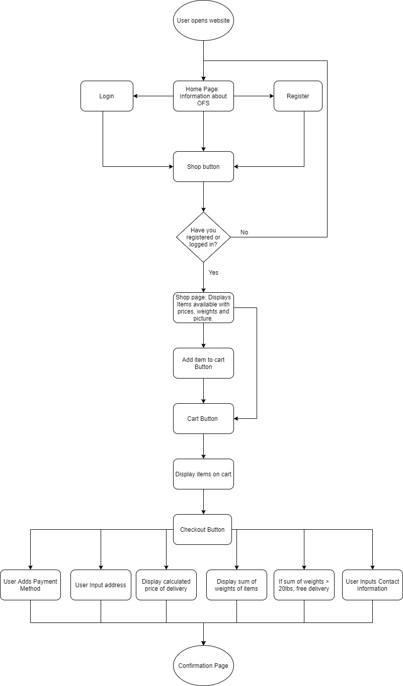

Architecture / High-level Design: 2-page minimum

**1. Component architecture diagram:**

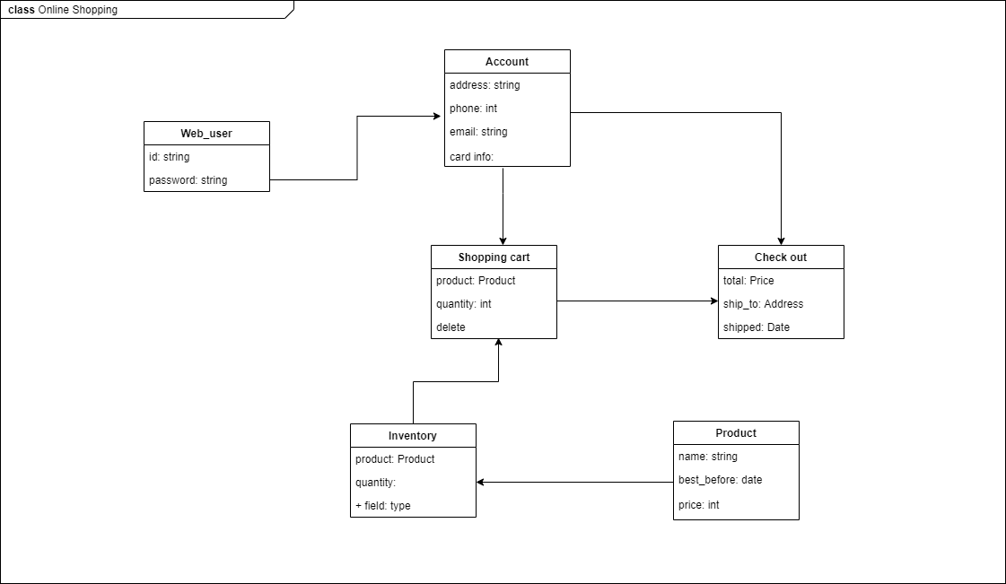

This program requires several databases based on php. Firstly, users need to create id and password to log-in and to keep their information including address, phone number, email address and card information. Another DB is information of each product such as name and expiration date and price. Inventory DB manages how many products are sold and in stock. Shopping cart DB stores number of products and subtotal price on each account. Using each accounts’ card information, Check-out allows users to pay and enter the address to ship and to keep track of the delivery.

**2. Component design and descriptions**

The program is the online food store to deliver food in the San Jose Downtown area. In the home page, there are four main sections which are login, register, shop button and shopping cart button. For the login section, it allows users to type in username and password, if the user has not created his/her own account, he/she can click the register button which will jump into the register page. A list of all available products will be shown as the user clicks the shop button. On the right top side, there will be a tiny shape of shop cart and it can bring users into their shopping cart.

**3. HW, SW, Tools, Framework, ... etc**

At the beginning stage of our software development, the team came together and discussed what hardware and software we were using. On the developer's side, hardwares being used for this project will be every group member's personal computer that is with MacOS and Windows operating systems. On the customer's end, we expect users will use computers and mobile devices to load into our website. The software that will mainly be used in this project are Ide such as Atoms, Intellij, PhpStorm and XAMPP that is able to run language such as HTML, PHP, Java and run database Mysql. Another Language our team aims to use is JAVASCRIPT. With online tools such as W3schools, youtube tutorials, and peer help our team will create the project. The team also further discussed aspects of framework usage. Framework options such as Django, React, Spring Boot and many more are used widely by many tech companies. But due to the development level of our team being fairly entry level, and different operating systems used during the development stage of a website it will be hard for every member to configure their person computer to use the framework, learn to use the framework and develop a website with the framework. Thus, we decide to use our basic knowledge being taught in class about HTML, PHP and CSS to develop the frame and infrastructure of the website.

The knowledge of coding and algorithms are different for each of the students. The team comprises four Industrial and Systems Engineers and three Computer Science and Computer Engineers. Each member brings different aspects to the table. The dynamics of the team have been split into roles to help manage the project efficiently. are Makayla as the Scrum leader and Project Manager. Meeting minutes are to be taken by Lesley and Guido. The team has also designated “go-to” people for certain situations. These students are in the group who are responsible for the section and answering questions. Yuchao, Snoop, and Jooyul are the designated people to ask about software implementations and questions. Guido and Ben are the designated people to ask about design, design changes, or implementations. Each member in this group is to ask these students first, then ask the rest of the group for needed help. In a special case where none of the students are able to answer the question, students will ask peers and then follow up with messaging the professor.