C program: Develop a modular program to find GCD and LCM of given numbers
Program:

#include <stdio.h>
main()
{

int a, b, x, y, temp, gcd, lcm;
printf("Enter two numbers: ");
scanf("%d %d", &a, &b);

x = a;
y = b;

// Standard GCD logic
while (y != 0)
{
temp = y;
y = x % y;
x = temp;
}

gcd = x;
lcm = (a * b) / gcd;

printf("GCD: %d\n", gcd);
printf("LCM: %d\n", lcm);

}

GCD (Greatest Common Divisor)
The largest number that can divide into both numbers without leaving a remainder.
- Example: For 12 and 18.
  - Divisors of 12: 1, 2, 3, 4, 6, 12
  - Divisors of 18: 1, 2, 3, 6, 9, 18
- GCD = 6 (The biggest one they both share).
LCM (Least Common Multiple)
The smallest number that both numbers can divide into perfectly.
- Example: For 12 and 18.
  - Multiples of 12: 12, 24, 36, 48...
  - Multiples of 18: 18, 36, 54...
- LCM = 36 (The first "meeting point" on their number lines).
The Connection
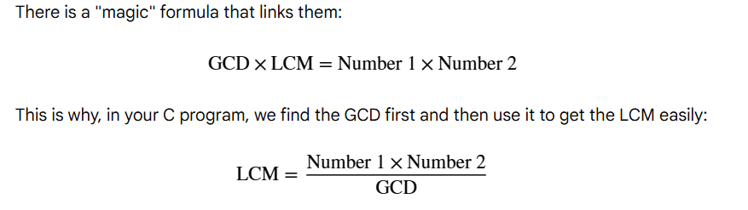
A Practical Example: GCD(48, 18)
The program keeps dividing the numbers until the remainder is zero.
- Step 1: 48 % 18 = 12 remainder.
  - Now, we forget 48 and look at 18 and 12.
- Step 2: 18 % 12 = 6 remainder.
  - Now, we look at 12 and 6.
- Step 3: 12 % 6 = 0 remainder.
  - The loop stops.
The last number that divided perfectly (without a remainder) was 6. That is your GCD.

