SET-A

Question:1

Program
import matplotlib.pyplot as plt
import numpy as np
x = np.array(['mon','tue','wed','thur','fri','sat'])
y = np.array([130,120,135,130,150,80])
plt.subplot(1, 2, 1)
plt.plot(x,y)
plt.plot(x,y, linestyle = 'dotted',color='blue',marker='D',mec='yellow',mfc='yellow')
plt.xlabel("Days ")
plt.ylabel("No: of absentees")

Output
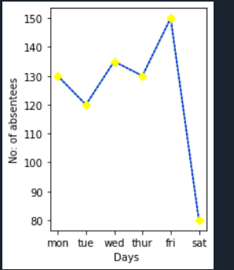

Question:2

Program
i = 1
n= int(input("Enter limit:"))
for k in range(1, n+1):
c = 0
for j in range(1, i+1):
a = i % j
if a == 0:
c = c + 1
if c == 2:
print(i)
else:
k = k - 1
i = i + 1

Output
