**Тема: “Команди Linux для архівування та стиснення даних”**

**Мета роботи:**

1. Отримання практичних навиків роботи з командною оболонкою Bash.
2. Знайомство з базовими командами для архівування та стиснення даних.

**Завдання для попередньої підготовки. Nikita**

1. Прочитайте короткі теоретичні відомості до лабораторної роботи та зробіть невеличкий словник базових англійських термінів з питань призначення команд та їх параметрів.

|  |  |
| --- | --- |
| tools | інструменти |
| compression | стиснення |
| blanketed | ковдрою |
| algorithm | алгоритм |
| affect | впливати |
| advantages | переваги |
| software | програмне забезпечення |
| archive | архів |
| drawbacks | недоліки |

1. На базі розглянутого матеріалу дайте відповіді на наступні питання:
   1. Яке призначення команд *tar*, *xz*, *zip*, *bzip*, *gzip*? Зробіть короткий опис кожної команди та виділіть їх основні параметри. Яким чином їх можна встановити.

tar Linux is a built-in archiver.

**tar опции архив.tar файлы_для_архивации**

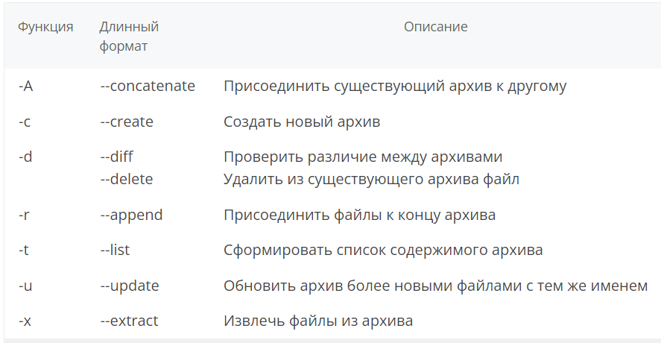

xz is a new general-purpose, command line data compression utility, similar to gzip and bzip2. It can be used to compress or decompress a file according to the selected operation mode.

**xz** [*option*]... [*file*]...

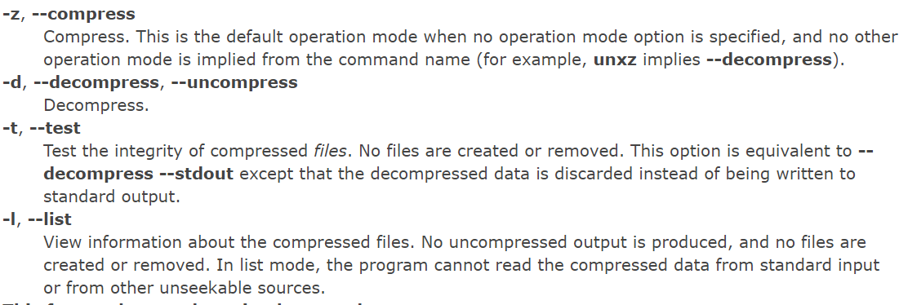

ZIP is a compression and file packaging utility for Unix. Each file is stored in single .zip {.zip-filename} file with the extension .zip.

zip [options] zipfile files_list

-d Option: Removes the file from the zip archive

-u Option: Updates the file in the zip archive

-m Option: Deletes the original files after zipping

-r Option: To zip a directory recursively, use the -r option with the zip command and it will recursively zips

-x Option: Exclude the files in creating the zip

-v Option: Verbose mode or print diagnostic version info

bzip2 command in Linux is used to compress and decompress the files

bzip2 [OPTIONS] filenames ...

-z : This option forces compression. It is an opposite command of decompression i.e. -d Option.

-k: This option does compression but does not deletes the original file

d : This option is used for decompression of compressed files

t : This option does the integrity check of the file and does not decompresses the file. It gives us the idea that the file is corrupt or not

-v : Verbose mode show the compression ratio for each file processed

gzip command compresses files. Each single file is compressed into a single file. The compressed file consists of a GNU zip header and deflated data.

gzip [Options] [filenames]

-f option : Sometimes a file cannot be compressed. Perhaps you are trying to compress a file called “myfile1” but there is already a file called “myfile1.gz”. In this instance, the “gzip” command won’t ordinarily work.

-k option :By default when you compress a file using the “gzip” command you end up with a new file with the extension “.gz”.If you want to compress the file and keep the original file you have to run the gzip command with -k option:

-L option : This option displays the gzip license.

-r option : This option can compress every file in a folder and its subfolders

-[1-9] option : It allows to change the compression level

-v option: This option displays the name and percentage reduction for each file compressed or decompressed.

* 1. Наведіть три приклади реалізації архівування та стискання даних різними командами.

gzip -9 mydoc.txt

zip myfile.zip filename.txt

zip –m filename.zip *.txt

**Хід роботи. Misha**

* 1. Створіть таблицю команд вивчених у п.2 ходу роботи у наступному вигляді:

|  |  |
| --- | --- |
| Назва команди | Її призначення та функціональність |
| Tar | Manipulate archives: create, delete, extract, add, update |
| gzip | Technic of compress files. Access to manipulate created by this command files |
| Bzip2 | Technic of compress files. Access to manipulate created by this command files |

* 1. Ознайомтесь з командою tar та за її допомогою виконати:
* створити файл з розширенням .tar;

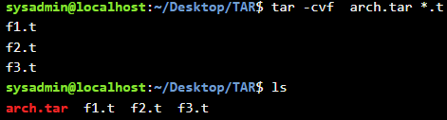

* створити файл з розширенням .tar, що складається з декількох файлів і каталогів одночасно;

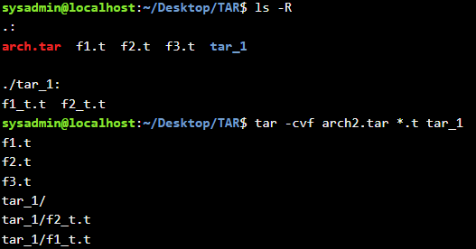

* перегляду вмісту файлу;

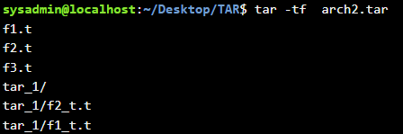

* витягти вміст файлу tar;

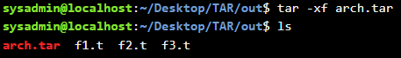

* створити архівний файл tar, стиснений за допомогою bzip;



* витягти вміст файлу tar bzip;

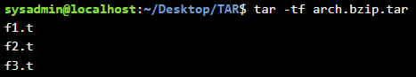

* створити архівний tar файл, стисненого за допомогою gzip
* витягти вміст файлу tar gzip.

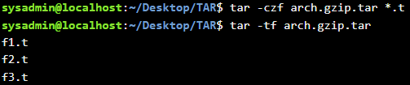

**Контрольні запитання Nikita Misha**

1. Надайте порівняльну характеристику процесам стискання та архівування.

|  |  |
| --- | --- |
| Compress | Archive |
| Process of minimize size of file by simplifying them. This cost quality of file but have efficient influence on size | Process of minimize size of file by using technology based on type of archived file, to reduce recurring section, code the file data into another – more rational. This method don`t cost any information or quality of file |

1. Які програми, окрім наведених в роботі, можуть використовуватись для стискання та архівування файлів та каталогів в ОС Linux? Наведіть приклади та їх короткий опис.

SHAR

Shar allows you to create self-extracting archives. It is essentially a shell script and needs a Bash shell or other Bourne Shell compatible shell to unpack. Shar has several advantages, but it is also potentially insecure because the archive is an executable file.

AR

ar is a utility for creating and managing archives. Mainly used for archiving static libraries, but can be used to create any kind of archive.

CPIO

cpio stands for Copy in and out. This is another standard archiver for Linux. It is actively used in the Red Hat package manager, as well as for creating initramfs. Archiving in Linux for regular files using this program is not applicable.

XZ

Another highly efficient compression algorithm. Backwards compatible with Lzma. Call parameters are also similar to Gzip.

1. Порівняйте алгоритми стискання, що використовуються в командах (програмах), використовуваних в Linux. Які з алгоритмів можна вважати найшвидшим та найефективнішим?

gzip

The most commonly used is Gzip. This is the standard Unix/Linux compression utility. For decompression use gunzip or gzip -d Let's look at its syntax first:

bzip

bzip2 is another alternative compression utility for Linux. It is more efficient than gzip, but slower. To unpack, use the bunzip2 utility.

LZMA

New and highly efficient compression algorithm. The syntax and options are also similar to Gzip. Use unlzma to unpack.

ZIP

Cross-platform utility for creating compressed zip archives. Compatible with Windows implementations of this algorithm. Zip archives are very often used to share files on the Internet.

1. Опишіть програмні засоби для стискання та архівування, що можуть бути використані у вашому мобільному телефоні.

Google Play have many programs to compress, archive, de-archive – usually one program have all this tools:



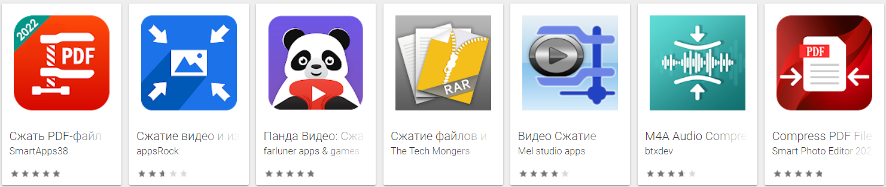

1. Опишіть та порівняйте програмні засоби для стискання та (де)архівування даних у ОС сімейства Windows.

WinRAR is a file archiver for 32-bit and 64-bit Windows operating systems that allows you to create, modify and unpack RAR and ZIP archives, as well as work with many archives of other formats. WinRAR and the RAR archive format are constantly evolving. Starting from version 5, WinRAR has added support for the new RAR5 archive format, which is incompatible with the previous format but uses the same RAR extension. In the RAR5 archive format, the maximum dictionary size has been increased to 1 GB (you can choose from 11 values ​​- from 1 MB to 1 GB). By default, WinRAR version 5 uses a 32 MB dictionary (previously 4 MB), which usually achieves a higher compression ratio.

7-Zip is a free file archiver with a high degree of data compression. Supports multiple compression algorithms and many data formats, including native 7z format with highly efficient LZMA compression algorithm. The program has been developed since 1999, it is free and open source, most of which is freely distributed under the terms of the GNU LGPL, with the exception of the UnRAR unpacker code, which has limitations. Primary Platform - Windows

PeaZip is a free (GNU Lesser General Public License) and free cross-platform archiver and GUI for other archivers.

PeaZip supports Pea's own archive format (with support for compression, multi-volume archives, and a flexible encryption and integrity system) and other formats, using external programs and libraries for many of them. Most of the utilities mentioned can be run both in console mode and through a graphical shell that has a friendly user interface.

The current version of the program has the following disadvantages:

* UTF-8 encoding is not fully supported by the user interface;
* The program shell prioritizes the compression/decompression process over the interface, so the interface may react to user actions with a delay during operations.

1. Поясніть яким чином стиснення та архівування даних може бути використано для резервування даних. В яких ще задачах системного адміністрування воно може бути використано.

To back up data, we can use archiving or compression technologies that are able to create a copy of the current original file that takes up less space. Thus, we have a backup copy of data on our computer, and even with a reduced size - a miracle!

In the tasks of reducing the space occupied in the storage of those data that not just exist, but are not specifically required now.

Висновок **Nikita Misha**

In this lab, we learned about archivers and data compressors. How they work, what technologies are used (algorithms), how they are presented in Linux and Windwos and how to use them