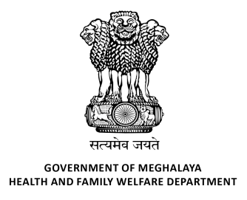
GOVERNMENT OF MEGHALAYA
HEALTH AND FAMILY WELFARE DEPARTMENT

OFFICE OF PROJECT DIRECTOR
GOVERNMENT OF MEGHALAYA
HEALTH AND FAMILY WELFARE DEPARTMENT ____________________________________________________________________

ADMIT CARD

Name: - «Name»

Roll No: - «Roll_No»

Sub: Written Exam for the post of Cluster Programme Manager

Shri/Smt,
In reference to your application for the post mentioned above, you are hereby requested to appear for the Written Exam on the 31st May 2025 at Jail Road Boys Higher Secondary School, Police Bazar, Shillong from 10:00 A.M. to 11:30 A.M. (You are hereby directed to report to the venue at 9:30 A.M. i.e. Half an hour earlier before the commencement of the examination).
Kindly note that only Candidates qualified in the written exam will be eligible to appear for the Personal Interview. For more information you can visit the office website www.meghalayasacs.com / Notice Board of the office of the undersigned.

Instruction to Candidates

1. No candidates will be allowed to sit in the examination hall without producing their PHOTO IDENTITY PROOF like Voter ID Card, Driving License, Pan Card and any ID Proof issued by the Govt. recognized Institution or Govt. of India or any State Govt. only will be accepted.
2. Possession/Use of Correction Pen, Mobile Phone, Calculator or any Electronic Device is banned in
the Examination Hall.
3. No TA/DA will be paid for appearing the Written Exam/Interview.
4. This letter should be treated as an ADMIT CARD
5. Please bring BLACK BALL POINT PEN to darken the appropriate circle in the OMR Answer Sheet

Sd/-
Project Director,
Meghalaya AIDS Control Society,
Shillong.

