**Supplementary Material:**

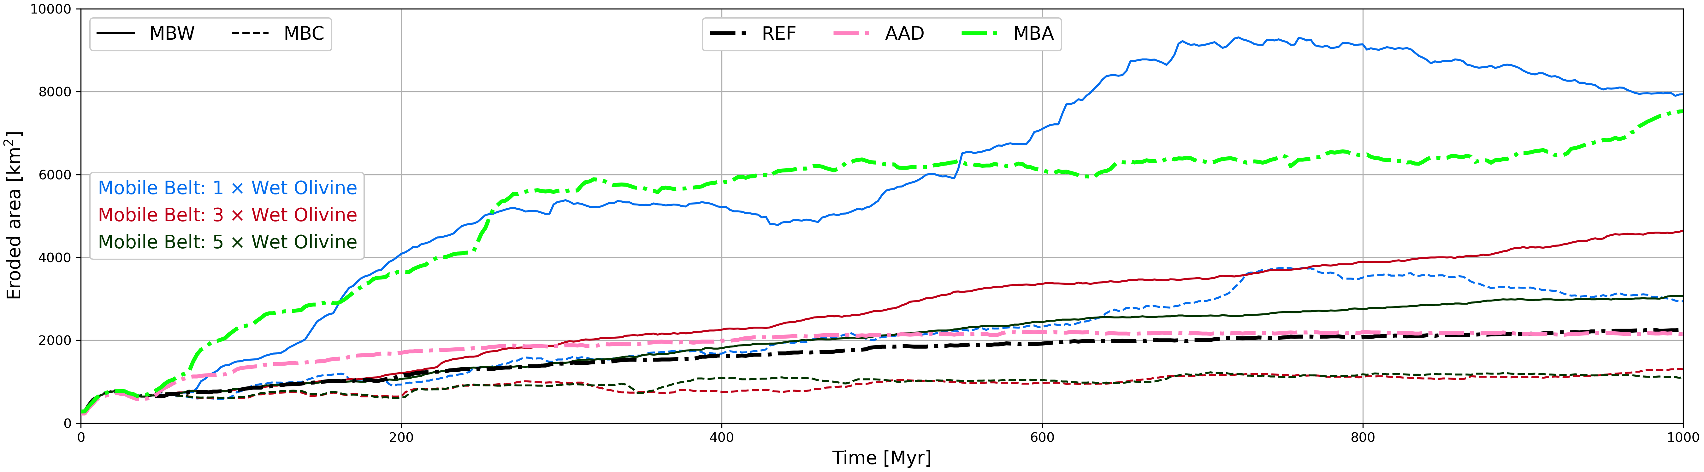Figura 1: Evolution of the erosion of lithospheric base for MBW (solid lines) and MBC (dashed lines) according to the scale factor of mobile belt rheology: 5 (green), 3 (red) and 1 (blue). Black, pink and light green dashed dotted lines corresponds to Reference (REF), Alternating Asthenospheric Drag (AAD) and Mobile Belt with Alternating drag (MBA) scenarios, respectively.

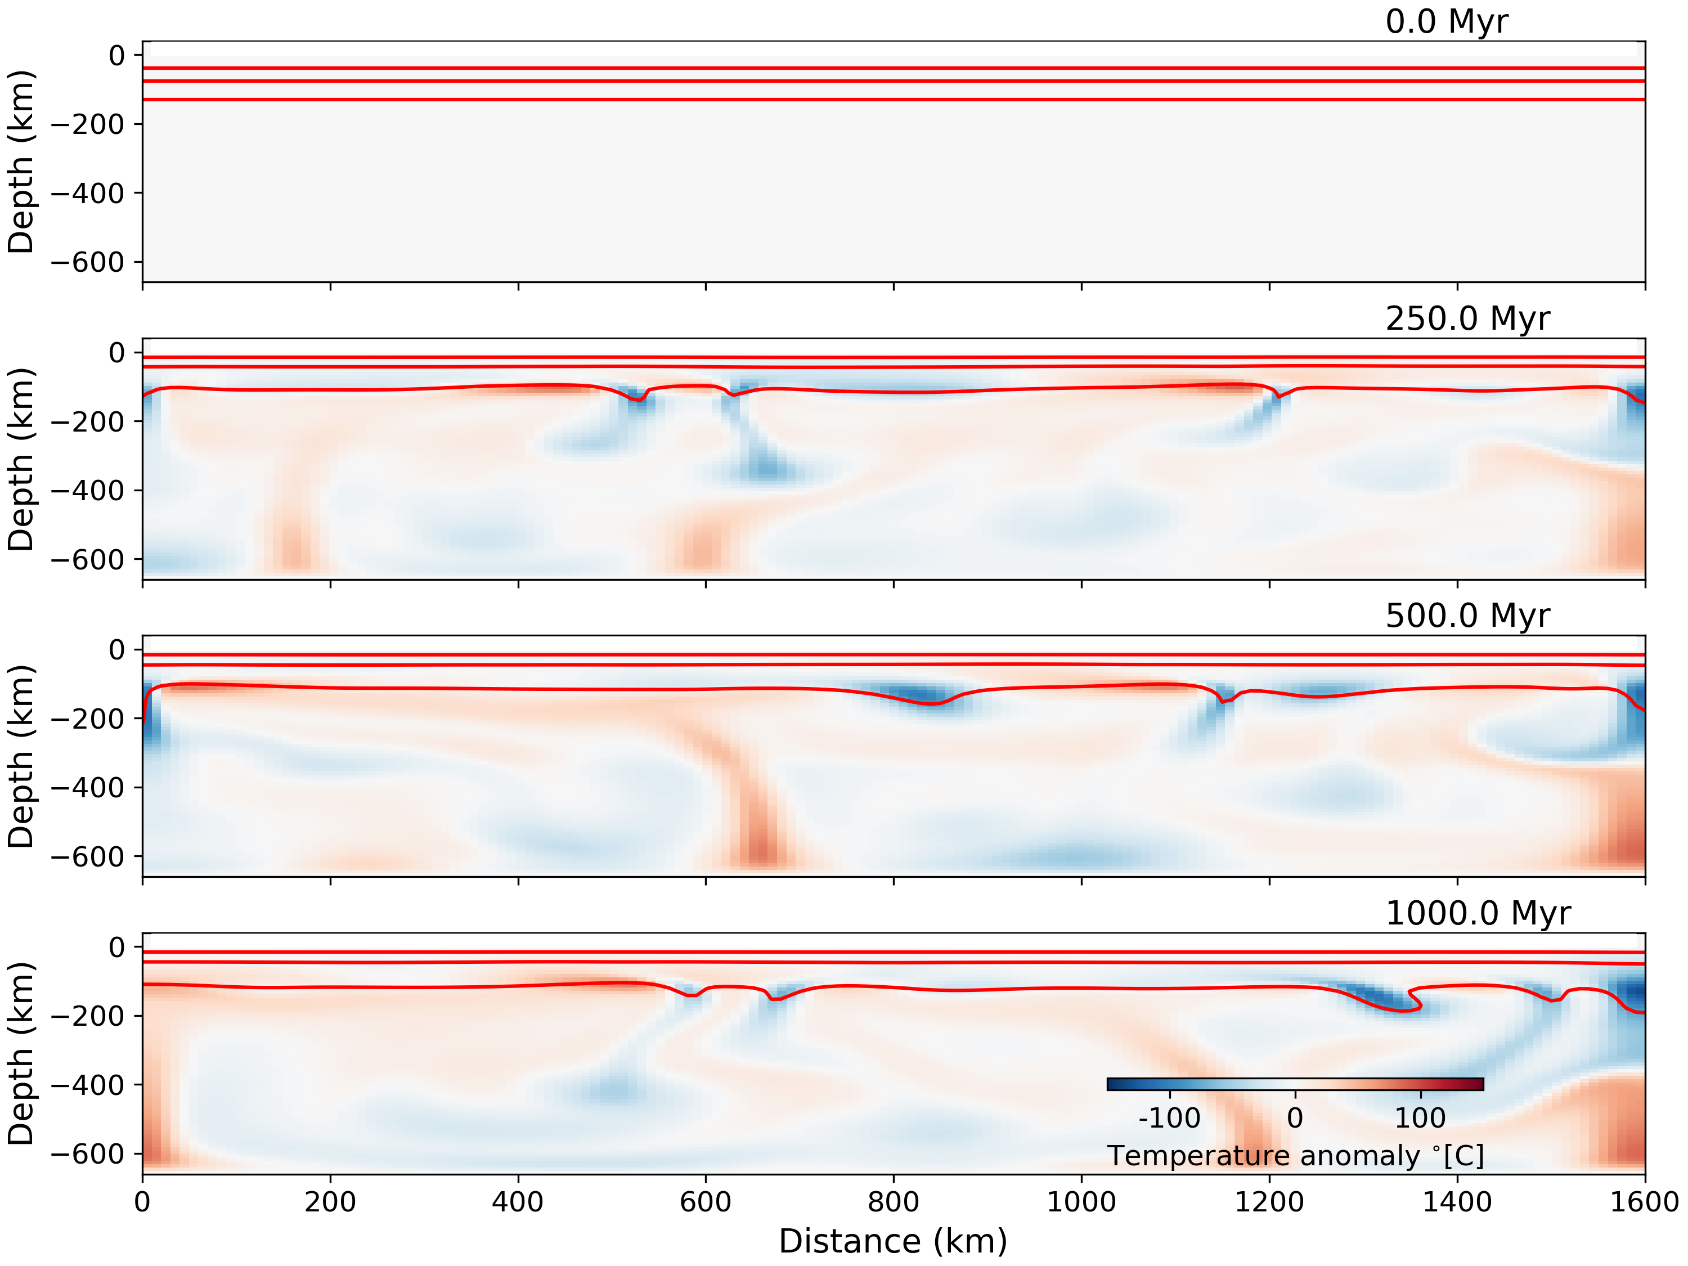Figura 2: Evolution of temperature anomaly for the preliminary scenario used to build the cratonic keel scenarios. Red lines shows the 500, 800, 1300 °C isotherms.

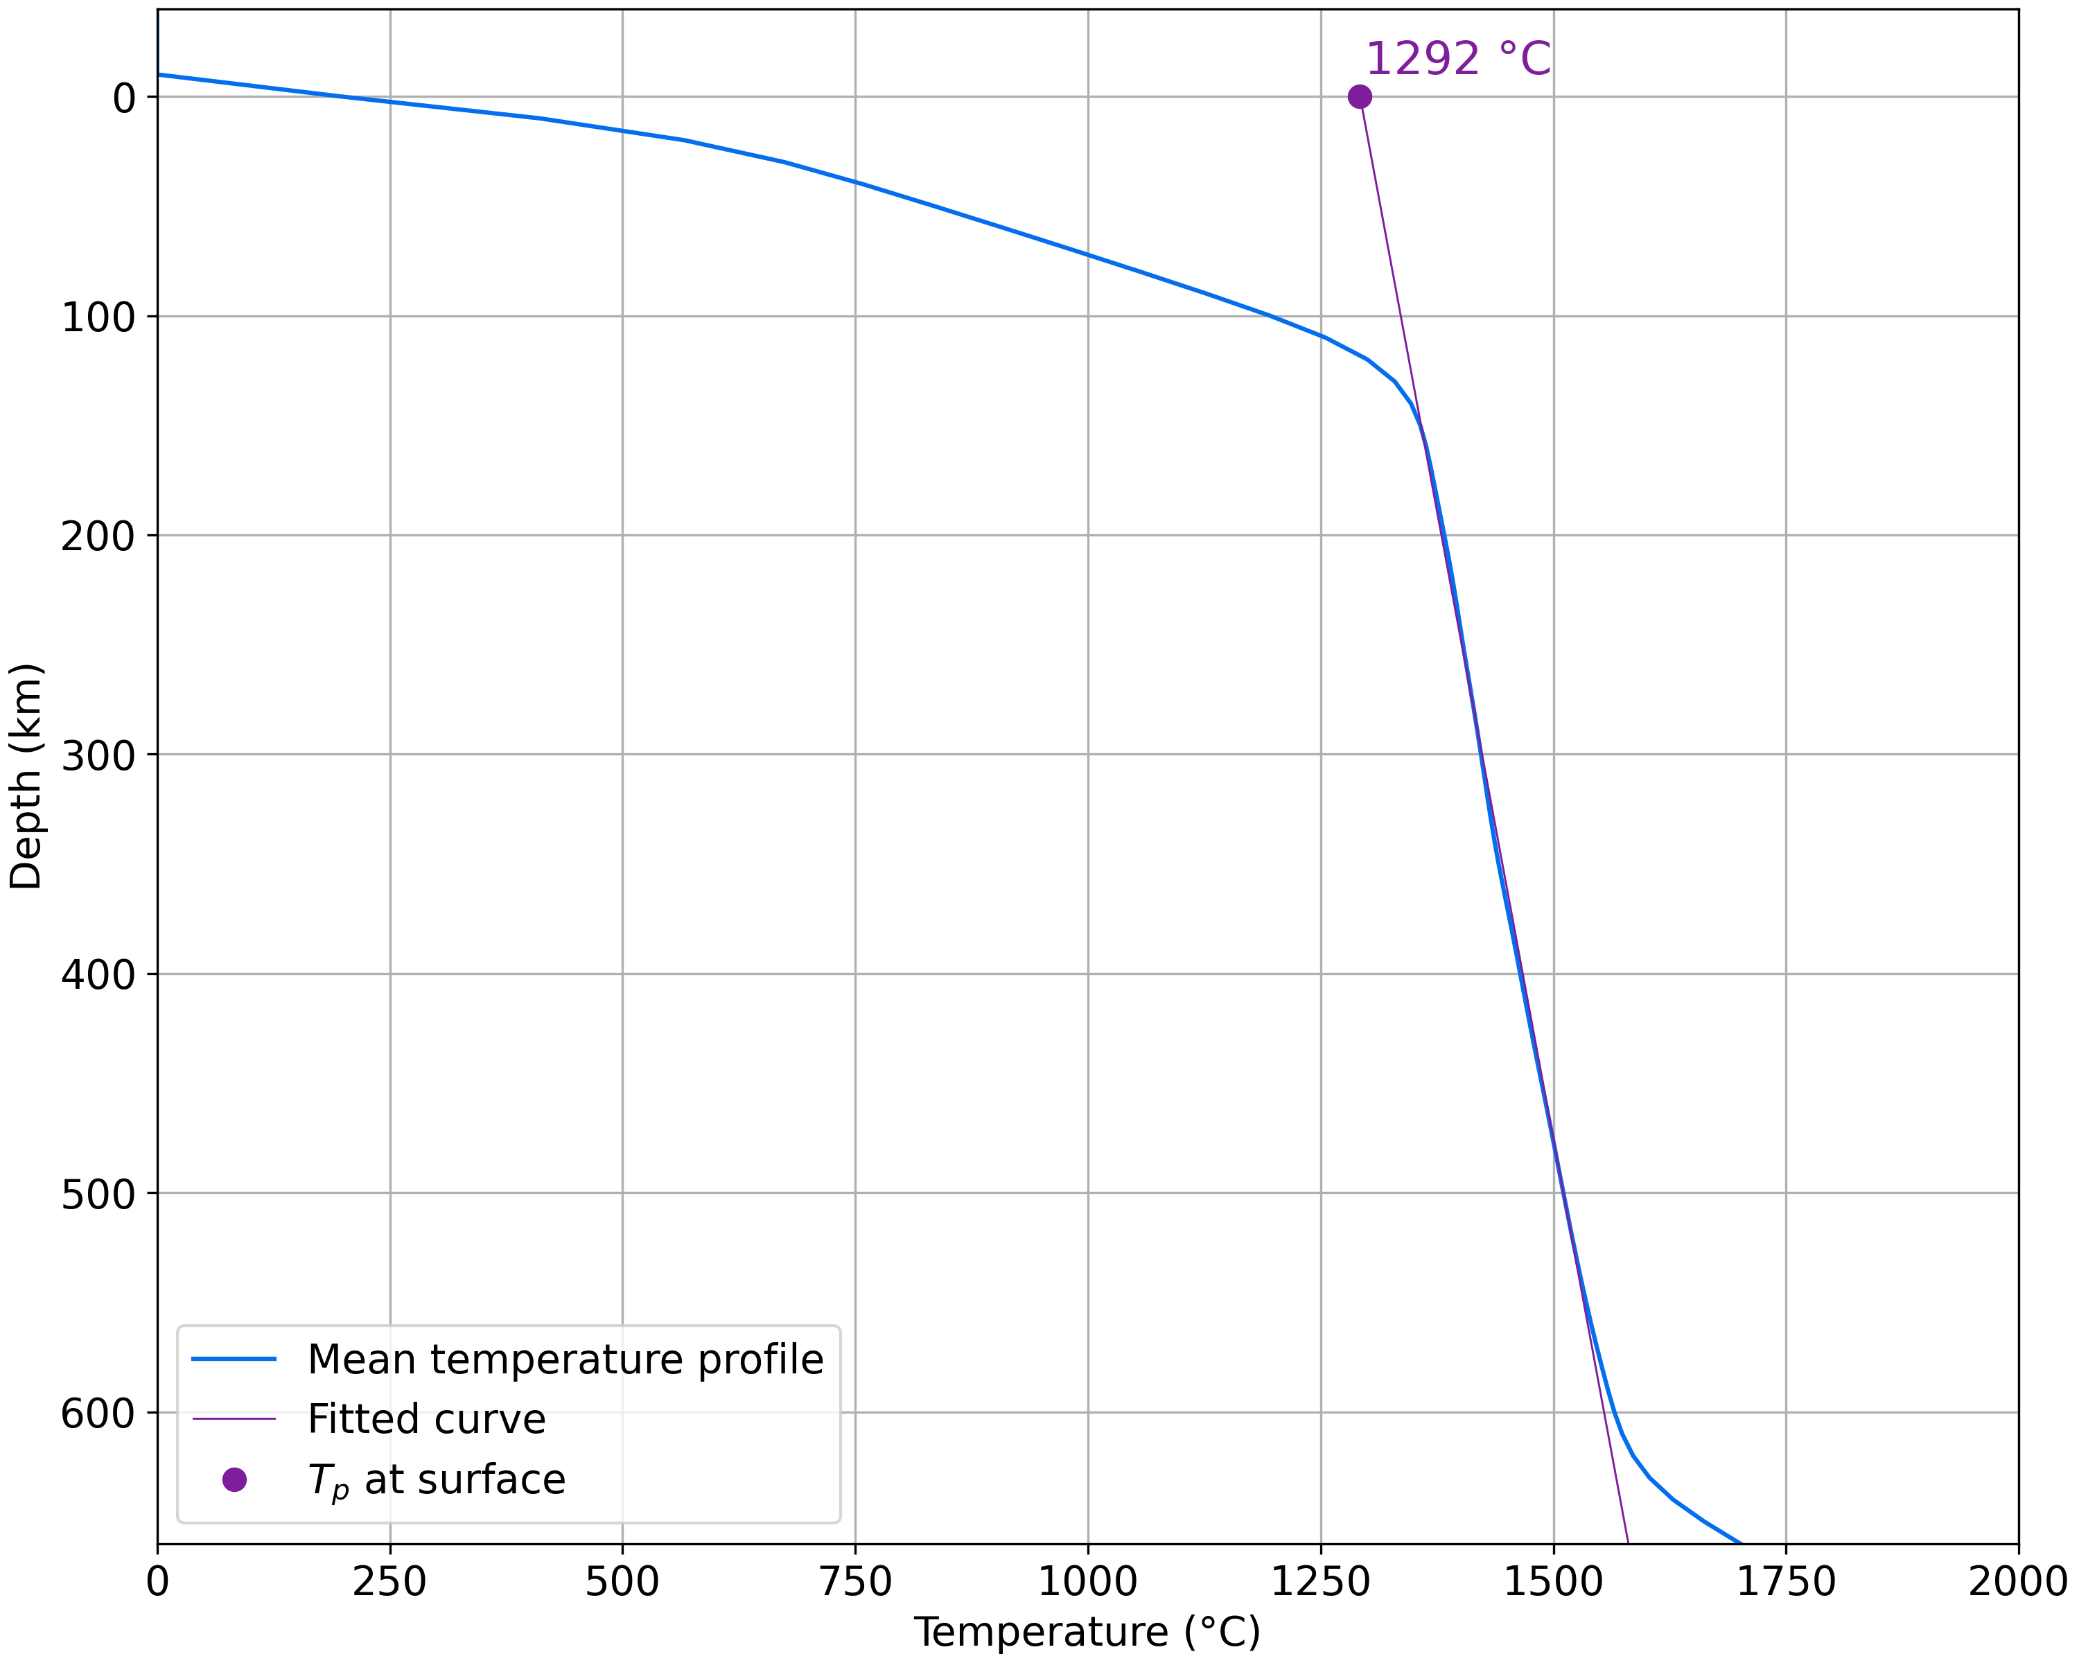Figura 3: Final mean thermal profile for preliminary scenario (blue line) with fitted curve (purple line) used to estimate the mantle potential temperature of 1292 °C (purple filled circle).