*Research paper*

*Prefabs in Unity*

Joona Räisänen

Research paper

3D Modelling and Texturing, Risto Koskenkorva

3.12.2023

Bachelor's Degree Programme in Business Information Technology

Contents

1 What are Prefabs? 3

1.1 Creating Prefab Assets 3

2 Using Prefabs 4

3 Changing Prefabs 4

3.1 Prefab Mode 5

3.2 Prefab Overrides 5

References 6

# *What are Prefabs?*

Prefabs are object templates that allow you to save the configuration of a game object that’s in your scene as an asset in your project (French 2023).

Prefabs are a better way of reusing a GameObject in multiple places in your Scene, or across multiple scenes. Because the prefab system allows you to automatically keep all the copies in sync (Unity Manual 2018).

Prefabs are an easy way of making copies of your assets and modifying them independently.

## *Creating Prefab Assets*

To create a Prefab asset, drag a game object from the hierarchy window into the project window. This will save copy of it as a template, exactly as it is, with its structure, components and unique data intact, so that it can be reused elsewhere in the game (French 2023).

Figure 1 Making a prefab of the original GameObject.

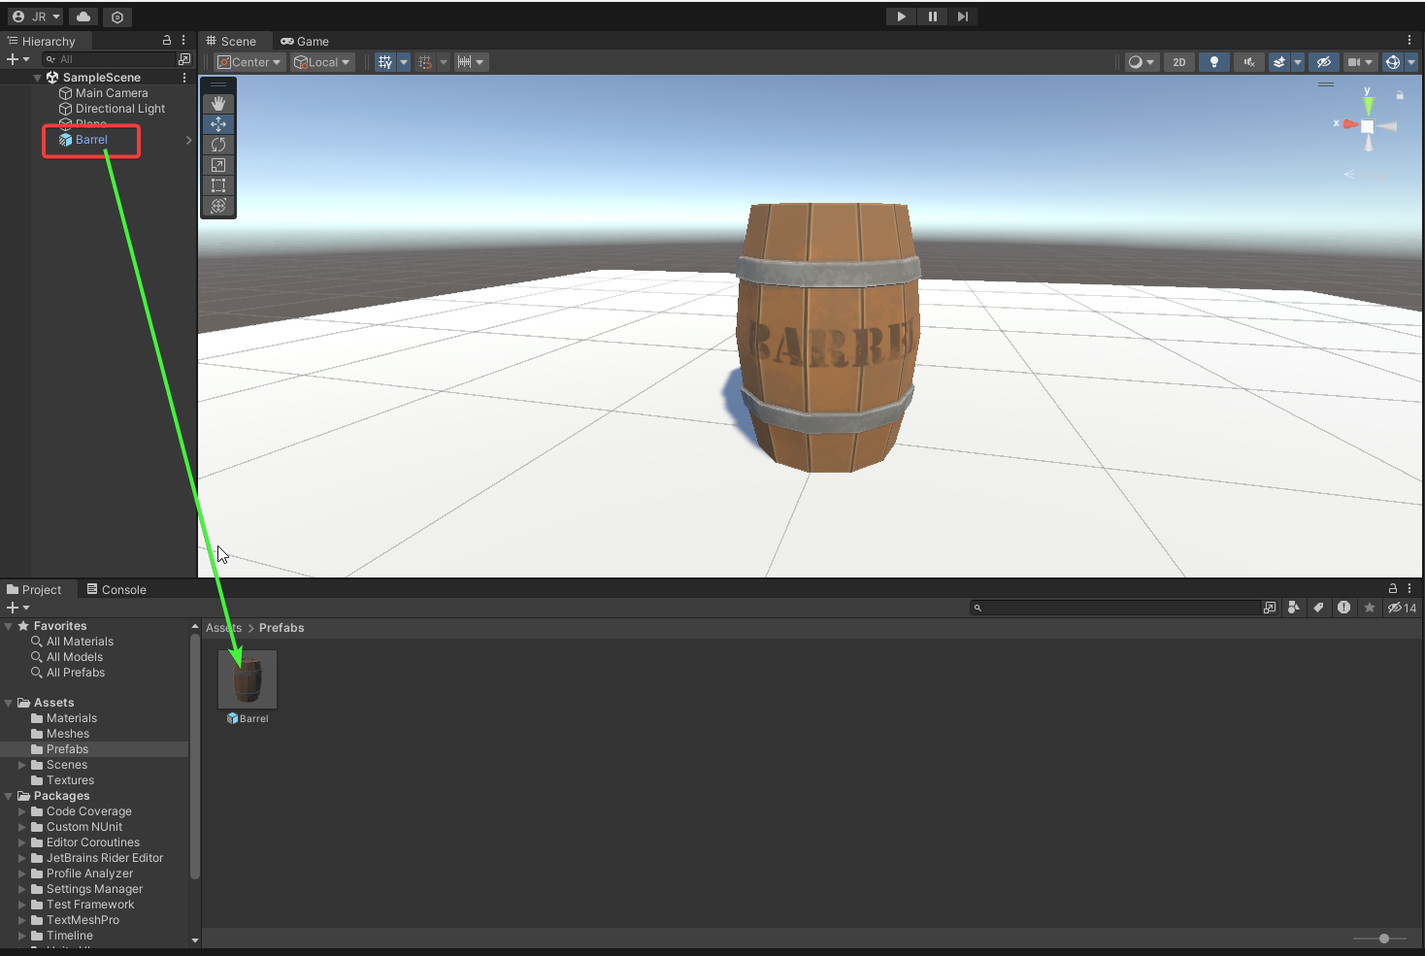

This also makes your original Game Object a prefab instance indicated by the blue icon in the hierarchy window.

# *Using Prefabs*

You can create a new instance of a prefab by dragging it from the project window to the scene or hierarchy windows.

This instance can be modified independently without affecting other instances of the prefab.

Figure 2 Creating a new instance of a Prefab.

# *Changing Prefabs*

According to French (2023). There are two ways you can change a prefab in Unity. Either by changing the preb itself, in Prefab Mode, or by modifying one of it’s instances with a Prefab Override (French 2023).

## *Prefab Mode*

Figure 3 You can enter prefab mode by double clicking a Prefab in the Project window, or by clicking open in the inspector.

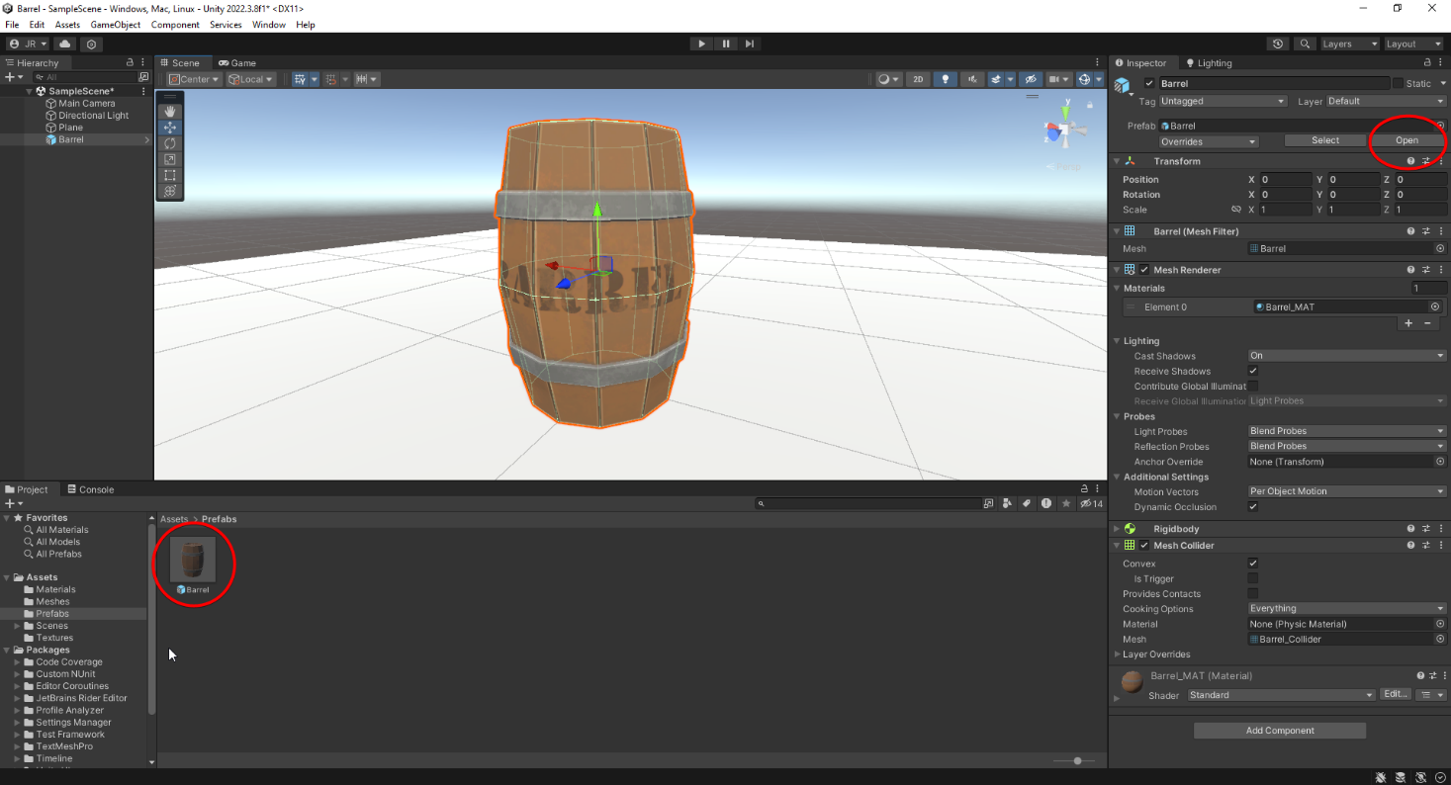

Any Modifications you make in Prefab mode will be applied to other copies of the asset, anywhere else in the game(French 2023).

## *Prefab Overrides*

A prefab override is a change made on an instance of a prefab, not the original prefab asset itself. This overrides the prefabs original value, preventing it from being changed when the base prefab is (French 2023).

This could be useful when you have multiple instances of a prefab in the same scene and want them to have some variations.

*References*

French, J. (2023, Apr 16). How to use Prefabs in Unity. Gamedevbeginner. <https://gamedevbeginner.com/how-to-use-prefabs-in-unity/>

Unity Technologies. (2018, Jul 31). Prefabs. Unity Documentation. <https://docs.unity3d.com/Manual/Prefabs.html>