Network Architecture:
Via Router and port forwarding each worker has an unique Ip address and port number.
Communication protocol between workers is implemented with SSL/TSL package.

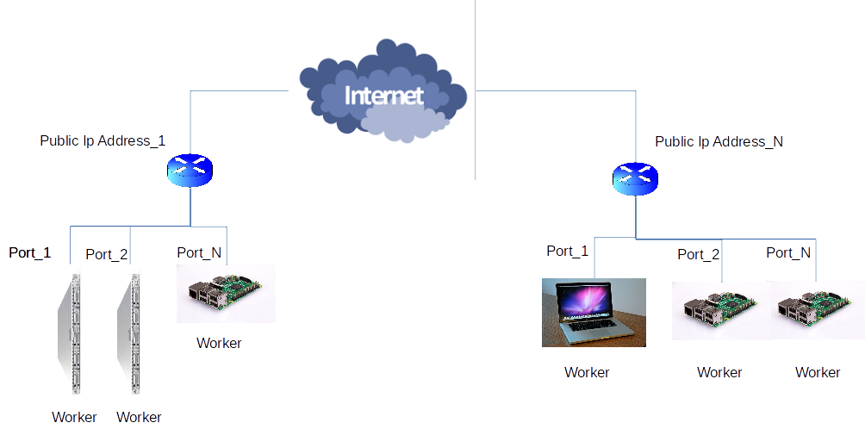

SW Architecture

