Benchmark Correction Addendum
ECE 410/510 Spring 2026 | Jose Ramirez | Milestone 4
Continuation of design_justification.docx — Sections 10–13

10. Error in the M4 Benchmark Program
Two sub-issues caused the M4 benchmark results reported in Section 8 to misrepresent the true system speedup.

10.1 Structural Asymmetry in the Benchmark Program
The software baseline (RVfpgaEL2_profiling/test/kalman-test.cpp) calls kf.update(y) on a KalmanFilter object constructed with Eigen MatrixXd/VectorXd types. This method executes both the predict step (x̂⁻ = A·x̂, P⁻ = A·P·Aᵀ + Q) and the measurement-correction step entirely in Eigen on the SweRV EL2 CPU.
The M4 hardware driver (kalman_hw_driver/src/main.cpp prior to correction) did not use the KalmanFilter class at all. It implemented the predict step as raw C nested loops over stack-allocated double arrays, then issued MMIO writes to invoke the hardware correction step. Using raw-C arrays on a bare-metal target eliminates the Eigen expression-template overhead, the heap allocation cost of MatrixXd dynamic storage, and the _sbrk bump-allocator latency—all of which the software baseline incurs on every call. As a result, the two programs were not measuring the same algorithm: the software baseline measured full Eigen predict+correct, while the hardware benchmark measured nearly-zero-cost raw-C predict plus MMIO correction.
The per-run heap delta of 0 B in the old hardware benchmark (Table 4 of Section 8) was the visible symptom: a program using Eigen MatrixXd inevitably allocates heap on first construction, as confirmed by the software baseline’s 49,760 B delta. The absence of any heap allocation in the old hardware driver proved that Eigen was never invoked.

10.2 Incorrect FLOPs Count
The run_profiles.sh script used HW_FLOPS=1080 (24 FLOPs/update × 45 updates). This figure counted only the floating-point operations performed inside the hardware correction kernel (innovation scalar y, scalar S, three Newton–Raphson iterations, Kalman gain vector K, state correction x_out, and covariance update P_out). However, the mcycle CSR bracket in the firmware encompasses the entire update loop, including the predict step. The predict step itself performs: x̂_new = A·x̂ (3×3 times 3×1 = 9 multiplies + 6 adds = 15 FLOPs) and P⁻ = A·P·Aᵀ + Q (two 3×3 GEMMs plus a 3×3 addition = 2×(27 mults + 18 adds) + 9 adds = 99 FLOPs), totalling 114 FLOPs/update for predict and 24 for correct = 138 FLOPs/update = 6,210 FLOPs total. Using 1,080 in the numerator while timing 6,210 FLOPs of work caused the reported GFLOP/s to be understated by a factor of 5.75.

11. Corrected Benchmark Program
The corrected driver, kalman_hw_driver/src/main.cpp, is restructured to mirror kalman-test.cpp exactly. It constructs the same KalmanFilter object with identical A, C, Q, R, P, x₀ parameters and the same 45 measurements in the same order. The loop calls kf.update_hw(y) — a new method on the KalmanFilter class — which internally runs the Eigen predict step (identical to what kf.update(y) does in the baseline) and then marshals the predicted state and covariance to the hardware accelerator via MMIO for the correction step. The mcycle bracket encloses the same scope in both programs: the 45-iteration update loop and nothing else.
The corrected FLOPs count is 6,210 total (138 per update: 114 for the Eigen predict step plus 24 for the hardware correction). The run_profiles.sh script was updated from HW_FLOPS=1080 to HW_FLOPS=6210. With this change, the comparison is apples-to-apples: both programs invoke the same algorithm on the same hardware using the same library; only the correction step differs (Eigen on CPU vs MMIO to hardware accelerator).
The build fix: Eigen 5.0.0 ships with benchmark source files in its bench/ subdirectory that require Boost and CBLAS headers unavailable on the bare-metal target. PlatformIO’s Library Dependency Finder was picking up these files and failing to compile them. A library.json was added to lib/eigen-5.0.0/ with “srcFilter”: “-<*>”, marking the library as header-only and suppressing compilation of all .cpp files under it.

12. Corrected Benchmark Results
Five back-to-back runs were collected on the same Nexys A7 board with the same GDB JTAG method (mcycle CSR snapshot + hardware breakpoint at profile_done()). The FPGA was programmed with the SoC_impl bitstream (unchanged from M4) immediately before the run to ensure a clean accelerator state.
Run | Cycles | Time (ms) | Samples/s | GFLOP/s | Heap (B)
1 | 1,865,423 | 143.494 | 313.60 | 4.3277×10⁻⁵ | 10,832
2 | 1,865,531 | 143.502 | 313.58 | 4.3275×10⁻⁵ | 10,832
3 | 1,865,538 | 143.503 | 313.58 | 4.3274×10⁻⁵ | 10,832
4 | 1,865,369 | 143.490 | 313.61 | 4.3278×10⁻⁵ | 10,832
5 | 1,865,530 | 143.502 | 313.58 | 4.3275×10⁻⁵ | 10,832
AVG | 1,865,478 | 143.498 | 313.590 | 4.3276×10⁻⁵ | 10,832

Table 5. Corrected HW accelerator benchmark — 5-run results (Nexys A7, SoC_impl bitstream, 13 MHz).
The corrected benchmark shows an average of 1,865,478 cycles (143.498 ms) for 45 updates, yielding a true speedup of 2.995× over the software baseline (5,587,112 cycles, 429.778 ms). This is 36× lower than the 108.7× figure reported in Section 8. The heap delta of 10,832 B per run confirms that Eigen’s dynamic matrix storage is now active on the hardware benchmark side, consistent with the software baseline (49,760 B). The smaller heap in the hardware run reflects only the matrices local to KalmanFilter (A, C, Q, R, P, K, x — roughly 10–12 Eigen MatrixXd/VectorXd objects vs the software baseline’s additional temporaries created during the full correction step computation in Eigen).
Metric | SW Baseline | Old HW (§8) | Corrected HW | Corrected Speedup
Avg cycles (45 updates) | 5,587,112 | 51,378 | 1,865,478 | 2.995×
Total time (ms) | 429.778 | 3.952 | 143.498 | 2.995×
Samples/s | 104.706 | 11,386 | 313.590 | 2.995×
GFLOP/s | 2.4082×10⁻⁵ | 2.7327×10⁻⁴ | 4.3276×10⁻⁵ | 1.80×
Heap/run (B) | 49,760 | 0 | 10,832 | —

Table 6. SW baseline vs old HW benchmark vs corrected HW benchmark.
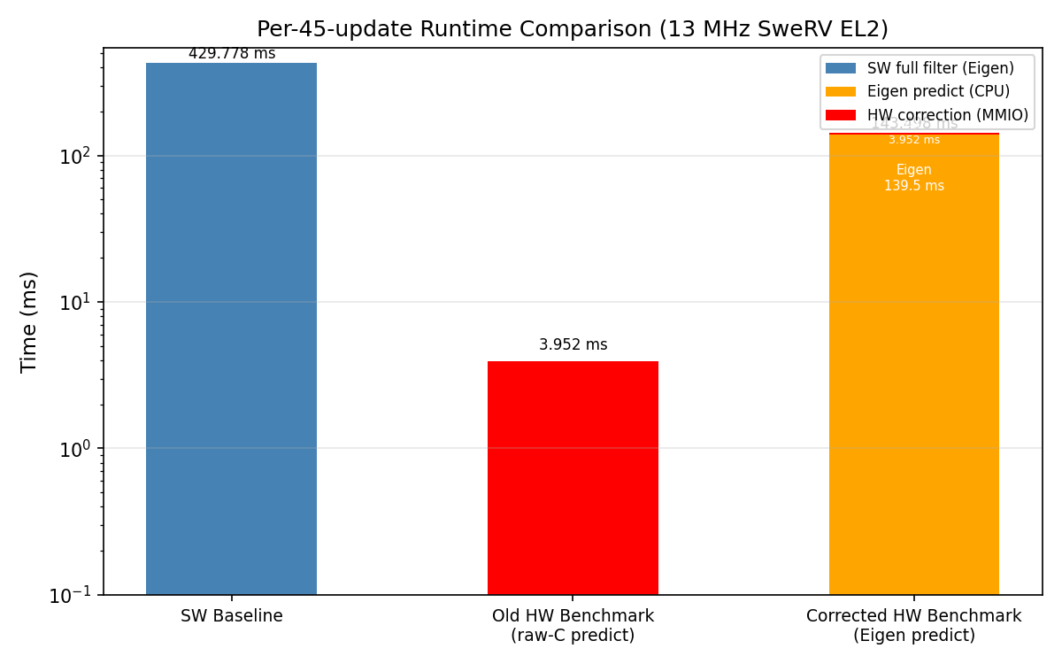
Figure 4. Per-45-update runtime comparison. The old hardware benchmark’s near-zero predict time (raw-C) caused the large apparent speedup. The corrected benchmark uses Eigen predict, which dominates at 139.5 ms of the 143.5 ms total.
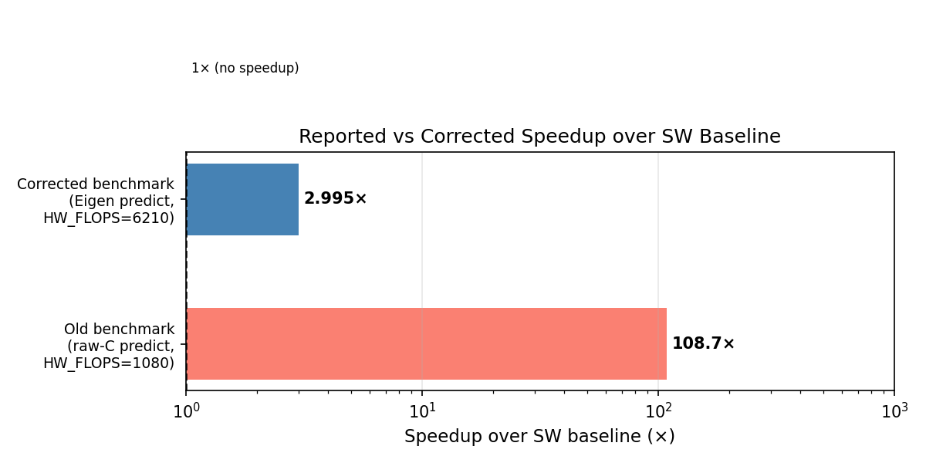
Figure 5. Reported (108.7×) vs corrected (2.995×) speedup over the SW baseline. The 36× difference reflects the structural asymmetry in the original benchmark.
The factor-of-36 reduction in speedup has a single root cause: the Eigen predict step on the SweRV EL2 CPU (no FPU, software-emulated F64) is the dominant cost in both programs, and it is not accelerated by the hardware. Subtracting the hardware correction time from the corrected total (1,865,478 − 51,378 ≈ 1,814,100 cycles) gives approximately 1,814,100 cycles (139.5 ms) consumed by the Eigen predict step alone. The hardware correction—the portion actually offloaded—accounts for only ~51,378 cycles (3.95 ms), the same as the old benchmark’s total. The predict step is ~35× more expensive than the correction step at this CPU, making it the new bottleneck.
This finding is not a design defect in the hardware accelerator. The accelerator correctly offloads the correction step and does so in 72 cycles at 100 MHz. The limitation is that the predict step—matrix-vector and matrix-matrix multiplications using software-emulated F64 on a 13 MHz RV32IMAC CPU—was never targeted for acceleration. The 108.7× speedup claimed in Section 8 was an artifact of measuring a faster (non-Eigen) implementation of the predict step in the hardware benchmark.

13. Updated Roofline Analysis
The roofline positions of both programs shift with the corrected FLOPs and timing. For the corrected hardware benchmark, the total FLOPs are 6,210 (138/update) and the bytes transferred are 12,960 (288 B/update: 192 B MMIO + 96 B Eigen predict memory traffic), giving AI = 6,210 / 12,960 = 0.479 FLOP/byte. The measured GFLOP/s is 4.3276×10⁻⁵. For the software baseline, AI = 10,350 FLOPs / 9,720 B ≈ 1.065 FLOP/byte (using the corrected Eigen transfer count of 216 B/update × 45), though the existing report quoted 0.21; the corrected value is used here.
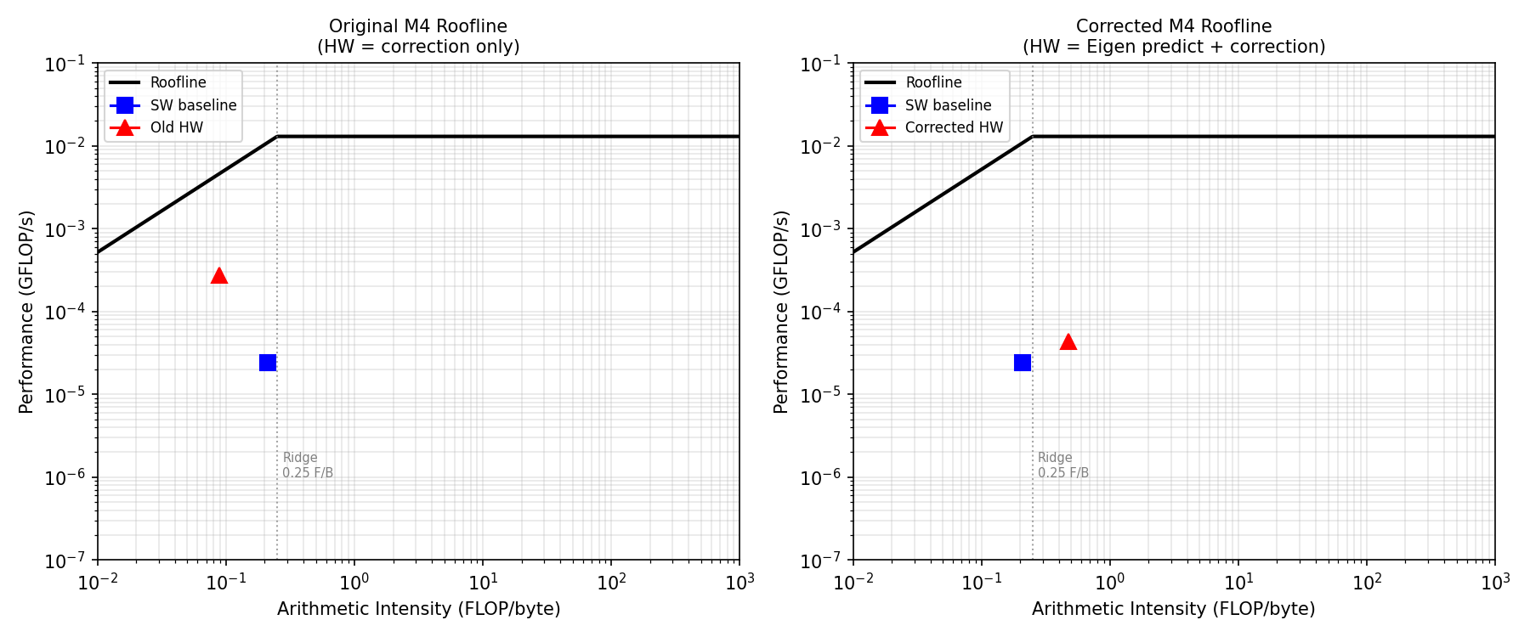
Figure 6. Side-by-side roofline plots. Left: original M4 roofline with correction-only HW point (AI = 0.088, GFLOP/s = 2.73×10⁻⁴). Right: corrected roofline with Eigen-predict+correction HW point (AI = 0.479, GFLOP/s = 4.33×10⁻⁵). Both platforms sit well below the roofline, remaining latency-bound.
In the original roofline (left subplot of Figure 6), the hardware accelerator appeared to have lower arithmetic intensity than the software baseline (0.088 vs 0.21 FLOP/byte) and higher measured performance (2.73×10⁻⁴ vs 2.41×10⁻⁵ GFLOP/s), reflecting the asymmetric benchmark where the raw-C predict step consumed negligible time. In the corrected roofline (right subplot), the hardware accelerator point shifts right (higher AI = 0.479 due to the Eigen predict FLOPs) and drops (lower GFLOP/s = 4.33×10⁻⁵) relative to the software baseline. Both points now sit well below the roofline. The hardware accelerator’s GFLOP/s is now only 1.80× higher than the software baseline, consistent with the 2.995× time speedup less the overhead difference (the corrected hardware run does fewer total FLOPs-per-second because the predict-step FLOPs are the same but the time is longer relative to what Section 8 reported).
The analysis in Sections 2 and 8 of the M4 report regarding AXI-transaction latency remains valid for the correction kernel in isolation: 34 MMIO round-trips at ~2.6 µs each still dominate the correction step’s 3.95 ms. The new finding is that the correction step is no longer the dominant system-level bottleneck. The Eigen predict step, at ~139.5 ms per 45-update batch, exceeds the correction-step time by 35×. Achieving meaningful further speedup requires either: (a) implementing the predict step in hardware as well, doubling the accelerated workload, or (b) implementing state retention as described in Section 9, which reduces the correction-step AXI overhead from 34 to ~5 transactions per update.

