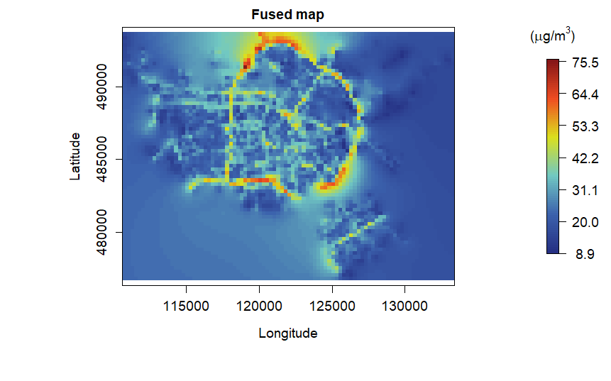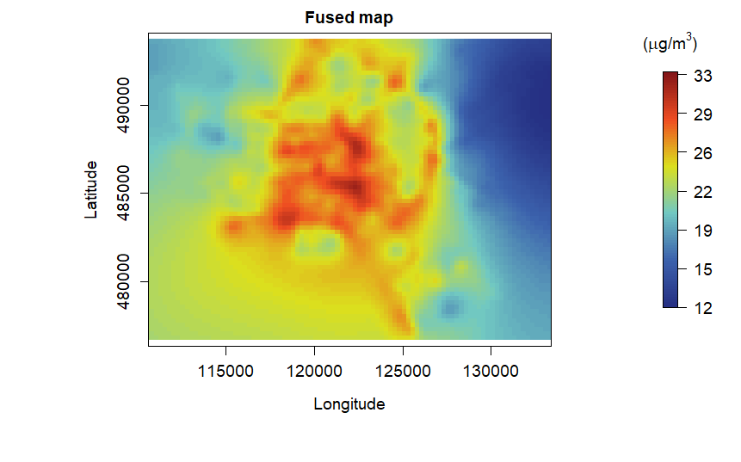

 drift grid size

 # driving days

 concentration restriction

 averaging of AirView observations

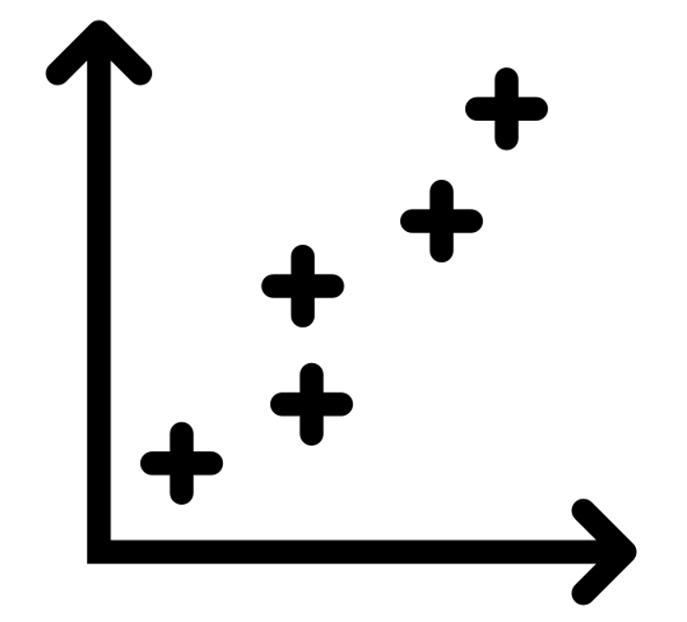 correlation

uncertainty measurement sensors

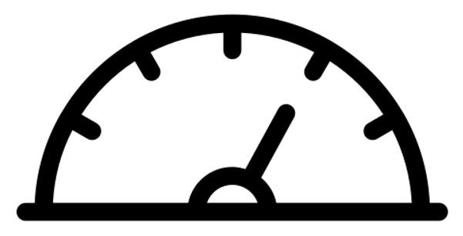

 model performance on Palmes | AirView data

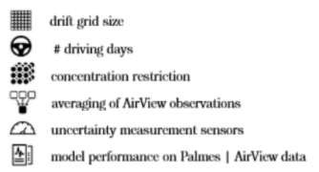

drift grid size

# driving days

concentration restriction

averaging of AirView observations

correlation

uncertainty measurement sensors

model performance on Palmes | AirView data