**Heuristic Analysis By Ng Fang Kiang**

**Udacity – Artificial Intelligence Nanodegree (Class of 2017)**

**Heuristic 1:**

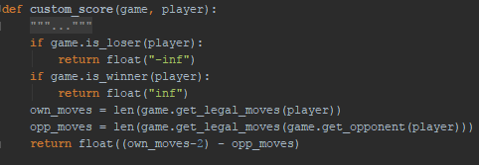

**Result 1:**

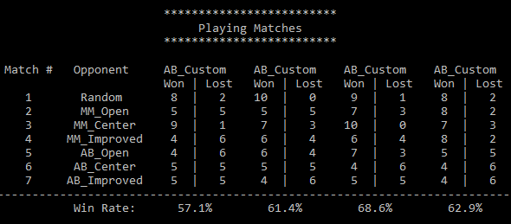

**Heuristic 2:**

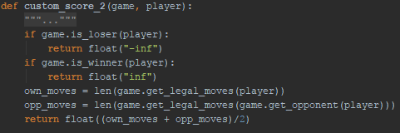

**Result 2:**

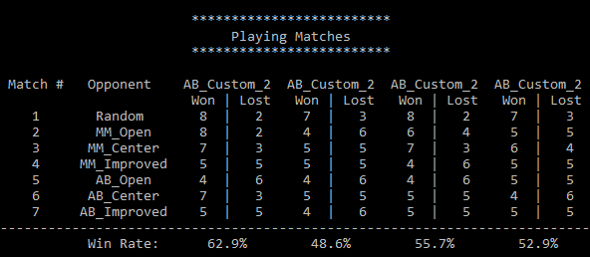

**Heuristic 3:**

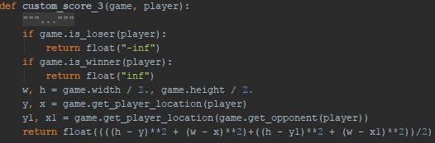

**Result 3:**

