1.Describe the difference between the Gouraud shading and Phong shading models. Include screen shots from your application (or pictures from lector or online) to help strengthen your discussion.

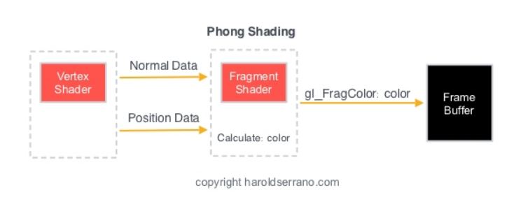

The biggest difference between Gouraud shading and Phong shading is that Gouraud computes color in the vertex shader, and Phong computes color in the fragment shader. Gouraud shading also interpolates the vertex intensities between polygons, and Phong shading interpolates the normals between polygons. In other words, Gouraud shading uses the vertices as the center point of determining the light intensity of 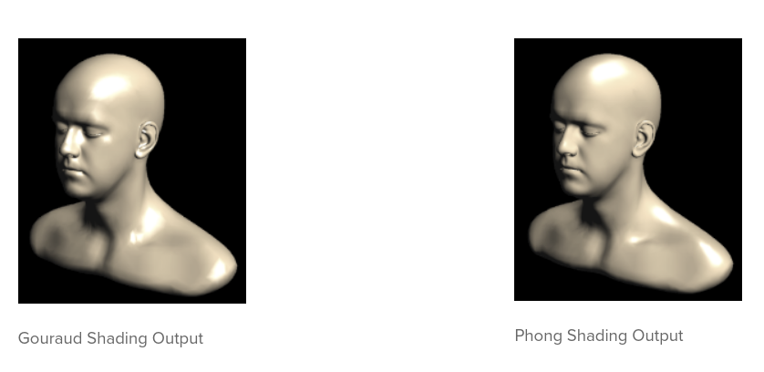the polygons around it, while Phong shading uses the normals of each polyg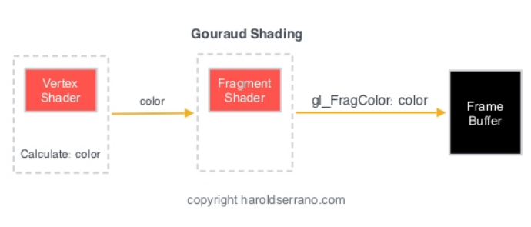on to interpolate values. Gouraud shading is also known as smooth shading, while Phong shading is also known as per-fragment shading since the shading model needs to be applied to each individual fragment.

https://www.haroldserrano.com/blog/what-is-the-difference-between-gouraud-and-phong-shading

and

Textbook PDF

2.The Phong reflection model includes several non-physical (non-realistic) components in the model. List and describe these components that are not realistic and describe why they are made.

The shininess value does not operate the way one might expect it to in real life, since as the value decreases, the size of the reflected light on the sphere is larger than would be expected. In order to address this, the value of Ks needs to be m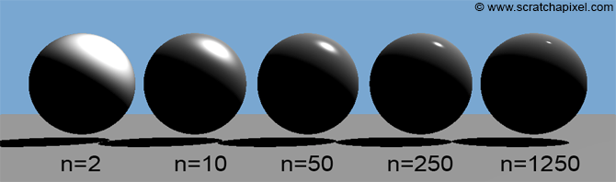anually adjusted to make it appear the way it should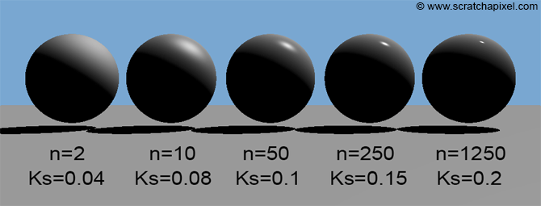.

We also choose to use ambient light for a room instead of computing the travel path and reflections of each individual photon from the light source, for the purpose of easing the computational strain of the rendering process.

https://www.scratchapixel.com/lessons/3d-basic-rendering/phong-shader-BRDF