CS4S772-CW2
30065257

Introduction
The hand dataset has a large amount of image data depicting a person gesturing different numbers and letters. This report will show that with limited preprocessing and a logical convolutional model, individual classes can be easily and accurately identified from this dataset. There is not a class imbalance and variance in the data is kept to a relative minimum with backgrounds being a white wall or a greenscreen. This results in a model that is unequipped to classify real-world messy data. This project will attempt to address this by implementing object recognition techniques so that the trained model might identify hand gestures more reliably in trickier settings.

Initial Dataset Exploration and Discussion
The dataset contains 34000 images of hand gestures distributed evenly amongst 34 classes. For each gesture there are 1000 images where the hand in question is pictured moving from laterally and vertically frame by frame. For that reason, augmentation will not be utilized with the assumption that hand structure is sufficiently represented to preserve identifiable features. However, this may be explored later. In addition, normalisation is implemented so that the pixel values for each colour channel lie between 0 and 1 which a scale more manageable for CNNs. The images are also resized for computational efficiency.

Model Architecture
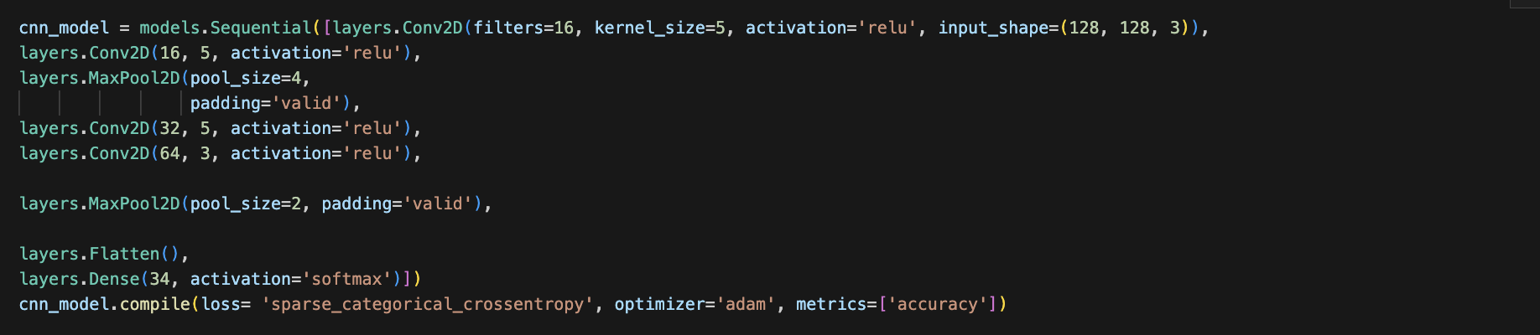
The model is constructed with four convolutional layers, two pooling layers and then a flattening layer before its dense classification. The first model trialled had a kernel size of (3,3) in each layer and a size of (2,2) on both max pooling layers. Training accuracy was consistently high however validation accuracy was 10 - 12 percent lower. By extension, there was a notable difference in validation loss relative to the current model. The current model employs an approach that aims to discard an element of feature extraction in the early layers and then take on a more refined approach as the data moves forward. Recognising that each hand gestures lies relatively far from the boarder of an image, the idea of the structure is to bias the model into focussing on more centralised features where our region of interest will most likely be. Examining the early layers, there is a smaller focus on feature extraction (16 filters) and a more global method of synthesising the patterns of the images. The larger kernel serves the purpose of degrading meaning found from boarder pixels because it can’t be centred near the edge. It’s an attempt of pushing the model towards the centre when it attempts to extract more meaning in the later layers. Note that the pooling layer is also 4 by 4 which means at every stride it takes the max pixel from a window of 16 which goes to the idea that the first two layers are about getting global information. Then the data moves through the layers, eventually lowering the kernel size and maximizing feature extraction. In that final convolutional layer, the model learns high level features in a context engineered for it to get the most from the region of interest. By extension, we add a smaller max pooling layer to retain more concentrated information. Finally, flattening outputs one long array of information that feeds into a dense layer of class size. A SoftMax activation then outputs a 34-dimension probability distribution for each image.
Evaluation of Model

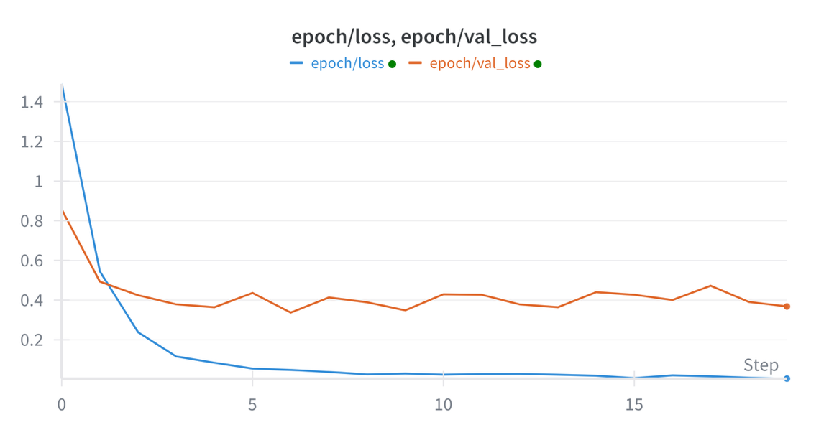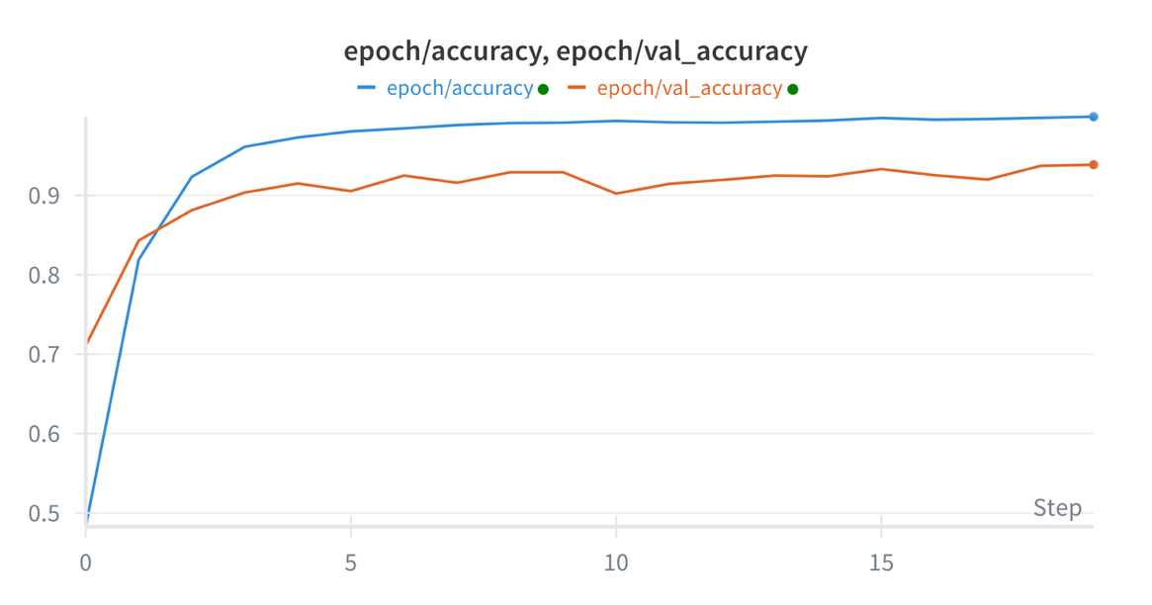
Figure 1 (Model where kernel size 3, 3 universally)
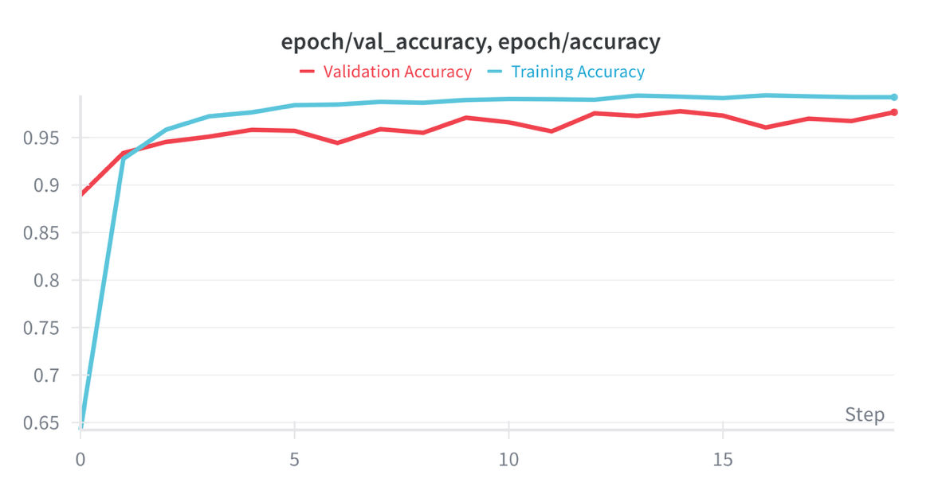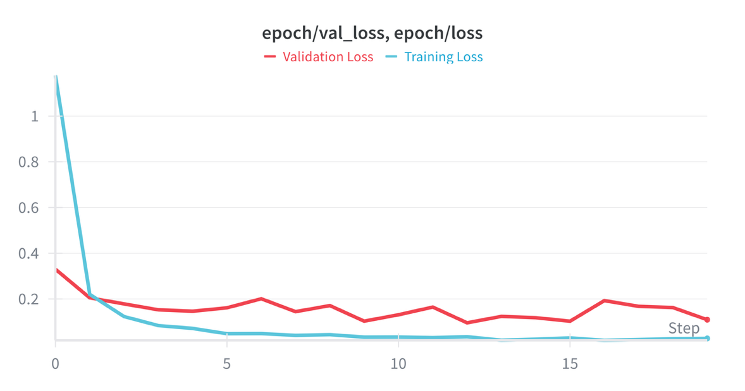
Figure 2 Adjusted Model
The model, with very basic preprocessing, performed to excellently reaching 96 percent validation accuracy and a validation loss minimum of 0.095 at epoch 12. The adjustments to the model resulted in a bridged gap between training and validation and a sizable improvement. Overfitting was much milder because of the changes, though still minimally present. The difference between the two models is stark with the first model failing to fall below 0.33 in validation loss and peaking at 93 percent validation accuracy. The large gap between training and valid loss highlights poorer generalization than the adjusted model. Nevertheless, the training of any model with this dataset is inherently flawed due to the cleanliness of the data with regards to the background and class balance. This is highlighted with the model’s prediction of random external images following training:
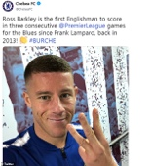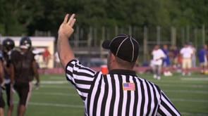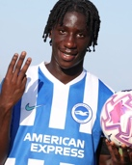
These images are of footballers holding up the same hand gesture for the number three as seen in the training data. As expected, despite performing well with the training data, the model misclassified each of the seven real-world images. This is likely due to background noise the model won’t have seen, colour varieties, image noise etc. Therefore, the next step would be to revisit the preprocessing stage and prepare the images with a focus on pure hand detection.
Proposals to Improve External Classification
There is a vast number of methods that might improve the model’s ability to classify hand gestures seen in varying settings. It’s clear that the model can identify hands, how they vary and extract the correct features required to differentiate between gestures. This is evidenced by its 96 percent validation accuracy. Though the background’s repetition harms the model’s performance on messier images, it’s lack of change helps the model to clearly build a feature map outlining the representation of hands in different poses. If this was not the case, the model wouldn’t generalise so well. The problem is that when new backgrounds are introduced, so too are new colours, new objects and new meanings that simply confuse the model. For example, an object with similar colour channel values to a hand may cause the model to focus on an incorrect part of the image. Additionally, skin tones vary and if the model knows a hand to be of a certain colour, then a hand with a different tone may simply be ignored in the context of predictive features. This is simply the meaning found through colour. The final layer of the model has 64 filters which leads to 64 different representations of meaning in the images before classification - of course introducing an image even slightly different could cloud what is currently a fixed understanding of hand gestures and their contexts.
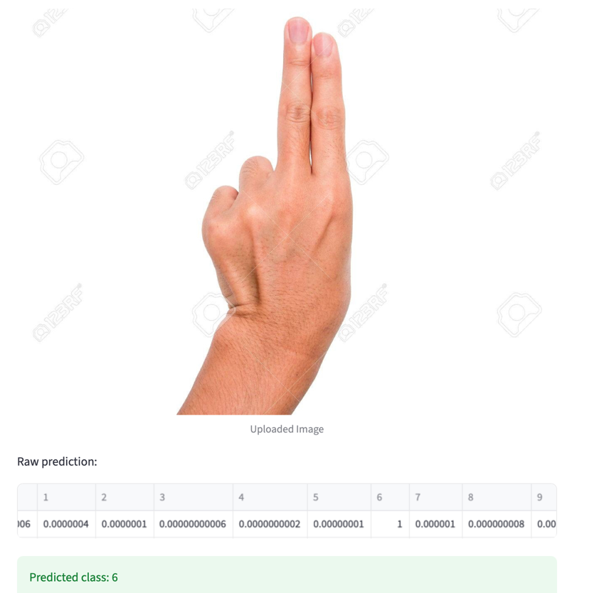
Figure 3 Misclassification of a two
Here we can see that even with a mundane background, the model is simply unable to capture the reliably learned shape of two.
Object Detection using Fast
The real consistencies of hand gesture lie in their shape. Fast (Features from accelerated segment test) is a way of capturing corners of images. Corners identified by the difference in intensities in surrounding pixels. Simplified, if a pixel has 16 surrounding pixels that are very different to it in value, a corner is identified. The image needs to be converted to grayscale so that there is only one colour channel and then a threshold for identifying major intensity difference is set. If the 16 pixels around the subject pixel are all different by at the threshold amount or more, a corner is identified. In this case, this helps to identify hand shape relative to its local position. Take this image:
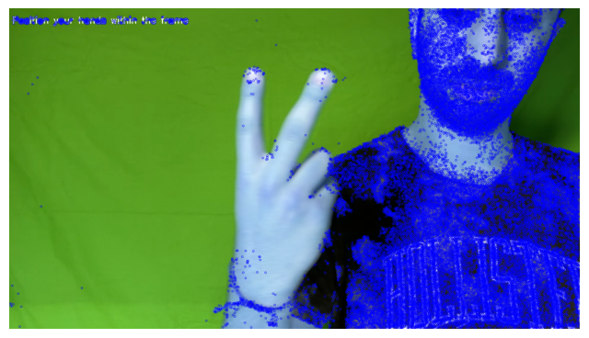
Here, the threshold is set to 2 and you can see the points of where two fingers are up as well as where the other fingers are in closed positions. Because the hand is a uniform colour, the threshold needed to be low but if we use equalisation to intensify the image, these corners can be found at a higher threshold.
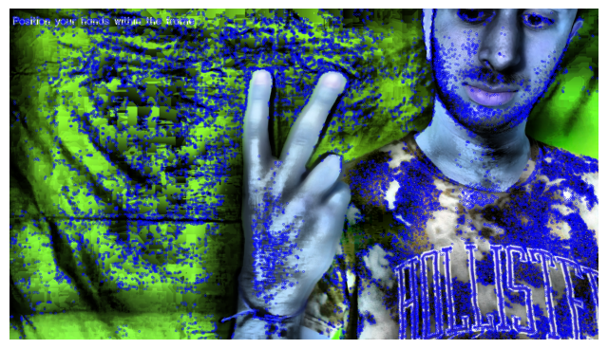
Here we equalize and the threshold is set to 30 and we start to see key points highlighting distinctive features of a hand, notably in the middle of the hand where we get a unique cluster. This may help to make a hand standout in an otherwise crowed image. Noise is still a key issue however with this concept.
Object Detection using Bounding Boxes
Another concept is bounding boxes. Bounding boxes are a way of annotating the training data for object recognition. They are described by their top left and bottom right coordinates. There are pretrained models that can be used like ‘Faster RCNN.’ Faster RCNN takes an image and generates ‘anchor boxes’ which are scored on ‘objectness’. These scores are then fed to a proposal network which takes high scores to be into a regressor, which adjust the coordinates of each box to fit the object, and a classifier. To apply this to this work, hands would need to be located and labelled.

Streamlit deployment on number gestures
http://localhost:8501

