# overview

This is a ride-share application which is built on top of PHP

This application has 2 main users as driver and passenger.

When driver create a ride he has to specify rides information. Then passengers can join those rides.

By sharing the ride, it will be profitable to driver and passenger as well. It will also allow to reduce traffics.

# Resources

# Architecture

High level system architecture as follows,

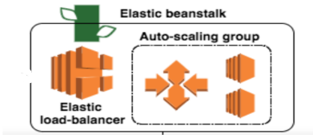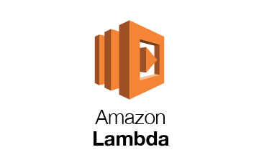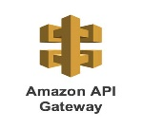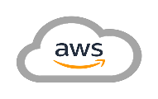

Third party applications



Users can access the application through web http web address

AWS Beanstalk used to deploy and maintain the application.

It includes a PHP server (PHP version 7.3)

Beanstalk environment consist of EC2 instances and load balancers.

It handles http traffics and create new instances using AWS Load-balancer.

AWS S3 keep all source codes and other required assets and use AWS CloudFront to deliver them efficiently.

AWS CloudFront connected to directly to load balancer.

AWS RDS used as the database of the application. It has a mysql server running mysql version 5.7

Third party application can get details on rides via an API. For that awe use AWS API Gateway service

API trigger a AWS Lambda function and extract data from RDS to API gateway.

AWS QuickSight used to get analytical reports on rides.

# Application

1. Login page / check rides available

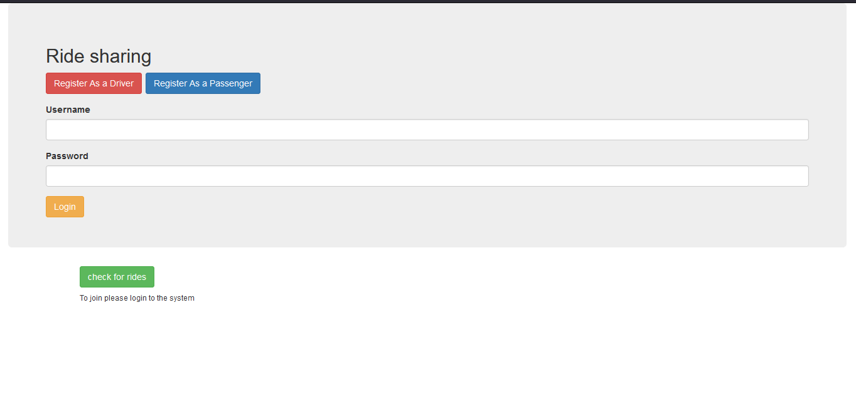

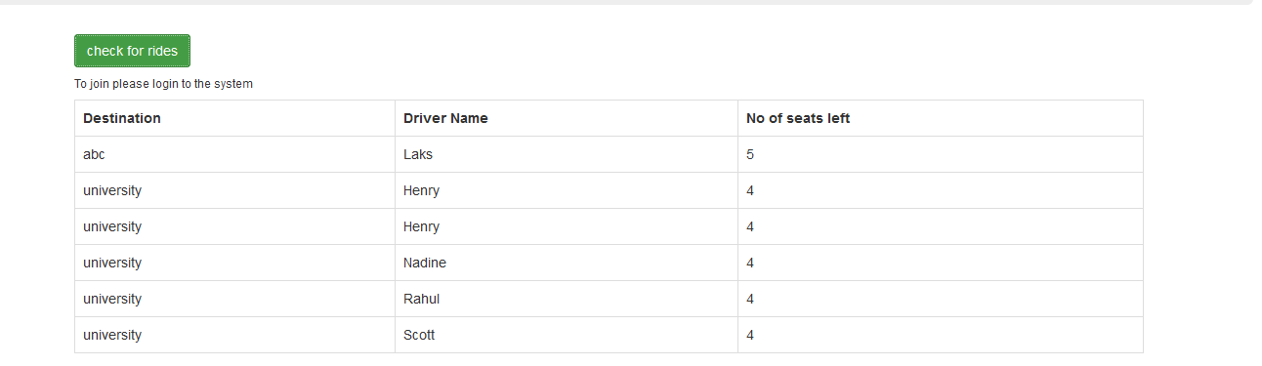

1. Register as driver

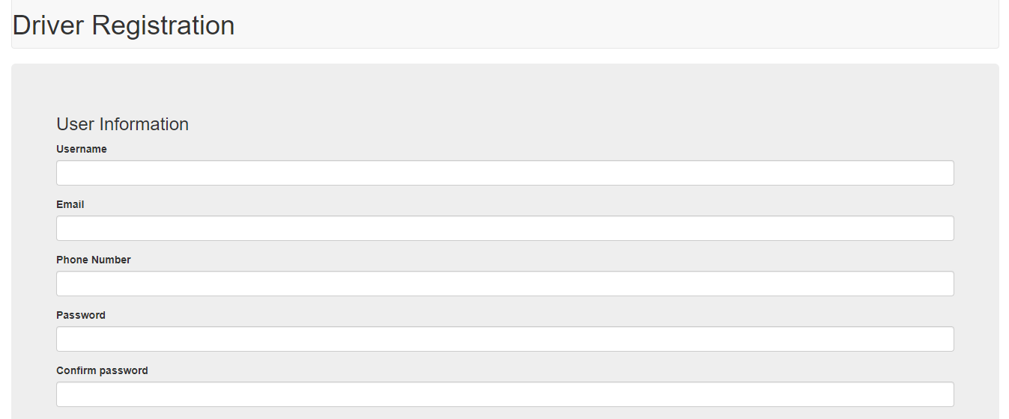

1. Register as passenger

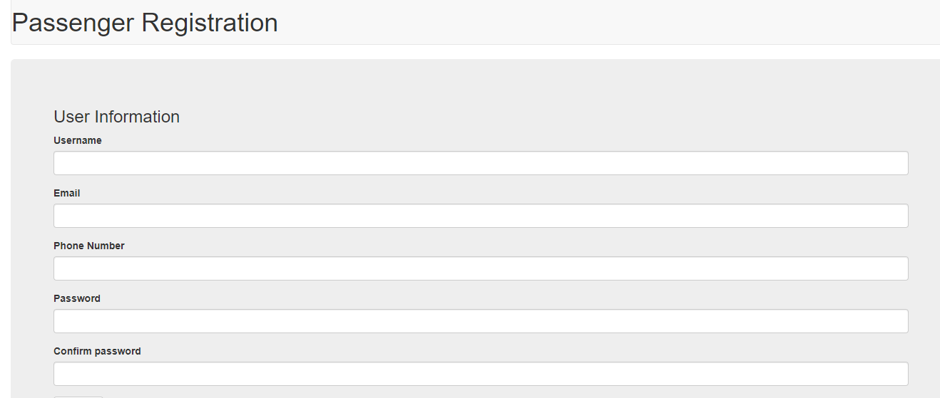

1. Driver portal

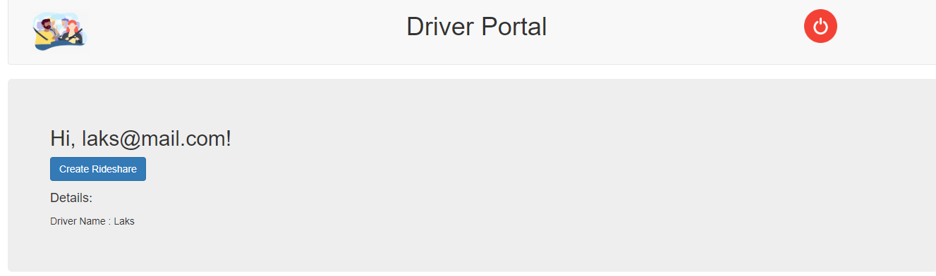

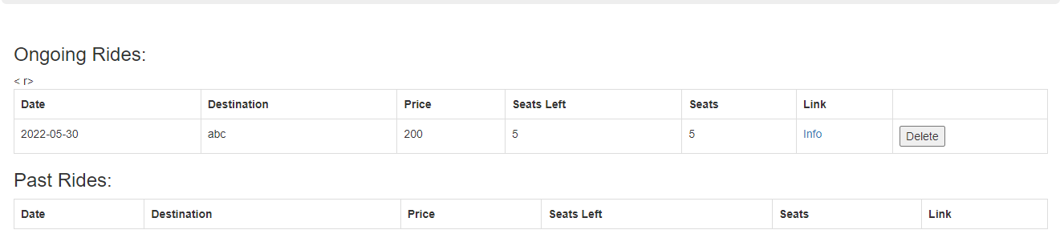

1. Create new ride

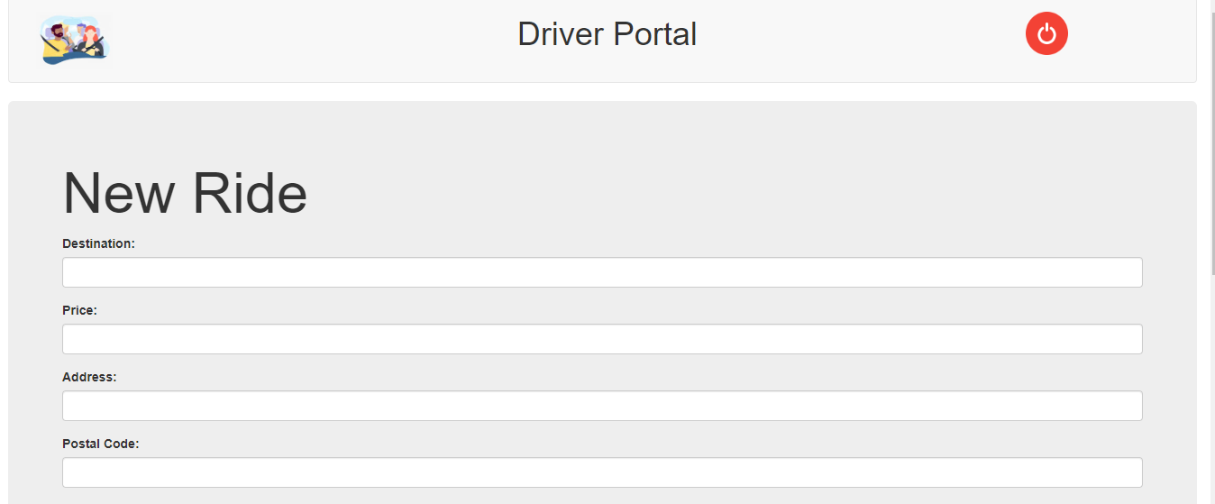

1. Passenger portal

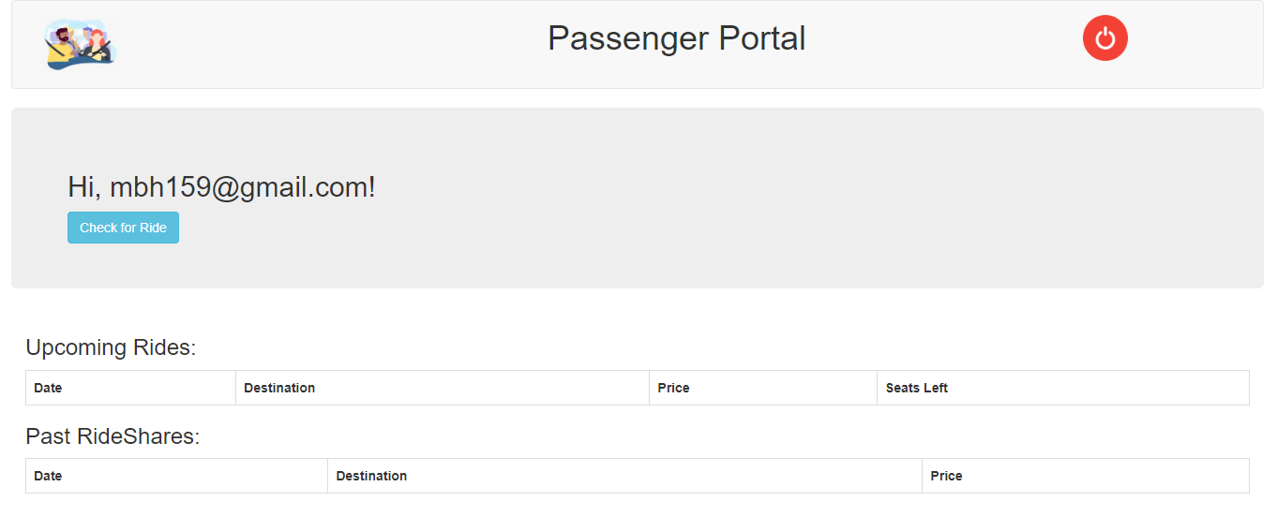

1. Check for rides

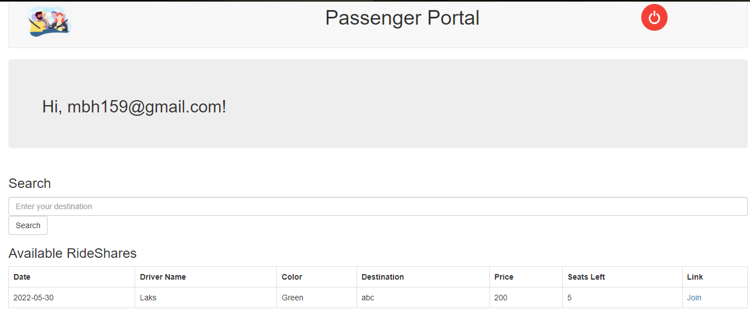

1. Join for rides

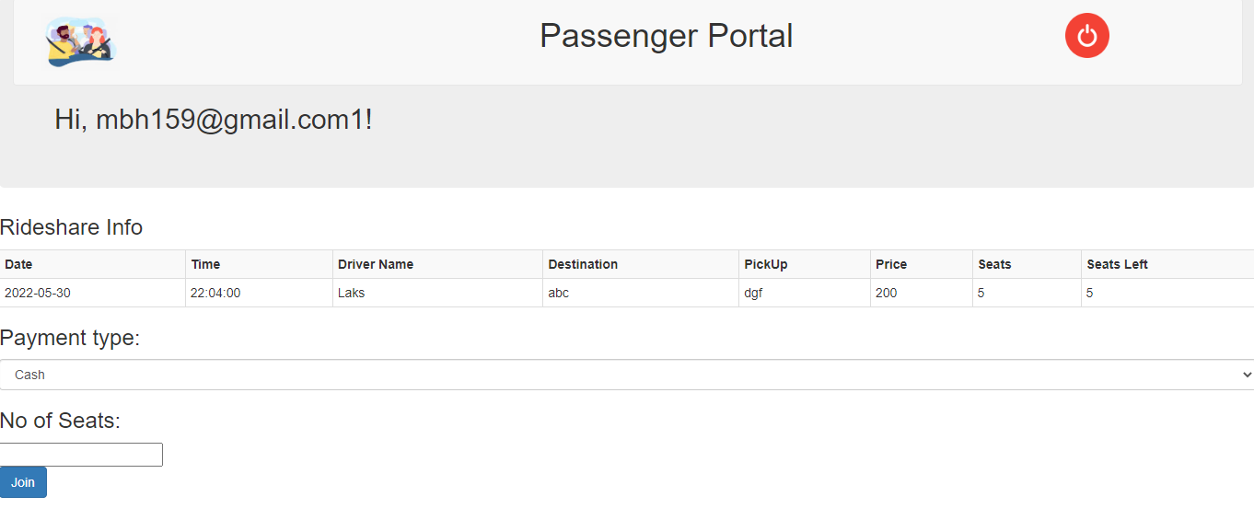

# API

Details of the rides can be get from following URL

<https://7tuivugno9.execute-api.us-east-1.amazonaws.com/rides>/

sample output:

{

"statusCode":200,

"body":"{\"5\": {\"destination\": \"abc\", \"drivername\": \"Laks\", \"seats left\": 5}}"

}

Please note that Database should running to get data.

# QuickSight

There several analytical reports to get information rides. Some as follows

