PROGRESS REPORT III
CSCI 463- SOFTWARE ENGINEERING
DR. GRANT
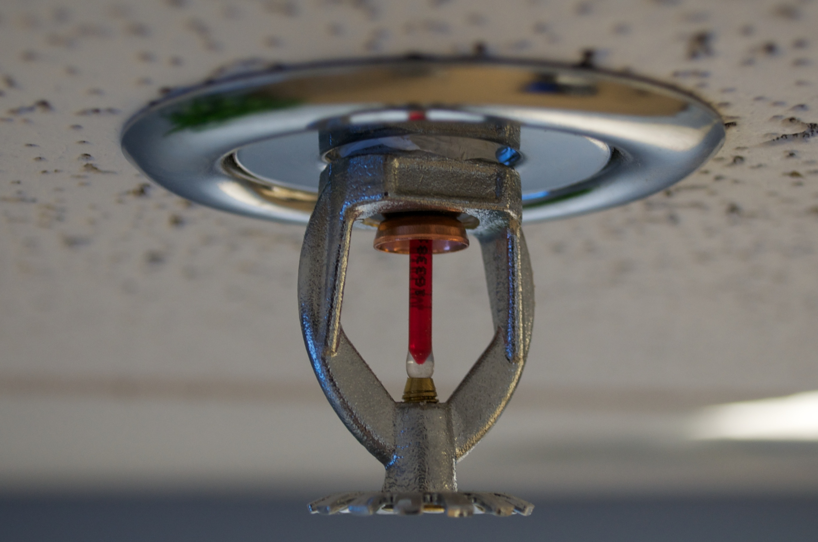
TEAM 03
ALEXANDER HOLMES
JORDAN HERNANDEZ

2) Updated Class Diagram

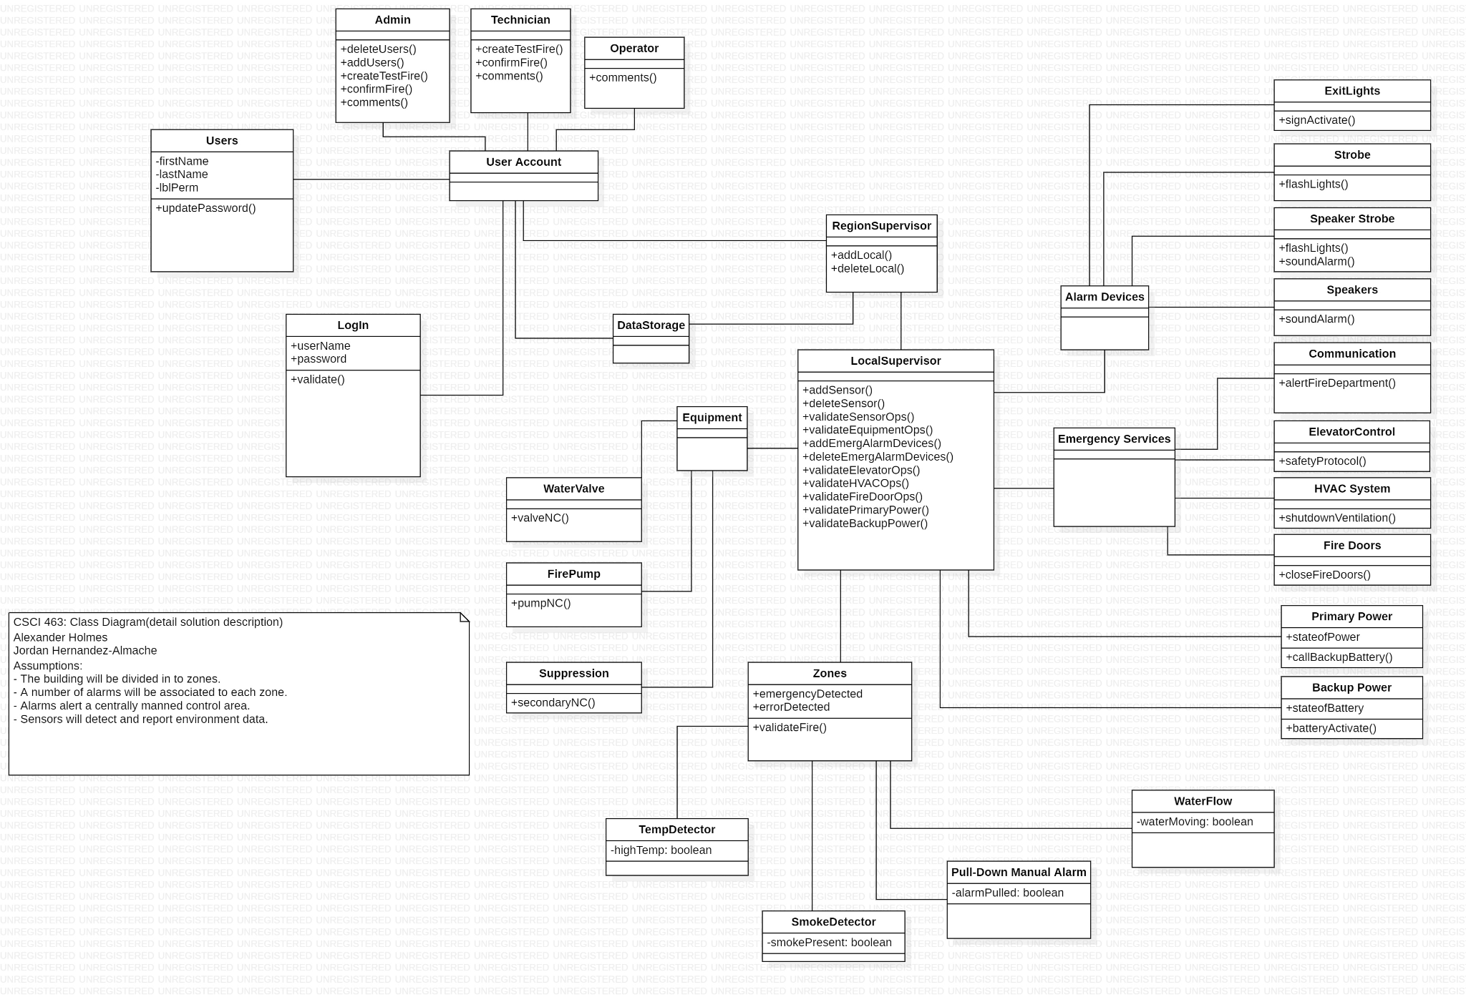

3) Sequence Diagram (only 2)

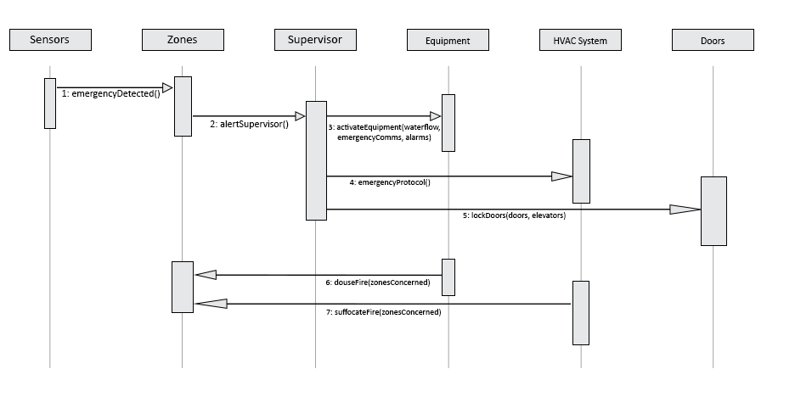
Sequence Diagram 1: Fire Detection Scenario
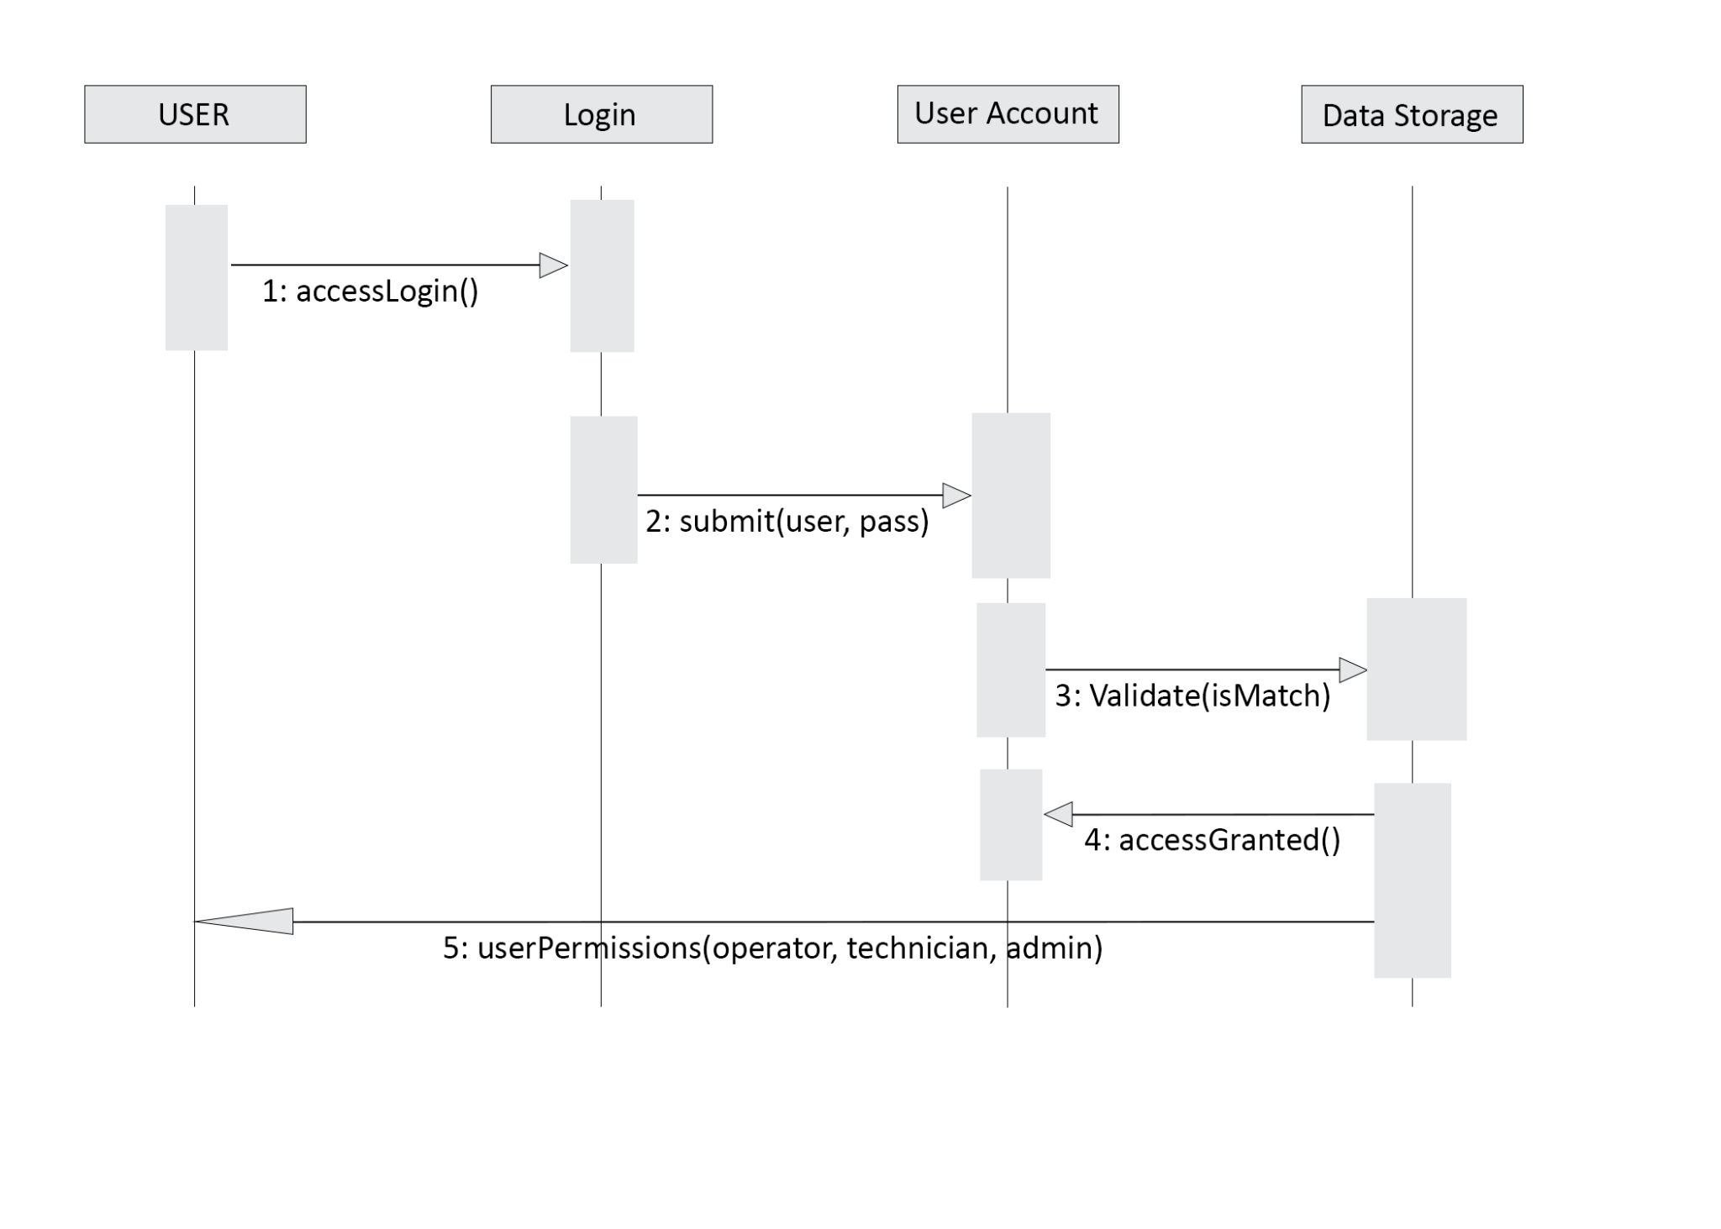
Sequence Diagram 2: Login and user authorization

4) Updated System Dictionary

Term | Description | Example
Sensor | Device that reflects environment status to the system | Smoke detector
Admin | Person responsible for system management. | Gregory
NC | Status of natural state. Normally Close (NC) | valveNC
Technician | Person responsible for system troubleshooting. | Mark
Operator | Person responsible for monitoring daily events. | Tom
Equipment | Device that activate on an environment status from the system | WaterValve
HVAC | Heating Ventilation and Air Conditioning | HVAC System
Sub Controller | Device that conduct operations for a singular facility | Local Supervisor
Main Controller | Device that conduct operations for multiple facilities | Region Supervisor
Alarm Device | Device that activate and warn on environment status from the system | Strobe

5) Issues Encountered and their resolutions
In this stage in the game, especially with collaborative coding becoming pertinent with the presentation and turn in coming up, most of our issues continued to occur in the realm of us both having access to the program. As we’ve tried true coding collaboration via liveshare and other means to no prevail, we have fallen back to sending the program back and forth which proved to come along with a world of its own problems. We found that by default our system won't give permissions to the acquired files to open their resources properly in visual studio, so for all of the form.resx files we had to go into the properties manually and unblock all the permissions so that we could successfully pick up on our partners work. While it was all our biggest pain for a while to figure out, it has helped make things go a lot more smoothly moving forward with our work.

Another issue that was encountered in the wheel-house of coding itself, was passing information from form to form. We ended up finding that If we created a public class for the variable we wanted to pass, that from another form, we were able to use the identifier of the form from which the variable we wanted to access resided, and store that variable using
(varType) <newVarName> = formName.<varName>. A simple seeming solution for what proved to be a large, time consuming, headache.

6) What’s Next?
Moving forward with our project we will implement code, use basic design principles that take into consideration ANSI standards for uniformity/safety, as well as fine tune features we believe to be useful. Once coding is completed and the functionality of the user interface comes together with the design we’re looking to implement, we will move towards working on how to eloquently present and explain our design, our code, our process, and our thinking throughout the process of developing our program, and working on these deliveries.

