CS 255 System Design Document Template

UML Diagrams

UML Use Case Diagram
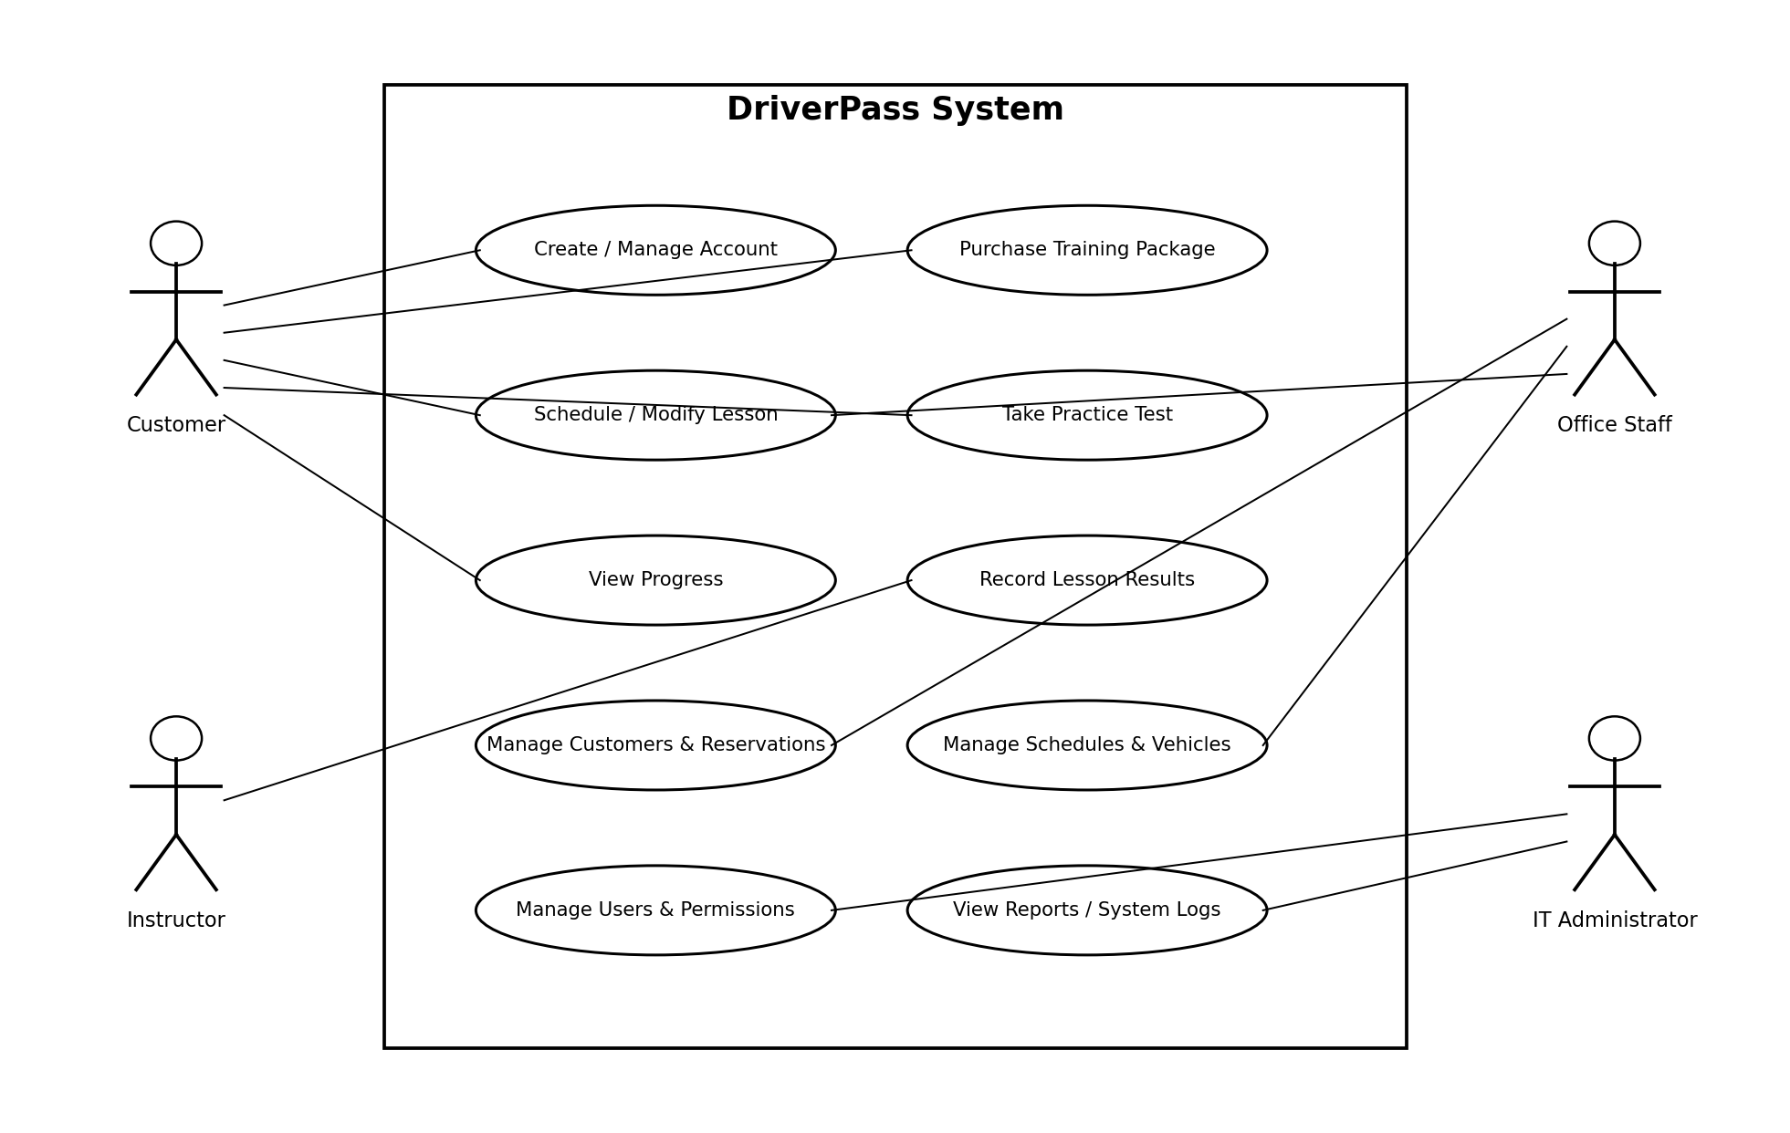

UML Activity Diagrams
Activity 1: Schedule Driving Lesson
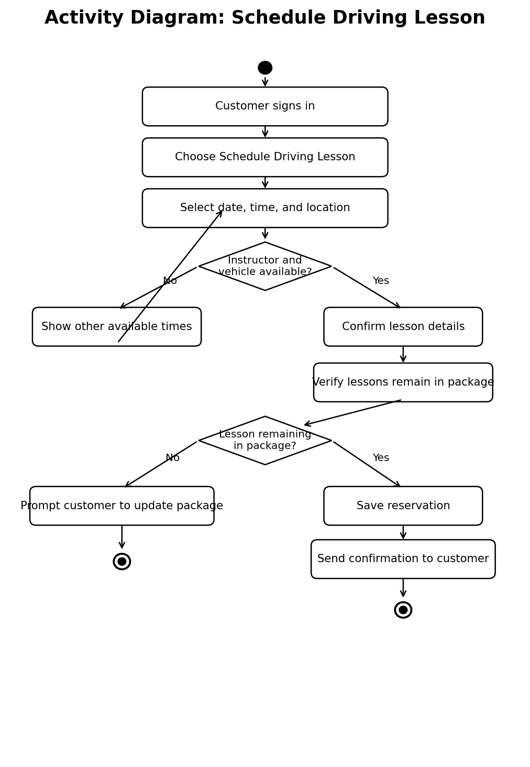

Activity 2: Take Practice Test
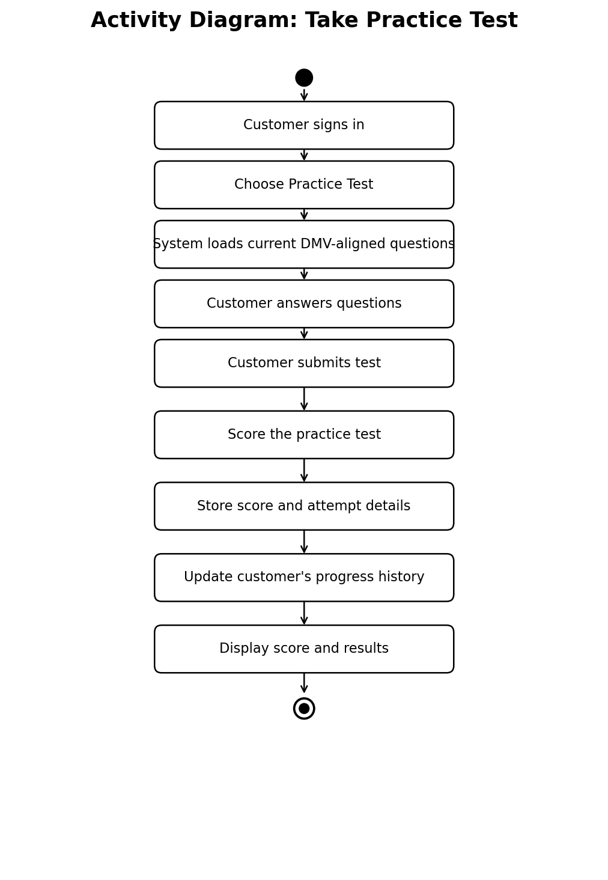

UML Sequence Diagram
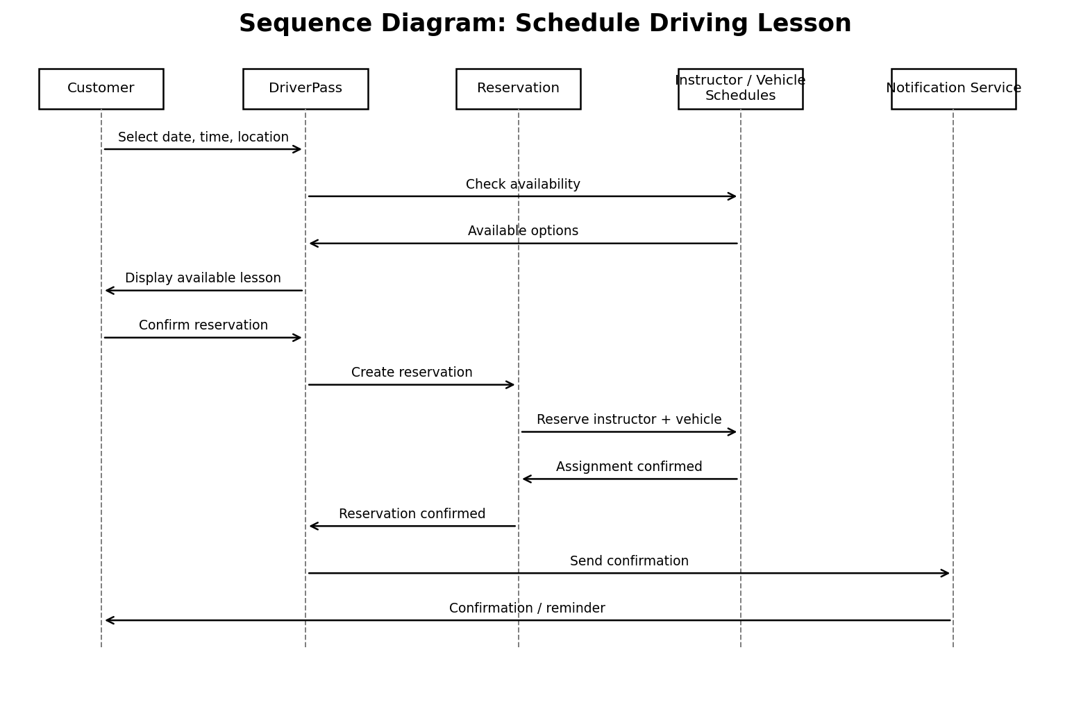

UML Class Diagram
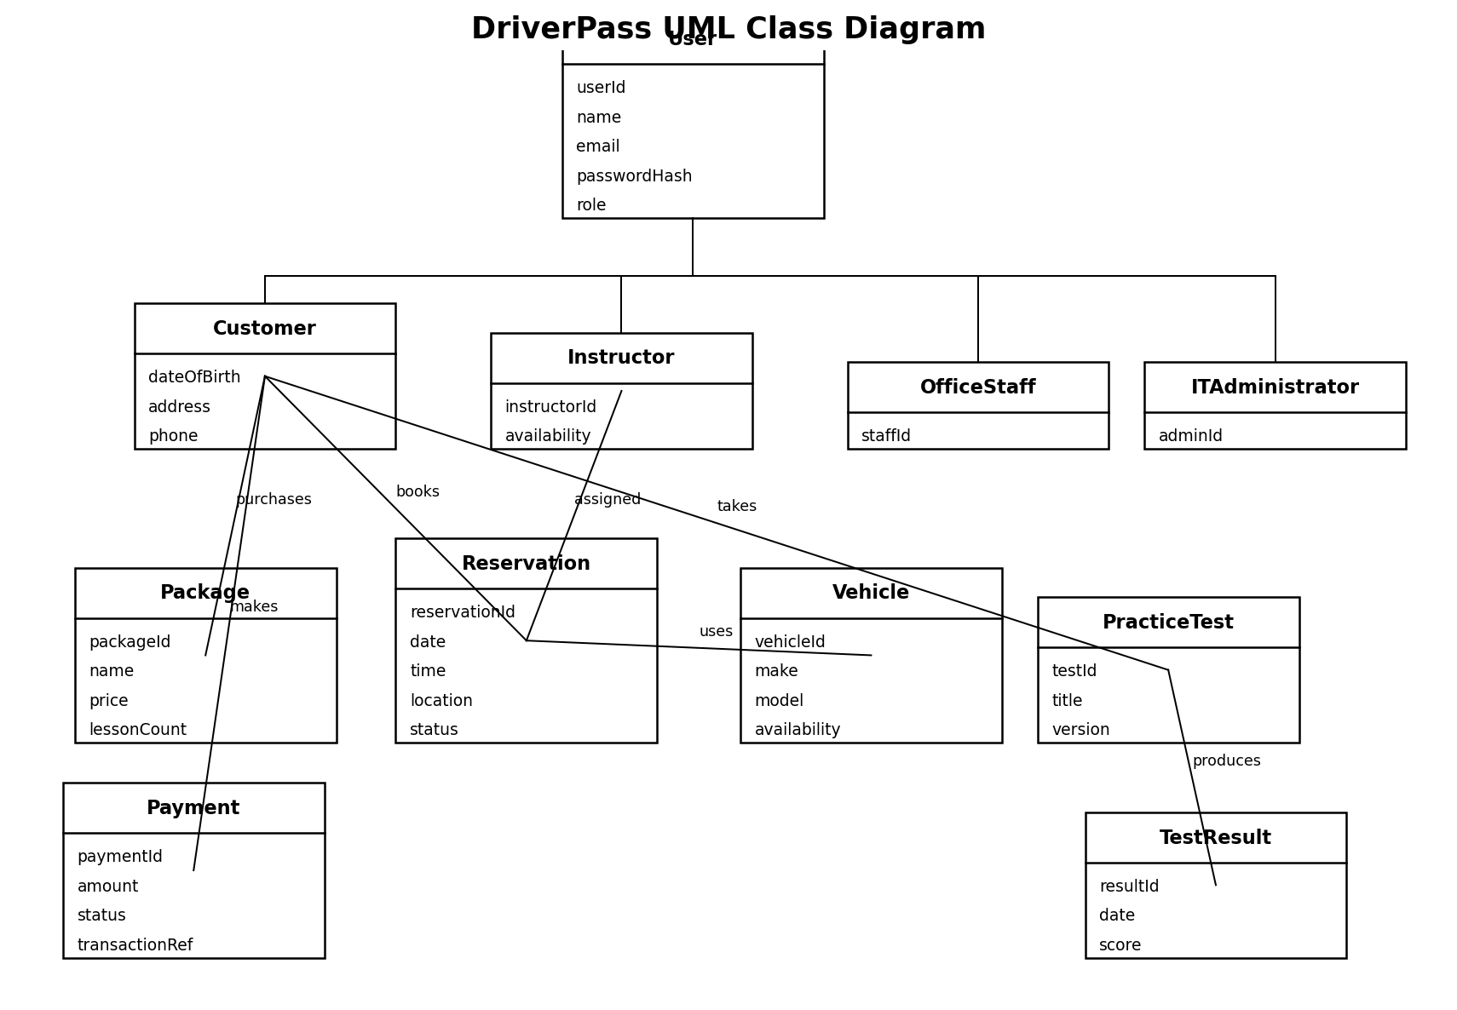

Technical Requirements
The DriverPass system requires a cloud-hosted, browser-based application that customers and staff can access from current desktop and mobile browsers without installing separate software. The application should use a responsive web interface and a relational database to store user accounts, packages, reservations, instructor and vehicle schedules, practice-test content and results, payments, and reporting data.
The system requires secure user authentication and role-based access for customers, instructors, office staff, and the IT administrator. Passwords should be protected, network traffic should be encrypted, inactive sessions should expire, and repeated failed logins should trigger account protection and administrator notification. Payment processing should be handled by a PCI-compliant third-party payment provider so DriverPass does not store full credit-card information.
The infrastructure should include scalable cloud application hosting, redundant storage, and automated nightly database backups with a tested restore process. The scheduling service must check instructor, vehicle, and time-slot availability before saving a reservation to prevent double booking. An email notification service is also required for confirmations, reminders, cancellations, and password resets. Development and design tools should include a CASE/UML tool such as Lucidchart, source-control software, a supported web-development framework, database-management tools, and automated testing tools. The completed system should support Chrome, Edge, Firefox, and Safari and remain usable on Windows, macOS, Linux, iOS, and Android through the browser.

