**DEVELOPMENT OF A DENTAL**

**APPOINTMENT RECORD SYSTEM FOR THE**

**DENTAL HEROES**

By:

Aguilar, Jordan B.

Dolores, Khing Edsan M.

Tabor, Aldrine G.

# INTRODUCTION

The Dental Appointment Records System is a simple tool designed to help dental clinics record and manage patient appointments. This project focuses only on storing appointment details making it easier for staff to keep track of who is scheduled and when.

Carrying the information will be easier.In many clinics, appointments are still written down on paper or in notebooks. This can lead to problems like lost information, double bookings, or difficulty finding past records. These issues can slow down the clinic and affect how well patients are served. A digital records system can solve these problems by keeping everything organized and easy to access.

* Makes it easy to add and view appointment records
* Keeps appointment history organized and secure
* Helps clinics run more smoothly by improving how appointments are managed.

# CLIENT INFORMATION



Client Name: The Dental Heroes

Client E-mail: ddentalheroes@gmail.com

The Dental Heroes is a private dental clinic that offers general and specialized dental services such as cleanings, fillings, braces, and tooth extractions. Located in the heart of the city, the clinic serves a wide range of patients, from children to adults. With a growing number of clients, the clinic aims to improve its appointment management system to make scheduling easier and more organized

# PROJECT SCOPE

Dental Appointment Records System that allows clinic staff to record, view, and manage patient appointments efficiently. The system will include features like adding new appointments, searching appointment history, and updating schedules.

# Inclusions

* Appointment creation and listing
* Basic patient information linked to each appointment
* Simple user interface for clinic staff
* Local database to store appointment data

# Exclusions

* No billing or payment tracking features
* No patient treatment history or dental records
* No online appointment booking or website integration

# Assumptions and Constraints

* The system will be used only by authorized clinic staff on-site
* Internet access may not always be reliable, so the system will work offline
* The clinic may have limited technical staff for ongoing maintenance.

# PROJECT APPROACH

The project will follow a straightforward and structured approach to design, develop, and implement the appointment system for The Dental Heroes clinic.

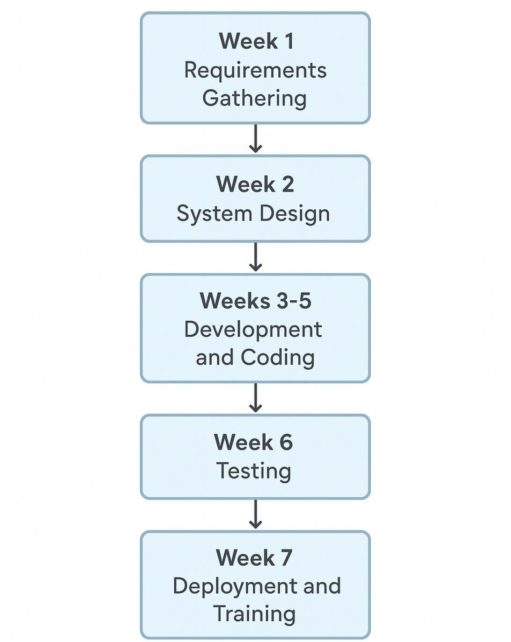

# PROJECT TEAM

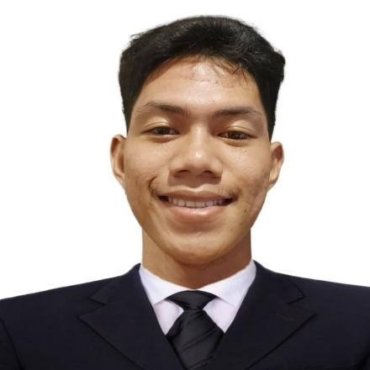

**Lead Developer**: Tabor, Aldrine G.

* I am determined not to give up and to learn various types of design, as well as simple programming languages

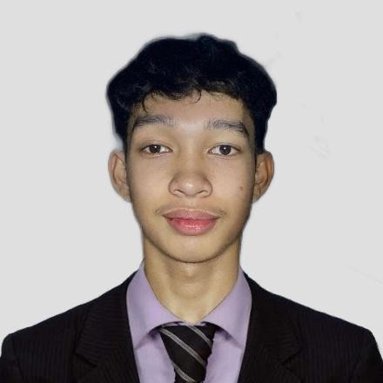

**Designer**: Aguilar, Jordan B.

* I applied the Designer from their 2nd year thesis project
* I am able lead a group members to complete tasks form previous schools year



**System Analyst**: Dolores, Khing Edsan M.

* Analytic skill Communication and documentation

# PROJECT TIMELINE

The project will be implemented over a total of seven weeks, following a structured sequence of activities designed to ensure smooth progress from planning to deployment. Each phase is carefully scheduled to allow adequate time for gathering requirements, designing the system, developing features, conducting thorough testing, and finally deploying the solution

|  |  |
| --- | --- |
|  | ACTIVITY |
| 1 Week | Requirements Gathering |
| 2 Weeks | System Design |
| 3-5 Weeks | Development |
| 6 Week | Testing and Bug Fixing |
| 7 Week | Deployment & Staff Training |

# DEPENDENCIES

* Timely feedback from the clinic during testing
* Availability of computers at the clinic

**PROJECT RESOURCES**

# Required Resources

* Hardware: Clinic desktop/laptop for installation
* Software: Visual Studio.NET, local database (SSMS)
* Human Resources: Developer and clinic staff

# Budget ₱ 30,000

* Development tools: Free or open-source
* No external licenses or subscriptions needed
* Minimal cost for maintenance and upgrades

# RISK MANAGEMENT

|  |  |
| --- | --- |
| RISK | SOLUTION |
| System data loss | Regular backups and offline data storage |
| Staff unfamiliar with system | Simple interface and training session |
| Technical issues during use | Clear user guide and contact support |

# COMMUNICATION PLAN

* Weekly team meetings via Discord/Google Meet
* Client updates via email and messenger
* Regular progress reports (every 2 weeks)

# APPROVAL

Prepared by:

Project Manager: Prince Harold M. Labay August

4, 2025

Signature: _________________________

Approved by:

Operations Manager: The Dental Heroes

Date: _______________

Signature: _________________________