**DESIGN DOCUMENT OF DENTAL**

**APPOINTMENT RECORD SYSTEM FOR THE**

**DENTAL HEROES**

A Design Document Presented to the

Faculty of Datamex College of Saint Adeline,Inc

Submitted by:

Aguilar, Jordan B.

Dolores, Khing Edsan M.

Tabor, Aldrine G.

Submitted to:

Mr. Gabriel Thomas Torneros

**INTRODUCTION**

The Dental Appointment Records System is a simple tool designed to help dental clinics record and manage patient appointments. This project focuses solely on storing appointment details, making it easier for admin and staff to keep track of who is scheduled and when. Carrying and accessing the information will also be more convenient.

In many clinics, appointments are still written down on paper or in notebooks. This can lead to problems such as lost information, double bookings, or difficulty retrieving past records. These issues can slow down the clinic and affect the quality of patient service. A digital records system can solve these problems by keeping everything organized and easily accessible.

The clinic that offers general and specialized dental services such as cleanings, fillings, braces, and tooth extractions. Located in the heart of the city, the clinic serves a wide range of patients, from children to adults. With a growing number of clients, the clinic aims to improve its appointment management system to make scheduling easier and more organized.

It shows that all of a person's information can be more easily shared and viewed by administrators and owners, with each form and record specifically formatted.

**SYSTEM ARCHITECTURE**

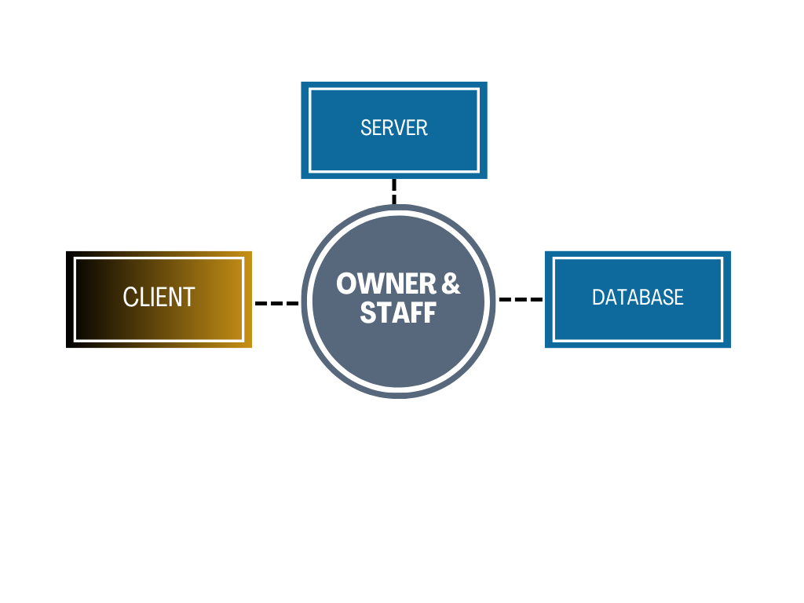

*Figure 1. Dental Clinic*

The architecture for an dental appointment system is a structured design that separates It will demonstrate improvements in usability, efficiency, and security.

**Presentation Layer (Front-End)**

This is the admin and staff part of the system. It includes the Loading screen, Login page, Main form interface, built with technologies in Visual Studio.NET, local database (SSMS).

**Main form Layer (Login layer)**

This layer processes admin requests and enforces system rules. It manages and views operations such as validating logins, handling form searches, processing records, and securely and properly providing information to clients.

**Data Layer (Database)**

This layer including Owner accounts, Dashboard, Records, Appointment, Staff and Admin updates and Viewings. It ensures secure data retrieval and updates through queries handled by the Data layer.

**SYSTEM COMPONENTS AND THEIR INTERACTIONS**

The proposed Dental Appointment system consists of several interconnected system components. Each pages smooth, secure, and admin interactive experience while supporting the long-term scalability of the system. The following subsections describe the main pages and how they can be used correctly from start to finish.

**Admin, Staff and Owner Module**

The Admin, Staff, Owner Module is the entry point of the system where individuals manage their accounts. It via loading, login ensuring that only authorized admins and owner can access the platform. This process guarantees that only the admin is authorized to viewing their personal information.

**Dashboard and Appointment Module**

This module viewing includes personal information, records, contacts, schedules, dates, times, and locations, which are commonly found in systems and are essential for ongoing admin, owner, staff access.

**Records Module**

The system is responsible for displaying each patient's record clearly and accurately. **Records Module** is a core component of the Dental Appointment Records System, designed to securely store and manage essential patient related data. This module maintains comprehensive records that include patient profiles, past and upcoming appointments, treatments received, prescriptions.

**Admin and Content Management Module**

The admin and staff content Management Module provides Owner with tools to maintain and oversee the platform’s operations. It enables to (View, Read, Update, Delete) functionalities for patients appointment listings, allowing admins to add new records, and Reschedules.

**DATA FLOW** **AND COMMUNICATION DATABASE DESIGN**

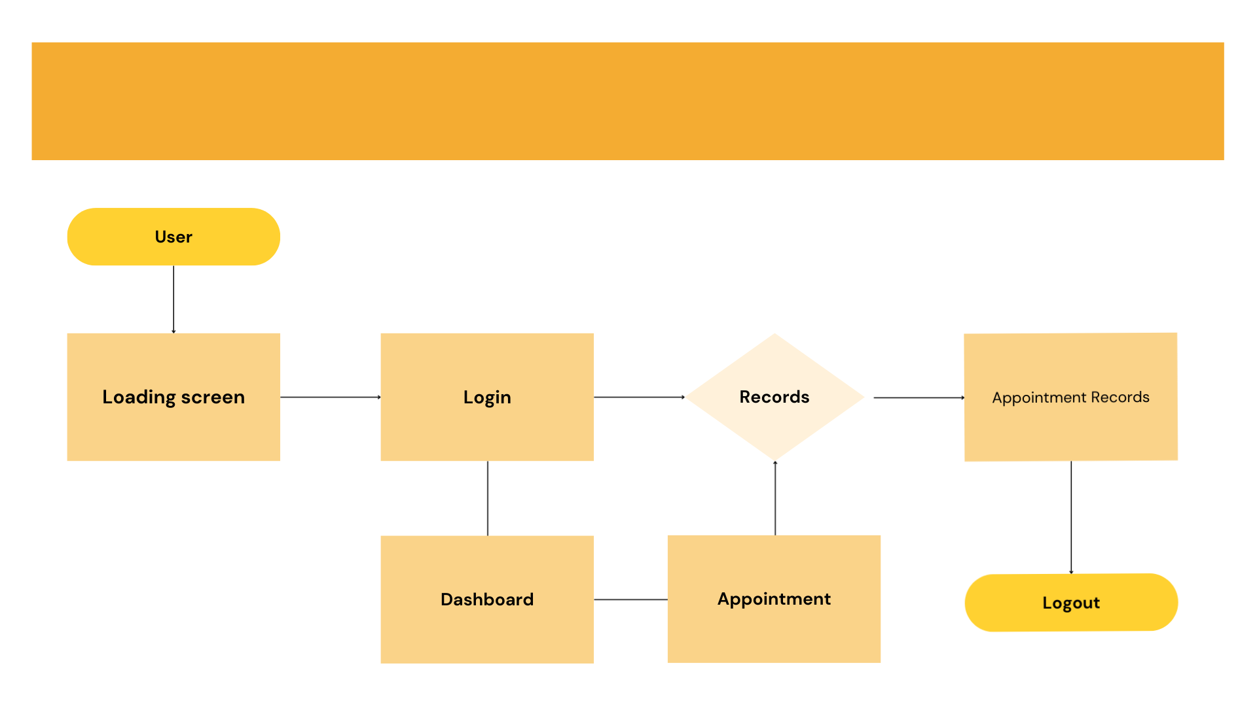

*Figure 2. Data Flow and communication database design*

**ADMIN AND OWNER VIEWING INTERFACE DESIGN**

The **Admins and Staff interface Design** of the Dental Appointment Records System It demonstrates the clear and clean design of the system’s interface. Focuses on simplicity, clarity, and ease of use to ensure smooth interaction for all admin and Staff.

**Description of Admins and Staff Interface Elements, Layout, and Navigation**

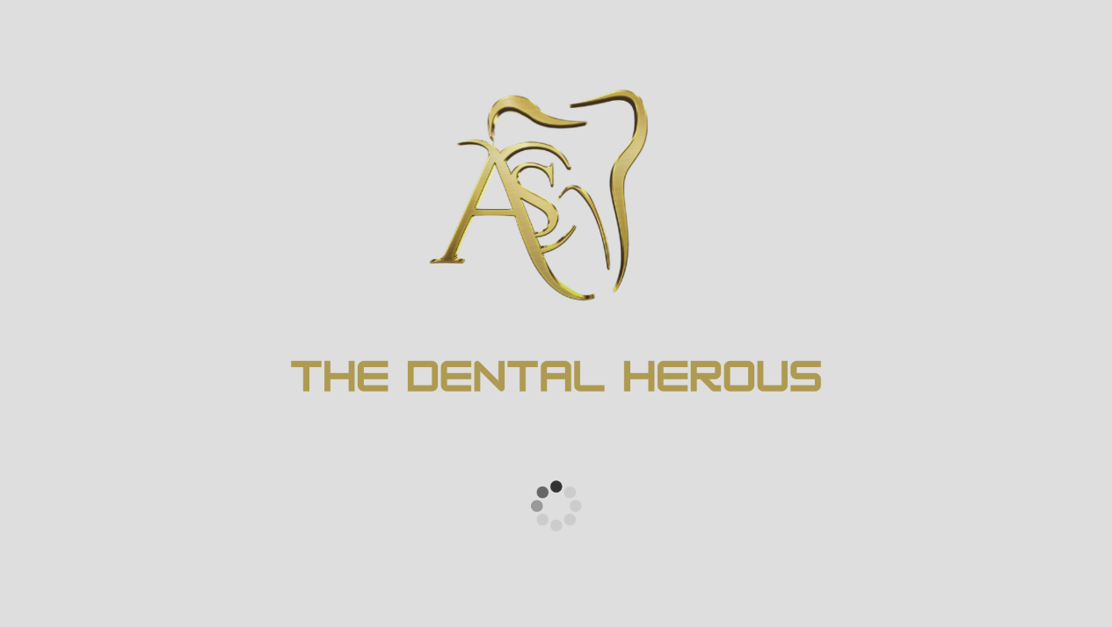

*Figure 3. Loading Screen*

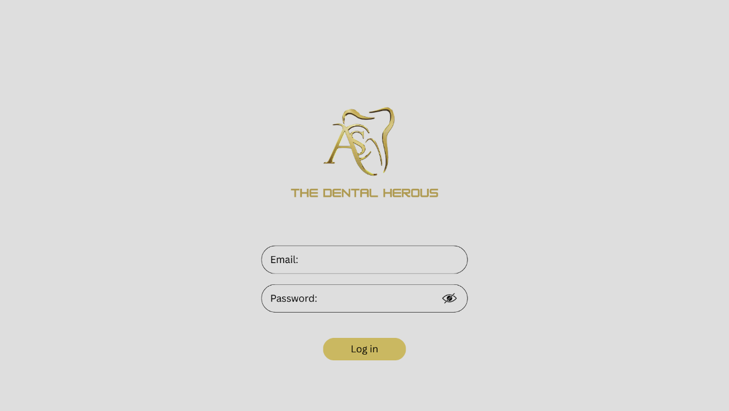

*Figure 4. Login Page*

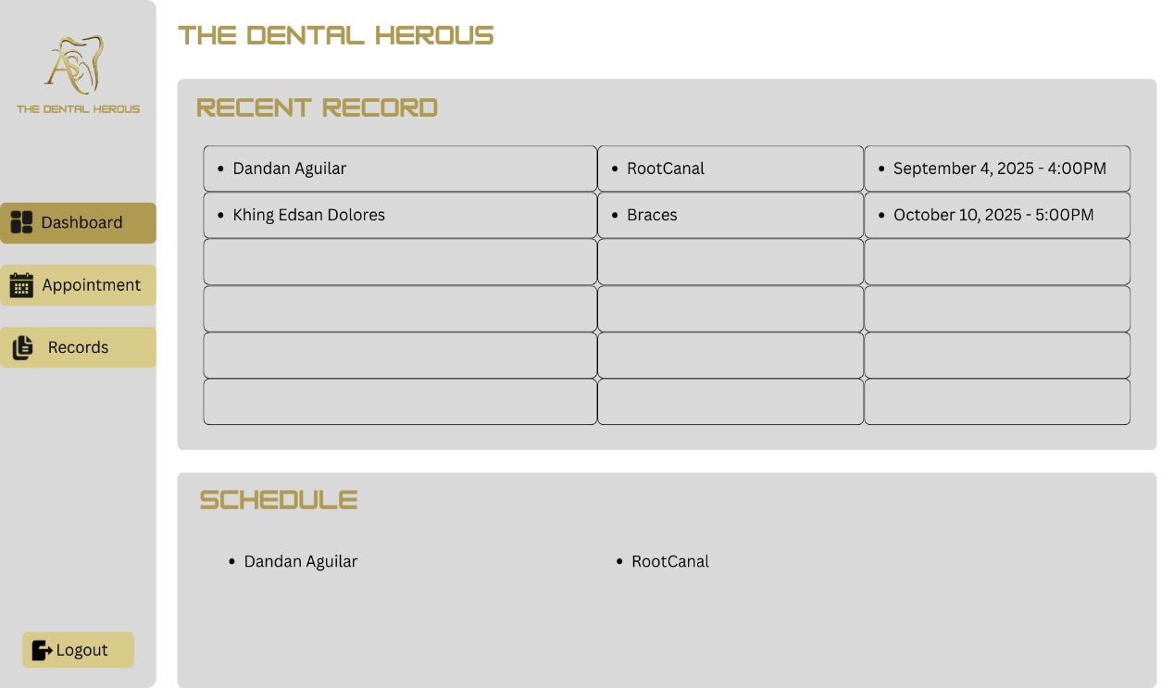

*Figure 5. Viewing Dashboard – Recent Records*

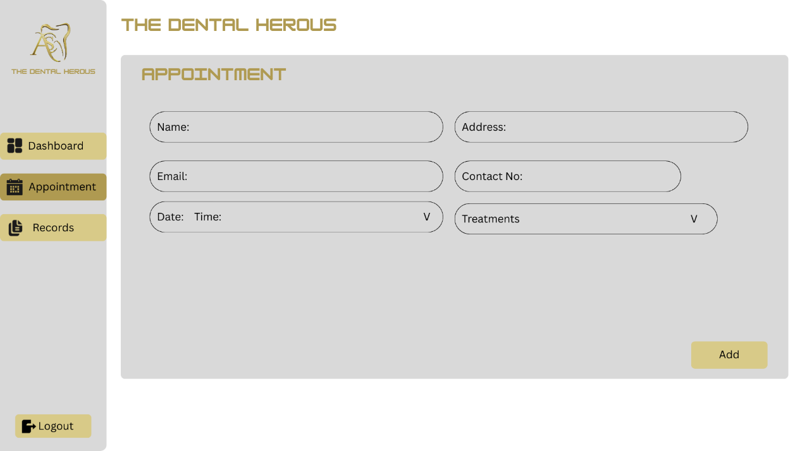

*Figure 6. Appointment - Information*

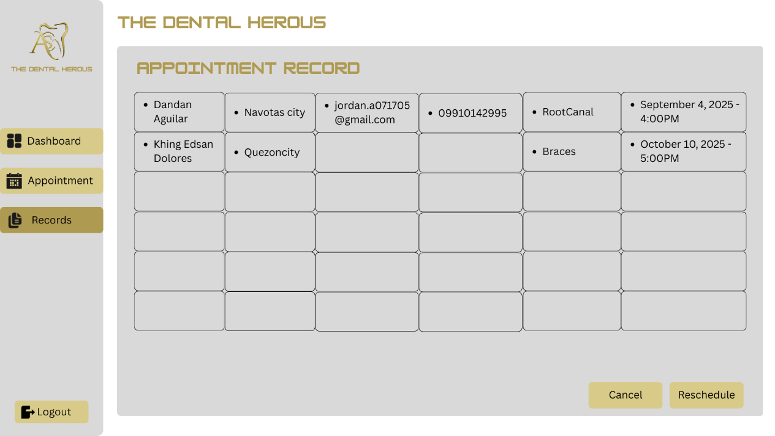

*Figure 7. Viewing Appointment Records*

**COMPONENT DESIGN**

Each functional module is implemented as a reusable component:

* **Owner Authentication Component:** manages login processes, It is responsible for verifying the identity of clinic staff members such as Admin and Staff.
* **Loading Screen Component:** This helps ensure proper screen refresh, preventing the system from freezing during startup or while opening components.
* **Login Component:** is a fundamental part of the Dental Appointment Records System, responsible for verifying the identity of users before granting access to the system. It ensures that only authorized staff members such as Owner, Admin, Staff can access sensitive data and perform specific tasks.
* **Main Form Component:** The system has been improved to be clearer and more organized, ensuring that no issues arise within the form records.
* **Admin Component:** It enables to (View, Read, Update, Delete) functionalities for patients appointment listings, allowing admins to add new records, and Reschedules.

**DATA FLOW DIAGRAM**



*Figure 8. Flow diagram of the system* *showing admins and staffs*

This data flow diagram represents the user journey within the Dental Appointment Records System. The process begins when the user enters the **Loading Screen**, followed by the **Login** page for authentication. Once logged in, the user accesses the **Dashboard**, Here, you will see the recent records along with the patients' schedules. When you create a new appointment, the patient's personal information will be displayed. You can review and confirm that the details are correct and clear before adding them to the records.

By navigating to the Records section, you can view the full information of each patient. From here, you have the option to reschedule an appointment using the button at the bottom or cancel it if there are any issues. You can log out using the button located on the lower left side of the screen.

**PERFORMANCE DESIGN**

We have tested it thoroughly before it was enabled and released, ensuring that this dental appointment system will be faster and cleaner to operate in an easy and mobile way. And created a neat and clean design based on the system we operate, not just for aesthetics or beauty, and we simplified each color.

**Error Handling and logging**

Error Handling:

* Invalid login → user-friendly error message.
* Main form error → retry option and error log.
* Server errors → fallback error page.

Logging:

* Maintain system logs for user activities, failed transactions, and server issues.
* Logs stored securely and analyzed for debugging and security monitoring.

**DEPLOYMENT PLAN**

It is important to clearly demonstrate and explain to the Owner and Administrator how the system can be implemented and effectively used in their clinics. The deployment plan outlines the process of installing, configuring, and launching the Dental Appointment Records System, ensuring that it is accessible, functional, and secure for clinic staff and administrators. Training sessions may be conducted for staff to ensure they understand how to use the system effectively. Ongoing **monitoring and maintenance** are also planned to address bugs, security updates, and performance improvements post deployment. Next, the **application code** is deployed, and environment variables (such as database credentials staff and admin access keys) are securely set. The system is tested in a **staging environment** to ensure all modules including login, appointment scheduling, records management, and logout are functioning correctly.

Top of Form

Bottom of Form

**MAINTENANCE AND SUPPORT**

Providing assurance to them to make the system more beautiful and reliable for long-term use ongoing maintenance and support are essential to ensure the Dental Appointment Records System remains reliable, secure, and up to date. Regular maintenance involves checking for bugs, fixing system errors, and optimizing performance to prevent slowdowns or data issues. This includes updating software data, databases, and security protocols to protect patient data and ensure compliance with health information standards. The maintenance and support strategy ensures that the system remains secure, updated, and user focused. Regular updates will address security patches, framework improvements, and bug fixes to maintain system stability.

**REVISION HISTORY**

It will run faster to prevent any problems or system slowdowns and also provide updates. Here we show what we can add or fix.

|  |  |  |  |
| --- | --- | --- | --- |
| **Date** | **Description of Change** | **Part(s) Affected** | **Designated Task Owner** |
| August 25, 2025 | Revision and improving the overall architecture and planning | All | Tabor, Aguilar, Dolores |
| August 27, 2025 | Adding more info for Introduction, Maintenance and Support, and Deployment Plan | Databases and Back-end | Dolores, Aguilar, Tabor |
| August 31, 2025 | Expanding some short parts to give more details to the system design document | System Between  Main form Design  Interface Design, Component Design | Tabor |
| September 2, 2025 | Created a proper data flow of the system | Data Flow and Communication Database design | Aguilar |

*Table 1. Revision table*