# Conway’s Game of Life - Proposal

Description:

Conway’s Game of *‘Life’* is a complex algorithm solver which can produce an endless amount of patterns. ‘*Life’* works by checking four possibly rules. The rules being, if there are less than two live cells around said living cell it dies, if there are two or 3 live cells around a live cell then it continues to live, if there are more than 3 live cells around a living cell it dies, and if a dead cell had 3 neighboring live cells, it comes back to life. There are 3 main pattern types. The first one being still lifes, which will not move as they have enough cells in correct positions to never be forced to die or come back to life. The second one are oscillators, which repeat endlessly until told to do otherwise. The third are spaceships, which maintain a relatively similar form to how it started but will move itself across the grid.

Target:

The target audience would most likely be programmers as this is a complex algorithm which took mathematicians 40 years to figure out. Due to its complexity, other programmers would reap benefits by analyzing the code of this algorithm and learning from it. Age doesn’t matter as it’s age appropriate, featuring no explicit content, with the only barrier for entry being having an interest in learning. As for payments it could be relatively cheap as it costs virtually nothing to have created in the first place, and is mostly just to help people therefore it should be inexpensive. As for marketing, we’d advertise this towards schools and universities, students and professors alike, to offer them a challenge and a learning experience.

Specific Functionalities:

As demonstrated earlier, this program is designed for educational purposes. Using algorithms, plenty of patterns can be inputted to allow users to study and learn off the program. Can also be used as a Turing program. The basic functions of the program are as follows:

1. The program allows user input to decide which location on the infinitely generated grid. This allows the user to have some interaction with the program, before experiencing the algorithm do what it was intended to do.
2. The program will then from that point begin to generate dots which represent cells. They will continue to be generated, with each cell being generated off the middle cell of that area.
3. The program will take into account the rules of Conway’s Game of Life, which are as follows:

* If there are less than 2 cells, the central cell will become dead
* If there are 2 or 3 neighbouring cells, the central cell will be living
* If there are more than 3 neighbouring cells, the central cell will become dead
* If there is a dead cell with 3 neighbours, it will become living through “regeneration”

The various rules show off the program feature titled ‘generations’. As a cell is generated and others become dead or living, the program treats each modification as a new generation.

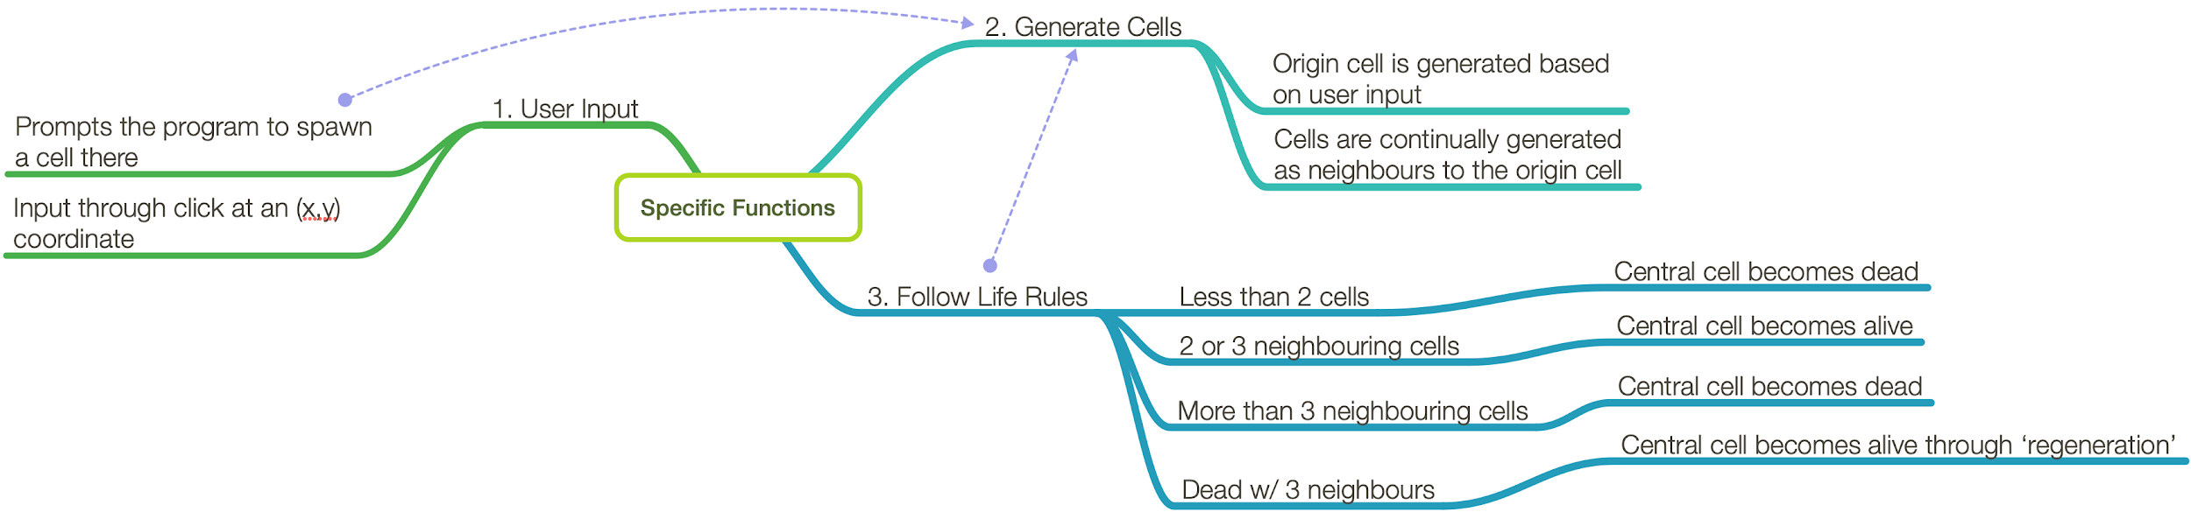

Programming Team:

Team Leader - Jeremy Weisberg

* Map out each part of the programming process and assign subprojects
* Program code for each step of the project
* Co-manage class diagrams and error checking

Programmer - Ritchie Dimaria

* Debug the code and check for errors
* Program code for each step of the project
* Creating class diagrams

Programmer - Jordan Belinsky

* Manage the github repository
* Debug the code and check for errors
* Program code for each step of the project

Project Manager - Alex Giannoulis

* Creating diagrams
* Creating visuals
* Assisting with programming if necessary