**Title:** A web based risk calculator incorporating preoperative opioid use to predict revision of total-knee arthroplasty

**Background:** Over 700,000 total-knee arthroplasties (TKAs) are performed in the United States each year1 with 6% requiring revision after 5 years due to wear, osteolysis, instability, infection, or other causes2-4. Some risk factors for knee revision have been previously identified5-8. However, given the high prevalence of prescription opioid use in the United States9, we sought to specifically investigate the role of opioids in TKA revision. Additionally, due to the increased complexity, expense, morbidity, and mortality associated with TKA revision1,10, we aimed to create a freely available online risk calculator to assist providers in predicting TKA revision.

**Methods:** We retrospectively analyzed the medical records of all Veterans Administration patients who underwent unilateral TKA from Jan. 1, 2006 to Dec. 31, 2011. Exclusion criteria included bilateral knee replacement in a single procedure, undetermined surgical laterality, or irreconcilable surgical dates. Preoperative daily morphine equivalent doses were calculated for each patient based on prescription records from Jan. 1, 2005 to their initial TKA date. All patients were followed from their initial TKA date until Dec. 31, 2012. Time to knee revision, grouped by non-opioid users versus opioid users divided into tertiles, was plotted using Kaplan-Meier curves11. A multivariate Cox proportional hazard model was then fit to predict TKA revision with daily morphine equivalent dose as a continuous variable. Backwards stepwise selection with the Akaike information criterion (AIC), employing 10-fold cross validation, was used for variable selection12. P-values less than 0.05 were considered significant. Model performance was evaluated by the accuracy of the survival function on a 40-sample bootstrapped calibration plot for predicting TKA revision at 1 year12. The model was used for a decision support application13 to quantify the risk of knee revision following TKA. R (version 3.1.2; http://www.r-project.org) was utilized for data analysis and application development14.

**Results:**  A total of 34,461 VA patients who underwent TKA between 2006-2011 were identified, and 33,642 patients met inclusion criteria. The cohort was 94% male with a mean age of 64.4 (sd = 9.5). Follow-up time ranged from 1 to 7 years (median = 3.70). A total of 1,715 (5.10%) patients required revision. Figure 1 displays the distribution of morphine equivalent dose use in our cohort. Figure 2 displays Kaplan-Meier curves comparing TKA revision by opiate use group. Patients not using opiates were less likely to need a revision than patients using up to 3.7 morphine equivalents daily (p = 0.016). Furthermore, patients using up to 3.7 morphine equivalents daily were less likely to be revised than patients using more (p = 0.002). For the Cox model, hazard ratios and associated p-values for all variables included are listed in Table 1. Daily morphine equivalents were independently associated with TKA revision (HR 1.0008, p = 0.0013). Accuracy of the model at 1 year is displayed in the calibration plot shown in Figure 3. The Bias corrected mean absolute error was 0.0027. Using the model, we generated a web based risk calculator for TKA revision ([bit.do/tka](http://bit.do/tka)). A screen shot of the application is shown in Figure 4.

**Conclusions:** Preoperative opioid use is an independent predictor of TKA revision in a dose-dependent manner.In an effort to quantify the preoperative risk of TKA revision for patients undergoing TKA, a risk calculator was created and published online.

Figure 1: Histogram showing the distribution of daily morphine equivalent dose usage among patients in our study cohort.

Jordan's MacBook:Users:jack:Desktop:Research:TKA Revision:MEDdist.pdf

Figure 2: Kaplan-Mayer curves showing earlier TKA revision for patients with higher daily opioid consumption. MED = morphine equivalent dose.

Jordan's MacBook:Users:jack:Desktop:Research:TKA Revision:Survival.pdf

Table 1: Variables included in the Cox proportional hazard model predicting TKA revision.

|  |  |  |  |
| --- | --- | --- | --- |
| **Variable** | **Hazard Ratio** | **95% CI** | **P-Value** |
| Age | 0.9518 | 0.9489 - 0.9547 | < 0.0001 |
| CKD | 1.5106 | 1.3820 - 1.6512 | < 0.0001 |
| Daily Oral Morphine Equivalents (mg) | 1.0008 | 1.0005 - 1.0009 | 0.0013 |
| Diabetes | 1.1616 | 1.0979 - 1.2290 | 0.0079 |

Figure 3: Calibration plot of the TKA Revision model at 1 year showing predicted versus observed revision rates. A histogram plotting frequencies of each predicted revision rate is inlaid on the x-axis.

Jordan's MacBook:Users:jack:Desktop:Research:TKA Revision:Calibration.pdf

Figure 4: Screen shot of the decision support application at [bit.do/tka](http://bit.do/tka) for predicting knee revision following TKA. The user is prompted to enter the patient’s age, daily morphine equivalent dose, and diabetes and chronic kidney disease status. The application displays the patient’s time dependent risk for knee revision.

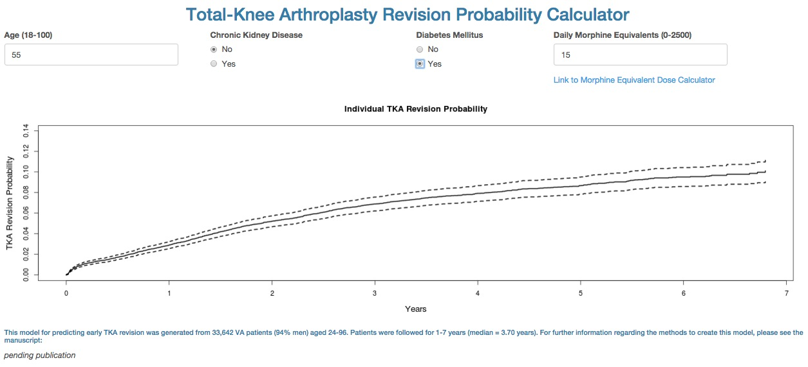

References:

1. Centers for Disease Control and Prevention. National Hospital Discharge Survey: 2010. Available at [http://www.cdc.gov/nchs/fastats/inpatient-surgery.htm](https://www.google.com/url?q=http://www.cdc.gov/nchs/fastats/inpatient-surgery.htm&sa=D&ust=1450204599044000&usg=AFQjCNHEV-QJsjaj2in9iOlFvUCj6SpriQ" \t "_blank). Accessed on Dec. 19, 2015.

Australian Orthopaedic Association National Joint Replacement Registry. Annual Report 2015. https://aoanjrr.dmac.adelaide.edu.au/documents/10180/217745/Hip%20and%20Knee%20Arthroplasty. Accessed on Dec. 19, 2015.

Garellick G, Kaurrholm J, Rogmark C, Herberts P. Swedish Hip Arthroplasty Register Annual Report 2013. Available at http://www.shpr.se/Libraries/Documents/AnnualReport\_2013-04-1\_1.sflb.ashx. Accessed on Dec. 19, 2015.

Paxton EW, Namba RS, Maletis GB, Khatod M, Yue EJ, Davies M, et al. A prospective study of 80,000 total joint and 5000 anterior cruciate ligament reconstruction procedures in a community-based registry in the United States. J Bone Joint Surg Am. 2010;92(suppl2):117–132.

Hagen TP, Vaughan-Sarrazin MS, Cram P. Relation between hospital orthopaedic specialisation and outcomes in patients aged 65 and older: retrospective analysis of US Medicare data. BMJ. 2010;340:c165.

Katz JN, Mahomed NN, Baron JA, Barrett JA, Fossel AH, Creel AH, et al. Association of hospital and surgeon procedure volume with patient-centered outcomes of total knee replacement in a population-based cohort of patients age 65 years and older. Arthritis Rheum. 2007;56:568–574.

Namba RS, Cafri G, Khatod M, Inacio MC, Brox TW, Paxton EW. Risk factors for total knee arthroplasty aseptic revision. J Arthroplasty. 2013;28(8 suppl):122–127.

Santaguida PL, Hawker GA, Hudak PL, Glazier R, Mahomed NN, Kreder HJ, et al. Patient characteristics affecting the prognosis of total hip and knee joint arthroplasty: a systematic review. Can J Surg. 2008;51:428–436.

1. Manchikanti L, Helm S, Fellows B, Janata JW, Pampati V, Grider JS, et al. Opioid epidemic in the United States. Pain Physician. 2012;15:ES9-38.
2. Kurtz SM, Ong KL, Schmier J, Mowat F, Saleh K, Dybvik E, et al. Future clinical and economic impact of revision total hip and knee arthroplasty. J Bone Joint Surg Am. 2007;89(suppl 3):144–151.
3. Therneau T. A Package for Survival Analysis in S. R package version 2.38, http://CRAN.R-project.org/package=survival.
4. Harrell FE. rms: Regression Modeling Strategies. R package version 4.3-1. http://CRAN.R-project.org/package=rms.
5. Chang W, Cheng J, Allaire JJ, Xie Y, McPherson J. shiny: Web Application Framework for R. R package version 0.12.0. http://CRAN.R-project.org/package=shiny.
6. R Core Team. R: A language and environment for statistical computing. R Foundation for Statistical Computing, Vienna, Austria. http://www.R-project.org/.