**EATING OUT.**

**FINDING A PLACE TO EAT?**

**Tripadvisor, yelp, foursquare, google maps**

**DECIDING WHAT TO EAT?**

**???**

**INTRODUCING DISHOOS**

**SHIFTING THE FOCUS FROM RESTAURANTS TO DISHES**

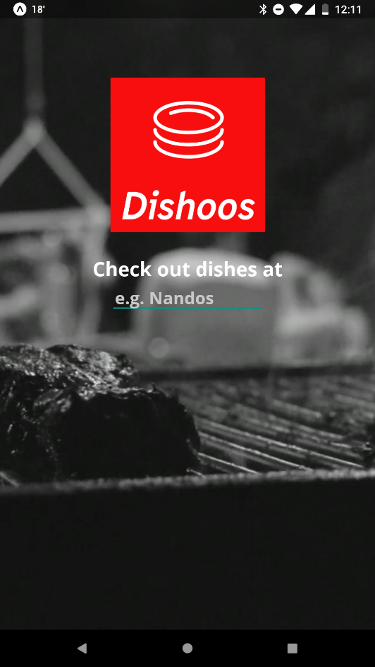

Check out reviews of a restaurant’s dishes

Filter and sort by preference

Add your own

Dish search instead of restaurant search (Find me the best fish and chips in town!)