**Interface Design Explanation**

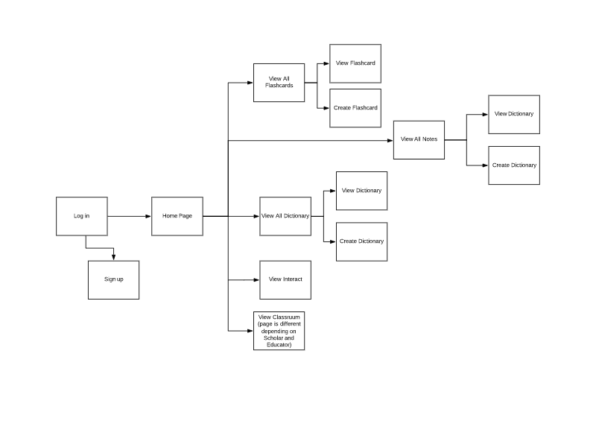

In the initial design for our interface, we had to consider the form and functionality of our program. We have chosen to implement a more professional approach (whilst maintaining our accessibility) compared to the likes of competitor applications (for example Quizlet). This is denoted through our simplistic and minimalistic colour pallet (pastel) and ease of access. to We ensured to fulfil the objectives specified in the requirements whilst maintaining the theme and visual representation of our product.

Our target demographic are students (age 15-25) and teachers. Below is an analysation of some of the important aspects to some of the pages, mostly outlining how navigation works through the scenes. The scene numbers to do not generally dictate the order of slides and are used just to refer to the scenes.

**Scene: 1 Log in**

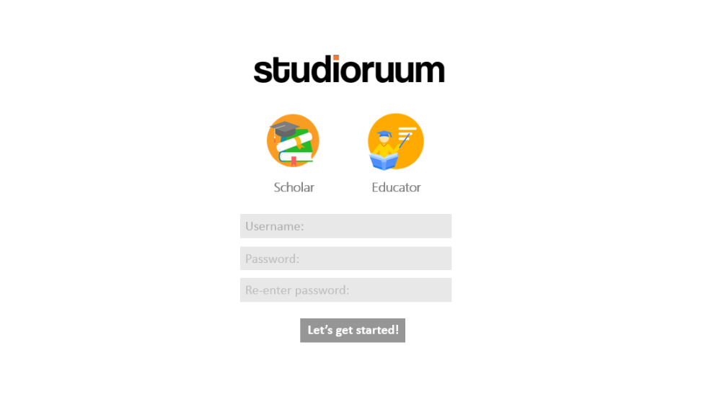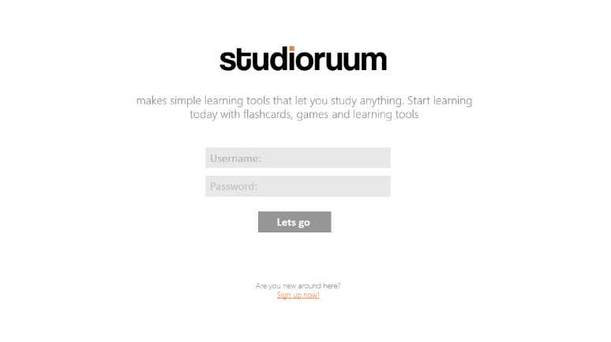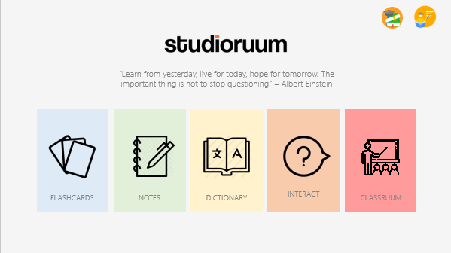

**Scene: 2 Sign up**

User can choose their preferred account type: Scholar or Educator

Button that will take them to home page, and add the users account to the database saving there username/email, password and account type.

If user is new, they can create a new account, which will lead them to the next page: create account.

Button that will take them to home page, if their account credentials are correct. Chose to used colloquial verbiage to connote accessibility, and make the program appear more user friendly.

Greet the user with the logo and a short sentence that explains what our program does.

Log in to an existing account by using usernames and passwords.

**Scene: 3 Home**

If you are using the Educator account type, this icon will appear at top right. Likewise with Scholar

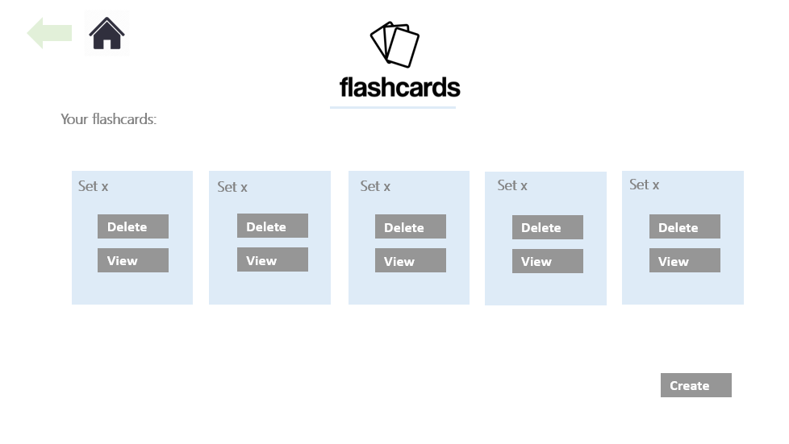 

This shows the users flash card sets, and allows the user to view or delete them

Back button used to navigate to previous page. (Can be used if the user makes a mistake)

**Scene: 4 View flashcards**

This button will take them to the

This will take them to the view dictionaries where they can save and delete sets of dictionaries

This will take them to the view notes where they can save and delete sets of notes

This will take them to the view flashcards where they can save and delete sets of flashcards. (scene 4)

View will take to view flash card page.

Home button takes to home page

This shows the users flash card sets, and allows the user to view or delete them

This indicates the page the user is on.

Short quote that used to inspire the user.

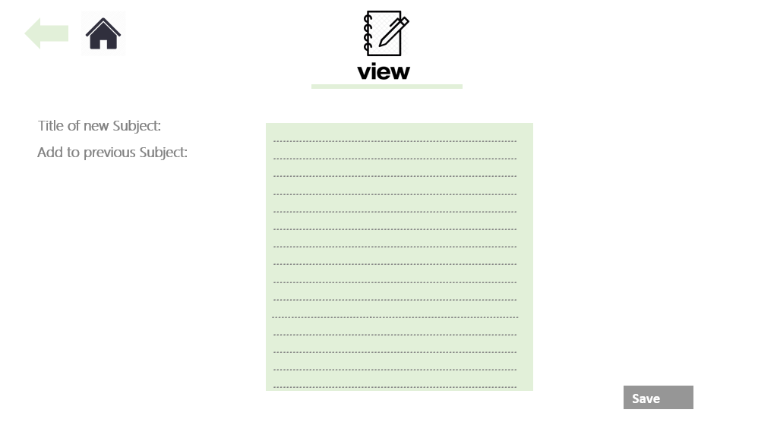

**Page: 9**

Button saves notes to the database and into the subject (new or previous)

Choose whether to name a new set or save note in another subject

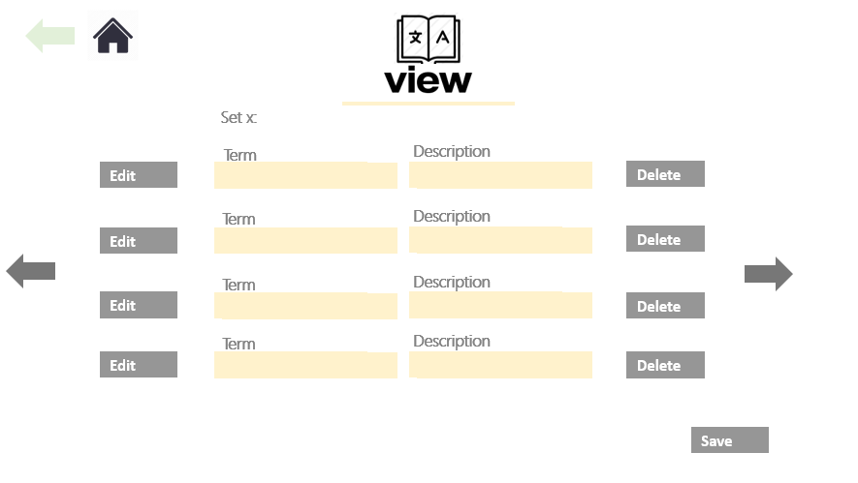

This will delete the attributes in the database.

This will delete the attributes in the database.