

Android App User Manual

Overview

The app is an offline version of the standard Studioruum application for desktop. The user is given the ability to create and consult notes, dictionaries and flashcards on the go, from their Android mobile device.

Requirements

In order to be able to install and use the app, the user needs an Android device running at least on version 4.0 (“Ice Cream Sandwich”).

Installing the app

To install the app, simply download the studioruum.apk file from <https://github.com/lloydgjones/Studioruum>. You will be able to find this file in the directory ***app/android/app/release***. Depending on the Android version running on your device and your settings, you may have to allow installing apps from unknown sources. A prompt to let you change this setting may appear. Simply click on it, change the setting and navigate back to the installation page to complete the process.

Using the app

When opening the app, the user is presented a menu with three options: *Flashcards*, *Notes* and *Dictionary*.

By tapping the *Notes* option, the user is able to create new notes, edit and deleting existing ones, as well as consulting them. To create a new note, the user simply needs to tap the *Edit* button to unlock the text area for the note. When the user is satisfied with the content of their note, they can save it by tapping the *Save as new* button. The new note will appear in the drop-down menu at the top of the page. By selecting a note from said menu, the user can consult it, overwrite it with new content (in a similar way to creating a new note, this time by tapping the *Save* button) or delete it. To create a new note when other ones are already present, the user should tap on *Edit* (the currently selected note is unimportant), change the content of the note according to their preferences and then tap *Save as new*.

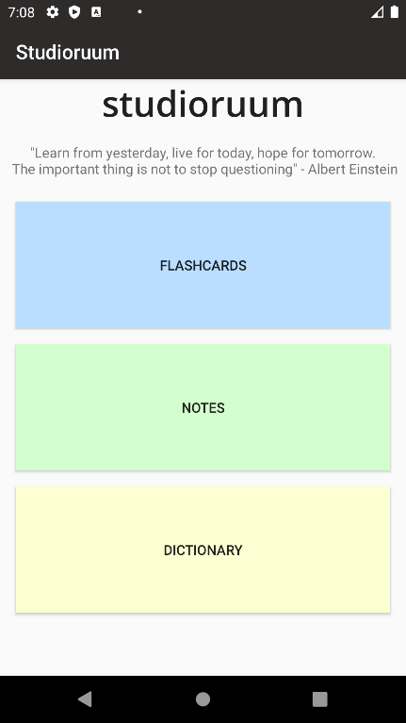 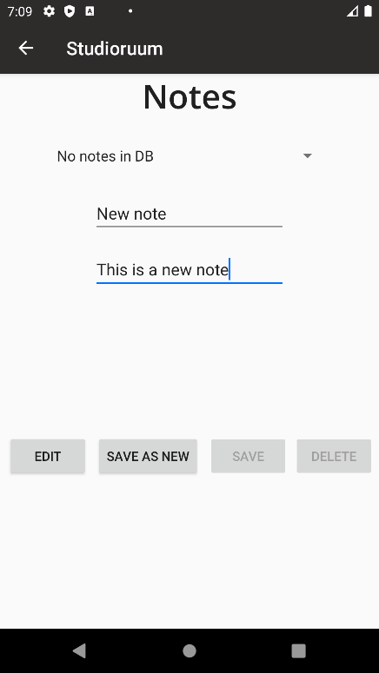 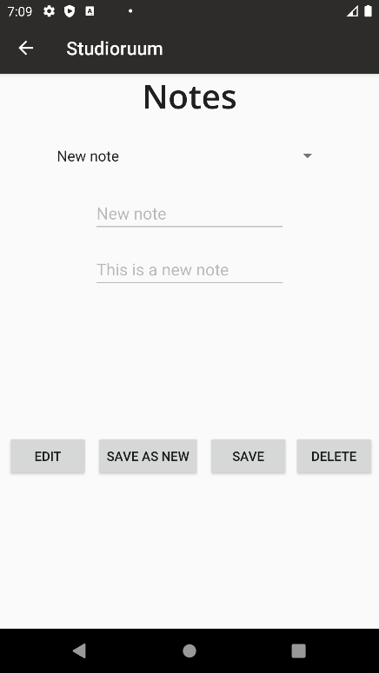

By tapping the *Dictionary* option, the user can create a new Dictionary (a container for their flashcards), as well as renaming, consulting and deleting existing ones. After creating a new Dictionary, the user can choose to be redirected to the Flashcards page, in order to start adding them to their newly created Dictionary.

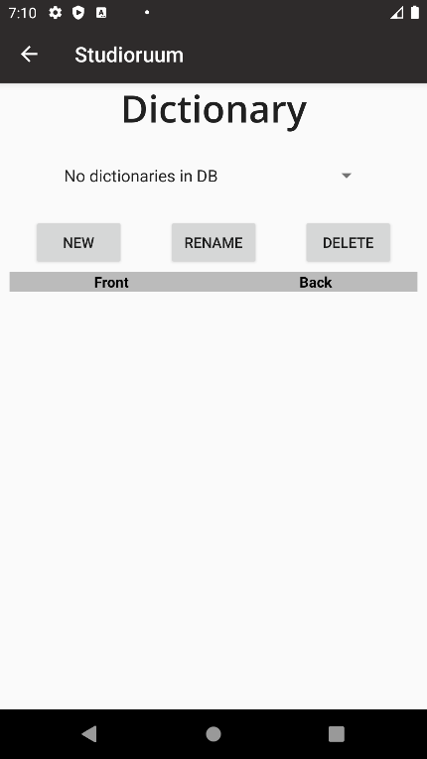 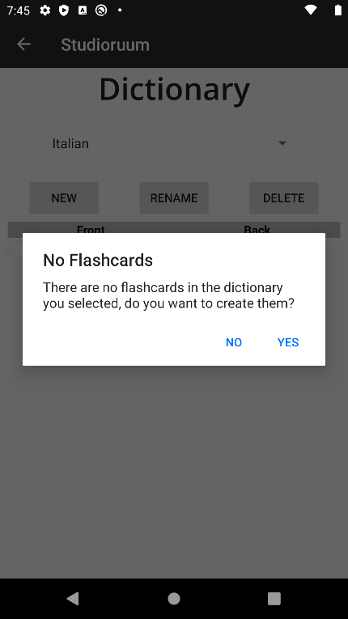 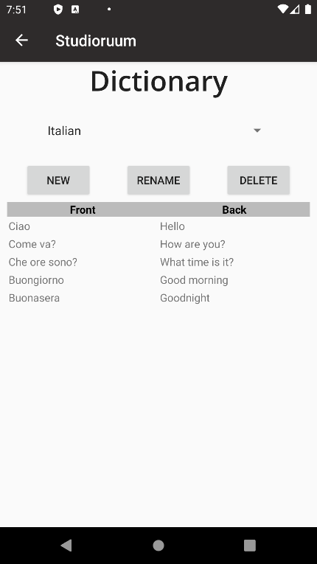

In the *Flashcard* page, the user can create Flashcards to be saved in a Dictionary of their choice, along with modifying and deleting existing ones and, obviously, consult them. The user can navigate through existing flashcards by tapping the *Prev* and *Next* buttons, and flip them to reveal their answer with the *Flip* button.

