

Windows App User Manual

Table of contents

1. Overview
2. Requirements
3. Installing the app
4. Launching the app
5. Using the app
   1. Notes
   2. Dictionary
   3. Flashcards
   4. Foruum
   5. Classruum – Educators
   6. Classruum - Scholars

Overview

Studioruum is an application which gives users the possibility to create and manage their own Flashcards and Notes. The application is aimed at students and educators, which are identified respectively by the account types *Scholar* and *Educator*.

Requirements

Due to the inclusion of JavaFX and a number of other dependencies, compiling a JAR file proved to be problematic. Due to this, you will need the following to access the app:

* ***Java Runtime***
  + <https://java.com/en/download/manual.jsp>
* ***Java Development Kit***
  + <https://www.oracle.com/java/technologies/javase-downloads.html>
* ***IntelliJ IDEA - Community Edition***
  + <https://www.jetbrains.com/idea/download/#section=windows>
* ***JavaFX Windows SDK***
  + <https://gluonhq.com/products/javafx/>

If your Java is setup for developing and running applications as normal, you will only need to run the installer for *IntelliJ IDEA* and place the downloaded *javafx-sdk-11.0.2* folder in a place of your choosing (such as documents).

Installing the app

Navigate to the GitHub repository for the project via the link below:

<https://github.com/lloydgjones/Studioruum>

1. 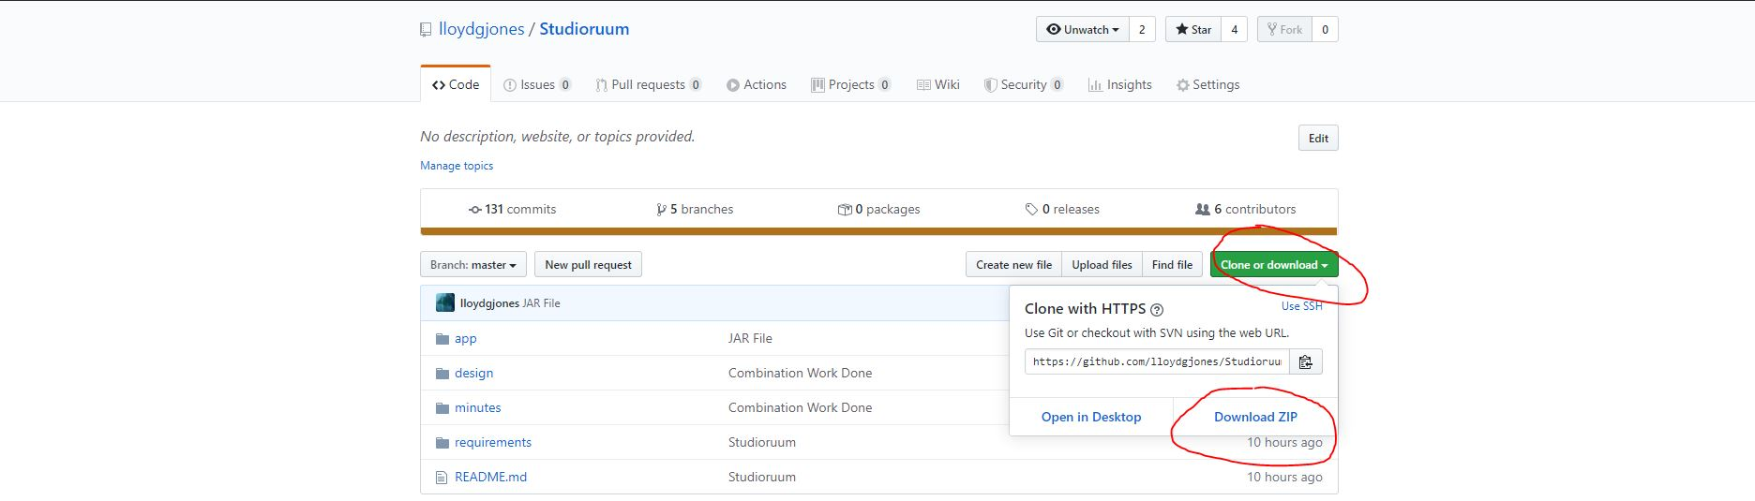Download the repository by clicking on ***Clone or Download > Download ZIP*** as shown in the screenshot below:
2. Navigate to ***Studioruum\app\windows*** and double click ***windows.iml*** to open it in IntelliJ IDEA. Once there, go onto ***File > Open File in Project…*** to get the project open.

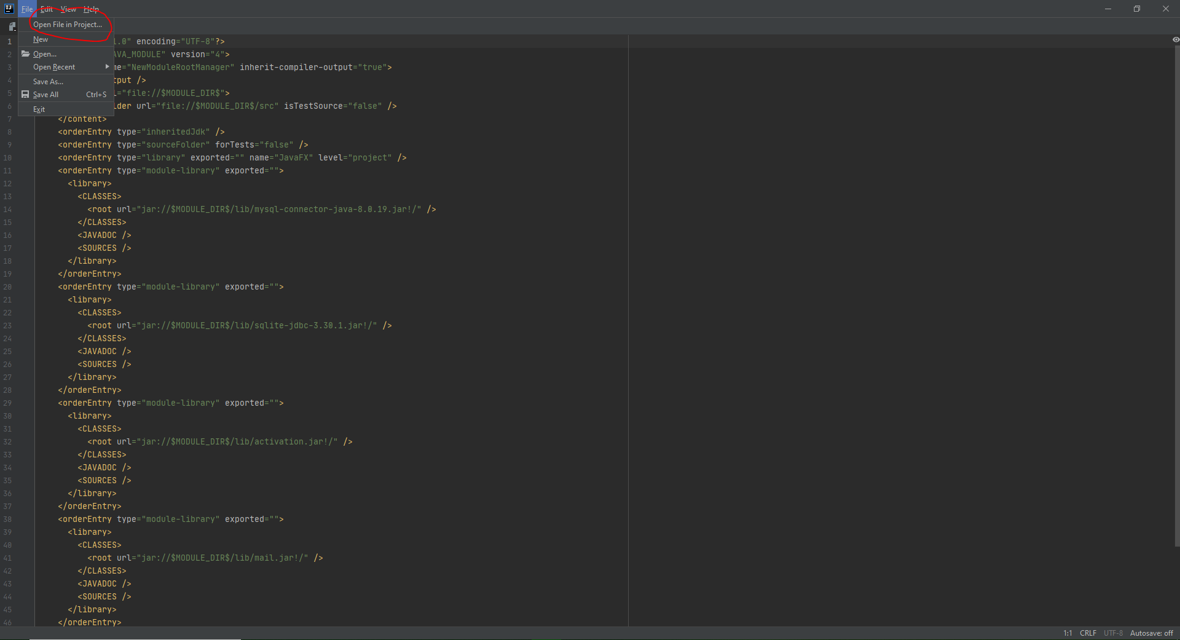

1. Your current screen should look like the image below. From here we need to configure the settings of the project, which can be done with ***File > Project Structure***.

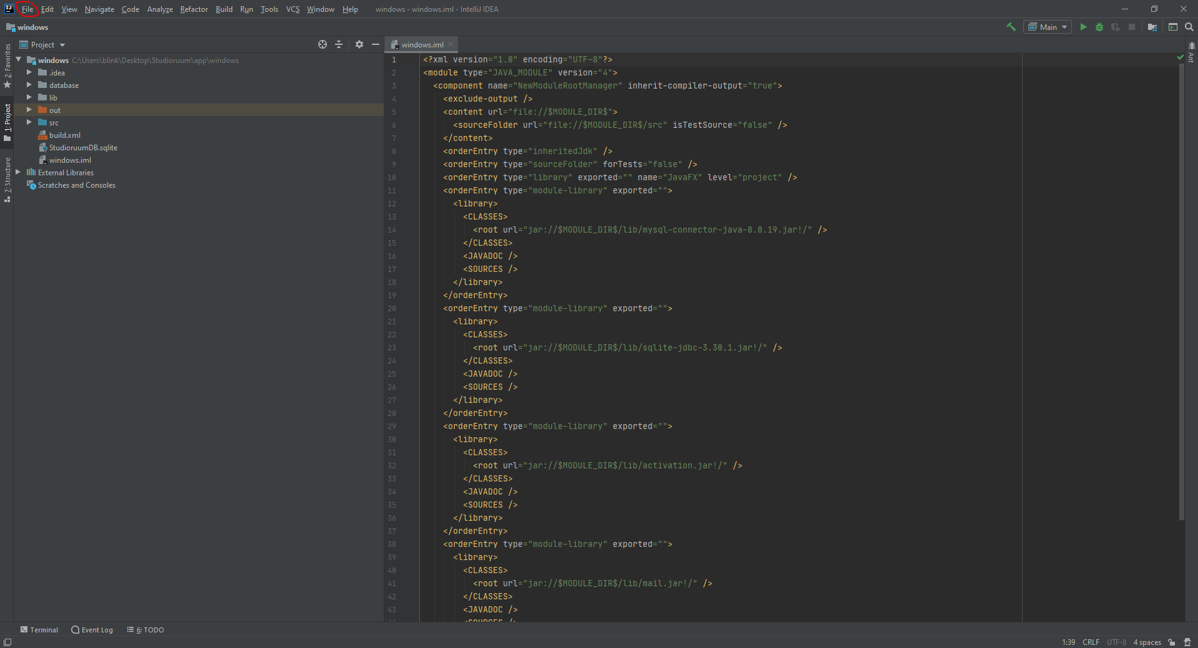

1. For the final step of setup, we need to configure a few tabs in the Project Structure panel that should have popped up after the last step. Go onto the ***libraries page***, and do the following:
   1. Click on the ***+* > Java** and then navigate to wherever you placed your ***JavaFX*** folder, and select the ***JavaFX/lib*** to add your version of JavaFX to the project.
   2. Set the name at the top of the screen to ***JavaFX***. You should have the following classes and sources directories set up as below (with the path to your JavaFX/lib folder).

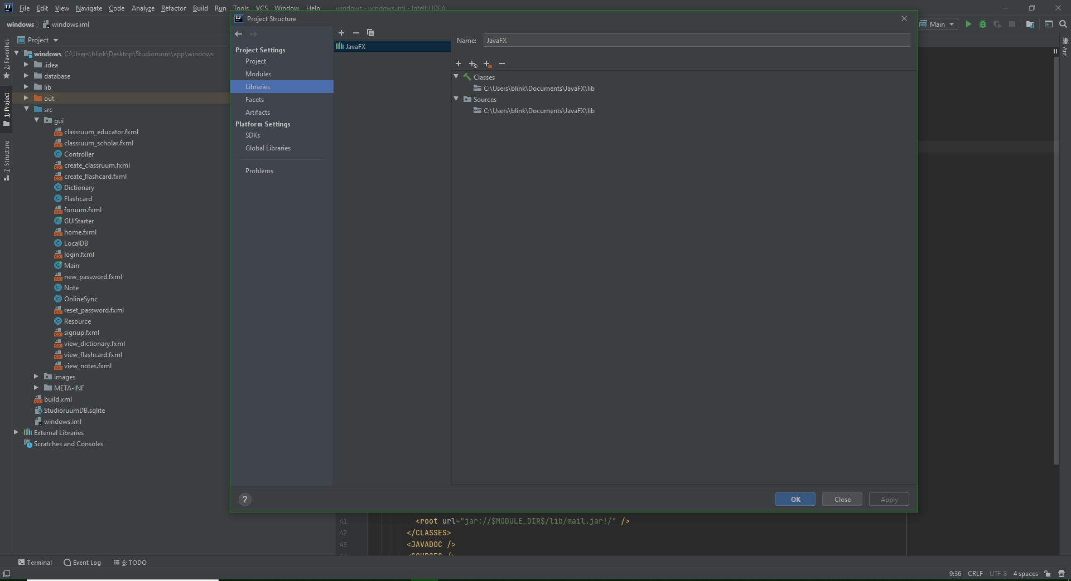

1. Navigate to the ***modules*** tab and go onto **dependencies**. Click on the ***+ button*** on the right of the screen and click on the second option, ***library***. From there you should only have the optional to add the JavaFX library you added in the previous step. Once this is done, ensure your page looks as below, with all the other dependencies/JARs from the ***app/windows/lib*** folder being included also.

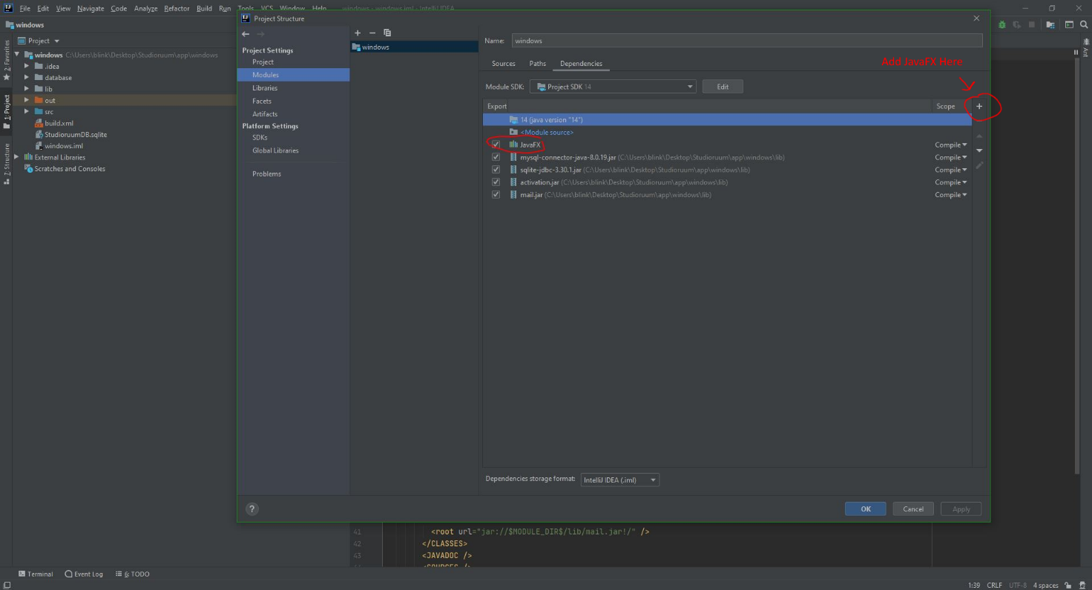

Launching the Application

* To launch the application, simply click on the ***run button*** as highlighted below, or do ***Run > Run ‘Main’***.

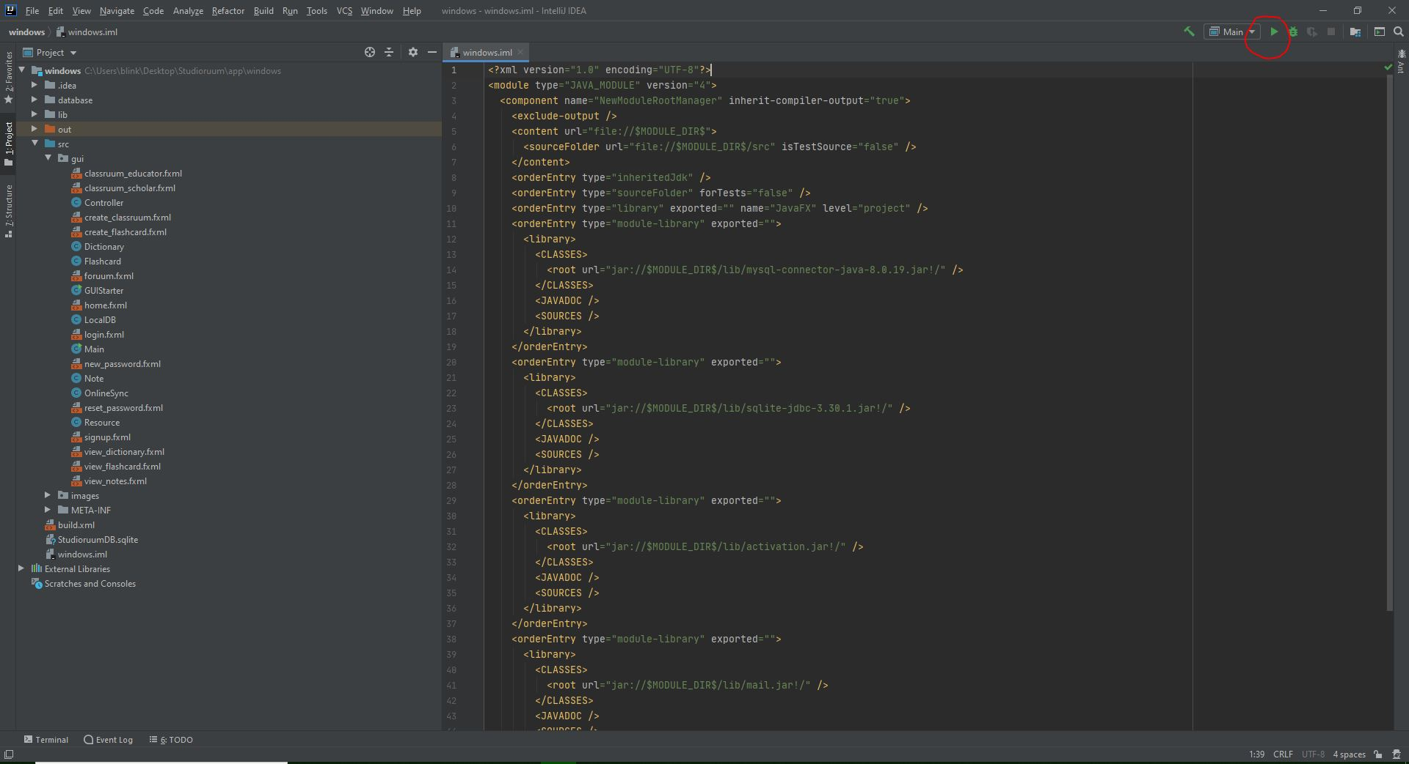

Using the app

When first launched, the user is presented with a login screen. A new account can be created by clicking “Sign Up Now!”, which will redirect the user to a page where to choose their account type and fill in their personal data. After creating an account, the user will simply have to type in their username and password every time the app is launched.

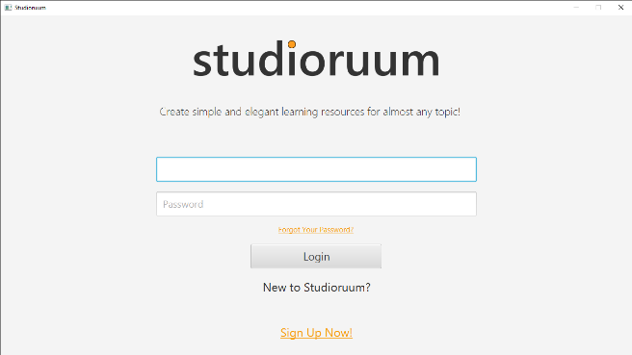 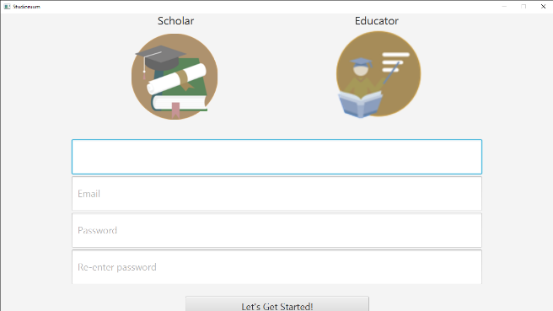

If the login/signup process is successful, the user will be greeted by a main menu providing five options: *Flashcard, Notes, Dictionary, Foruum* and *Classruum.*

*Notes*

In the *Notes* page, the user is given the ability to create, read, modify and delete their notes. To create a new Note, simply type a note title, the note content and then press the button Save as New. The newly created Note will appear in the dropdown menu at the top-right corner of the page, ready to be selected, consulted, modified or deleted.

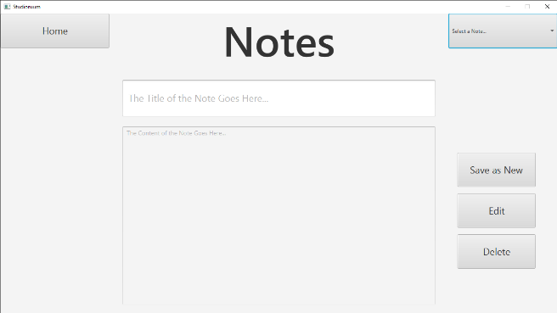 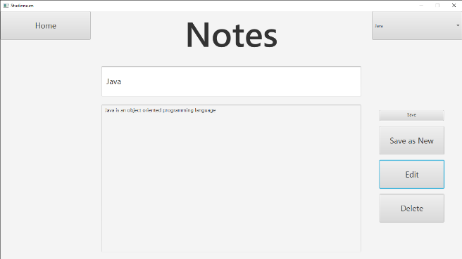

*Dictionary*

The *Dictionary* aggregates all Dictionaries (containers in which Flashcards are stored) created by the user. A Dictionary must be created in order to start creating Flashcards. By clicking the button New Dictionary, the user will be prompted with a small window where to specify the name of their newly created Dictionary. As with other pages in the applications, the Dictionaries that have been created will be displayed in the drop-down menu at the top-right corner of the window. By selecting an existing Dictionary from it, the Flashcards contained will appear in the table at the bottom of the screen. The user can decide to rename or delete an existing Dictionary by using the buttons provided.

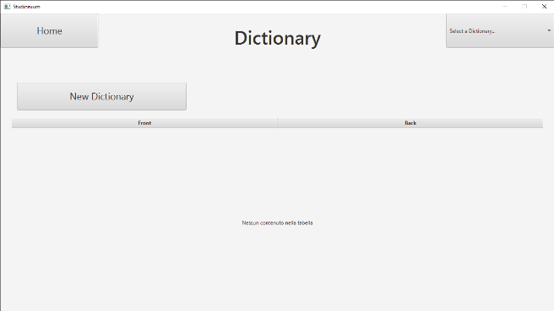 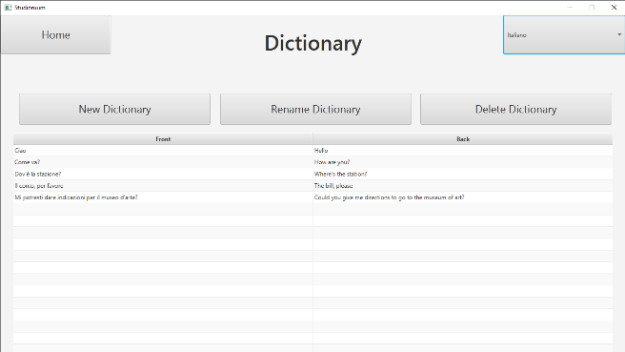

*Flashcards*

In this page (provided that at least one Dictionary is available), the user is able to create, edit and delete Flashcards using the correspondent buttons. The Flashcards created will automatically be added to the currently selected Dictionary, and be navigated through using the Prev and Next buttons. The user can reveal the answer of a Flashcard by pressing Flip.

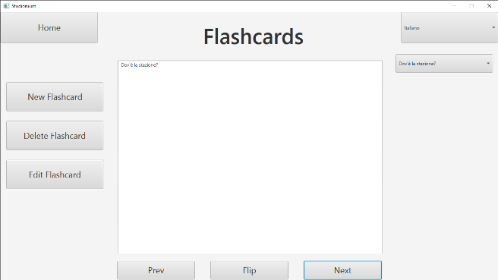

*Foruum*

The *Foruum* is a page where both *Scholar* and *Educator* users can post comments in sub-forums categorised by subject. To post a comment, a user first needs to click the subject they are interested in, which will subsequently provide them the ability to type in their comment and save it using the Comment button.

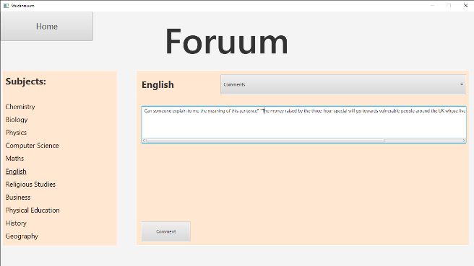

*Classruum – Educators*

A Classruum is an environment created by an *Educator* user to share their own made resources with *Scholar* users signed up to their Classruum. When clicking the *Classruum* option from the main menu for the first time, an *Educator* user will be shown with a window inviting them to create their own Classruum. Just under the previously clicked button, there should be a *Create* button, prompting another window in which to type a name and a description for the Classruum. After that, the *Educator* will be able to access their Classruum and upload the resources they have made, as well as inviting *Scholar* users to join the class by typing their username.

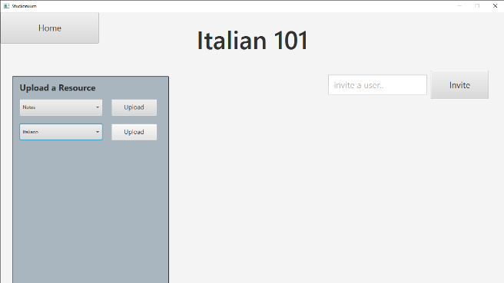 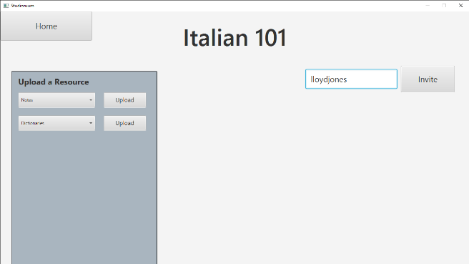

*Classruum – Scholars*

A *Scholar* user can be part of multiple Classruums. To join one, the *Scholar* will need to receive an invite by an *Educator* user managing a Classruum. After joining one or multiple Classruums, the *Scholar* will be able to download the resources uploaded to a Classruum by clicking on the name of it in the Classruum section on the left-hand side of the screen and then clicking on the button Get Resources.

