# Planning

## Gannt Chart

We have created an initial Gannt Chart to show some rough estimations of how we expect the product to be conducted. Whilst earlier sections have more detail (such as task allocations), the later sections are currently estimating the time needed for general phases of development and don’t have individual tasks underneath them. Throughout the development of the project, we will use the tools shown below to add to and refine upon this Gannt Chart and the planning of the project as a whole.

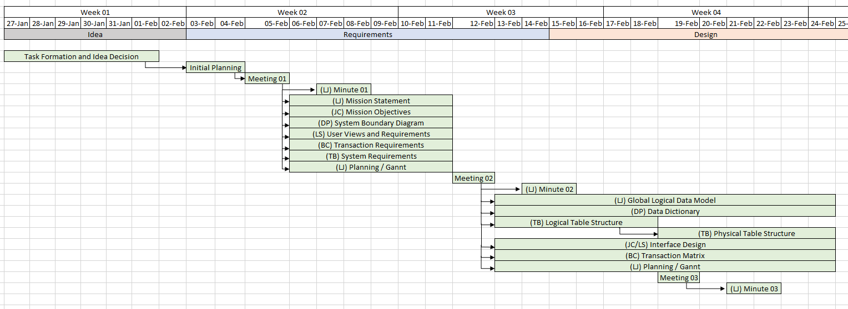

## Meetings

We aim to meet every week (excluding the first week) for an hour review session to check the quality of work produced and allocate tasks to be completed over the next week(s). Currently, we have had two meetings (see the minutes for more detail), with the general topics discussed being:

1. Allocating Tasks for the Requirements and General Planning
2. Allocating Tasks for the Design and Finalising the Requirements Document

## Other Tools

As well as the above methods, we have been using a *Discord Server* that allows us to communicate quickly with each other and share files for feedback. The main use thus far has been to schedule meetings, brainstorm ideas, check requirements of the system and mention any important information needed for the project.

As with many larger software development projects, we are using a *GitHub Repository* to aid in source control, and host all of the project files. All planning updates and important information are listed on this page to be easily accessible, and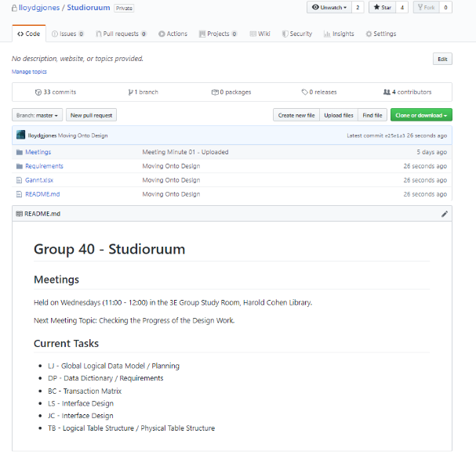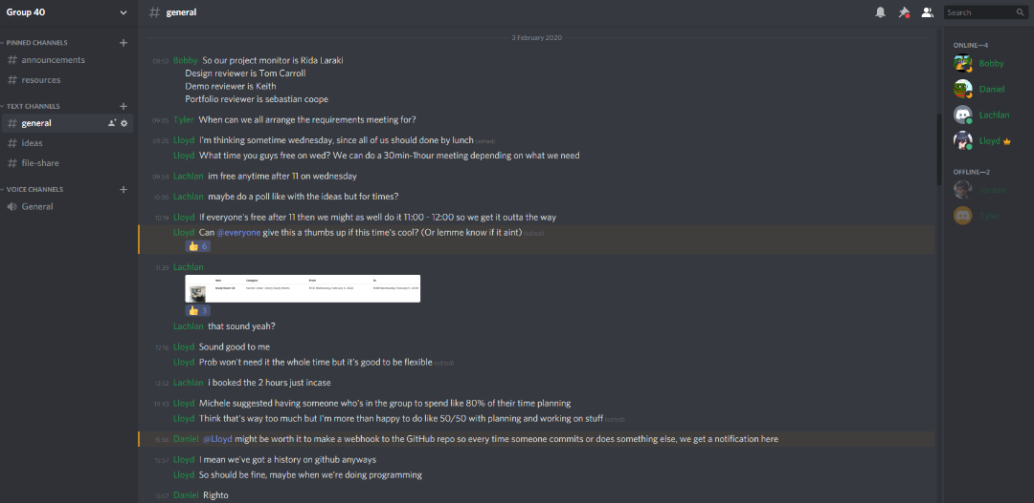 all work completed by group members are quickly available in a centralised place.

## Planning Choices

Though the schedule given in the lectures for the project completion is to be mostly adhered to, we have decided that it would be beneficial to try and complete the design in *two or three weeks* as opposed to *four* to try and give ourselves more time for implementation. Combining that with the time over the break should allow us to have more than enough time as is needed for the coding needed to implement the project in its entirety.

# Signatures

In the Order - Lloyd Jones, Daniel Ponturo, Tyler Bunsie, Bobby-Chase Davies, Lachlan Smith, Jordan Clewlow.

