ELEC 4700 Assignment 1
Part 1 Electron Modelling 1
Part 2 Collisions With MFP 3
Part 3 Enhancements 6

Part 1 Electron Modelling
Before callculting the thermal velocity, it is important to note that
this simulation contains 2 degrees of freedom. With this information the
thermal velocity can be calculate as Follows
K = 1.3806e-23;
m = 0.26*9.1093e-31;
T = 300;
vth = sqrt(2*K*T/m)
vth =
1.8702e+05
Above we see that thermal velociy is 18700 m/s. The mean free path is simply the product of thermal velocity and mean time between colissions (0.2 ps)
L = vth*2e-12
L =
3.7403e-07
Above shows that the mean free path is about 37.4 nm.
The following code sets up the simulation. It generates the x, and y coordinates for 1000 electrons (stored in variabes x and y). The elctrons are randomly distributed in the 200nm X 100nm box. Then each particle is assigned a velocity in the x and y direction (Vx and Vy). And the time step, dt, is defined
x = 200e-9*rand(1000,1);
y = 100e-9*rand(1000,1);
theta = 2*pi*rand(1000,1);
Vx = vth.*cos(theta);
Vy = vth.*sin(theta);
dt = 100e-9/vth/100;
Tplot = zeros(1000,1); %calculated temperature for plotting
This code updates the postion of each electron based on its velocity. It also checks if the electron has gone out of the boundaries. and reflects the electron (y boundary) or translates it to the oposite edge. (x boundary). It then plots the trajectory of 10 of the electrons as wel as the temperature of the system at each timestep.
for i =1:1000
xold = x;
yold = y;
xboundRight = x > 200e-9;
xboundLeft = x < 0;
ybound = (y > 100e-9) | (y <0);
x(xboundRight) = 0;
x(xboundLeft) = 200e-9;
xold(xboundRight|xboundLeft) = x(xboundRight|xboundLeft);
Vy(ybound) = -Vy(ybound);
x = x + Vx*dt;
y = y + Vy*dt;
xplot = transpose([xold(1:10) x(1:10)]);
yplot = transpose([yold(1:10) y(1:10)]);
T(i) = (1/(2*K))*mean(Vx.^2 + Vy.^2)*m;
subplot(2,1,1);
plot(xplot,yplot)
xlim([0 200e-9])
ylim([0 100e-9])
title('Electron Trajectory')
xlabel('x')
ylabel('y')
hold on
subplot(2,1,2)
plot(T)
title('Temperature vs Time Step')
xlabel('Number of Time Steps')
ylabel('Temperature (K)')
hold on
drawnow
end
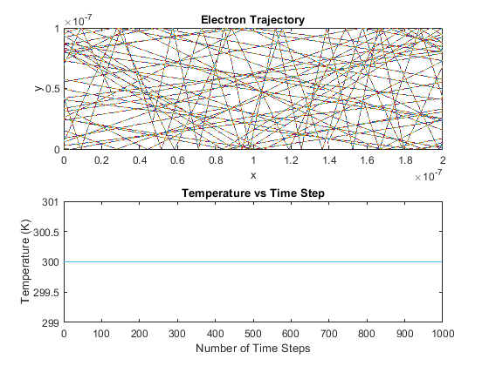

Part 2 Collisions With MFP
In this part of the assignment the code is improved by adding random scattering to the electrons and by asigning the electrons different velocities based on the Maxwell Boltzman distribution. The basic setup of this code is shown below.
%constants
K = 1.3806e-23;
m = 0.26*9.1093e-31;
%Place electrons in Boundary
x = 200e-9*rand(1000,1);
y = 100e-9*rand(1000,1);
dt = 100e-9/vth/100;
%Initilizing varibales for calculating mean free path and mean time between
%collisions
numScat = zeros(1000,1);
xScat = zeros(1000,1); % x distance between scatters
yScat = zeros(1000,1); % y distance between scatters
tScat = zeros(1000,1); % time between scatters
distScat = zeros(1000,1); % Total free distance travelled by each electron
totalfreetime = zeros(1000,1); % total time travlled between all scatters
Now the Velocities of the electrons are determined. Acoording to the Maxwel Boltazman distribution, each componenet of the electrons velocity follows a normal distribution with mean zero and a standard deviation as shown below.
std = sqrt(K*T/m);
With the standard deviation known the x and y componenets of the velocity can be determined
% Assign electron velocity based on Maxwell Boltzman Distribution
T = 300;
vth = sqrt(2*K*T/m);
Vx = normrnd(0,std,[1000,1]);
Vy = normrnd(0,std,[1000,1]);
V = sqrt(Vx.^2 + Vy.^2);Now it is important to check that the velocicties were assigned correctly by confirming that the average velocity is close to the thermal velocity and by plotting a histogram of the velocity.
mean(V)
figure(2)
histogram(V);
xlabel('Velocity')
ylabel('Number of Electrons')
The above results show that the mean velocity is close to the thermal velocity
ans =

1.6482e+05
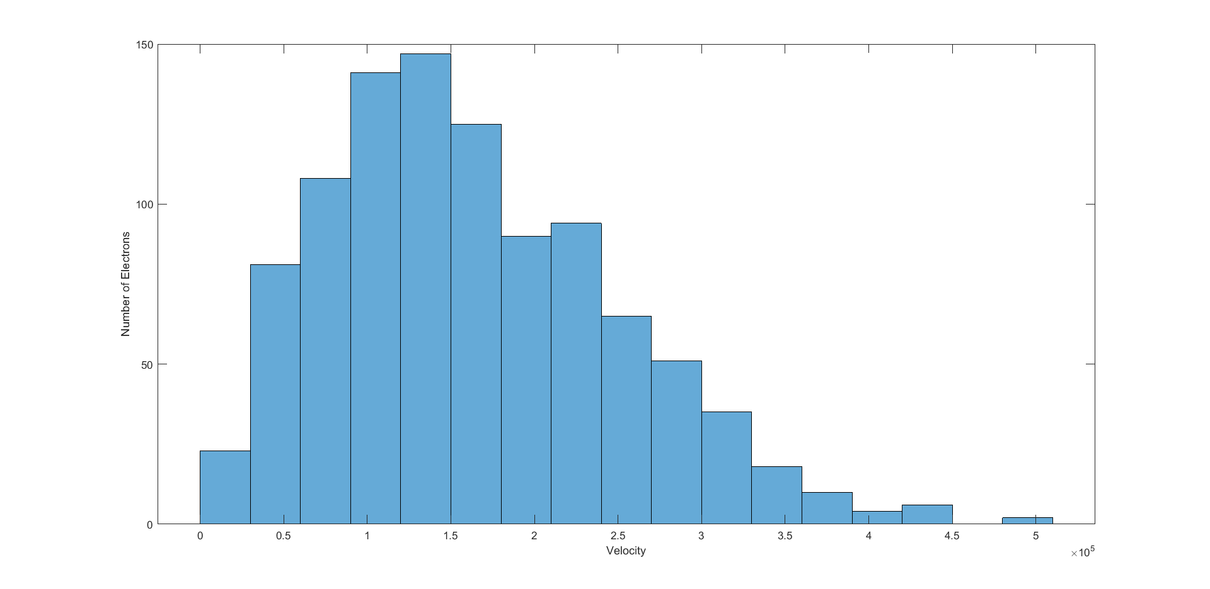
Now there is enough information to run the main loop of the program updates the electron's position based off of it's velocity as well as determines if the electron has scatterd, and if so, updates it's velocity using Maxwell Boltzman distribution.
for i =1:500
xold = x;
yold = y;
% Define region boundaries and rules for interacting with boundaries
xboundRight = x > 200e-9;
xboundLeft = x < 0;
ybound = (y > 100e-9) | (y <0);
x(xboundRight) = x(xboundRight) - 200e-9;
x(xboundLeft) = x(xboundLeft) + 200e-9;
xold(xboundRight | xboundLeft) = x(xboundRight | xboundLeft);
Vy(ybound) = -Vy(ybound);
%Update Position
x = x + Vx*dt;
y = y + Vy*dt;
% Determine Witchelectrons scatter and update velocity
scatter = rand(1000,1) < (1 - exp(-dt/0.2e-12));
Vx(scatter) = normrnd(0,std,size(Vx(scatter)));
Vy(scatter) = normrnd(0,std,size(Vy(scatter)));
%Determine distance and time between scatters for all electrons
xScat(scatter) = x(scatter) - xScat(scatter);
yScat(scatter) = y(scatter) - yScat(scatter);
tScat(scatter) = dt*i - tScat(scatter);
distScat(scatter) = distScat(scatter) + sqrt(xScat(scatter).^2 + yScat(scatter).^2);
totalfreetime(scatter) = totalfreetime(scatter) + tScat(scatter);
numScat(scatter) = numScat(scatter) + 1;
xplot = transpose([xold(1:10) x(1:10)]);
yplot = transpose([yold(1:10) y(1:10)]);
Tplot(i) = (1/(2*K))*mean(Vx.^2 + Vy.^2)*m;
figure(3)
subplot(2,1,1);
plot(xplot,yplot)
xlim([0 200e-9])
ylim([0 100e-9])
title('Electron Trajectory')
xlabel('x')
ylabel('y')
hold on
subplot(2,1,2)
plot(Tplot(1:i))
title('Temperature vs Time Step')
xlabel('Number of Time Steps')
ylabel('Temperature (K)')
hold on
drawnow
end
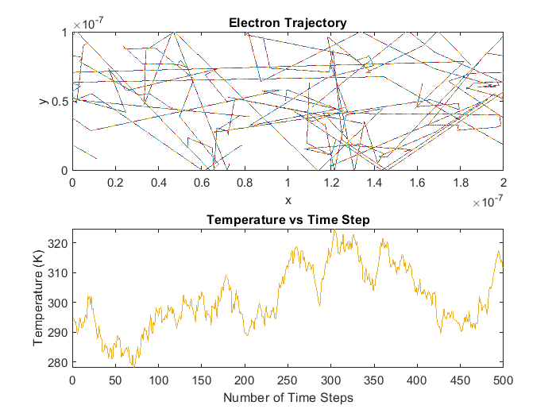
The results of this simulation show that the temperature fluctuates over time due to the scattering of the electrons but stays in the neighborhood of 300 K.
The mean free path and average time between collisions can be calculated as follows.
MFPelectron = distScat./numScat; %Mean Free Path of each electron
MFP = nanmean(MFPelectron) %overall Mean Free Path
tauElectron = totalfreetime./numScat; %Mean time between scatters for each electron
tau = nanmean(tauElectron) % Overall mean time between scatters
MFP =
1.0232e-07
tau =
7.2534e-13
These values show reasonable agreement with the values in part1 but due to the statistcal nature of these calculation and a relatively small population size (1000 electrons) there is bound to be some significant differences in some simulations

Part 3 Enhancements
In this part of the assignment the code is further enhanced by adding boxes that the electrons can scatter off of. Also, boundaries can now be either diffuse or specular. The code that sets up the simulation is shown below
K = 1.3806e-23;
m = 0.26*9.1093e-31;
x = 200e-9*rand(1000,1);
y = 100e-9*rand(1000,1);
yboundSpecular = true; %Specular reflection when treu, diffuse otherwize;
xboundSpecular = true;
boxSpecular = true;
%defines the boxes
inbox1 = x > 80e-9 & x < 120e-9 & y > 60e-9;
inbox2 = x > 80e-9 & x < 120e-9 & y < 40e-9;
%checks for any electrons generated inside a box and moves them outside
x(inbox1) = x(inbox1) + ((rand() > 0.5)*2 - 1)*40e-9*rand(size(x(inbox1)));
x(inbox2) = x(inbox2) + ((rand() > 0.5)*2 - 1)*40e-9*rand(size(x(inbox2)));
y(inbox1) = y(inbox1) - 0.2*rand(size(y(inbox1)));
y(inbox2) = y(inbox2) + 0.2*rand(size(y(inbox2)));
%sets the initial temperature and generates velocities
T = 300;
vth = sqrt(2*K*T/m);
std = sqrt(K*T/m);
Vx = normrnd(0,std,[1000,1]);
Vy = normrnd(0,std,[1000,1]);
V = sqrt(Vx.^2 + Vy.^2);
Tplot = zeros(1000,1); %calculated temperature for plotting
dt = 100e-9/vth/100;
The main loop of the code that calculates the electron trajectories and temperature is shown below
xold = x;
yold = y;
xold = x;
yold = y;
for i =1:400
%Defines the boundaries of the simulation as well as the boxes
yboundTop = y > 100e-9;
yboundBottom = y < 0;
inbox1 = x >= 80e-9 & x <= 120e-9 & y >= 60e-9;
inbox2 = x >= 80e-9 & x <= 120e-9 & y <= 40e-9;
xboundRight = x > 200e-9;
xboundLeft = x < 0;
%Reflection off of xboundary
if xboundSpecular
Vx(xboundRight | xboundLeft) = - Vx(xboundRight | xboundLeft);
else
theta = pi*rand();
Vx(xboundRight | xboundLeft) = V(xboundRight | xboundLeft)*cos(theta);
Vy(xboundRight | xboundLeft) = V(xboundRight | xboundLeft)*sin(theta);
end
%Reflection off of y boundary
if yboundSpecular
Vy(yboundTop | yboundBottom) = -Vy(yboundTop | yboundBottom);
else
theta = pi*rand();
Vy(yboundTop | yboundBottom) = V(yboundTop | yboundBottom)*cos(theta);
Vx(yboundTop | yboundBottom) = V(yboundTop | yboundBottom)*sin(theta);
end
%Reflection off of box
if boxSpecular
%Reflection off of verticle face
Vx(inbox1 & yold >= 60e-9) = -Vx(inbox1 & yold >= 60e-9);
Vx(inbox2 & yold <= 40e-9) = -Vx(inbox2 & yold <= 40e-9);
%Reflection off of Horizontal face
Vy(inbox1 & yold <= 60e-9) = -Vy(inbox1 & yold <= 60e-9);
Vy(inbox2 & yold >= 40e-9) = -Vy(inbox2 & yold >= 40e-9);
else
theta = pi*rand();
%Reflection off of verticle face
Vx(inbox1 & yold >= 60e-9) = V(inbox1 & yold >= 60e-9)*cos(theta);
Vx(inbox2 & yold <= 40e-9) = V(inbox2 & yold <= 40e-9)*cos(theta);
Vy(inbox1 & yold >= 60e-9) = V(inbox1 & yold >= 60e-9)*sin(theta);
Vy(inbox2 & yold <= 40e-9) = V(inbox2 & yold <= 40e-9)*sin(theta);
%Reflection off of Horizontal Face
Vy(inbox1 & yold <= 60e-9) = V(inbox1 & yold <= 60e-9)*cos(theta);
Vy(inbox2 & yold >= 40e-9) = V(inbox2 & yold >= 40e-9)*cos(theta);
Vx(inbox1 & yold <= 60e-9) = V(inbox1 & yold <= 60e-9)*sin(theta);
Vx(inbox2 & yold >= 40e-9) = V(inbox2 & yold >= 40e-9)*sin(theta);
end
%Make sure all electrons are in the proper boundary
y(yboundTop) = 100e-9;
y(yboundBottom) = 0;
x(xboundRight) = 200e-9;
x(xboundLeft) = 0;
x(inbox1 & yold >= 60e-9 & x <= 100e-9) = 80e-9;
x(inbox1 & yold >= 60e-9 & x > 100e-9) = 120e-9;
x(inbox2 & yold <= 40e-9 & x <= 100e-9) =80e-9;
x(inbox2 & yold <= 40e-9 & x >= 100e-9) =120e-9;
y(inbox1 & yold <= 60e-9) = 60e-9;
y(inbox2 & yold >= 60e-9) = 40e-9;
xold = x;
yold = y;
x = x + Vx*dt;
y = y + Vy*dt;
%Scatter electrons randomly and reasign velocity using Maxwell Boltzman
%distribution
scatter = rand(1000,1) < (1 - exp(-dt/0.2e-12));
Vx(scatter) = normrnd(0,std,size(Vx(scatter)));
Vy(scatter) = normrnd(0,std,size(Vy(scatter)));
%Plot trajectory and temperature
xplot = transpose([xold(1:20) x(1:20)]);
yplot = transpose([yold(1:20) y(1:20)]);
figure(4)
subplot(2,1,1)
Tplot(i) = (1/(2*K))*mean(Vx.^2 + Vy.^2)*m;
plot(xplot,yplot)
xlim([0 200e-9])
ylim([0 100e-9])
hold on
plot(1e-9*[80 80 120 120],1e-9*[200 60 60 200])
plot(1e-9*[80 80 120 120],1e-9*[0 40 40 0])
subplot(2,1,2)
plot(Tplot(1:i))
drawnow
end
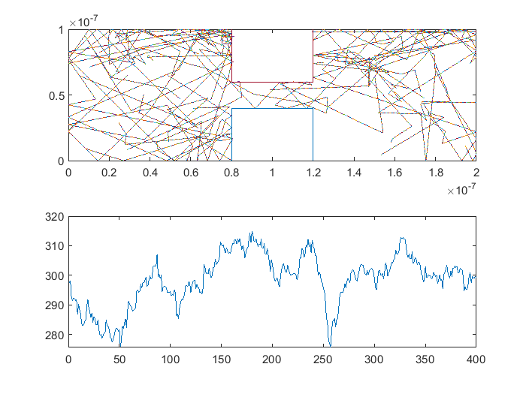
Just like in part 2 we see that the temperature fluctuates with time but remains in the neighborhood of 300 K. Now it is time for some post processing to create the density and temperature maps. The code to create the density map is shown below
%Create histogram for electron density map
figure(5);
hist3([x y],'CdataMode','auto');
view(2);
title('Electron Density');
xlabel('x (m)');
ylabel('y (m)');
title('Electron Density Heat Map');
%Divide region into bins and determine witch bin each electron belongs to
temp_sum_x = zeros(20,10);
temp_sum_y = zeros(20,10);
temp_num = zeros(20,10);
for i=1:400
x1 = floor(x(i)/1e-8);
y1 = floor(y(i)/1e-8);
if(x1<=0)
x1 = 1;
end
if(y1<=0)
y1= 1;
end
if(y1>100)
y1 = 100;
end
if(x1>200)
x1=200;
end
%Sum speed of each electron over each bin
temp_sum_y(x1,y1) = temp_sum_y(x1,y1) + Vy(i).^2;
temp_sum_x(x1,y1) = temp_sum_x(x1,y1) + Vx(i).^2;
temp_num(x1,y1) = temp_num(x1,y1) + 1;
end
%Determine temperature of each bin
temp = (temp_sum_x + temp_sum_y).*m./K./2./temp_num;
temp(isnan(temp)) = 0;
temp = transpose(temp);
%plot temperature
figure(6)
surf(temp)
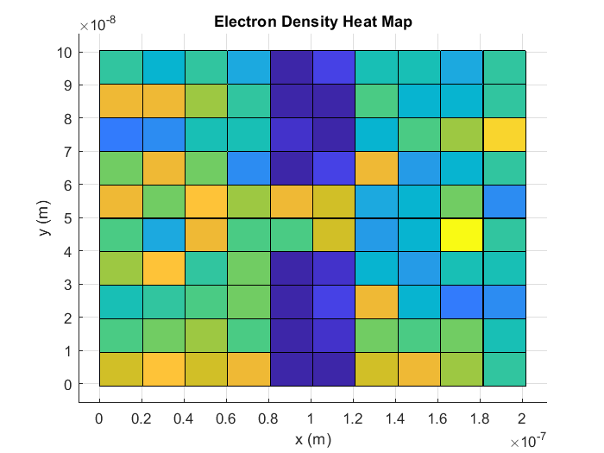
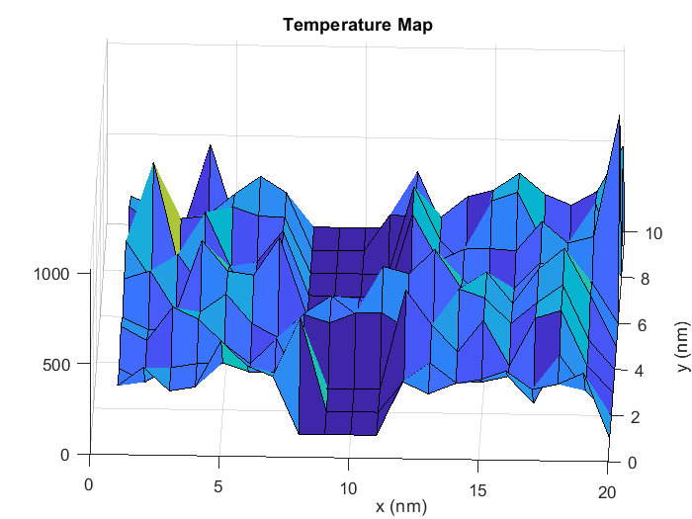
Published with MATLAB® R2018a

