Student name: Jordan Elkin
Student ID: 226621873

SIT225: Data Capture Technologies

Activity 7.1: Data analysis and interpretation

Data analysis is a broad term that covers a wide range of techniques that enable you to reveal any insights and relationships that may exist within raw data. As you might expect, Python lends itself readily to data analysis. Once Python has analyzed your data, you can then use your findings to make good business decisions, improve procedures, and even make informed predictions based on what you’ve discovered.

You have done data wrangling using Python Pandas module already in activity 5.2. In this activity, you will learn Data science statistics and linear regression models.

Hardware Required
- No hardware is required.

Software Required
Python 3
Python packages including Pandas, Numpy, Scikit-learn, seaborn, plotly

Steps:
Step | Action
1 | A Jupyter Notebook is provided for Data Science exploration here (https://github.com/deakin-deep-dreamer/sit225/tree/main/week_7 ). You will need to fill in your student ID and name and run all the cells to observe the output. Convert the Notebook into PDF and merge with this activity sheet which needs to be combined with this week’s task for OnTrack submission.  Question: There are sections in the Notebook. After running the cells and observing the outputs, provide your reflection in brief on the topic items for each section of the Notebook.  Answer:  The notebook demonstrated how descriptive statistics can be used to summarise and understand a dataset through measures such as averages, percentiles, standard deviation and variance. It also showed how correlation can identify relationships between variables, while reinforcing that correlation does not necessarily imply causation because other confounding variables may be involved. The linear regression section demonstrated how relationships between variables can be modelled and compared, and how the strength of a regression line can indicate which variables may be more useful for prediction. Overall, the activity helped me understand how statistical techniques and visualisations can be combined to interpret data and identify meaningful patterns.
2 | Question: In the 1.1 Percentile subsection of Descriptive statistics section in the Notebook, you have calculated 10%, 25%, 50% and 75% percentiles for Max_Pulse. Compare these percentiles with Average_Pulse percentiles for any trend, if exists.  Answer:  There is a similar increasing trend between the percentiles of Average_Pulse and Max_Pulse. For Average_Pulse, the 10th, 25th, 50th and 75th percentiles are approximately 92.2, 100, 105 and 111 bpm, respectively. For Max_Pulse, the corresponding percentiles are 120, 124, 131 and 141 bpm. In both variables, the pulse value increases as the percentile increases. This suggests that higher average pulse values tend to be associated with higher maximum pulse values. A visualisation using Seaborn also shows a positive relationship between the two variables.
3 | Question: In the “Correlation Does not imply Causality” section answer the question regarding the increase of ice cream sale in your own understanding.  Answer:  No you could not conclude that the increase in ice cream sales has caused an increase in drowning accidents. It is most likely there is a confounding variable that is skewing the data. When this is identified it will show that there is no relationship between the two variables.
4 | Question: In the 1.7 Linear Regression section in the Notebook, a linear regression model was used to predict Calorie_Burnage from attributes such as Average_Pulse. The Duration value was predicted from the model for all the value range of Average_Pulse and a regression line was drawn. You will need to answer the follow up question next to 1.7 section where it is required to generate a linear regression model for Duration instead of Average_Pulse to predict the Calorie_Burnage. Take a screenshot of the regression line and paste it here. Also, comment on both the regression lines.  Answer:  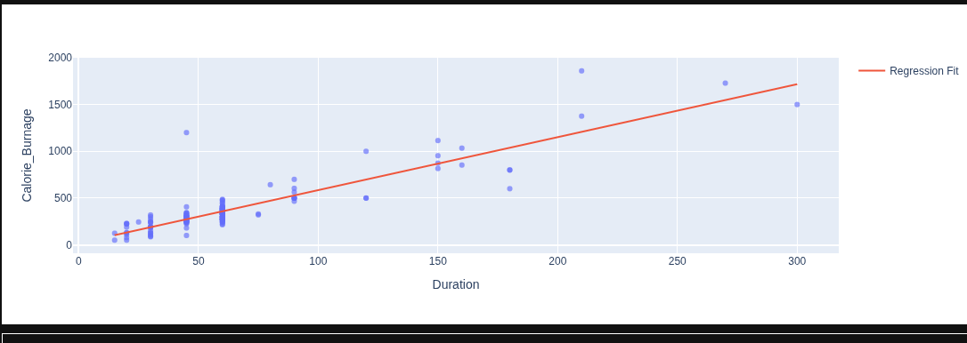  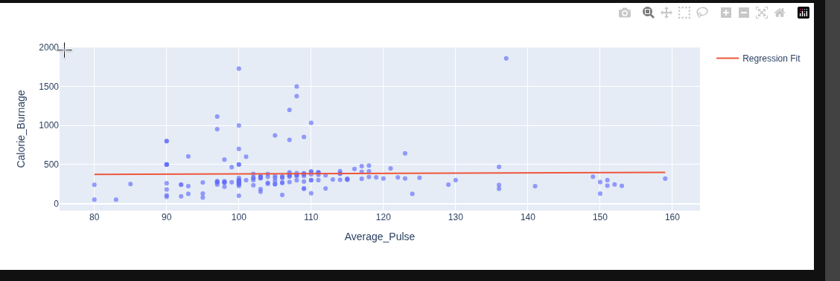  The regression plots show that duration has a much stronger positive relationship with calorie burnage than average pulse. As duration increases, calorie burnage generally increases, which is demonstrated by the upward-sloping regression line. In comparison, the regression line for average pulse is almost flat, suggesting that average pulse has little linear relationship with calorie burnage. Therefore, duration appears to be a better predictor of calorie burnage than average pulse.

