Adventure Works

Jordan Beck | 11164548

Assignment 4

Management Information systems 557

2017

**Table of Contents**

**Executive Summary 2**

**Sales Rep Performance by Quarter (4a)** **3**

**Performance of Michael Blythe by Quarter (4b)**  **5**

**Sales by Region (5a)**  **7**

**Sales by Business Type (5b) 9**

**Comparison of Sales by Promotion Type (5d) 11**

**Appendix 13**

**Executive Summary**

**Discussion**

The purpose of this report is to provide information in order to better understand the performance of employees and the impact that their selling abilities make on the company. The employee’s performance has been measured by their percentage of sales quota, but will also be analyzed by geographic region, business type, and promotion type. Several scenarios will be conceptualized and various forecasts will be made based on the current trends of employee performances and sales.

**Questions**

In some cases the data shows that the sales performance of specific employees is lacking in comparison to other employees. However, there is other information which would be valuable to providing context for the information presented. As is mentioned later in the report, it is often not enough to make a decision based on a single query. In many cases the context needed is another short query away, however some is more hypothetical scenarios.

**Recommendation**

Overall the recommendations made to Adventure Works range from very subtle such as increasing budgets for employee spending to more drastic such as expanding into the asian market. Often sales patterns are analyzed and predictions are made based on the current trajectory of sales. More specific suggestions to the company would be to drop many of the promotions that are utilized and to just focus on a few specific promotions. Lastly, Adventure works may consider changing their employee review system to be more encouraging.

**Sales Rep Performance by Quarter (4a)**

**Discussion**

An analysis of the 3rd quarter employee ratings of 2007 shows that, with the exception of two employees, all of the employees are underperforming. The distribution of the underperforming employees is even. None of the employees are underperforming. The two outstanding employees are Garrett Vargas and Pamela Ansman-Wolfe. Pamela's performance is notably outstanding, exceeding sales quota by over 15%. The average sales quota percentage of these 17 employees was only 81% with 10 employees performing worse than average. The standard deviation of the employees was 10% meaning the majority sold between 70% and 90% of their sales quota.

**Questions**

The performance of the employees is valuable information, but seeing their performance relative to other time frames gives context to the direction that the company is headed. Perhaps all of the employee’s performances have improved since last quarter. Additionally since the average employee performance is at 80%, perhaps management’s expectations of the employees is too high. 15 of 17 employees were rated as "Underperformers" and only two received a satisfactory rating. Perhaps the benchmarks should be adjusted to reflect the distribution of the performance more accurately. Within one standard deviation of average are rated satisfactory. Those lower than one standard deviation are rated as "Needs Improvement" and above one standard deviation are rated as "Outstanding".

**Recommendations**

Employee satisfaction is a key to their success so reviewing them in a way which builds their confidence is very important. The highest performing employees might be entitled to a reward. Additionally management must also consider the possibility of standard being set too high. Perhaps it is the training program which has led to poor performances rather than the employees themselves. For underperforming employees, management might consider a warning or two before letting an employee go.

**Performance of Michael Blythe by Quarter (4b)**

**Discussion**

Michael Blythe has been with Adventure Works since its inception in 2005. Michael’s performance has varied in the "Underperforming" range for most of his career but has never dipped below 70%. Michaels average performance is a respectable 83%, 3% above the average of other employees. His standard deviation is 5% making him fairly consistent. For the past 3 quarters Michaels’ performance has increased and has most recently exceeded 90% giving him a rating of Satisfactory. His performance is unrelated to the current season, though his best full year was 2007.

**Questions**

Michael’s performance is quite satisfactory but it would be useful to know his performance relative to the other employees who work with him. It’s possible that all of the employees that work with Michael are outperforming. It would also be beneficial to know Michael's performance as it relates to specific product categories. Is Michael better at selling one over the other? Also knowing Michaels intentions as an employee would be useful. His increased performance is great, but may be a sign that he is trying to attain a management position, or perhaps on the other end of the spectrum Michael is a temporary employee who is planning on leaving the Adventure Works company, and his increased performance relates to his excitement of moving on to other things.

**Recommendations**

Knowing the demographics of the employees at Adventure Works will give management much more insight into their employee’s intentions. Also an annual employee review can be useful for gaining insight into more in-depth questions. These reviews should not be perceived as a pass fail exam which is common for many employee reviews, but rather just a conversation between upper management and the sales force. Lastly, as noted earlier, compensation for well performing employees makes a significant difference in employee retention. Michael’s performance spiked in the first quarter of 2007 but dropped afterwards. Perhaps his performance went unnoticed by management and he lost motivation. Michael represents a very average employee so additional information about him would be valuable for the company.

**Comparison of Sales by Region (5a)**

**Discussion**

The United States is broken up into five regions, all of which are competing with entire countries elsewhere in the world. Adventure Works best market is the North American Continent which stems from their incredible sales in the western regions of the United States. These sales make up 40% of the total sales of the company. The next best region is the European area and lastly is Australia. The average sales of any given region are over a million dollars, however this figure is only exceeded by three regions, the Southwest, the Northwest, and Canada. The distribution of the sales are skewed to the right, meaning fewer companies performed better than average than the number of companies that performed worse than average.

**Questions**

The sales of any outdoor recreation company are likely to be dependent on sales. Quarter number three are the summer months so it is likely that these sales are higher than the other quarters. The sales as they relate to the year are less likely to be correlated but will show the success of the overall company. Adventure work's best year was its most recent so management might expect quarter 3 of year 4 to be proportionately higher. Lastly employee performance undoubtedly plays a performance in the sales of each region, but having an idea of the success of each region if the employees weren’t a factor would give management a baseline to measure the difference that employees are making in each region. Perhaps an analysis of the internet sales by region would allude to such information.  
**Recommendations**

So far Adventure Works has stuck to a Caucasian demographic in the global northern regions of the world. It seems as though the company is still growing in this market, but management might soon consider expanding to the Asian market. The Asian market would expand their potential customers immensely. On the other hand Adventure Work might prefer to expand by geographic terrain rather than wealth. Countries such as Mexico are in close proximity to Adventure Works best selling region so may be another untapped market. Lastly, Adventure Works may consider the possibility of a new product altogether. The company already manufactures street bikes for transportation so perhaps small motor vehicles such as mopeds would appeal to a similar target audience.

**Comparison of Revenues by Business Type (5b)**

**Discussion**

In quarter 3 of 2007 the majority of the sales of Adventure Works came from the warehouse. The next best-selling business type was the value added Reseller followed by the Specialty Bike Shop. These figures come from the actual dollar amount of sales as opposed to the quantity sold. Another figure that isn't shown on the graph is the cost associated with the sales. It would be easy for management to see only seven percent of their sales coming from specialty bike shops and to consider cutting those types of shops, however, the cost of running a specialty bike shop is likely much lower than running an entire warehouse. Management should compare the efficiency of each type of business before considering adjusting their business type proportions.

**Questions**

The quality of the employee also likely relates to the business type. In a warehouse the employees are not going to be nearly as knowledgeable about all of the products and are more likely to lose a sale to another company as opposed to a specialty shop, where a highly knowledgeable employee can give much more useful information to a potential customer resulting in a sale. It is also likely that the business type relates to the geographical location. It is much more likely that Adventure Works will place a specialty bike shop in an urban environment whereas a warehouse might thrive in a rural environment.

**Recommendations**

As the company matures and sales increase it becomes important for the company to focus on a specific business type. Most of Adventure Works sales are coming from warehouses so they may put an emphasis on them while expanding into the Asian market which would likely benefit the most from the warehouse business type. A single business type would also allow Adventure Work to focus on a specific type of promotion and hiring a single type of employee. Their competitive advantage could be that they are the most efficient company, selling bicycles at a lower cost of goods sold than other companies.

**Comparison of Sales by Promotion Type (5d)**

**Discussion**

Volume discount 11 to 14 involved in most sales. This is likely the most common discount of warehouse business types. Many of their promotions are involved in only a few sales in comparison. Adventure works only uses promotions for around 2% of all of their sales. As the company changes business types it may be advantageous to offer additional promotions in order to keep public awareness high.

**Questions**

There are many questions relating to their promotions such as what geographical location are they most often used, what business type are they most often used, what type of city environment are they most often used. Knowing this information will allow Adventure Works to reach their target audience more efficiently.

**Recommendations**

Adventure Works should focus on a more solid strategy for using promotions since their use is currently very sporadic. Focusing more on clearance sales will allow Adventure Works to have a better inventory turnover ratio which will allow them to sell the newest equipment faster. Some of their promotions can be timed with the season to increase customer count such as offering discounts on road bikes before the weather improves.

**Appendix**

**Mapping**

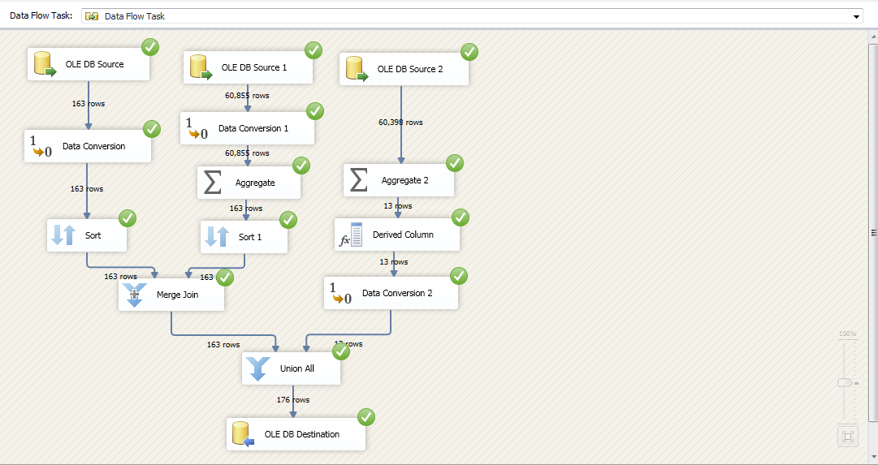

**Query 1**

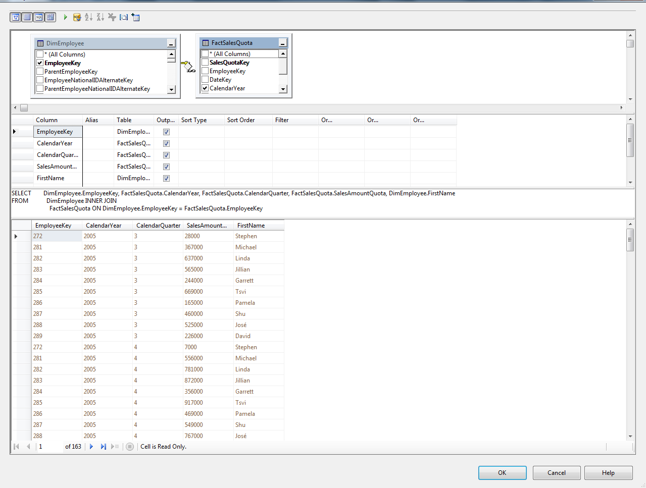

**Data Conversion**

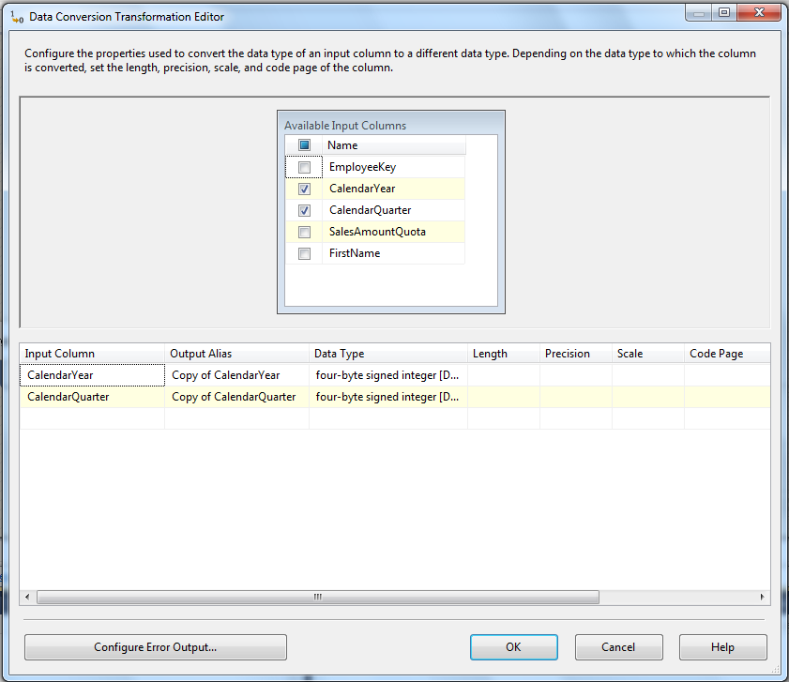

**Sort**

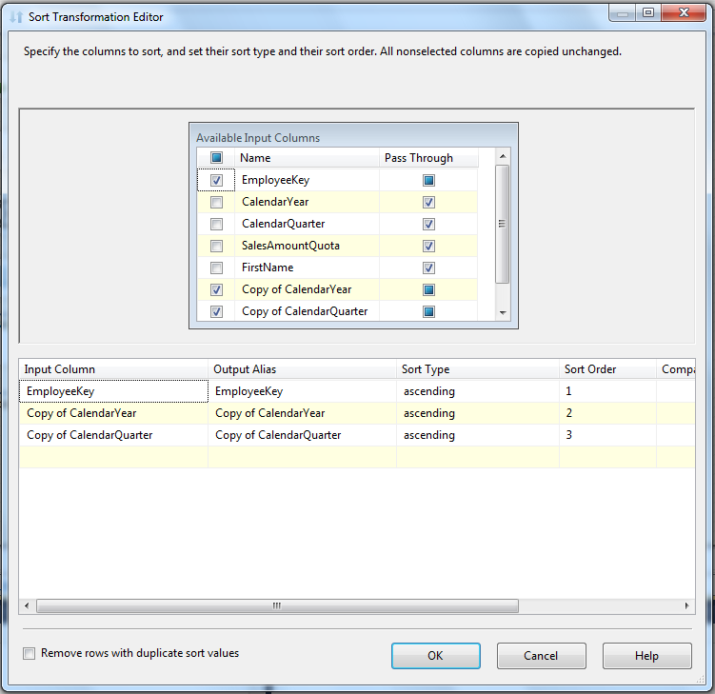

**Query 2**

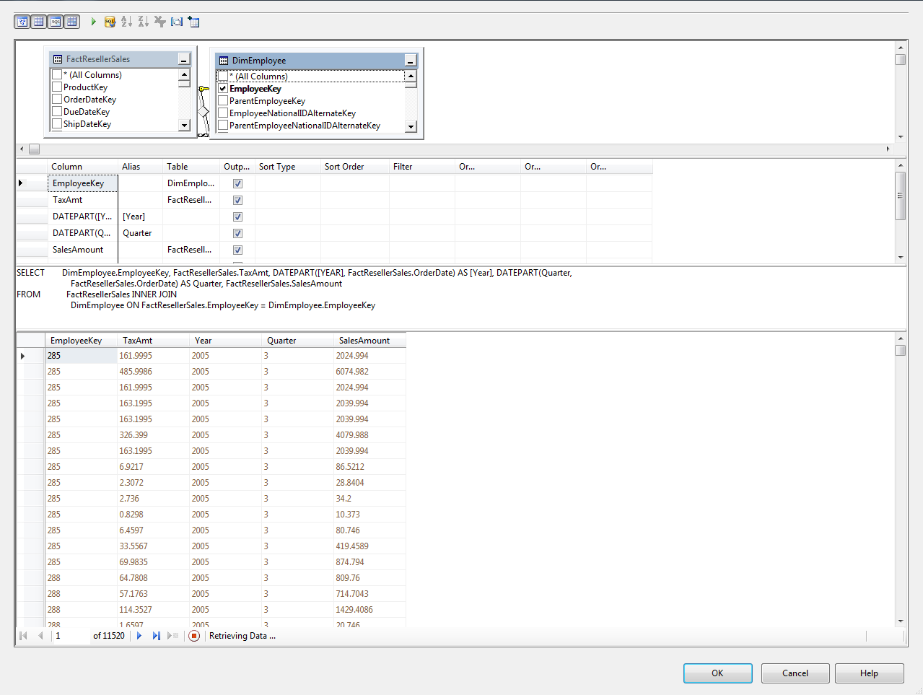

**Aggregate**

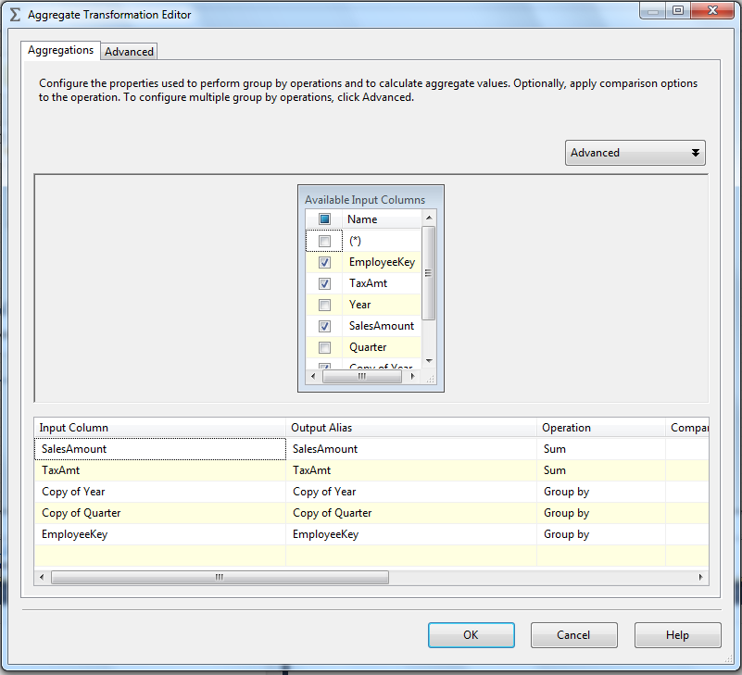

**Sort**

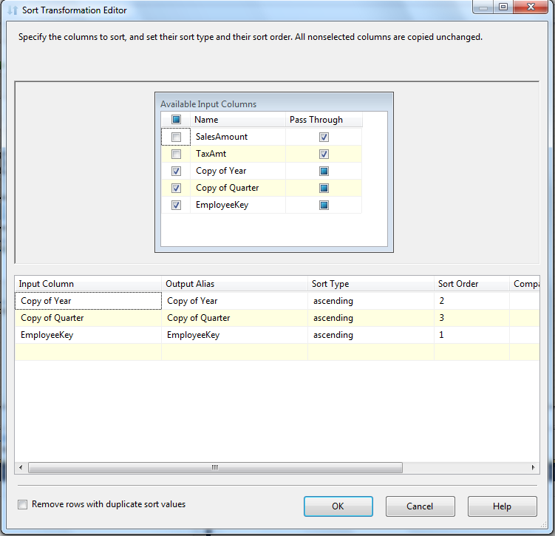

**Merge**

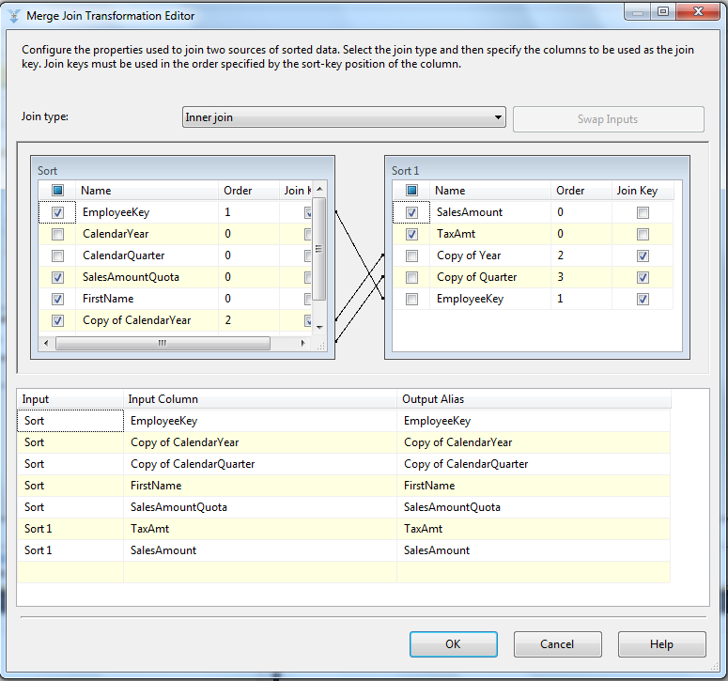

**Source 3**

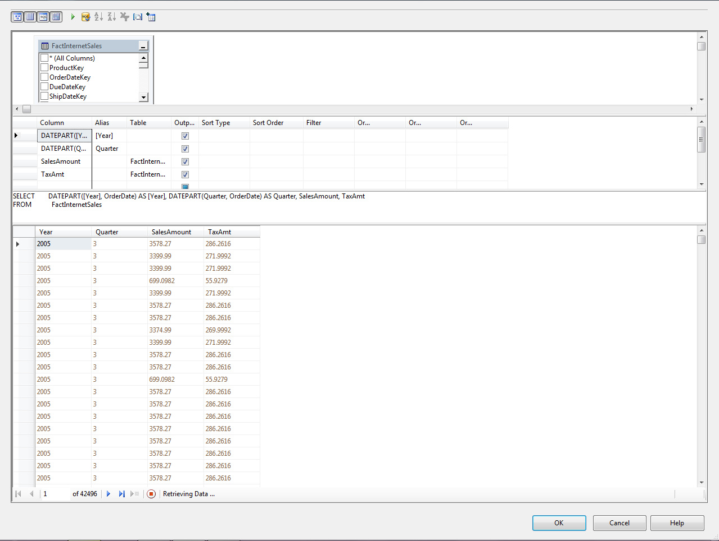

**Aggregate**

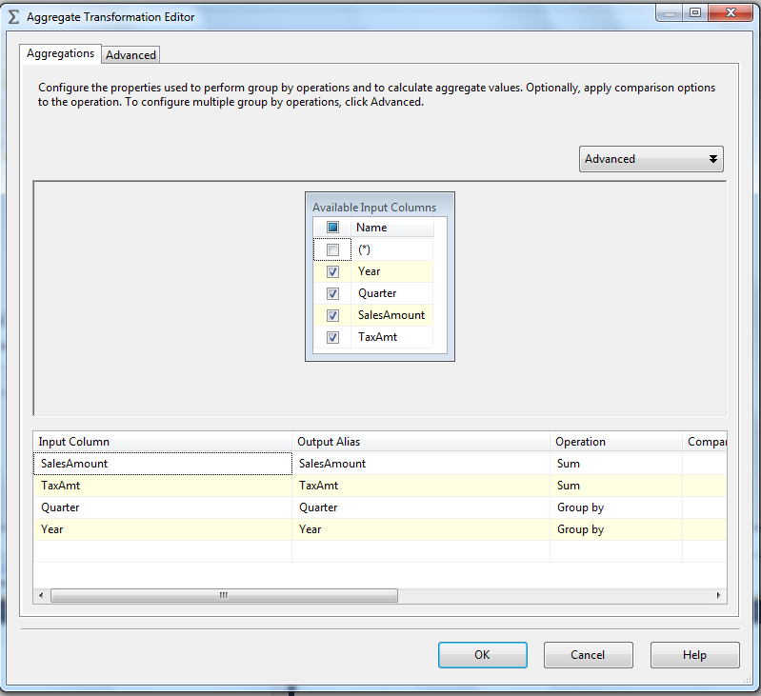

**Derived Column**

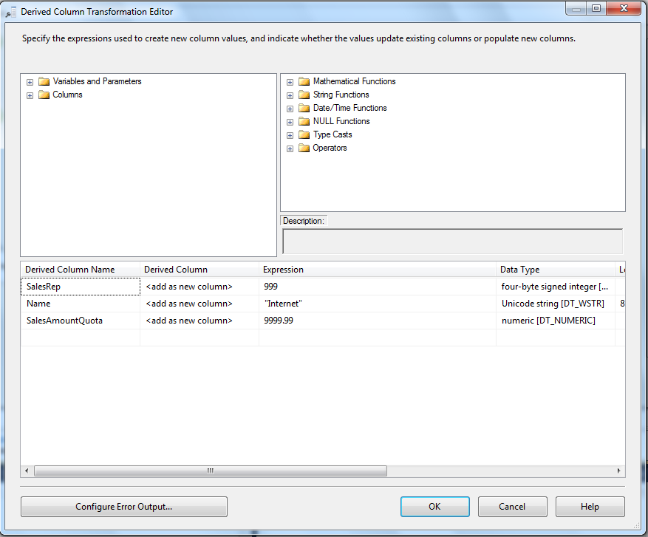

**Data Conversion**

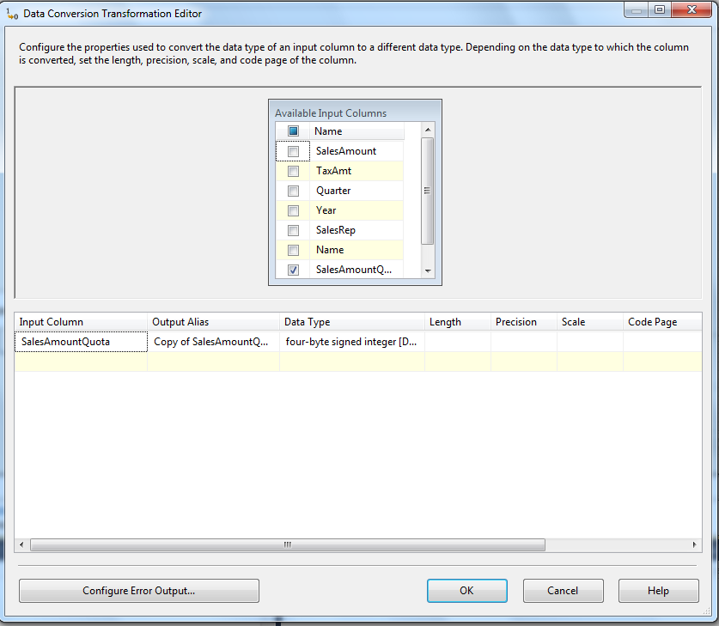

**Union**

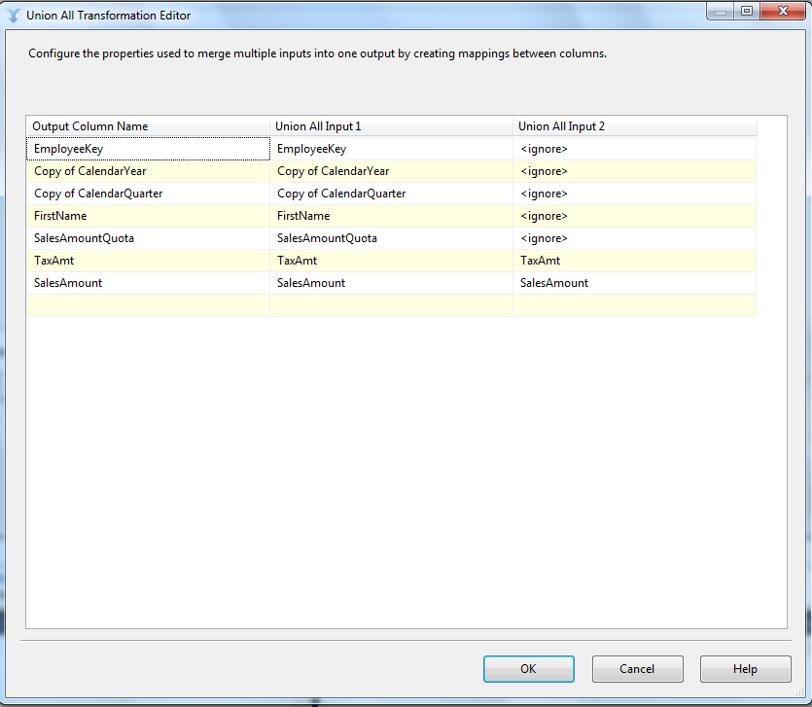

**Destination**

