Adventure Works

Jordan Beck | 11164548

Assignment 4

Marketing 555

2016

**Table of Contents**

**Executive Summary 2**

**Products Specific to the Reseller Channel (1a) 3**

**Product Subcategories Specific to the Reseller Channel (1b) 5**

**Gloves and Jersey Product Widths (1c) 7**

**Shipping Costs of Products (1d) 9**

**Products Sold Disproportionately on the Internet (1e) 11**

**Appendix 13**

**Executive Summary**

**Discussion**

This purpose of this report is to figure out which products should be sold on the internet channel. To find these products various selling channels were analyzed as well as the costs associated with certain products. By analyzing these products, management will be able to make more accurate recommendations for products that should be sold on the Internet channel without taking away sales from the reseller channel.

**Questions**

Other information that would be important for management to know is the geographic locations of both their distribution centers and of their reseller locations. These will allow them to analyze the costs associated with getting the products from the company to the customer, a large portion of why the internet channel would be so successful.

**Recommendation**

The products that would be best for the internet channel are those that have low shipping costs but high profitability. Additionally products that can come in many colors and designs would be best sold on the internet so that they can take up less shelf space. Other products that Adventure Works might be interested in selling on the Internet channel would be products which have not yet been sold on the channel. These suggestions are all explored in-depth in the following report.

**Products Specific to the Reseller Channel (1a)**

**Discussion**

A list of products which are sold on the reseller channel and not the internet channel provides a list of candidates that could potentially be sold on the internet. It is important to note which of these products might be better sold on the internet or which of the products should not be sold on the internet at all. Seeing the order quantity of these products allows the company to ignore the profitability of the product and focus solely on its popularity. From this list we can see that the best-selling items are in the apparel category, or generally items that need to be fitted to the person.

**Questions**

The revenue of these products is not displayed but would be valuable information to know so that Adventure Works can reduce the possibility of cannibalizing the revenue of their items. Lower revenue items are better candidates to be sold on the internet for two reasons. The first is that there is less profit to cannibalize from and also the lack of revenue may be due to poor variety and thus availability leading to less sales. Additional information that would be valuable are the 25 worst selling products in retail stores. A quick analysis of these products may reveal that they should be sold online. Again this may be a factor of poor advertising for the products that can be better done online.

**Recommendations**

Products that would sell the best on the internet would be those that are highly specialized and have limited availability or products that are more general and don't need to be fitted on to the bike. On this list of products that are popular in retail stores, we see products that need to be fitted on to a person or general components. Since components are already being successfully sold in resellers then Adventure Works may want to only sell highly specialized products on the internet. Another note is that these products in the graph are 10 of the 250 products sold on the reseller channel. Their order quantities are very high compared to all of the other products so Adventure Works would not want to cannibalize any of these products.

**Product Subcategories Specific to the Reseller Channel (1b)**

**Discussion**

Another analysis of the top 25 products sold by products sub-category shows which products categories are candidates to be sold on the internet. Here brakes, derailleurs and pedals are the least popular items sold on the reseller channel and are also not sold on the internet. Since these products are not very successful on reseller channels they may be better sold on the internet. One interesting note about these products is that they are all general bike components that a person would not need to inspect very closely before purchasing them. For this reason it may be better to keep them off the shelves and move them into the warehouse.

**Questions**

Information that would be important to know would be the most popular product subcategories that are sold on the internet and not the reseller channel. Another important graph would be the least popular subcategories that are sold on the reseller channel but not the internet channel. Adventure Works should also calculate the cost of shelf space compared to the profit of the item to see if it is worth its space in the reseller channel. Items that are less profitable on display should be cycled out with products that would word better on display. Many types of products are all very similar and a simple picture on the internet will suffice for selection.

**Recommendations**

Adventure works would also want to note the popularity of specific products. There were almost 7000 units of gloves sold on the reseller channel but only 7 subcategories broke 2000 units of sales. This gap is significant and shows that these specific subcategories of products really are best sold only on the reseller channel but not the internet channel. There are several subcategories that are not displayed on the graph but there is a consistency of about 1000 units for each category starting at pumps. Adventure Works can use this as a benchmark for products that sell significantly less than 1000 units should be pulled from the shelves.

**Gloves and Jersey Product Widths (1c)**

**Discussion**

Adventure Works can start widening their gloves and jersey product lines. These are their two best-selling product subcategories and thus might benefit from a wider variety of products. Currently these products are very successful on the reseller channel but are not doing well on the internet channel. Perhaps a wider product variety will help the internet sales without reducing the reseller channel sales. It is interesting to note that the long sleeve logo jersey is by far the best selling product, its sales almost double those of the other products

**Questions**

The revenue and thus profitability of the products that are sold on the reseller channel as compared to the internet will be key in understanding if the product line should be widened or not. Also since both products fall under the apparel category it would be wise to look at pants, socks, and shoes since they are all similar. Adventure Works can package several of their apparel items together in outfits. These would all have similar designs and may improve revenue for people who are unsure about purchasing certain items.

**Recommendations**

Gloves and Jerseys are two subcategories which heavily favor the reseller channel over the internet channel. These products are ideal for expansion into the internet channel because of the amount of space that would be taken for all of the possible designs and colors. Given the wide variety of types of biking that exists and equally wide variety of gloves and jerseys should exist. A mountain biker for example will want gloves for different reasons then someone who rides a touring bike. Because of this Adventure Works can look to expanding their gloves available on the internet channel. Additional designs and features will not cannibalize the reseller channel but will bring in more customers who are looking for a more specialized glove. The same can be said for jerseys which only come in long and short sleeve varieties but should also vary in the type of material as well as the colors offered and the designs offered.

**Shipping Costs of Products (1d)**

**Discussion**

An analysis of a products revenue per dollar spent on freight allows Adventure Works to see which products are worth shipping and which products should not be shipped. This helps them decide which products would be best sold from a warehouse, in which the consumer would pay for shipping or which products can be sold from specific Retailers. This list of product displays those that are better sold on the reseller channel since they hold the most value for their weight. Unsurprisingly the items displayed are all very lightweight items such as tubes and socks and water bottles. Consequently it would be better to sell items that are heavier on the internet channel since they will cost more in shipping.

**Questions**

It is viable to assume that heavier items should be sold on the internet but often these items will sell for more money as well. Thus a graph of the profit per freight cost ratio by product category will confirm in general which products should be sold on the internet channel or on the reseller channel. Also as with manufacturing there are often times discounts that can be achieved at certain volumes of products. For example perhaps some kind of deal can be made for products whose volume fits exactly in a shipping container or products that are not on a strict timeline and thus can work with the shipping company better.

**Recommendations**

The profit per freight costs are all very similar for these items but it is important to keep in mind that Adventure Works sells thousands of these products. A difference of only 3 cents can mean hundreds in gained profits if Adventure Works decides to pay close attention to shipping costs. Adventure Works would also not have to worry about a loss of consumers since they are already used to paying for shipping for online products. Additionally products that are sold online might charge shipping by different metrics, meaning adventure works can use two shipping companies. One that uses volume for their reseller channel and one that uses weight for their online customers. This would allow them to save money on both fronts.

**Products Sold Disproportionately on the Internet (1e)**

**Discussion**

This list of items shows which products sell more units on the internet channel than on the reseller channel. The graph doesn’t take into account the volume of products sold only the proportions so it is possible that some products can still be very popular on the reseller channel as well as the internet channel. Most of the products listed here are components for bikes or different types of bikes entirely. It is important to note that this data is not filtered by year meaning that if a product has not sold on the reseller channel it either is a new product or it is sold on the internet channel exclusively. The units sold category will help in determining the age of the product though it is not a guarantee.

**Questions**

It is interesting to note that Road bikes are sold predominantly on the internet channel but none of the other types of bikes are sold on the internet channel. Adventure Works can also look at the proportions of products that are sold exclusively on the reseller channel and use that as a starting point to figure out which of those products lines should be expanded. Products that are sold exclusively on one channel or the other do not run any risk of cannibalism. Additionally this information is for the products specifically but the product subcategory sales and category sales would also be useful information.

**Recommendations**

Since these products are already successful on the internet channel it may be advisable to expand their product lines. This guarantees that Adventure Works will not be cannibalizing their reseller channel since they would be bringing brand new products to the line and also because many of these products are not sold on the reseller channel to begin with. Another way to organize this information would be to include the profitability of each item due to its internet sales only. This would provide a better comparison of specific products and how well they are selling on the internet channel

**Appendix**

**Figure 1**

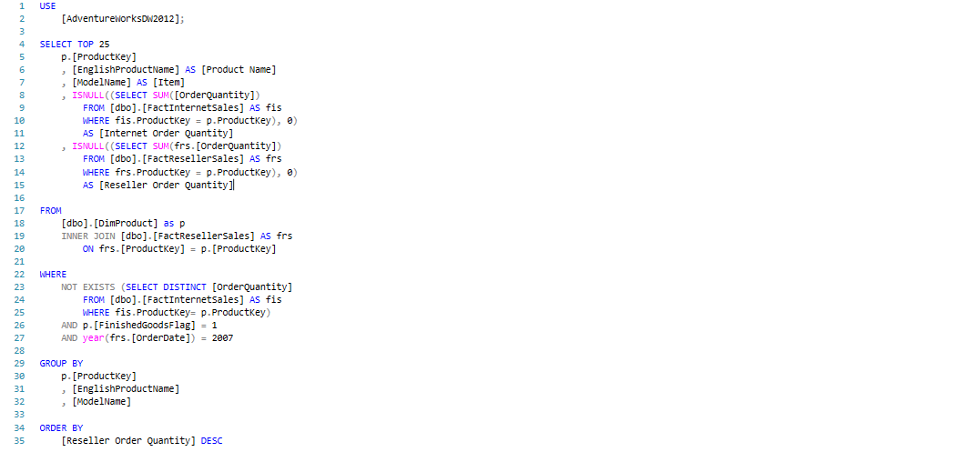

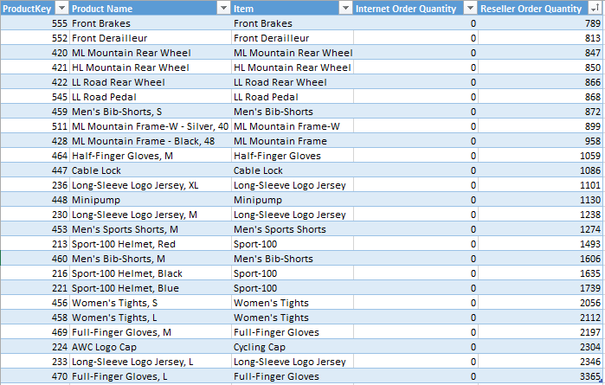

**Figure 1b**



|  |  |
| --- | --- |
| **Row Labels** | **Sum of Reseller Order Quantity** |
| Gloves | 6621 |
| Helmets | 4867 |
| Jerseys | 4685 |
| Tights | 4168 |
| Wheels | 2563 |
| Bib-Shorts | 2478 |
| Caps | 2304 |
| Mountain Frames | 1857 |
| Shorts | 1274 |
| Pumps | 1130 |
| Locks | 1086 |
| Pedals | 868 |
| Derailleurs | 813 |
| Brakes | 789 |
| **Grand Total** | **35503** |

**Figure 1c**



|  |  |  |
| --- | --- | --- |
| **Row Labels** | **Sum of Internet Order Quantity** | **Sum of Reseller Order Quantity** |
| Full-Finger Gloves, L | 0 | 3365 |
| Full-Finger Gloves, M | 0 | 2197 |
| Full-Finger Gloves, S | 0 | 493 |
| Half-Finger Gloves, L | 443 | 833 |
| Half-Finger Gloves, M | 499 | 2965 |
| Half-Finger Gloves, S | 488 | 1700 |
| Long-Sleeve Logo Jersey, L | 452 | 6140 |
| Long-Sleeve Logo Jersey, M | 442 | 3194 |
| Long-Sleeve Logo Jersey, S | 429 | 0 |
| Long-Sleeve Logo Jersey, XL | 413 | 2567 |
| Short-Sleeve Classic Jersey, L | 374 | 2474 |
| Short-Sleeve Classic Jersey, M | 407 | 0 |
| Short-Sleeve Classic Jersey, S | 406 | 1549 |
| Short-Sleeve Classic Jersey, XL | 409 | 3455 |
| **Grand Total** | **4762** | **30932** |

**Figure 1d**

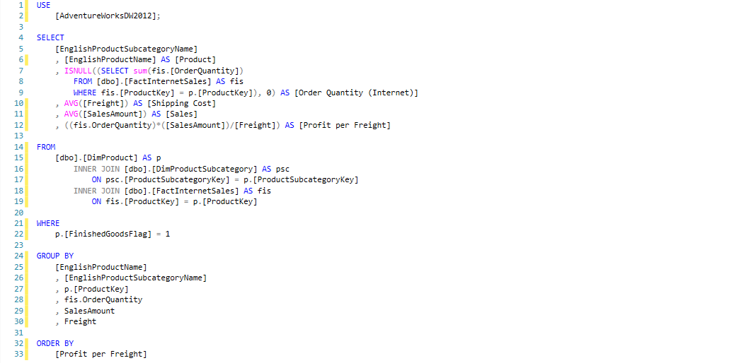

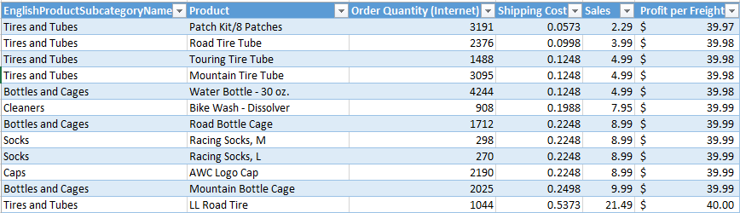

**Figure 1e**



