Lieutenant Colonel Jordan Firth
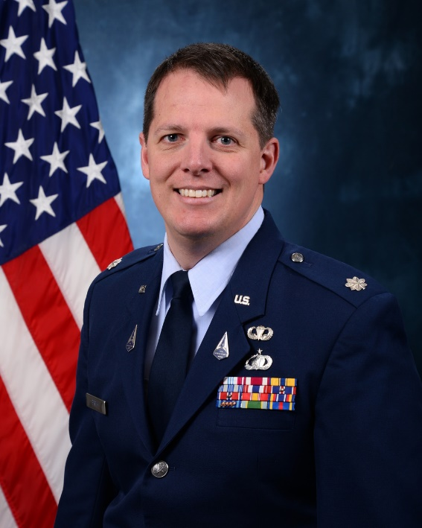
Lieutenant Colonel Jordan Firth is currently the Director of Assessments and an Assistant Professor in the Department of Astronautics at the United States Air Force Academy, CO.

Lt Col Firth attended the United States Air Force Academy and graduated in 2006 with a bachelor's degree in Engineering Mechanics. He has significant test and evaluation experience in both air and space and has achieved Level 3 DAWIA certification in Test & Evaluation.

Lt Col Firth’s PhD research focused on development of an unpowered deployment mechanism for rollable spacecraft booms. He secured a NASA flight opportunity grant and led a team of 14 researchers through safe and successful execution of two Zero-G parabolic flight tests, demonstrating controlled boom deployment in a space-relevant environment.

In his previous assignment, Lt Col Firth served as the Multi-Domain Warfare Branch Chief in the Acquisition Intelligence Division of DIA’s Defense Technology and Long-Range Analysis Office.

EDUCATION
2006 Bachelor of Science, Engineering Mechanics, US Air Force Academy CO
2011 Master of Science, Astronautical Engineering, US Air Force Institute of Technology, Dayton OH
2019 Doctor of Philosophy, Aerospace Engineering, North Carolina State University, Raleigh NC

ASSIGNMENTS
Aug 2006–Sep 2008, Flight Test Engineer, 586 Flight Test Squadron, Holloman AFB NM
Sep 2008–Aug 2009, Rocket Sled Test Engineer, 846 Test Squadron, Holloman AFB NM
Aug 2009–Apr 2011, Graduate Student, U.S. Air Force Institute of Technology, Wright-Patterson AFB, OH
Apr 2011–Mar 2012, Project Officer, DSP Ops, Infrared Space Systems Directorate, Los Angeles AFB CA
Mar 2012–May 2014, SBIRS System Test Engineer, Infrared Space Systems Directorate, Los Angeles AFB CA
May 2014–Jul 2016, Instructor, Department of Astronautics, USAF Academy CO
Aug 2016–Aug 2019, Graduate Student, North Carolina State University, Raleigh NC
Aug 2019–Nov 2020, Air Team Lead, DIA Defense Tech. & Long-Range Analysis, Charlottesville VA
Dec 2020–Jul 2022, Chief, Multi-Domain Warfare Branch, DIA Defense Tech. & Long-Range Analysis, Charlottesville VA
Aug 2022–Present, Assistant Professor and Assessments Director, Department of Astronautics, USAF Academy CO

PROFESIONAL MILITARY EDUCATION
Air and Space Basic Course, 2006
Squadron Officer School, 2012
Air Command and Staff College, 2017

MAJOR AWARDS AND DECORATIONS

John P. Wittry Award, top instructor of Engineering Design, USAFA Department of Astronautics (2023)

Defense Meritorious Service Medal

Meritorious Service Medal

Air Force Commendation Medal

Air Force Achievement Medal

EFFECTIVE DATES OF PROMOTION
Second Lieutenant 31 May 2006
First Lieutenant 31 May 2008
Captain 31 May 2010
Major 1 May 2016
Lieutenant Colonel 1 Sep 2021

